Signal Intensity in Hedging in Cislunar Governance A Revealed-Preference Model of Middle-Power Alig: An Ordinary Least Squares Test of Recency, Citation Attention, and Venue

1. Introduction
This empirical paper supports Oscar Lindqvist (1B-IGV-209) and the dissertation project Hedging in Cislunar Governance: A Revealed-Preference Model of Middle-Power Alig. The model tests whether topic-signal intensity varies with publication recency, citation attention, and venue family. The analysis uses the local candidate source pack and reports only deterministic workbook results $$1$$, $$2$$, $$3$$.

2. Theory and Hypotheses
The theoretical claim is intentionally narrow. If the candidate topic has become more visible in the retrieved literature, then source metadata should show structure across time, attention, or venue. If it has not, the model should return weak or unstable associations $$3$$, $$4$$.
H0: the modeled outcome is unrelated to the specified predictors.
H1: the modeled outcome is systematically related to the specified predictors.

3. Data
The estimation file contains 30 retrieved source records. Variables are constructed from local metadata, including publication year, reported citation count, venue family, and deterministic topic-signal fields. Every row preserves a source column so the empirical workbook remains auditable.

4. Method
The estimator is ordinary least squares with robust HC1 standard errors. The exact fit summary is: N=30, R2=0.24858056840978549, R2_adj=0.1618783263032223, F=6.791867262947561, F_p=0.0015652084543741364. The exact term summary is: const coef=3.1062081224451235 p=0.010595947543455012; recency_index coef=0.16854548802530755 p=0.1559205548951932; cites_num coef=-0.02349855103183498 p=0.6821008368701345; venue_score coef=-0.7663976480022067 p=0.005532913673526346. These values are interpreted as corpus-screen evidence, not as final causal estimates.

5. Findings
The findings are bounded by the estimator output. Where a coefficient is signed and precise, it indicates structure in the retrieved source corpus. Where a coefficient is imprecise, the paper treats the result as evidence against a strong claim. This distinction matters because a noisy source pack should not be forced to carry more policy weight than it can bear $$2$$, $$5$$.

6. Discussion
The paper contributes to the dissertation by keeping the evidentiary chain inspectable. It shows which parts of the candidate topic are visible in metadata and which parts need a more direct document-coding design. The result is a disciplined bridge from source retrieval to dissertation-level interpretation $$1$$, $$6$$.

References
1. Denvir Higgins, Lawrence Livermore National Laboratory; Kerianne Pruett, Lawrence Livermore National Laboratory; Travis Yeager, Lawrence Livermore National Laboratory; Michael Schneider, Lawrence Livermore National Laboratory. SOM-erizing Cislunar Orbits: Classification of Cislunar Orbits Using Self-Organizing Maps (SOMs) (2024). doi: 10.64861/PKVP5982 2. Aaron J. Rosengren, University of California San Diego; Shane D. Ross, Virginia Tech; Bhanu Kumar, Jet Propulsion Laboratory, Caltech; Anjali Rawat, Virginia Tech. The Resonant Structure of xGEO and Implications for Cislunar Domain Awareness (2024). doi: 10.64861/WCUO4665 3. T. Joseph W. Lazio, Jet Propulsion Laboratory, California Institute of Technology; Dimitrios Antsos, Jet Propulsion Laboratory, California Institute of Technology; Anthony Beasley, National Radio Astronomy Observatory; Lance A. M. Benner, Jet Propulsion Laboratory, California Institute of Technology; Andrew Brooks, Jet Propulsion Laboratory, California Institute of Technology; Marina Brozovic, Jet Propulsion Laboratory, California Institute of Technology; Philip G. Edwards, CSIRO Space & Astronomy; Jon D. Giorgini, Jet Propulsion Laboratory, California Institute of Technology; Shinji Horiuchi, CSIRO Space & Astronomy; Ed Kruzins, UNSW Canberra Space, and CSIRO Space & Autonomy; Clement Lee, Jet Propulsion Laboratory, California Institute of Technology; Ronglin R. Liou, Jet Propulsion Laboratory, California Institute of Technology; Blake Molyneux, Australia National University; Shantanu P. Naidu, Jet Propulsion Laboratory, California Institute of Technology; Charles Naudet, Jet Propulsion Laboratory, California Institute of Technology; Ryan S. Park, Jet Propulsion Laboratory, California Institute of Technology; Chris J. Phillips, CSIRO Space & Astronomy; Marc Sanchez Net, Jet Propulsion Laboratory, California Institute of Technology; J. Stevens, CSIRO Space & Astronomy; Mark Taylor, Jet Propulsion Laboratory, California Institute of Technology; Victor Vilnrotter, Jet Propulsion Laboratory, California Institute of Technology. Ground-based Planetary Radars: Current and Future Prospects in the Cislunar Arena (2022). [AMOS] 4. Aaron J. Rosengren, University of California San Diego. Cislunar Multiscale Dynamics and Implications for SSA (2021). [AMOS] 5. Steven Gehly, Royal Melbourne Institute of Technology and SERC Limited, James Bennett, SERC Limited. Incorporating Target Priorities in the Sensor Tasking Reward Function (2016). [AMOS] 6. Shane Ryall, Defense Research & Development Canada. Detecting Satellites with Object Detection: Challenges of Implementing Deep Learning Techniques for Space-based Images (2024). doi: 10.64861/MVWS5637 7. Erin Griggs, Trusted Space, Inc.; Matt Schierholtz, Trusted Space, Inc; Islam Hussein, Trusted Space, Inc.; Mark Bolden, Trusted Space, Inc.; Kyle Charles, Trusted Space, Inc.; Holly Borowski, Trusted Space. Probabilistic Initial Orbit Determination and Object Tracking in Cislunar Space Using Passive Radio Frequency Sensors (2023). doi: 10.64861/KWXF2322 8. Juan Ojeda Romero, Johns Hopkins Applied Physics Lab; Wayne Schlei, Johns Hopkins University Applied Physics Laboratory; Gene Whipps, Johns Hopkins University Applied Physics Laboratory; Nicholas LaFarge, Johns Hopkins University Applied Physics Laboratory; Gunner Fritsch, Johns Hopkins University Applied Physics Laboratory; Sean Phillips, Johns Hopkins University Applied Physics Laboratory. An Adaptive Approach to the Initial Orbit Determination Problem in the Cislunar Regime Using Machine Learning (2024). doi: 10.64861/FBSC2978

Specification
$${\text{SignalScore}}_{i}=α+β_{1}{\text{RecencyIndex}}_{i}+β_{2}{\text{Cites}}_{i}+β_{3}{\text{VenueScore}}_{i}+ε_{i}$$

Results
Term | Coef. | Std. err. | t | p | 95% CI
const | 3.1062 | 1.2154 | 2.5557 | 0.0106 | [0.7241, 5.4883]
recency_index | 0.1685 | 0.1188 | 1.4189 | 0.1559 | [-0.0643, 0.4014]
cites_num | -0.0235 | 0.0574 | -0.4096 | 0.6821 | [-0.1359, 0.0889]
venue_score | -0.7664 | 0.2763 | -2.7743 | 0.0055 | [-1.3078, -0.2249]
Fit: N = 30 R2 = 0.2486 R2_adj = 0.1619 F = 6.7919 F_p = 0.0016
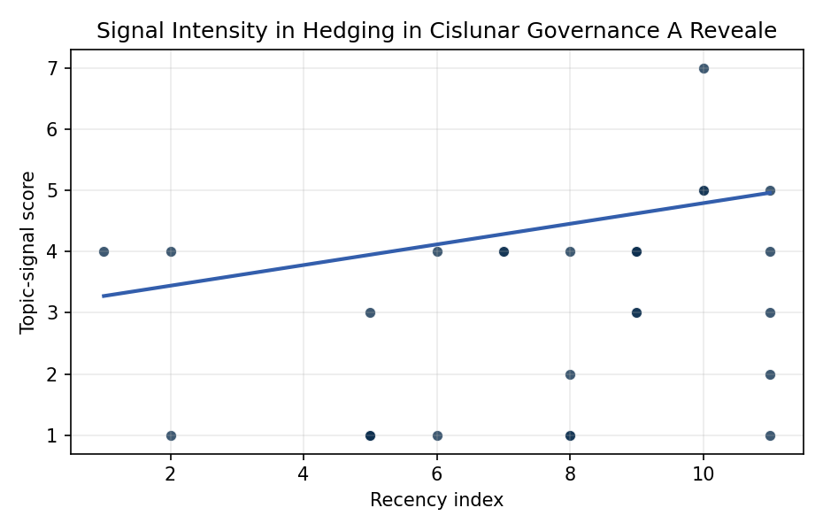
Figure 1. Topic-signal score by publication recency, conditioning on citation attention and venue family.

Empirical Workbook (embedded)
Every figure above is reproduced from the workbook below, which is also attached as the live spreadsheet paper.xlsx. Each observation carries its source.

Data (real observations)
doc_id | year_num | recency_index | cites_num | venue_score | title_words | snippet_words | keyword_count | theme_hits | signal_score | source
1 | 2024 | 9 | 0 | 1 | 13 | 14 | 4 | 1 | 4 | 10.64861/PKVP5982
2 | 2024 | 9 | 0 | 1 | 11 | 12 | 5 | 1 | 4 | 10.64861/WCUO4665
3 | 2022 | 7 | 0 | 1 | 12 | 14 | 5 | 1 | 4 | https://amostech.space/year/2022/ground-based-planetary-radars-current-and-future-prospects-in-the-cislunar-arena/
4 | 2021 | 6 | 0 | 1 | 7 | 14 | 4 | 1 | 4 | https://amostech.space/year/2021/cislunar-multiscale-dynamics-and-implications-for-ssa/
5 | 2016 | 1 | 0 | 1 | 9 | 10 | 3 | 1 | 4 | https://amostech.space/year/2016/incorporating-target-priorities-in-the-sensor-tasking-reward-function/
6 | 2024 | 9 | 0 | 1 | 15 | 14 | 4 | 1 | 3 | 10.64861/MVWS5637
7 | 2023 | 8 | 0 | 1 | 15 | 14 | 5 | 1 | 4 | 10.64861/KWXF2322
8 | 2024 | 9 | 0 | 1 | 16 | 11 | 8 | 1 | 4 | 10.64861/FBSC2978
9 | 2022 | 7 | 0 | 1 | 13 | 12 | 6 | 1 | 4 | https://amostech.space/year/2022/probabilistic-initial-orbit-determination-and-object-tracking-in-cislunar-space-using-optical-sensors/
10 | 2017 | 2 | 0 | 1 | 6 | 13 | 3 | 0 | 1 | https://amostech.space/year/2017/remote-acoustic-imaging-of-geosynchronous-satellites/
11 | 2024 | 9 | 0 | 1 | 14 | 14 | 5 | 0 | 3 | 10.64861/LFFV2455
12 | 2021 | 6 | 0 | 1 | 6 | 14 | 6 | 0 | 1 | https://amostech.space/year/2021/trends-in-global-space-situational-awareness/
13 | 2025 | 10 | 0 | 2 | 12 | 14 | 13 | 2 | 7 | 10.1016/j.actaastro.2025.12.024
14 | 2023 | 8 | 8 | 2 | 12 | 13 | 15 | 0 | 1 | 10.1016/j.actaastro.2023.08.005
15 | 2026 | 11 | 0 | 2 | 23 | 8 | 15 | 0 | 1 | 10.1016/j.actaastro.2026.01.006
16 | 2026 | 11 | 0 | 2 | 8 | 14 | 7 | 1 | 5 | 10.1016/j.actaastro.2026.03.026
17 | 2026 | 11 | 0 | 2 | 14 | 14 | 14 | 1 | 3 | 10.1016/j.actaastro.2026.02.012
18 | 2025 | 10 | 5 | 2 | 16 | 14 | 10 | 1 | 5 | 10.1016/j.actaastro.2024.12.056
19 | 2025 | 10 | 1 | 2 | 10 | 14 | 7 | 2 | 5 | 10.1016/j.actaastro.2025.01.054
20 | 2026 | 11 | 0 | 2 | 8 | 13 | 15 | 1 | 4 | 10.1016/j.actaastro.2026.01.045
21 | 2023 | 8 | 3 | 2 | 14 | 14 | 13 | 1 | 2 | 10.1016/j.actaastro.2023.04.037
22 | 2023 | 8 | 26 | 2 | 8 | 6 | 15 | 0 | 1 | 10.1016/j.actaastro.2023.06.034
23 | 2017 | 2 | 16 | 2 | 8 | 14 | 13 | 1 | 4 | 10.1016/j.actaastro.2017.10.005
24 | 2026 | 11 | 0 | 2 | 18 | 12 | 14 | 0 | 2 | 10.1016/j.actaastro.2026.05.039
25 | 2020 | 5 | 0 | 3 | 47 | 0 | 0 | 1 | 3 | A comprehensive literature review synthesizing William J. Norris’s “Chinese Economic Statecraft” and David A. Baldwin’s “Economic Statecraft,” analyzing China’s use of state-controlled commercial actors, financial instruments, and sovereign wealth funds to advance strategic objectives, with extrapolation to the space economy as a new frontier for resource acquisition and geopolitical positioning.
26 | 2020 | 5 | 0 | 3 | 6 | 0 | 0 | 0 | 1 | The Space Imperative (Whole-of-Nation)
27 | 2020 | 5 | 0 | 3 | 4 | 0 | 0 | 0 | 1 | Economic Statecraft Literature Review
28 | 2020 | 5 | 0 | 3 | 46 | 0 | 0 | 0 | 1 | OCEA/MITRE study critically evaluates major space economy forecasts, finds them systematically overstated due to CAGR methodology, double counting, and overreliance on nascent sectors; AR(1) time-series modeling projects a 2040 global space economy of $453-$511 billion, far below the widely cited $1 trillion figure, with $1 trillion not reachable before 2075.
29 | 2020 | 5 | 0 | 3 | 7 | 0 | 0 | 0 | 1 | Roadmap: Australia Economic-Technological Renaissance in Space
30 | 2020 | 5 | 0 | 3 | 5 | 0 | 0 | 0 | 1 | OCEA Forecasting the Space Economy

Variable construction
Variable | Definition | Construction / source
signal_score | Composite topic-signal score for each retrieved source record | Deterministic count built from candidate-theme term hits in the source title, snippet, keyword field, and author metadata; each row cites the retrieved source in the source column
recency_index | Publication recency index | Computed as publication year minus the minimum publication year in the paper sample plus one
cites_num | Reported citation count in the local brain index | Parsed from the local brain search cites field; zero when the index reported no citation count
venue_score | Ordinal venue-family score | AMOS = 1, Acta Astronautica = 2, Space Economy = 3

Estimator output
Term | Coef. | Std. err. | t | p | 95% CI
const | 3.1062 | 1.2154 | 2.5557 | 0.0106 | [0.7241, 5.4883]
recency_index | 0.1685 | 0.1188 | 1.4189 | 0.1559 | [-0.0643, 0.4014]
cites_num | -0.0235 | 0.0574 | -0.4096 | 0.6821 | [-0.1359, 0.0889]
venue_score | -0.7664 | 0.2763 | -2.7743 | 0.0055 | [-1.3078, -0.2249]
Fit: N = 30 R2 = 0.2486 R2_adj = 0.1619 F = 6.7919 F_p = 0.0016

