Attention Accumulation in Norm Entrepreneurship and the Drafting of the Artemis Accords Whose Language Su: A Learning-Curve Analysis of Citation Growth by Article Age

1. Introduction
This empirical paper supports Amara Rahman (1B-IGV-208) and the dissertation project Norm Entrepreneurship and the Drafting of the Artemis Accords: Whose Language Su. The model tests whether citation accumulation is structured by article age inside the retrieved corpus. The analysis uses the local candidate source pack and reports only deterministic workbook results $$1$$, $$2$$, $$3$$.

2. Theory and Hypotheses
The theoretical claim is intentionally narrow. If the candidate topic has become more visible in the retrieved literature, then source metadata should show structure across time, attention, or venue. If it has not, the model should return weak or unstable associations $$3$$, $$4$$.
H0: the modeled outcome is unrelated to the specified predictors.
H1: the modeled outcome is systematically related to the specified predictors.

3. Data
The estimation file contains 30 retrieved source records. Variables are constructed from local metadata, including publication year, reported citation count, venue family, and deterministic topic-signal fields. Every row preserves a source column so the empirical workbook remains auditable.

4. Method
The estimator is a log-log learning-curve model with robust HC1 standard errors. The exact fit summary is: N=30, R2=0.006798623643227364, elasticity_b=-0.13234450119780067, progress_ratio_2^b=0.912347603014938. The exact term summary is: const coef=0.719875366395704 p=0.014339913659512996; _ln_x coef=-0.13234450119780067 p=0.5083106199187482. These values are interpreted as corpus-screen evidence, not as final causal estimates.

5. Findings
The findings are bounded by the estimator output. Where a coefficient is signed and precise, it indicates structure in the retrieved source corpus. Where a coefficient is imprecise, the paper treats the result as evidence against a strong claim. This distinction matters because a noisy source pack should not be forced to carry more policy weight than it can bear $$2$$, $$5$$.

6. Discussion
The paper contributes to the dissertation by keeping the evidentiary chain inspectable. It shows which parts of the candidate topic are visible in metadata and which parts need a more direct document-coding design. The result is a disciplined bridge from source retrieval to dissertation-level interpretation $$1$$, $$6$$.

References
1. Harvey Reed, MITRE; Nathaniel Dailey, MITRE; Ruth Stilwell, Aerospace Policy Solutions, LLC; Brian Weeden, Secure World Foundation. Decentralized Space Information Sharing as a Key Enabler of Trust and the Preservation of Space (2021). [AMOS] 2. Jacqueline Smith, MIT; Moriba Jah, University of Texas; Danielle Wood, MIT. Architecting a Decision Support System for Continuing Supervision of Commercial In-Space Servicing (2024). doi: 10.64861/SYQO6621 3. Todd Harrison, Center for Strategic and International Studies. International Perspectives on Space Weapons (2020). [AMOS] 4. Purin Tanirat, Geo-Informatics and Space Technology Development Agency (GISTDA); Sittiporn Channumsin, Geo-Informatics and Space Technology Development Agency (GISTDA); Suwat Sreesawet, Geo-Informatics and Space Technology Development Agency (GISTDA); Setthanun Thongsuwan, Geo-Informatics and Space Technology Development Agency (GISTDA); Keerati Puttasuwan, Geo-Informatics and Space Technology Development Agency (GISTDA); Phasawee Saingyen, Geo-Informatics and Space Technology Development Agency (GISTDA); Borirak Kitrattana, Geo-Informatics and Space Technology Development Agency (GISTDA); Yodyium Tipsuwan, Kasetsart University. Enhancing Space Safety and Security: GISTDA’s Integrated Approach to Space Situational Awareness and Traffic Management (2025). doi: 10.64861/KSPN2451 5. Grant Privett, Defence Science Technology Laboratory (Dstl); Calum Meredith, Defence Science Technology Laboratory (Dstl); Andy Winterbotham, Defence Science Technology Laboratory (Dstl); Jamie Symons, Defence Science Technology Laboratory (Dstl); Lauchie Scott, Defense R&D Canada; Allie Fawcett, Bornea Dynamics; Simon Lyddiatt, Bornea Dynamics; Ricky Gill, University of Manitoba; Brendan Doherty, University of Manitoba; Riley Sweeney, University of Manitoba; Philip Ferguson, University of Manitoba; Paul Harrison, Magellan Aerospace; Matthew Driedger, Magellan Aerospace; Vojtech Balaban, Magellan Aerospace. On-Orbit Satellite Detection and Extraction in J Band Imagery (2025). doi: 10.64861/AZUD8556 6. Tomasz Zubowicz, Polish Space Agency; Mikolaj Kruzynski, Polish Space Agency; Zygmunt Aniol, Polish Space Agency; Krzysztof Arminski, Polish Space Agency; Mikolaj Karawacki, Polish Space Agency; Krzysztof Szyszka, Polish Space Agency; Tymoteusz Trocki, Polish Space Agency; Judyta Wojtala, Polish Space Agency; Pawel Zmudzki, Polish Space Agency. An Introduction to the Optical Fence Subnetwork for Optical Triangulation (2025). doi: 10.64861/OEWV1817 7. Tomasz Zubowicz, POLSA; Mikolaj Kruzynski, POLSA; Krzysztof Arminski, POLSA; Mikolaj Karawacaki, POLSA; Krzysztof Szyszka, POLSA; Marcin Teofilewicz, POLSA; Artur Makarewicz, POLSA; Edwin Wnuk, POLSA; Zygmunt Aniol, POLSA; Tymoteusz Trocki, POLSA. POLSA Sensor Network Capabilities Under Different Operating Modes (2024). doi: 10.64861/SFBT8061 8. Maciej Konacki, Nicolaus Copernicus Astronomical Center, Polish Academy of Sciences; Adrian Malacz, Polish Space Agency; Arkadiusz Chimicz, Polish Space Agency; Pawe? Lejba, Space Research Center, Polish Academy of Sciences, Borowiec Astrogeodynamic Observatory; Piotr Sybilski, Sybilla Technologies; Rafa? Paw?aszek, Sybilla Technologies; Stanis?aw Koz?owski, Cillium Engineering; Tomasz Suchodolski, Space Research Center, Polish Academy of Sciences, Borowiec Astrogeodynamic Observatory; Krzysztof Koz?owski, Institute of Automation and Robotics; Agnieszka Sybilska, Baltic Institute of Technology; Beata Rogowska, Nicolaus Copernicus Astronomical Center, Polish Academy of Sciences; Dariusz Pazderski, Institute of Automation and Robotics; Micha? ?o?nowski, 6Roads Ltd; Andy Shearer, National University of Ireland Galway; Agnieszka S?owikowska, Centre for Astronomy, Faculty of Physics, Astronomy and Informatics, Nicolaus Copernicus; Maciej Pilichowski, Sybilla Technologies; Marek Malawski, Polish Space Agency; Marcin G?dek, 6Roads Ltd. Optical, Laser and Processing Capabilities of the New Polish Space Situational Awareness Centre (2019). [AMOS]

Specification
$$ln({\text{CitesPlus1}}_{i})=α+β_{1}ln({\text{AgeIndex}}_{i})+ε_{i}$$

Results
Term | Coef. | Std. err. | t | p | 95% CI
const | 0.7199 | 0.294 | 2.4486 | 0.0143 | [0.1437, 1.2961]
_ln_x | -0.1323 | 0.2001 | -0.6615 | 0.5083 | [-0.5245, 0.2598]
Fit: N = 30 R2 = 0.0068 elasticity_b = -0.1323 progress_ratio_2^b = 0.9123
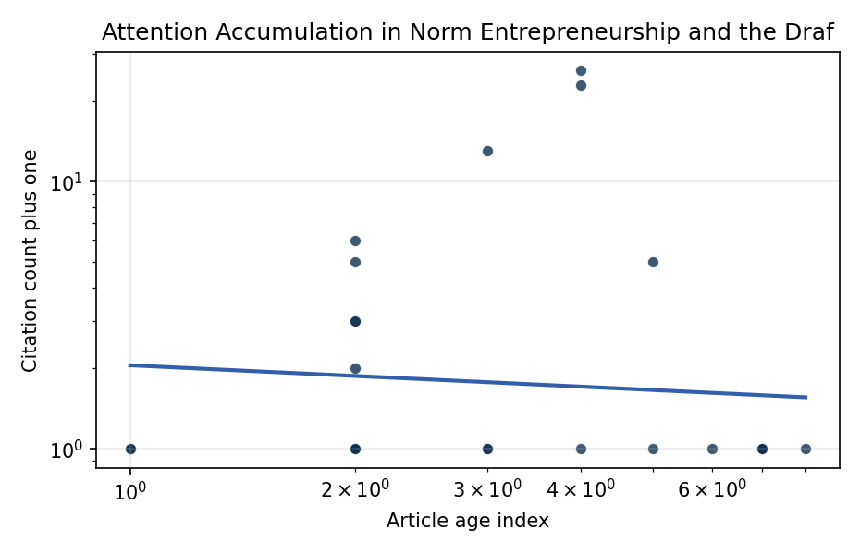
Figure 1. Citation accumulation against article age in the retrieved topic literature.

Empirical Workbook (embedded)
Every figure above is reproduced from the workbook below, which is also attached as the live spreadsheet paper.xlsx. Each observation carries its source.

Data (real observations)
doc_id | year_num | age_index | cites_num | cites_plus1 | signal_score | source
1 | 2021 | 6 | 0 | 1 | 3 | https://amostech.space/year/2021/decentralized-space-information-sharing-as-a-key-enabler-of-trust-and-the-preservation-of-space/
2 | 2024 | 3 | 0 | 1 | 5 | 10.64861/SYQO6621
3 | 2020 | 7 | 0 | 1 | 1 | https://amostech.space/year/2020/international-perspectives-on-space-weapons/
4 | 2025 | 2 | 0 | 1 | 4 | 10.64861/KSPN2451
5 | 2025 | 2 | 0 | 1 | 1 | 10.64861/AZUD8556
6 | 2025 | 2 | 0 | 1 | 1 | 10.64861/OEWV1817
7 | 2024 | 3 | 0 | 1 | 1 | 10.64861/SFBT8061
8 | 2019 | 8 | 0 | 1 | 3 | https://amostech.space/year/2019/optical-laser-and-processing-capabilities-of-the-new-polish-space-situational-awareness-centre/
9 | 2022 | 5 | 0 | 1 | 3 | https://amostech.space/year/2022/sharing-operational-risk-information-in-the-space-domain-to-facilitate-norms-development-and-compliance-monitoring/
10 | 2025 | 2 | 0 | 1 | 4 | 10.64861/VSAT2607
11 | 2023 | 4 | 0 | 1 | 1 | 10.64861/EZRE5509
12 | 2020 | 7 | 0 | 1 | 1 | https://amostech.space/year/2020/can-international-law-provide-a-basis-for-actively-removing-space-debris/
13 | 2025 | 2 | 2 | 3 | 3 | 10.1016/j.actaastro.2025.02.010
14 | 2025 | 2 | 1 | 2 | 3 | 10.1016/j.actaastro.2025.01.054
15 | 2025 | 2 | 2 | 3 | 7 | 10.1016/j.actaastro.2025.04.063
16 | 2023 | 4 | 22 | 23 | 6 | 10.1016/j.actaastro.2023.01.003
17 | 2025 | 2 | 4 | 5 | 2 | 10.1016/j.actaastro.2025.09.070
18 | 2022 | 5 | 4 | 5 | 5 | 10.1016/j.actaastro.2022.11.005
19 | 2026 | 1 | 0 | 1 | 2 | 10.1016/j.actaastro.2026.03.030
20 | 2025 | 2 | 5 | 6 | 3 | 10.1016/j.actaastro.2025.04.041
21 | 2025 | 2 | 0 | 1 | 4 | 10.1016/j.actaastro.2025.05.036
22 | 2025 | 2 | 0 | 1 | 3 | 10.1016/j.actaastro.2025.11.069
23 | 2024 | 3 | 12 | 13 | 8 | 10.1016/j.actaastro.2024.09.005
24 | 2023 | 4 | 25 | 26 | 5 | 10.1016/j.actaastro.2023.07.009
25 | 2020 | 7 | 0 | 1 | 1 | Roadmap: Australia Economic-Technological Renaissance in Space
26 | 2020 | 7 | 0 | 1 | 6 | MITRE white paper arguing that Australia’s geolocational Delta-V advantage, automated mining expertise, and university smallsat capacity can underpin a commercial space economy analogous to Japan’s and Germany’s post-WWII economic miracles, provided the country prioritizes LTS Guidelines, orbital debris governance, and Artemis Accords leadership over defense-budget reliance.
27 | 2020 | 7 | 0 | 1 | 2 | Mapping Outer Space Norms
28 | 2026 | 1 | 0 | 1 | 2 | 10.1177/00471178261418898
29 | 2020 | 7 | 0 | 1 | 11 | A 2021 Johns Hopkins SAIS doctoral thesis by Nathaniel Dailey proposing an International Space Reference Architecture (ISRA) as a socio-technological transformative mechanism to resolve contemporary space governance failures – orbital debris, policy fragmentation, and space traffic management – by coupling enterprise architecture methodology with international relations constructivist theory, blockchain-enabled information sharing, and norms entrepreneurship.
30 | 2020 | 7 | 0 | 1 | 4 | The Missing Ingredients for a Polycentric Governance System of Orbital Debris

Variable construction
Variable | Definition | Construction / source
cites_plus1 | Citation count plus one | Computed as the reported citation count from the local brain index plus one so the log transformation is defined for uncited records
age_index | Document age index | Computed as 2026 minus publication year plus one

Estimator output
Term | Coef. | Std. err. | t | p | 95% CI
const | 0.7199 | 0.294 | 2.4486 | 0.0143 | [0.1437, 1.2961]
_ln_x | -0.1323 | 0.2001 | -0.6615 | 0.5083 | [-0.5245, 0.2598]
Fit: N = 30 R2 = 0.0068 elasticity_b = -0.1323 progress_ratio_2^b = 0.9123

