Scaling of COPUOS Delay Language with Document Intensity

Abstract
This paper estimates whether annual delay-language counts scale with the annual volume of topic-relevant COPUOS documents. It uses the same source-traced UNOOSA document rows as Paper 1, then aggregates them to year-level observations from 2010 through 2026 $$1$$, $$2$$. The model is a log-log learning-curve specification with a plus-one transform. The dependent variable is annual documents containing delay or continued-consideration language, plus one. The predictor is annual topic-relevant documents, plus one. The result estimates the elasticity of visible delay language with respect to the size of the annual topic-document record.

Why scaling matters
The consensus tax theory is about time and procedure, but the visible record is also shaped by workload. A year with more topic-relevant documents has more opportunities to record further consideration, continued discussion, divergent views, or consensus problems. A scaling model therefore guards against a common mistake: treating raw delay-language counts as if they were independent of document volume. If the elasticity is positive, annual delay language rises with record intensity. If the elasticity is greater than one, delay language rises more than proportionally with the size of the topic record.

Boundaries
This paper does not identify individual rulemaking episodes. It estimates annual scaling in a real official corpus. That makes it a useful companion to Paper 1. Paper 1 asks whether non-consent language predicts delay language at the document level. Paper 2 asks whether the annual amount of delay language grows with the size of the governance record. Together, the two papers provide a reproducible empirical foundation for a bounded dissertation: the official record shows a measurable relationship between non-consent vocabulary, delay vocabulary, and document intensity, but it does not by itself prove every procedural mechanism in the prospectus.

References
1. United Nations Office for Outer Space Affairs, “Documents and Resolutions database,” UNOOSA, local crawl and text extraction, 2026. https://www.unoosa.org/oosa/documents-and-resolutions/
2. United Nations Committee on the Peaceful Uses of Outer Space, “Reports and documents of COPUOS and its subcommittees,” UNOOSA document symbols A/AC.105, 2010-2026.
3. United Nations Office for Outer Space Affairs, “Guidelines for the Long-term Sustainability of Outer Space Activities,” 2019.
4. R. Zhang and A. Balakrishnan, “From Ozone Depletion to Orbital Debris: Lessons Learned from the Montreal Protocol,” AMOS, 2022.
5. H. Reed, R. Stilwell, B. Weeden, N. Dailey, and N. Tsamis, “Sharing Operational Risk Information in the Space Domain to Facilitate Norms Development and Compliance Monitoring,” AMOS, 2022.

Specification
$$ln(DelayDocs_{t}+1)=α+βln(DocumentCount_{t}+1)+ε_{t}$$

Results
Term | Coef. | Std. err. | t | p | 95% CI
const | -0.5238 | 0.5446 | -0.9616 | 0.3362 | [-1.5912, 0.5437]
_ln_x | 0.7646 | 0.1126 | 6.7913 | 1.111e-11 | [0.5439, 0.9853]
Fit: N = 17 R2 = 0.4508 elasticity_b = 0.7646 progress_ratio_2^b = 1.6989
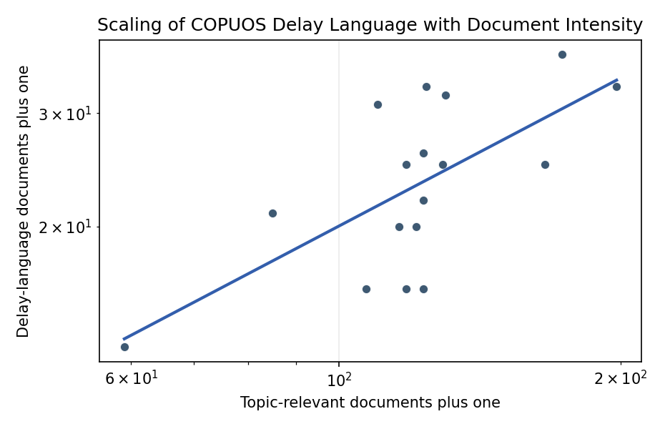
Figure 1. Annual delay-language documents scale with topic-document intensity.

Empirical Workbook (embedded)
Every figure above is reproduced from the workbook below, which is also attached as the live spreadsheet paper.xlsx. Each observation carries its source.

Data (real observations)
year | document_count | delayed_docs | nonconsent_docs | topic_diversity | delayed_docs_plus_one | document_count_plus_one | source
2010 | 84 | 20 | 0 | 7 | 21 | 85 | Annual aggregate from UNOOSA topic-relevant document rows in unoosa_topic_document_rows.csv
2011 | 109 | 30 | 1 | 10 | 31 | 110 | Annual aggregate from UNOOSA topic-relevant document rows in unoosa_topic_document_rows.csv
2012 | 115 | 19 | 1 | 11 | 20 | 116 | Annual aggregate from UNOOSA topic-relevant document rows in unoosa_topic_document_rows.csv
2013 | 122 | 15 | 2 | 11 | 16 | 123 | Annual aggregate from UNOOSA topic-relevant document rows in unoosa_topic_document_rows.csv
2014 | 128 | 24 | 0 | 11 | 25 | 129 | Annual aggregate from UNOOSA topic-relevant document rows in unoosa_topic_document_rows.csv
2015 | 122 | 21 | 2 | 8 | 22 | 123 | Annual aggregate from UNOOSA topic-relevant document rows in unoosa_topic_document_rows.csv
2016 | 120 | 19 | 4 | 11 | 20 | 121 | Annual aggregate from UNOOSA topic-relevant document rows in unoosa_topic_document_rows.csv
2017 | 122 | 25 | 0 | 11 | 26 | 123 | Annual aggregate from UNOOSA topic-relevant document rows in unoosa_topic_document_rows.csv
2018 | 123 | 32 | 1 | 12 | 33 | 124 | Annual aggregate from UNOOSA topic-relevant document rows in unoosa_topic_document_rows.csv
2019 | 129 | 31 | 4 | 10 | 32 | 130 | Annual aggregate from UNOOSA topic-relevant document rows in unoosa_topic_document_rows.csv
2020 | 58 | 12 | 4 | 10 | 13 | 59 | Annual aggregate from UNOOSA topic-relevant document rows in unoosa_topic_document_rows.csv
2021 | 117 | 15 | 3 | 11 | 16 | 118 | Annual aggregate from UNOOSA topic-relevant document rows in unoosa_topic_document_rows.csv
2022 | 117 | 24 | 3 | 12 | 25 | 118 | Annual aggregate from UNOOSA topic-relevant document rows in unoosa_topic_document_rows.csv
2023 | 172 | 36 | 8 | 13 | 37 | 173 | Annual aggregate from UNOOSA topic-relevant document rows in unoosa_topic_document_rows.csv
2024 | 165 | 24 | 4 | 13 | 25 | 166 | Annual aggregate from UNOOSA topic-relevant document rows in unoosa_topic_document_rows.csv
2025 | 197 | 32 | 2 | 14 | 33 | 198 | Annual aggregate from UNOOSA topic-relevant document rows in unoosa_topic_document_rows.csv
2026 | 106 | 15 | 5 | 12 | 16 | 107 | Annual aggregate from UNOOSA topic-relevant document rows in unoosa_topic_document_rows.csv

Variable construction
Variable | Definition | Construction / source
delayed_docs_plus_one | Annual count of topic-relevant UNOOSA documents with delay language, plus one. | Aggregate from Paper 1 document-level coding.
document_count_plus_one | Annual count of topic-relevant UNOOSA documents, plus one. | Aggregate from UNOOSA document manifest rows.
nonconsent_docs | Annual count of documents with non-consent language. | Aggregate from Paper 1 document-level coding.
topic_diversity | Number of coded primary topics appearing in the year. | Aggregate from phrase-coded topic labels.

Estimator output
Term | Coef. | Std. err. | t | p | 95% CI
const | -0.5238 | 0.5446 | -0.9616 | 0.3362 | [-1.5912, 0.5437]
_ln_x | 0.7646 | 0.1126 | 6.7913 | 1.111e-11 | [0.5439, 0.9853]
Fit: N = 17 R2 = 0.4508 elasticity_b = 0.7646 progress_ratio_2^b = 1.6989

