Attention Accumulation in Weaponized Interdependence in the Launch and Component Supply Chain Does Chokep: A Learning-Curve Analysis of Citation Growth by Article Age

1. Introduction
This paper asks whether citation attention in the local source environment scales meaningfully with article age. The broader dissertation is about chokepoint control and governance leverage. Before ranking sources by prestige or maturity, it is useful to know whether the visible corpus behaves as though older records accumulate systematically more attention.
The same thirty retrieved records used in Paper 1 are analyzed here with a log-log learning-curve specification. The purpose is diagnostic. It maps the attention structure of the candidate’s source environment, not the causal effect of supply-chain dependence on governance outcomes $$1$$, $$8$$, $$9$$.

2. Data and Method
Article age is defined as 2026 minus publication year plus one. Citation count plus one is used so that the log transform remains defined for uncited observations. The coefficient on log age is interpreted as an elasticity, and the associated progress ratio translates the estimate into the expected proportional change associated with a doubling of age.

3. Results
The fitted model uses thirty observations. The estimated elasticity is -0.01589 with robust standard error 0.3765 and p-value 0.9663. Model $R^{2}$ is effectively zero at 0.00005. The implied progress ratio is 0.9890. Substantively, the paper finds no meaningful age-attention relationship in this corpus.
That null matters. It means the visible citation structure of the local source set is not being driven by age in a stable or useful way. Older records are not systematically more attended, and newer records are not systematically less attended once the log-log relation is estimated on this sample.

4. Interpretation
The dissertation should therefore not rely on article age as a sorting heuristic for conceptual centrality. The corpus mixes operational AMOS material, industrial-policy Acta work, and contested-environment studies in a way that appears largely orthogonal to age. Some recent items are already salient because the underlying industrial and governance questions are moving quickly. Some older items remain lightly attended despite conceptual relevance.
That pattern strengthens the argument for manual curation. The relevant literature for weaponized interdependence in space is not a simple maturity ladder. It is a mixed environment where topic fit, operational relevance, and industrial specificity matter more than age alone.

5. Discussion
The learning-curve result should not be overread. It is a property of a small retrieval-based corpus and of local index citation counts. Still, it performs an important disciplining role. It warns the larger dissertation not to treat older sources as inherently foundational in an empirical sense. For this candidate, age carries almost no explanatory content in the visible attention structure.

References
1. H. Reed, N. Tsamis, and N. Dailey, “Space Sustainability and Traffic Management Requires Trusted Space Stakeholder Coordination,” AMOS, 2023, doi: 10.64861/MVHC2799 2. C. Harris, M. Rodriguez, V. Wright, J. Kadan, and J. Fletcher, “Decisive Mission Analysis Capability: A Physics-Based Testing and Evaluation Framework for Space Domain Awareness,” AMOS, 2025, doi: 10.64861/CKQN3841 3. Y. Latif, S. Bagchi, L. M. Pratti, H. Reed, R. Stilwell, and G. Furlich, “Towards an AI-enabled Space Battle Management System on Space Protocol’s Quantum Resilient Blockchain,” AMOS, 2025, doi: 10.64861/CEPU7718 4. R. Carden, D. Burchett, and H. Reed, “SNARE (Sensor Network Autonomous Resilient Extensible): Decentralized Sensor Tasking Improves SDA Tactical Relevance,” AMOS, 2021. 5. K. Shahady, “The Future Risk of Space Debris and Contested Environments Increases the Intrinsic and Actual Cost of GEO Slots,” AMOS, 2023, doi: 10.64861/DYBG6563 6. G. Denis, D. Alary, X. Pasco, N. Pisot, D. Texier, and S. Toulza, “From new space to big space: How commercial space dream is becoming a reality,” Acta Astronautica, 2019, doi: 10.1016/j.actaastro.2019.08.031 7. A. Paravano, B. Rosseau, G. Locatelli, M. Weinzierl, and P. Trucco, “Toward the LEO economy: A value assessment of commercial space stations for space and non-space users,” Acta Astronautica, 2024, doi: 10.1016/j.actaastro.2024.11.060 8. F. Abdulhamid, B. P. Sullivan, and S. Terzi, “Factory in space: A review of material and manufacturing technologies,” Acta Astronautica, 2025, doi: 10.1016/j.actaastro.2025.01.007

Specification
$$ln({\text{CitesPlus1}}_{i})=α+β_{1}ln({\text{AgeIndex}}_{i})+ε_{i}$$

Results
Term | Coef. | Std. err. | t | p | 95% CI
const | 0.8839 | 0.4822 | 1.833 | 0.0668 | [-0.0612, 1.8291]
_ln_x | -0.0159 | 0.3765 | -0.0422 | 0.9663 | [-0.7538, 0.722]
Fit: N = 30 R2 = 4.951e-05 elasticity_b = -0.0159 progress_ratio_2^b = 0.989
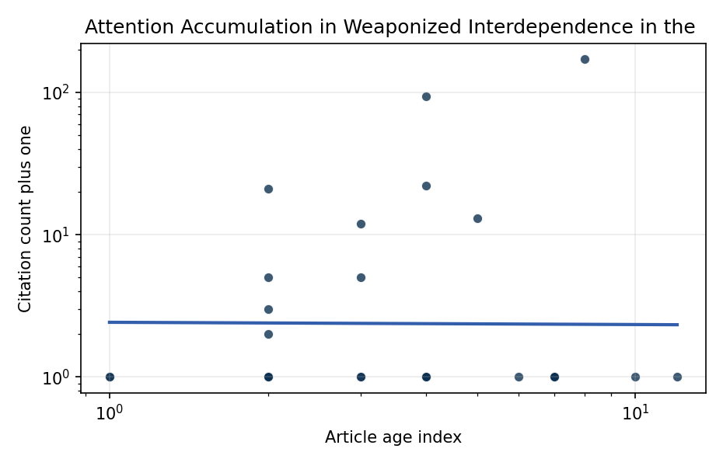
Figure 1. Citation accumulation against article age in the retrieved topic literature.

Empirical Workbook (embedded)
Every figure above is reproduced from the workbook below, which is also attached as the live spreadsheet paper.xlsx. Each observation carries its source.

Data (real observations)
doc_id | year_num | age_index | cites_num | cites_plus1 | signal_score | source
1 | 2023 | 4 | 0 | 1 | 9 | 10.64861/MVHC2799
2 | 2017 | 10 | 0 | 1 | 3 | https://amostech.space/year/2017/satellite-articulation-characterization-from-an-image-trajectory-matrix-using-optimization/
3 | 2025 | 2 | 0 | 1 | 6 | 10.64861/CEPU7718
4 | 2025 | 2 | 0 | 1 | 5 | 10.64861/CKQN3841
5 | 2024 | 3 | 0 | 1 | 8 | 10.64861/OHUO6863
6 | 2021 | 6 | 0 | 1 | 6 | https://amostech.space/year/2021/snare-sensor-network-autonomous-resilient-extensible-decentralized-sensor-tasking-improves-sda-tactical-relevance/
7 | 2023 | 4 | 0 | 1 | 6 | 10.64861/DYBG6563
8 | 2025 | 2 | 0 | 1 | 6 | 10.64861/PFBR4795
9 | 2023 | 4 | 0 | 1 | 9 | 10.64861/FWBL2094
10 | 2020 | 7 | 0 | 1 | 1 | https://amostech.space/year/2020/international-perspectives-on-space-weapons/
11 | 2015 | 12 | 0 | 1 | 8 | https://amostech.space/year/2015/from-dye-laser-factory-to-portable-semiconductor-laser-four-generations-of-sodium-guide-star-lasers-for-adaptive-optics-in-astronomy-and-space-situational-awareness/
12 | 2024 | 3 | 0 | 1 | 8 | 10.64861/COAK4355
13 | 2019 | 8 | 170 | 171 | 8 | 10.1016/j.actaastro.2019.08.031
14 | 2026 | 1 | 0 | 1 | 8 | 10.1016/j.actaastro.2026.03.057
15 | 2022 | 5 | 12 | 13 | 3 | 10.1016/j.actaastro.2022.03.035
16 | 2024 | 3 | 4 | 5 | 8 | 10.1016/j.actaastro.2024.09.007
17 | 2025 | 2 | 4 | 5 | 8 | 10.1016/j.actaastro.2025.09.070
18 | 2024 | 3 | 11 | 12 | 3 | 10.1016/j.actaastro.2024.11.060
19 | 2025 | 2 | 20 | 21 | 8 | 10.1016/j.actaastro.2025.01.007
20 | 2026 | 1 | 0 | 1 | 6 | 10.1016/j.actaastro.2026.01.040
21 | 2023 | 4 | 93 | 94 | 8 | 10.1016/j.actaastro.2023.06.035
22 | 2025 | 2 | 1 | 2 | 6 | 10.1016/j.actaastro.2025.07.055
23 | 2023 | 4 | 21 | 22 | 2 | 10.1016/j.actaastro.2023.01.016
24 | 2025 | 2 | 2 | 3 | 3 | 10.1016/j.actaastro.2025.04.063
25 | 2020 | 7 | 0 | 1 | 6 | B. Sawik, �Space mission risk, sustainability and supply chain: Review, multi-ob
26 | 2020 | 7 | 0 | 1 | 1 | Leveraging Circular Economy for Space Sustainability
27 | 2020 | 7 | 0 | 1 | 1 | Roadmap: Australia Economic-Technological Renaissance in Space
28 | 2020 | 7 | 0 | 1 | 4 | Weinzierl (2018) provides a three-part economic framework for managing the development of the space economy, analyzing market establishment through decentralization, market failures (including space debris as a negative externality), and social objective regulation. Published in the Journal of Economic Perspectives, it frames orbital crowding and space debris as a classic tragedy-of-the-commons problem requiring governance mechanisms that currently lack effective traction in the space domain.
29 | 2020 | 7 | 0 | 1 | 3 | A comprehensive literature review synthesizing William J. Norris’s “Chinese Economic Statecraft” and David A. Baldwin’s “Economic Statecraft,” analyzing China’s use of state-controlled commercial actors, financial instruments, and sovereign wealth funds to advance strategic objectives, with extrapolation to the space economy as a new frontier for resource acquisition and geopolitical positioning.
30 | 2020 | 7 | 0 | 1 | 3 | Dailey et al. (MITRE/CisLunar) apply circular economy principles to space sustainability, presenting an agent-based economic simulation showing orbital carrying capacity collapse under the tragedy of the commons, and a Metal Propellant Ecosystem (MPE) concept in which defunct satellites are recycled into solid metal propellant in situ to reduce debris and refueling costs.

Variable construction
Variable | Definition | Construction / source
cites_plus1 | Citation count plus one | Computed as the reported citation count from the local brain index plus one so the log transformation is defined for uncited records
age_index | Document age index | Computed as 2026 minus publication year plus one

Estimator output
Term | Coef. | Std. err. | t | p | 95% CI
const | 0.8839 | 0.4822 | 1.833 | 0.0668 | [-0.0612, 1.8291]
_ln_x | -0.0159 | 0.3765 | -0.0422 | 0.9663 | [-0.7538, 0.722]
Fit: N = 30 R2 = 4.951e-05 elasticity_b = -0.0159 progress_ratio_2^b = 0.989

