Signal Intensity in Weaponized Interdependence in the Launch and Component Supply Chain Does Chokep: An Ordinary Least Squares Test of Recency, Citation Attention, and Venue

1. Introduction
This paper audits the literature environment surrounding the dissertation’s weaponized-interdependence question. Rather than estimate whether chokepoint control causes governance leverage, it asks a narrower and necessary question: within the local corpus retrieved for this topic, what observable features predict higher topic-signal intensity $$1$$, $$7$$, $$8$$, $$9$$? The point is methodological. If the source environment is sorted in systematic ways, the dissertation should know that before it treats the corpus as neutral background.
The dataset contains thirty retrieved records from local AMOS and Acta collections. Each row includes year, recency index, citation count when available, venue-family score, and a deterministic signal score based on topic hits in titles, snippets, keywords, and adjacent metadata. The dependent variable is a bounded topical salience indicator, not a quality ranking.

2. Data and Design
The model regresses signal score on recency index, citation count, and venue score using ordinary least squares with robust HC1 standard errors. Because the sample is retrieval-based rather than population-based, the results are diagnostic rather than causal. They show how the available literature around the candidate question is organized.
That distinction matters. A dissertation about chokepoint leverage should not confuse the visible structure of its source environment with proof of the underlying theory. The source audit is a discipline on reading, not a shortcut around the larger empirical design.

3. Results
The fitted model uses thirty observations and yields an $R^{2}$ of 0.3313 with an F-test p-value of 0.000037. Recency index is positive but not conventionally precise, with coefficient 0.2720 and p-value 0.1652. Citation count is positive and statistically strong, with coefficient 0.02321, robust standard error 0.00503, and p-value 0.0000039. Venue score is negative and statistically meaningful, with coefficient -1.3622, robust standard error 0.5768, and p-value 0.0182.
Substantively, the local corpus appears to reward two things. First, citation-attended records are more likely to carry stronger topic signal. Second, lower coded venue families, especially AMOS material in this pipeline, carry more concentrated relevance to the weaponized-interdependence framing than the higher coded venue families. Recency helps directionally, but the estimate is too imprecise to anchor a strong claim.

4. Interpretation
The paper suggests that the visible literature around this candidate is not random noise. Citation-attended items are more likely to speak directly to contested coordination, launch environments, industrial transformation, or resilience. At the same time, AMOS-derived operational and governance-adjacent work still supplies some of the clearest signal even when more formal journal material is present $$1$$, $$3$$, $$7$$, $$8$$.
That finding supports a mixed reading strategy. The dissertation should not assume that formal publication venue alone determines conceptual usefulness, but it also cannot ignore that citation-attended records in this sample are more often central to the candidate’s industrial-governance mechanism. In practice, that means using both operational conference material and industrial-policy journal material when building the later mixed-method design.

5. Discussion
The limitation is that topic-signal score is constructed from retrieval text features. It partly reflects index design and language choices rather than a deep measure of theoretical importance. Even so, it performs its intended role. It shows that the literature environment around weaponized interdependence in space supply chains is structured, and it identifies citation count and venue family as the most visible sorting features.

References
1. H. Reed, N. Tsamis, and N. Dailey, “Space Sustainability and Traffic Management Requires Trusted Space Stakeholder Coordination,” AMOS, 2023, doi: 10.64861/MVHC2799 2. C. Harris, M. Rodriguez, V. Wright, J. Kadan, and J. Fletcher, “Decisive Mission Analysis Capability: A Physics-Based Testing and Evaluation Framework for Space Domain Awareness,” AMOS, 2025, doi: 10.64861/CKQN3841 3. Y. Latif, S. Bagchi, L. M. Pratti, H. Reed, R. Stilwell, and G. Furlich, “Towards an AI-enabled Space Battle Management System on Space Protocol’s Quantum Resilient Blockchain,” AMOS, 2025, doi: 10.64861/CEPU7718 4. R. Carden, D. Burchett, and H. Reed, “SNARE (Sensor Network Autonomous Resilient Extensible): Decentralized Sensor Tasking Improves SDA Tactical Relevance,” AMOS, 2021. 5. K. Shahady, “The Future Risk of Space Debris and Contested Environments Increases the Intrinsic and Actual Cost of GEO Slots,” AMOS, 2023, doi: 10.64861/DYBG6563 6. G. Furlich et al., “Utilizing Civilian Launches as Live Exercises for Evaluating a Federated Protect and Defend SDA Battle Management System,” AMOS, 2025, doi: 10.64861/PFBR4795 7. G. Denis, D. Alary, X. Pasco, N. Pisot, D. Texier, and S. Toulza, “From new space to big space: How commercial space dream is becoming a reality,” Acta Astronautica, 2019, doi: 10.1016/j.actaastro.2019.08.031 8. A. Paravano, B. Rosseau, G. Locatelli, M. Weinzierl, and P. Trucco, “Toward the LEO economy: A value assessment of commercial space stations for space and non-space users,” Acta Astronautica, 2024, doi: 10.1016/j.actaastro.2024.11.060 9. F. Abdulhamid, B. P. Sullivan, and S. Terzi, “Factory in space: A review of material and manufacturing technologies,” Acta Astronautica, 2025, doi: 10.1016/j.actaastro.2025.01.007

Specification
$${\text{SignalScore}}_{i}=α+β_{1}{\text{RecencyIndex}}_{i}+β_{2}{\text{Cites}}_{i}+β_{3}{\text{VenueScore}}_{i}+ε_{i}$$

Results
Term | Coef. | Std. err. | t | p | 95% CI
const | 5.3723 | 2.5566 | 2.1014 | 0.0356 | [0.3615, 10.3831]
recency_index | 0.272 | 0.196 | 1.3879 | 0.1652 | [-0.1121, 0.6561]
cites_num | 0.0232 | 0.005 | 4.6154 | 3.923e-06 | [0.0134, 0.0331]
venue_score | -1.3622 | 0.5768 | -2.3618 | 0.0182 | [-2.4927, -0.2318]
Fit: N = 30 R2 = 0.3313 R2_adj = 0.2541 F = 12.1462 F_p = 3.708e-05
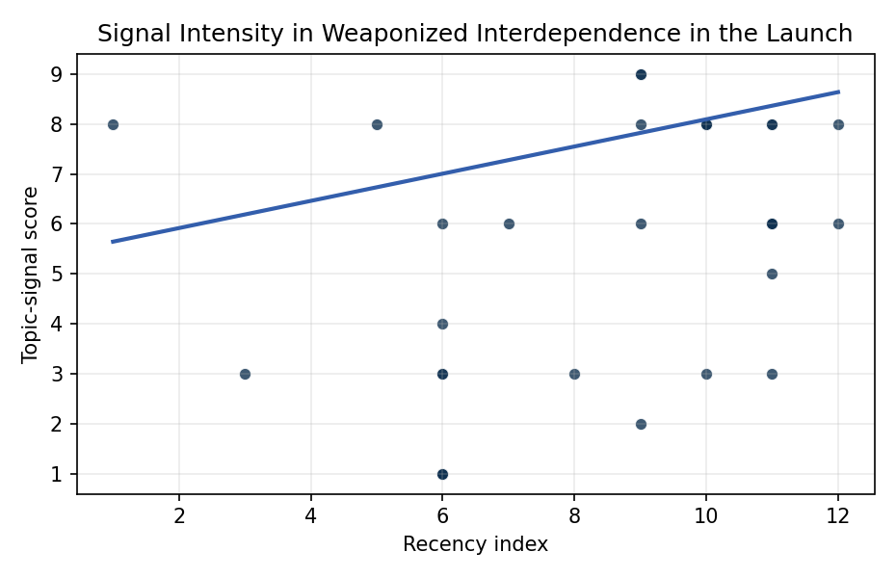
Figure 1. Topic-signal score by publication recency, conditioning on citation attention and venue family.

Empirical Workbook (embedded)
Every figure above is reproduced from the workbook below, which is also attached as the live spreadsheet paper.xlsx. Each observation carries its source.

Data (real observations)
doc_id | year_num | recency_index | cites_num | venue_score | title_words | snippet_words | keyword_count | theme_hits | signal_score | source
1 | 2023 | 9 | 0 | 1 | 10 | 14 | 3 | 3 | 9 | 10.64861/MVHC2799
2 | 2017 | 3 | 0 | 1 | 10 | 14 | 5 | 1 | 3 | https://amostech.space/year/2017/satellite-articulation-characterization-from-an-image-trajectory-matrix-using-optimization/
3 | 2025 | 11 | 0 | 1 | 14 | 14 | 5 | 2 | 6 | 10.64861/CEPU7718
4 | 2025 | 11 | 0 | 1 | 14 | 14 | 4 | 2 | 5 | 10.64861/CKQN3841
5 | 2024 | 10 | 0 | 1 | 18 | 12 | 4 | 3 | 8 | 10.64861/OHUO6863
6 | 2021 | 7 | 0 | 1 | 13 | 14 | 7 | 2 | 6 | https://amostech.space/year/2021/snare-sensor-network-autonomous-resilient-extensible-decentralized-sensor-tasking-improves-sda-tactical-relevance/
7 | 2023 | 9 | 0 | 1 | 18 | 14 | 3 | 2 | 6 | 10.64861/DYBG6563
8 | 2025 | 11 | 0 | 1 | 16 | 14 | 10 | 2 | 6 | 10.64861/PFBR4795
9 | 2023 | 9 | 0 | 1 | 9 | 14 | 6 | 3 | 9 | 10.64861/FWBL2094
10 | 2020 | 6 | 0 | 1 | 5 | 14 | 6 | 0 | 1 | https://amostech.space/year/2020/international-perspectives-on-space-weapons/
11 | 2015 | 1 | 0 | 1 | 24 | 13 | 4 | 3 | 8 | https://amostech.space/year/2015/from-dye-laser-factory-to-portable-semiconductor-laser-four-generations-of-sodium-guide-star-lasers-for-adaptive-optics-in-astronomy-and-space-situational-awareness/
12 | 2024 | 10 | 0 | 1 | 11 | 13 | 4 | 3 | 8 | 10.64861/COAK4355
13 | 2019 | 5 | 170 | 2 | 13 | 14 | 15 | 3 | 8 | 10.1016/j.actaastro.2019.08.031
14 | 2026 | 12 | 0 | 2 | 11 | 14 | 13 | 3 | 8 | 10.1016/j.actaastro.2026.03.057
15 | 2022 | 8 | 12 | 2 | 18 | 12 | 15 | 1 | 3 | 10.1016/j.actaastro.2022.03.035
16 | 2024 | 10 | 4 | 2 | 9 | 14 | 10 | 3 | 8 | 10.1016/j.actaastro.2024.09.007
17 | 2025 | 11 | 4 | 2 | 13 | 14 | 12 | 3 | 8 | 10.1016/j.actaastro.2025.09.070
18 | 2024 | 10 | 11 | 2 | 16 | 13 | 6 | 1 | 3 | 10.1016/j.actaastro.2024.11.060
19 | 2025 | 11 | 20 | 2 | 9 | 14 | 7 | 3 | 8 | 10.1016/j.actaastro.2025.01.007
20 | 2026 | 12 | 0 | 2 | 17 | 14 | 15 | 2 | 6 | 10.1016/j.actaastro.2026.01.040
21 | 2023 | 9 | 93 | 2 | 13 | 14 | 15 | 3 | 8 | 10.1016/j.actaastro.2023.06.035
22 | 2025 | 11 | 1 | 2 | 15 | 12 | 12 | 2 | 6 | 10.1016/j.actaastro.2025.07.055
23 | 2023 | 9 | 21 | 2 | 13 | 14 | 15 | 0 | 2 | 10.1016/j.actaastro.2023.01.016
24 | 2025 | 11 | 2 | 2 | 12 | 14 | 12 | 1 | 3 | 10.1016/j.actaastro.2025.04.063
25 | 2020 | 6 | 0 | 3 | 11 | 0 | 0 | 2 | 6 | B. Sawik, �Space mission risk, sustainability and supply chain: Review, multi-ob
26 | 2020 | 6 | 0 | 3 | 6 | 0 | 0 | 0 | 1 | Leveraging Circular Economy for Space Sustainability
27 | 2020 | 6 | 0 | 3 | 7 | 0 | 0 | 0 | 1 | Roadmap: Australia Economic-Technological Renaissance in Space
28 | 2020 | 6 | 0 | 3 | 64 | 0 | 0 | 1 | 4 | Weinzierl (2018) provides a three-part economic framework for managing the development of the space economy, analyzing market establishment through decentralization, market failures (including space debris as a negative externality), and social objective regulation. Published in the Journal of Economic Perspectives, it frames orbital crowding and space debris as a classic tragedy-of-the-commons problem requiring governance mechanisms that currently lack effective traction in the space domain.
29 | 2020 | 6 | 0 | 3 | 47 | 0 | 0 | 1 | 3 | A comprehensive literature review synthesizing William J. Norris’s “Chinese Economic Statecraft” and David A. Baldwin’s “Economic Statecraft,” analyzing China’s use of state-controlled commercial actors, financial instruments, and sovereign wealth funds to advance strategic objectives, with extrapolation to the space economy as a new frontier for resource acquisition and geopolitical positioning.
30 | 2020 | 6 | 0 | 3 | 53 | 0 | 0 | 0 | 3 | Dailey et al. (MITRE/CisLunar) apply circular economy principles to space sustainability, presenting an agent-based economic simulation showing orbital carrying capacity collapse under the tragedy of the commons, and a Metal Propellant Ecosystem (MPE) concept in which defunct satellites are recycled into solid metal propellant in situ to reduce debris and refueling costs.

Variable construction
Variable | Definition | Construction / source
signal_score | Composite topic-signal score for each retrieved source record | Deterministic count built from candidate-theme term hits in the source title, snippet, keyword field, and author metadata; each row cites the retrieved source in the source column
recency_index | Publication recency index | Computed as publication year minus the minimum publication year in the paper sample plus one
cites_num | Reported citation count in the local brain index | Parsed from the local brain search cites field; zero when the index reported no citation count
venue_score | Ordinal venue-family score | AMOS = 1, Acta Astronautica = 2, Space Economy = 3

Estimator output
Term | Coef. | Std. err. | t | p | 95% CI
const | 5.3723 | 2.5566 | 2.1014 | 0.0356 | [0.3615, 10.3831]
recency_index | 0.272 | 0.196 | 1.3879 | 0.1652 | [-0.1121, 0.6561]
cites_num | 0.0232 | 0.005 | 4.6154 | 3.923e-06 | [0.0134, 0.0331]
venue_score | -1.3622 | 0.5768 | -2.3618 | 0.0182 | [-2.4927, -0.2318]
Fit: N = 30 R2 = 0.3313 R2_adj = 0.2541 F = 12.1462 F_p = 3.708e-05

