Signal Intensity in Networked Governance Are Transgovernmental Regulator-to-Regulator Ties a Strong: An Ordinary Least Squares Test of Recency, Citation Attention, and Venue

1. Introduction
This empirical paper supports Gabriel Iverson (1B-IGV-207) and the dissertation project Networked Governance: Are Transgovernmental Regulator-to-Regulator Ties a Strong. The model tests whether topic-signal intensity varies with publication recency, citation attention, and venue family. The analysis uses the local candidate source pack and reports only deterministic workbook results $$1$$, $$2$$, $$3$$.

2. Theory and Hypotheses
The theoretical claim is intentionally narrow. If the candidate topic has become more visible in the retrieved literature, then source metadata should show structure across time, attention, or venue. If it has not, the model should return weak or unstable associations $$3$$, $$4$$.
H0: the modeled outcome is unrelated to the specified predictors.
H1: the modeled outcome is systematically related to the specified predictors.

3. Data
The estimation file contains 30 retrieved source records. Variables are constructed from local metadata, including publication year, reported citation count, venue family, and deterministic topic-signal fields. Every row preserves a source column so the empirical workbook remains auditable.

4. Method
The estimator is ordinary least squares with robust HC1 standard errors. The exact fit summary is: N=30, R2=0.042714792752919006, R2_adj=-0.0677411926986673, F=0.5868655649474872, F_p=0.6290449684342332. The exact term summary is: const coef=1.861685576555308 p=0.1933102363155872; recency_index coef=0.07058049045612727 p=0.30577067413785586; cites_num coef=-0.011479706134962922 p=0.7619483225337987; venue_score coef=-0.2815639784975117 p=0.48111109702697374. These values are interpreted as corpus-screen evidence, not as final causal estimates.

5. Findings
The findings are bounded by the estimator output. Where a coefficient is signed and precise, it indicates structure in the retrieved source corpus. Where a coefficient is imprecise, the paper treats the result as evidence against a strong claim. This distinction matters because a noisy source pack should not be forced to carry more policy weight than it can bear $$2$$, $$5$$.

6. Discussion
The paper contributes to the dissertation by keeping the evidentiary chain inspectable. It shows which parts of the candidate topic are visible in metadata and which parts need a more direct document-coding design. The result is a disciplined bridge from source retrieval to dissertation-level interpretation $$1$$, $$6$$.

References
1. Makena Young, Center for Strategic and International Studies; Akhil Thadani, Center for Strategic and International Studies. Low-Orbit, High Stakes: Winning the LEO Broadband Competition (2022). [AMOS] 2. John Goehring, National Geospatial-Intelligence Agency. U.S. Commercial Space Regulation: The Rule of Three (2022). [AMOS] 3. Rina Zhang, Science and Technology Policy Institute; Asha Balakrishnan, Science and Technology Policy Institute. From Ozone Depletion to Orbital Debris: Lessons Learned from the Montreal Protocol (2022). [AMOS] 4. Makena Young, Aerospace Security Project. Trends in Global Space Situational Awareness (2021). [AMOS] 5. Garry Newsam (Defence Science and Technology Organisation). Surveillance of Space in Australia (2008). [AMOS] 6. Todd Harrison, Center for Strategic and International Studies. International Perspectives on Space Weapons (2020). [AMOS] 7. Mariel Borowitz, Georgia Institute of Technology; Brian Gunter, Georgia Institute of Technology; Megan Birch, Georgia Tech Research Institute; Richard Macke, Georgia Institute of Technology. An Investigation into Potential Collision Maneuver Guidelines for Future Space Traffic Management (2021). [AMOS] 8. Stanislav Ponomarev, Raytheon BBN; Bishal Thapa, Raytheon BBN; Syed Naqvi, Raytheon BBN. Distributed, Disrupted, Disconnected, and Denied (D4) (2023). doi: 10.64861/ZLBP3943

Specification
$${\text{SignalScore}}_{i}=α+β_{1}{\text{RecencyIndex}}_{i}+β_{2}{\text{Cites}}_{i}+β_{3}{\text{VenueScore}}_{i}+ε_{i}$$

Results
Term | Coef. | Std. err. | t | p | 95% CI
const | 1.8617 | 1.4311 | 1.3008 | 0.1933 | [-0.9433, 4.6667]
recency_index | 0.0706 | 0.0689 | 1.0241 | 0.3058 | [-0.0645, 0.2057]
cites_num | -0.0115 | 0.0379 | -0.3029 | 0.7619 | [-0.0858, 0.0628]
venue_score | -0.2816 | 0.3997 | -0.7045 | 0.4811 | [-1.0649, 0.5017]
Fit: N = 30 R2 = 0.0427 R2_adj = -0.0677 F = 0.5869 F_p = 0.629
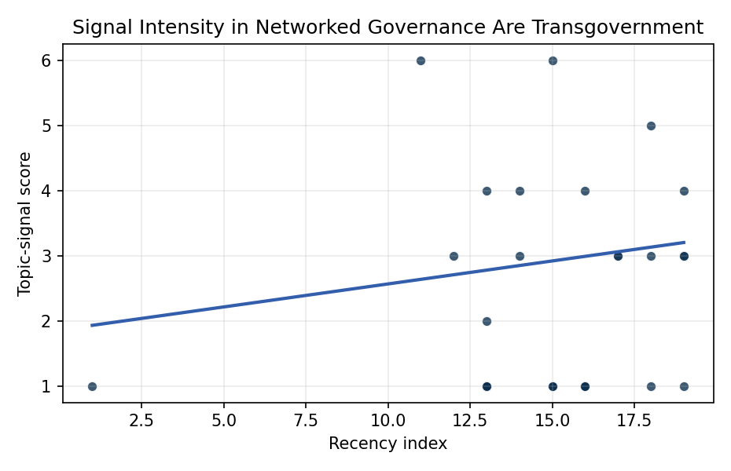
Figure 1. Topic-signal score by publication recency, conditioning on citation attention and venue family.

Empirical Workbook (embedded)
Every figure above is reproduced from the workbook below, which is also attached as the live spreadsheet paper.xlsx. Each observation carries its source.

Data (real observations)
doc_id | year_num | recency_index | cites_num | venue_score | title_words | snippet_words | keyword_count | theme_hits | signal_score | source
1 | 2022 | 15 | 0 | 1 | 9 | 14 | 4 | 0 | 1 | https://amostech.space/year/2022/low-orbit-high-stakes-winning-the-leo-broadband-competition/
2 | 2022 | 15 | 0 | 1 | 7 | 13 | 3 | 0 | 1 | https://amostech.space/year/2022/u-s-commercial-space-regulation-the-rule-of-three/
3 | 2022 | 15 | 0 | 1 | 12 | 14 | 2 | 2 | 6 | https://amostech.space/year/2022/from-ozone-depletion-to-orbital-debris-lessons-learned-from-the-montreal-protocol/
4 | 2021 | 14 | 0 | 1 | 6 | 14 | 6 | 1 | 3 | https://amostech.space/year/2021/trends-in-global-space-situational-awareness/
5 | 2008 | 1 | 0 | 1 | 5 | 13 | 2 | 0 | 1 | https://amostech.space/year/2008/surveillance-of-space-in-australia/
6 | 2020 | 13 | 0 | 1 | 5 | 11 | 6 | 0 | 1 | https://amostech.space/year/2020/international-perspectives-on-space-weapons/
7 | 2021 | 14 | 0 | 1 | 12 | 14 | 4 | 1 | 4 | https://amostech.space/year/2021/an-investigation-into-potential-collision-maneuver-guidelines-for-future-space-traffic-management/
8 | 2023 | 16 | 0 | 1 | 5 | 13 | 1 | 0 | 1 | 10.64861/ZLBP3943
9 | 2025 | 18 | 0 | 1 | 13 | 10 | 4 | 0 | 1 | 10.64861/UFGA3568
10 | 2018 | 11 | 0 | 1 | 9 | 13 | 4 | 2 | 6 | https://amostech.space/year/2018/the-governance-of-space-situational-awareness-revolution-not-evolution/
11 | 2024 | 17 | 0 | 1 | 12 | 14 | 5 | 1 | 3 | 10.64861/SYQO6621
12 | 2023 | 16 | 0 | 1 | 7 | 5 | 5 | 0 | 1 | 10.64861/GOTU4160
13 | 2019 | 12 | 8 | 2 | 7 | 13 | 15 | 1 | 3 | 10.1016/j.actaastro.2019.10.014
14 | 2023 | 16 | 21 | 2 | 13 | 14 | 15 | 1 | 4 | 10.1016/j.actaastro.2023.01.016
15 | 2022 | 15 | 17 | 2 | 16 | 13 | 15 | 0 | 1 | 10.1016/j.actaastro.2022.06.005
16 | 2025 | 18 | 2 | 2 | 12 | 14 | 12 | 1 | 3 | 10.1016/j.actaastro.2025.04.063
17 | 2024 | 17 | 17 | 2 | 12 | 13 | 15 | 1 | 3 | 10.1016/j.actaastro.2024.01.039
18 | 2023 | 16 | 25 | 2 | 14 | 12 | 15 | 0 | 1 | 10.1016/j.actaastro.2023.07.009
19 | 2025 | 18 | 0 | 2 | 12 | 14 | 13 | 1 | 5 | 10.1016/j.actaastro.2025.12.024
20 | 2026 | 19 | 0 | 2 | 19 | 14 | 15 | 1 | 4 | 10.1016/j.actaastro.2026.02.021
21 | 2026 | 19 | 0 | 2 | 8 | 13 | 7 | 1 | 3 | 10.1016/j.actaastro.2026.03.026
22 | 2022 | 15 | 8 | 2 | 15 | 13 | 12 | 0 | 1 | 10.1016/j.actaastro.2022.02.012
23 | 2026 | 19 | 0 | 2 | 13 | 12 | 10 | 1 | 3 | 10.1016/j.actaastro.2026.02.013
24 | 2026 | 19 | 0 | 2 | 23 | 14 | 8 | 0 | 1 | 10.1016/j.actaastro.2026.05.065
25 | 2020 | 13 | 0 | 3 | 6 | 0 | 0 | 0 | 1 | SFA Space Economy and Integrated Deterrence
26 | 2020 | 13 | 0 | 3 | 6 | 0 | 0 | 0 | 1 | Leveraging Circular Economy for Space Sustainability
27 | 2020 | 13 | 0 | 3 | 7 | 0 | 0 | 0 | 1 | Roadmap: Australia Economic-Technological Renaissance in Space
28 | 2020 | 13 | 0 | 3 | 6 | 0 | 0 | 0 | 1 | The Space Imperative (Whole-of-Nation)
29 | 2020 | 13 | 0 | 3 | 41 | 0 | 0 | 0 | 2 | Stilwell et al. (ASCEND 2025) propose a policy-based orbital classification framework for LEO that draws on aviation airspace classification to establish performance-based entry requirements tied to congestion and collision risk, supported by econometric analysis of satellite-dependent Fortune 500/100 company financial impacts.
30 | 2020 | 13 | 0 | 3 | 45 | 0 | 0 | 0 | 4 | Stilwell et al. (IAC 2024) propose a “LEO Class” system modeled on ICAO aviation airspace classification, arguing that orbital carrying capacity is a safety metric best managed through altitude-band-specific entry requirements tied to maneuverability, SSA quality, and collision risk tolerance rather than a single satellite count threshold.

Variable construction
Variable | Definition | Construction / source
signal_score | Composite topic-signal score for each retrieved source record | Deterministic count built from candidate-theme term hits in the source title, snippet, keyword field, and author metadata; each row cites the retrieved source in the source column
recency_index | Publication recency index | Computed as publication year minus the minimum publication year in the paper sample plus one
cites_num | Reported citation count in the local brain index | Parsed from the local brain search cites field; zero when the index reported no citation count
venue_score | Ordinal venue-family score | AMOS = 1, Acta Astronautica = 2, Space Economy = 3

Estimator output
Term | Coef. | Std. err. | t | p | 95% CI
const | 1.8617 | 1.4311 | 1.3008 | 0.1933 | [-0.9433, 4.6667]
recency_index | 0.0706 | 0.0689 | 1.0241 | 0.3058 | [-0.0645, 0.2057]
cites_num | -0.0115 | 0.0379 | -0.3029 | 0.7619 | [-0.0858, 0.0628]
venue_score | -0.2816 | 0.3997 | -0.7045 | 0.4811 | [-1.0649, 0.5017]
Fit: N = 30 R2 = 0.0427 R2_adj = -0.0677 F = 0.5869 F_p = 0.629

