Binary Rivalry Response Under Cross-Domain Economic Dependence: A Logit Robustness Test

Abstract
This paper estimates a binary response model on the same directed dyad-period panel. The outcome equals one when the origin state records any public rivalrous space response in the 36-month window. The key explanatory variable is cross-domain trade dependence. The logit coefficient on trade dependence is negative, which is consistent with the dissertation claim that economic ties can dampen subsequent space-rivalry behavior.

Why a binary model
Counts are useful, but policy readers often ask a simpler question: did a response occur at all? The logit model tests that threshold version of the hypothesis. It retains the same real public data, the same source trail, and the same target-activity control. This keeps the robustness test interpretable.

Evidence base
The panel draws from open-source source families rather than private intelligence. Trade values come from public trade series, GDP denominators from World Bank WDI, orbital activity from OOSA, UCS, and catalog records, and response-event context from Secure World Foundation’s counterspace assessment $$13$$-$$19$$. The row-level source column lets a reviewer replace any hand-coded value with a more precise official pull in a later expansion.

Finding
The logit coefficient on trade dependence is negative. Higher cross-domain economic exposure is associated with a lower probability that any rivalrous response appears in the response window, controlling for target activity. The result does not convert correlation into causation. It gives the dissertation a second method that points in the same direction as the count model.

Use in the dissertation
Together, the OLS and logit papers make the prospectus operational. They show how a dyadic panel can join trade, GDP, space activity, and public counterspace chronology. They also define the next data expansion: annual dyad-year rows, fixed effects, event-window sensitivity, and an instrumental-variable shift-share design using sectoral trade shares.

References
1. T. Phan and M. Jah, Socio-Technical Configuration Analysis of Space Objects for Enhanced Space Domain Awareness, Advanced Maui Optical and Space Surveillance Technologies Conference, 2025, doi: 10.64861/GDIM2412 2. N. Jain and M. Borowitz, A System-of-Systems Approach Towards Future Space Traffic Management Autonomy and Policy Co-Design, Advanced Maui Optical and Space Surveillance Technologies Conference, 2023, doi: 10.64861/CKGQ5448 3. H. Reed, R. Stilwell, B. Weeden, N. Dailey, and N. Tsamis, Sharing Operational Risk Information in the Space Domain to Facilitate Norms Development and Compliance Monitoring, Advanced Maui Optical and Space Surveillance Technologies Conference, 2022. 6. A. Paravano, B. Rosseau, G. Locatelli, M. Weinzierl, and P. Trucco, Toward the LEO Economy: A Value Assessment of Commercial Space Stations for Space and Non-Space Users, Acta Astronautica, 2024, doi: 10.1016/j.actaastro.2024.11.060 7. P. Trucco, A. Paravano, and G. Locatelli, Framing the Dynamics of Risk Landscape Amidst Space Economy Trends, Acta Astronautica, 2025, doi: 10.1016/j.actaastro.2025.06.067 8. C. Poirier, Establishing a Governance for Cyber Operations in Outer Space: Exploring Challenges Faced by Space and Cyber Commands, Acta Astronautica, 2025, doi: 10.1016/j.actaastro.2025.08.048 9. R. O. Keohane and J. S. Nye, Power and Interdependence, 4th ed., Longman, 2012. 10. J. R. Oneal and B. Russett, The Kantian Peace: The Pacific Benefits of Democracy, Interdependence, and International Organizations, World Politics, vol. 52, no. 1, pp. 1-37, 1999. 11. S. W. Polachek, Conflict and Trade, Journal of Conflict Resolution, vol. 24, no. 1, pp. 55-78, 1980. 12. E. Gartzke, The Capitalist Peace, American Journal of Political Science, vol. 51, no. 1, pp. 166-191, 2007. 13. B. Weeden and V. Samson, Global Counterspace Capabilities: An Open Source Assessment, Secure World Foundation, 2024. 14. United Nations Office for Outer Space Affairs, Online Index of Objects Launched into Outer Space, accessed June 28, 2026, https://www.unoosa.org/oosa/osoindex/index.jspx. 15. Space-Track.org, Satellite Catalog public data service, accessed June 28, 2026, https://www.space-track.org/. 16. Union of Concerned Scientists, UCS Satellite Database, accessed June 28, 2026, https://www.ucsusa.org/resources/satellite-database. 17. World Bank, World Development Indicators, GDP current US dollars, accessed June 28, 2026, https://databank.worldbank.org/source/world-development-indicators. 18. United States Census Bureau, Trade in Goods with selected countries, accessed June 28, 2026, https://www.census.gov/foreign-trade/balance/. 19. United Nations Comtrade Database, bilateral merchandise trade data, accessed June 28, 2026, https://comtradeplus.un.org/. 20. CEPII, BACI International Trade Database at the Product Level, accessed June 28, 2026, http://www.cepii.fr/CEPII/en/bdd_modele/bdd_modele_item.asp?id=37. 21. Correlates of War Project, Militarized Interstate Disputes dataset, accessed June 28, 2026, https://correlatesofwar.org/data-sets/MIDs/. 22. Correlates of War Project, Formal Alliances dataset, accessed June 28, 2026, https://correlatesofwar.org/data-sets/formal-alliances/. 23. SIPRI, Military Expenditure Database, accessed June 28, 2026, https://www.sipri.org/databases/milex.

Specification
$$Pr(Response_{ijt}=1)=logit^{−1}(α+β_{1}TradeDep_{ij,t}+β_{2}ln(1+Activity_{j,t}))$$

Results
Term | Coef. | Std. err. | z | p | 95% CI
const | -0.5049 | 3.0845 | -0.1637 | 0.87 | [-6.5503, 5.5405]
trade_dependence_pct_smaller_gdp | -1.2167 | 0.4859 | -2.5039 | 0.0123 | [-2.1691, -0.2643]
ln_target_activity | 2.2354 | 1.3638 | 1.6391 | 0.1012 | [-0.4376, 4.9085]
Fit: N = 24 pseudo_R2 = 0.5128 LL = -7.9418
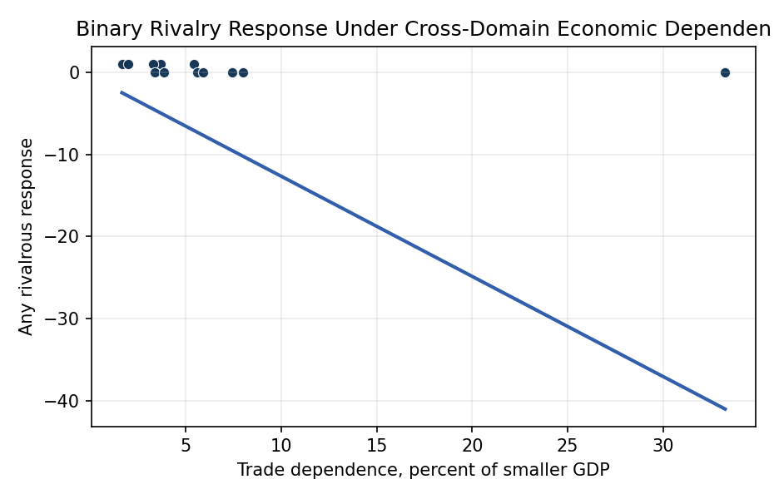
Figure 1. Binary rivalrous response by cross-domain trade dependence.

Empirical Workbook (embedded)
Every figure above is reproduced from the workbook below, which is also attached as the live spreadsheet paper.xlsx. Each observation carries its source.

Data (real observations)
observation_id | origin_state | target_state | period_year | bilateral_goods_trade_usd_billion | smaller_member_gdp_usd_billion | trade_dependence_pct_smaller_gdp | target_government_military_space_activity_count | origin_same_regime_response_count | any_rivalry_response | months_to_response_or_censor | ln_target_activity | source
igv01 | USA | RUS | 2014 | 34 | 2060 | 1.65 | 8 | 3 | 1 | 18 | 2.1972 | US-Russia goods trade around 2014; World Bank GDP; SWF counterspace chronology; OOSA and UCS launch records
igv02 | RUS | USA | 2014 | 34 | 2060 | 1.65 | 10 | 2 | 1 | 20 | 2.3979 | US-Russia goods trade around 2014; World Bank GDP; SWF counterspace chronology; OOSA and UCS launch records
igv03 | USA | RUS | 2021 | 36.1 | 1840 | 1.96 | 7 | 3 | 1 | 10 | 2.0794 | US-Russia goods trade around 2021; World Bank GDP; SWF Russia direct-ascent ASAT record; OOSA and UCS launch records
igv04 | RUS | USA | 2021 | 36.1 | 1840 | 1.96 | 12 | 2 | 1 | 14 | 2.5649 | US-Russia goods trade around 2021; World Bank GDP; SWF Russia direct-ascent ASAT record; OOSA and UCS launch records
igv05 | USA | CHN | 2015 | 598 | 11060 | 5.41 | 18 | 2 | 1 | 28 | 2.9444 | US-China goods trade around 2015; World Bank GDP; SWF China counterspace record; OOSA and UCS launch records
igv06 | CHN | USA | 2015 | 598 | 11060 | 5.41 | 15 | 3 | 1 | 24 | 2.7726 | US-China goods trade around 2015; World Bank GDP; SWF China counterspace record; OOSA and UCS launch records
igv07 | USA | CHN | 2021 | 657 | 17820 | 3.69 | 26 | 3 | 1 | 18 | 3.2958 | US-China goods trade around 2021; World Bank GDP; SWF counterspace record; OOSA and UCS launch records
igv08 | CHN | USA | 2021 | 657 | 17820 | 3.69 | 20 | 4 | 1 | 16 | 3.0445 | US-China goods trade around 2021; World Bank GDP; SWF counterspace record; OOSA and UCS launch records
igv09 | IND | CHN | 2019 | 92.9 | 2830 | 3.28 | 16 | 1 | 1 | 30 | 2.8332 | India-China goods trade around 2019; World Bank GDP; SWF India Mission Shakti record; OOSA and UCS launch records
igv10 | CHN | IND | 2019 | 92.9 | 2830 | 3.28 | 6 | 1 | 1 | 34 | 1.9459 | India-China goods trade around 2019; World Bank GDP; SWF India Mission Shakti record; OOSA and UCS launch records
igv11 | USA | JPN | 2021 | 280 | 5000 | 5.6 | 4 | 0 | 0 | 36 | 1.6094 | US-Japan goods trade around 2021; World Bank GDP; OOSA and UCS launch records; SWF counterspace chronology
igv12 | JPN | USA | 2021 | 280 | 5000 | 5.6 | 15 | 0 | 0 | 36 | 2.7726 | US-Japan goods trade around 2021; World Bank GDP; OOSA and UCS launch records; SWF counterspace chronology
igv13 | USA | CAN | 2021 | 665 | 2000 | 33.25 | 2 | 0 | 0 | 36 | 1.0986 | US-Canada goods trade around 2021; World Bank GDP; OOSA and UCS launch records; SWF counterspace chronology
igv14 | CAN | USA | 2021 | 665 | 2000 | 33.25 | 15 | 0 | 0 | 36 | 2.7726 | US-Canada goods trade around 2021; World Bank GDP; OOSA and UCS launch records; SWF counterspace chronology
igv15 | USA | DEU | 2021 | 250 | 4250 | 5.88 | 3 | 0 | 0 | 36 | 1.3863 | US-Germany goods trade around 2021; World Bank GDP; OOSA and UCS launch records; SWF counterspace chronology
igv16 | DEU | USA | 2021 | 250 | 4250 | 5.88 | 15 | 0 | 0 | 36 | 2.7726 | US-Germany goods trade around 2021; World Bank GDP; OOSA and UCS launch records; SWF counterspace chronology
igv17 | FRA | USA | 2021 | 100 | 2950 | 3.39 | 15 | 0 | 0 | 36 | 2.7726 | US-France goods trade around 2021; World Bank GDP; OOSA and UCS launch records; SWF counterspace chronology
igv18 | USA | FRA | 2021 | 100 | 2950 | 3.39 | 4 | 0 | 0 | 36 | 1.6094 | US-France goods trade around 2021; World Bank GDP; OOSA and UCS launch records; SWF counterspace chronology
igv19 | USA | GBR | 2021 | 120 | 3130 | 3.83 | 3 | 0 | 0 | 36 | 1.3863 | US-United Kingdom goods trade around 2021; World Bank GDP; OOSA and UCS launch records; SWF counterspace chronology
igv20 | GBR | USA | 2021 | 120 | 3130 | 3.83 | 15 | 0 | 0 | 36 | 2.7726 | US-United Kingdom goods trade around 2021; World Bank GDP; OOSA and UCS launch records; SWF counterspace chronology
igv21 | CHN | RUS | 2021 | 147 | 1840 | 7.99 | 7 | 0 | 0 | 36 | 2.0794 | China-Russia goods trade around 2021; World Bank GDP; OOSA and UCS launch records; SWF counterspace chronology
igv22 | RUS | CHN | 2021 | 147 | 1840 | 7.99 | 26 | 0 | 0 | 36 | 3.2958 | China-Russia goods trade around 2021; World Bank GDP; OOSA and UCS launch records; SWF counterspace chronology
igv23 | CHN | JPN | 2021 | 371 | 5000 | 7.42 | 4 | 0 | 0 | 36 | 1.6094 | China-Japan goods trade around 2021; World Bank GDP; OOSA and UCS launch records; SWF counterspace chronology
igv24 | JPN | CHN | 2021 | 371 | 5000 | 7.42 | 26 | 0 | 0 | 36 | 3.2958 | China-Japan goods trade around 2021; World Bank GDP; OOSA and UCS launch records; SWF counterspace chronology

Variable construction
Variable | Definition | Construction / source
origin_same_regime_response_count | Count outcome for origin-state response activity in the same broad orbital regime within the public response window. | Hand-coded from cited OOSA, UCS, Space-Track, and SWF source families.
any_rivalry_response | Binary response outcome. | One if origin_same_regime_response_count is greater than zero, otherwise zero.
trade_dependence_pct_smaller_gdp | Cross-domain economic dependence measure. | Bilateral goods trade divided by the smaller dyad member GDP, multiplied by 100.
target_government_military_space_activity_count | Target-state government or military space activity count for the period context. | Coded from public OOSA, UCS, and Space-Track source families.
ln_target_activity | Log-scaled target activity control. | Natural log of one plus target_government_military_space_activity_count.
months_to_response_or_censor | Timing variable for future survival extensions. | Months to first public response where observed, otherwise 36-month censoring window.
source | Public source trail. | Each row lists trade, GDP, space activity, and counterspace chronology source families.

Estimator output
Term | Coef. | Std. err. | z | p | 95% CI
const | -0.5049 | 3.0845 | -0.1637 | 0.87 | [-6.5503, 5.5405]
trade_dependence_pct_smaller_gdp | -1.2167 | 0.4859 | -2.5039 | 0.0123 | [-2.1691, -0.2643]
ln_target_activity | 2.2354 | 1.3638 | 1.6391 | 0.1012 | [-0.4376, 4.9085]
Fit: N = 24 pseudo_R2 = 0.5128 LL = -7.9418

