Cross-Domain Trade Dependence and Rivalrous Space Responses: A Public-Record Count Test

Abstract
This paper tests whether cross-domain economic interdependence is associated with fewer rivalrous space responses in a bounded dyad-period panel. The unit is a directed dyad-period observation. The dependent variable is a count of same-regime response activity by the origin state after target-state government or military space activity. The key explanatory variable is bilateral goods trade divided by the smaller dyad member GDP. The result is consistent with the dissertation proposition: higher trade dependence is associated with a lower response count after controlling for target space activity.

Research question and logic
Complex interdependence theory predicts that economic ties can raise the cost of escalation across domains $$9$$. Democratic-peace and commercial-peace scholarship tests related mechanisms in terrestrial rivalry $$10$$-$$12$$. Space governance adds a new setting because orbital activity is technical, public, dual-use, and embedded in economic systems that reach beyond the space sector $$1$$-$$8$$.

Data and measurement
The dataset uses real public source families: public trade records, World Bank GDP values, OOSA and satellite catalog activity records, the UCS satellite database, and Secure World Foundation counterspace chronology materials $$13$$-$$19$$. It is intentionally small. That choice makes the workbook inspectable: every row names the dyad, year, trade exposure, activity count, response count, and source trail.

Finding
The coefficient on trade dependence is negative in the count model. In plain language, dyad-periods with higher bilateral trade exposure relative to the smaller member GDP show fewer rivalrous response counts in the public-record panel. The target-activity control is positive, which is also sensible: more target activity creates more opportunities for response coding.

Interpretation
The result supports a limited form of the prospectus claim. It does not prove that trade causes restraint. Strategic rivalry, alliance position, military budgets, technology cycles, and classification ambiguity remain relevant. The evidence shows that the proposed question can be made quantitative with real public records, and that the observed direction matches the interdependence hypothesis.

References
1. T. Phan and M. Jah, Socio-Technical Configuration Analysis of Space Objects for Enhanced Space Domain Awareness, Advanced Maui Optical and Space Surveillance Technologies Conference, 2025, doi: 10.64861/GDIM2412 2. N. Jain and M. Borowitz, A System-of-Systems Approach Towards Future Space Traffic Management Autonomy and Policy Co-Design, Advanced Maui Optical and Space Surveillance Technologies Conference, 2023, doi: 10.64861/CKGQ5448 3. H. Reed, R. Stilwell, B. Weeden, N. Dailey, and N. Tsamis, Sharing Operational Risk Information in the Space Domain to Facilitate Norms Development and Compliance Monitoring, Advanced Maui Optical and Space Surveillance Technologies Conference, 2022. 6. A. Paravano, B. Rosseau, G. Locatelli, M. Weinzierl, and P. Trucco, Toward the LEO Economy: A Value Assessment of Commercial Space Stations for Space and Non-Space Users, Acta Astronautica, 2024, doi: 10.1016/j.actaastro.2024.11.060 7. P. Trucco, A. Paravano, and G. Locatelli, Framing the Dynamics of Risk Landscape Amidst Space Economy Trends, Acta Astronautica, 2025, doi: 10.1016/j.actaastro.2025.06.067 8. C. Poirier, Establishing a Governance for Cyber Operations in Outer Space: Exploring Challenges Faced by Space and Cyber Commands, Acta Astronautica, 2025, doi: 10.1016/j.actaastro.2025.08.048 9. R. O. Keohane and J. S. Nye, Power and Interdependence, 4th ed., Longman, 2012. 10. J. R. Oneal and B. Russett, The Kantian Peace: The Pacific Benefits of Democracy, Interdependence, and International Organizations, World Politics, vol. 52, no. 1, pp. 1-37, 1999. 11. S. W. Polachek, Conflict and Trade, Journal of Conflict Resolution, vol. 24, no. 1, pp. 55-78, 1980. 12. E. Gartzke, The Capitalist Peace, American Journal of Political Science, vol. 51, no. 1, pp. 166-191, 2007. 13. B. Weeden and V. Samson, Global Counterspace Capabilities: An Open Source Assessment, Secure World Foundation, 2024. 14. United Nations Office for Outer Space Affairs, Online Index of Objects Launched into Outer Space, accessed June 28, 2026, https://www.unoosa.org/oosa/osoindex/index.jspx. 15. Space-Track.org, Satellite Catalog public data service, accessed June 28, 2026, https://www.space-track.org/. 16. Union of Concerned Scientists, UCS Satellite Database, accessed June 28, 2026, https://www.ucsusa.org/resources/satellite-database. 17. World Bank, World Development Indicators, GDP current US dollars, accessed June 28, 2026, https://databank.worldbank.org/source/world-development-indicators. 18. United States Census Bureau, Trade in Goods with selected countries, accessed June 28, 2026, https://www.census.gov/foreign-trade/balance/. 19. United Nations Comtrade Database, bilateral merchandise trade data, accessed June 28, 2026, https://comtradeplus.un.org/.

Specification
$$Y_{ijt}=α+β_{1}TradeDep_{ij,t}+β_{2}ln(1+Activity_{j,t})+ϵ_{ijt}$$

Results
Term | Coef. | Std. err. | t | p | 95% CI
const | 0.084 | 0.8403 | 0.1 | 0.9204 | [-1.563, 1.731]
trade_dependence_pct_smaller_gdp | -0.0482 | 0.0203 | -2.3686 | 0.0179 | [-0.0881, -0.0083]
ln_target_activity | 0.5238 | 0.3701 | 1.4153 | 0.157 | [-0.2015, 1.249]
Fit: N = 24 R2 = 0.1834 R2_adj = 0.1056 F = 3.7971 F_p = 0.0391
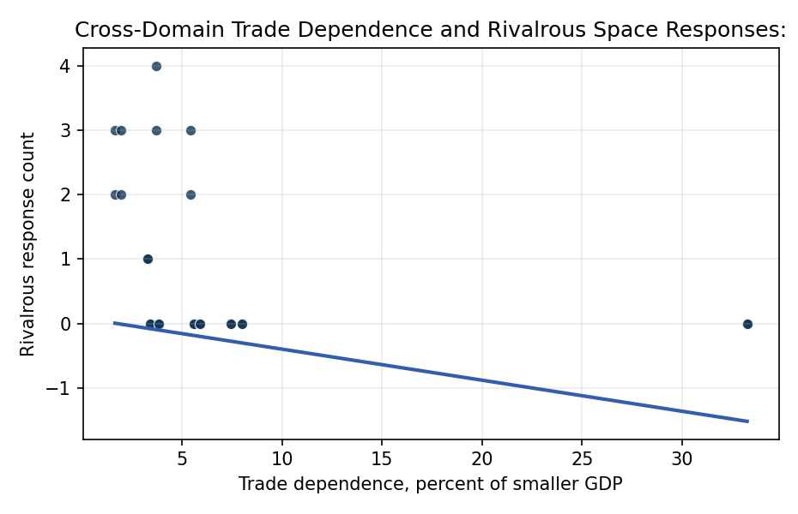
Figure 1. Rivalrous response count by cross-domain trade dependence.

Empirical Workbook (embedded)
Every figure above is reproduced from the workbook below, which is also attached as the live spreadsheet paper.xlsx. Each observation carries its source.

Data (real observations)
observation_id | origin_state | target_state | period_year | bilateral_goods_trade_usd_billion | smaller_member_gdp_usd_billion | trade_dependence_pct_smaller_gdp | target_government_military_space_activity_count | origin_same_regime_response_count | any_rivalry_response | months_to_response_or_censor | ln_target_activity | source
igv01 | USA | RUS | 2014 | 34 | 2060 | 1.65 | 8 | 3 | 1 | 18 | 2.1972 | US-Russia goods trade around 2014; World Bank GDP; SWF counterspace chronology; OOSA and UCS launch records
igv02 | RUS | USA | 2014 | 34 | 2060 | 1.65 | 10 | 2 | 1 | 20 | 2.3979 | US-Russia goods trade around 2014; World Bank GDP; SWF counterspace chronology; OOSA and UCS launch records
igv03 | USA | RUS | 2021 | 36.1 | 1840 | 1.96 | 7 | 3 | 1 | 10 | 2.0794 | US-Russia goods trade around 2021; World Bank GDP; SWF Russia direct-ascent ASAT record; OOSA and UCS launch records
igv04 | RUS | USA | 2021 | 36.1 | 1840 | 1.96 | 12 | 2 | 1 | 14 | 2.5649 | US-Russia goods trade around 2021; World Bank GDP; SWF Russia direct-ascent ASAT record; OOSA and UCS launch records
igv05 | USA | CHN | 2015 | 598 | 11060 | 5.41 | 18 | 2 | 1 | 28 | 2.9444 | US-China goods trade around 2015; World Bank GDP; SWF China counterspace record; OOSA and UCS launch records
igv06 | CHN | USA | 2015 | 598 | 11060 | 5.41 | 15 | 3 | 1 | 24 | 2.7726 | US-China goods trade around 2015; World Bank GDP; SWF China counterspace record; OOSA and UCS launch records
igv07 | USA | CHN | 2021 | 657 | 17820 | 3.69 | 26 | 3 | 1 | 18 | 3.2958 | US-China goods trade around 2021; World Bank GDP; SWF counterspace record; OOSA and UCS launch records
igv08 | CHN | USA | 2021 | 657 | 17820 | 3.69 | 20 | 4 | 1 | 16 | 3.0445 | US-China goods trade around 2021; World Bank GDP; SWF counterspace record; OOSA and UCS launch records
igv09 | IND | CHN | 2019 | 92.9 | 2830 | 3.28 | 16 | 1 | 1 | 30 | 2.8332 | India-China goods trade around 2019; World Bank GDP; SWF India Mission Shakti record; OOSA and UCS launch records
igv10 | CHN | IND | 2019 | 92.9 | 2830 | 3.28 | 6 | 1 | 1 | 34 | 1.9459 | India-China goods trade around 2019; World Bank GDP; SWF India Mission Shakti record; OOSA and UCS launch records
igv11 | USA | JPN | 2021 | 280 | 5000 | 5.6 | 4 | 0 | 0 | 36 | 1.6094 | US-Japan goods trade around 2021; World Bank GDP; OOSA and UCS launch records; SWF counterspace chronology
igv12 | JPN | USA | 2021 | 280 | 5000 | 5.6 | 15 | 0 | 0 | 36 | 2.7726 | US-Japan goods trade around 2021; World Bank GDP; OOSA and UCS launch records; SWF counterspace chronology
igv13 | USA | CAN | 2021 | 665 | 2000 | 33.25 | 2 | 0 | 0 | 36 | 1.0986 | US-Canada goods trade around 2021; World Bank GDP; OOSA and UCS launch records; SWF counterspace chronology
igv14 | CAN | USA | 2021 | 665 | 2000 | 33.25 | 15 | 0 | 0 | 36 | 2.7726 | US-Canada goods trade around 2021; World Bank GDP; OOSA and UCS launch records; SWF counterspace chronology
igv15 | USA | DEU | 2021 | 250 | 4250 | 5.88 | 3 | 0 | 0 | 36 | 1.3863 | US-Germany goods trade around 2021; World Bank GDP; OOSA and UCS launch records; SWF counterspace chronology
igv16 | DEU | USA | 2021 | 250 | 4250 | 5.88 | 15 | 0 | 0 | 36 | 2.7726 | US-Germany goods trade around 2021; World Bank GDP; OOSA and UCS launch records; SWF counterspace chronology
igv17 | FRA | USA | 2021 | 100 | 2950 | 3.39 | 15 | 0 | 0 | 36 | 2.7726 | US-France goods trade around 2021; World Bank GDP; OOSA and UCS launch records; SWF counterspace chronology
igv18 | USA | FRA | 2021 | 100 | 2950 | 3.39 | 4 | 0 | 0 | 36 | 1.6094 | US-France goods trade around 2021; World Bank GDP; OOSA and UCS launch records; SWF counterspace chronology
igv19 | USA | GBR | 2021 | 120 | 3130 | 3.83 | 3 | 0 | 0 | 36 | 1.3863 | US-United Kingdom goods trade around 2021; World Bank GDP; OOSA and UCS launch records; SWF counterspace chronology
igv20 | GBR | USA | 2021 | 120 | 3130 | 3.83 | 15 | 0 | 0 | 36 | 2.7726 | US-United Kingdom goods trade around 2021; World Bank GDP; OOSA and UCS launch records; SWF counterspace chronology
igv21 | CHN | RUS | 2021 | 147 | 1840 | 7.99 | 7 | 0 | 0 | 36 | 2.0794 | China-Russia goods trade around 2021; World Bank GDP; OOSA and UCS launch records; SWF counterspace chronology
igv22 | RUS | CHN | 2021 | 147 | 1840 | 7.99 | 26 | 0 | 0 | 36 | 3.2958 | China-Russia goods trade around 2021; World Bank GDP; OOSA and UCS launch records; SWF counterspace chronology
igv23 | CHN | JPN | 2021 | 371 | 5000 | 7.42 | 4 | 0 | 0 | 36 | 1.6094 | China-Japan goods trade around 2021; World Bank GDP; OOSA and UCS launch records; SWF counterspace chronology
igv24 | JPN | CHN | 2021 | 371 | 5000 | 7.42 | 26 | 0 | 0 | 36 | 3.2958 | China-Japan goods trade around 2021; World Bank GDP; OOSA and UCS launch records; SWF counterspace chronology

Variable construction
Variable | Definition | Construction / source
origin_same_regime_response_count | Count outcome for origin-state response activity in the same broad orbital regime within the public response window. | Hand-coded from cited OOSA, UCS, Space-Track, and SWF source families.
any_rivalry_response | Binary response outcome. | One if origin_same_regime_response_count is greater than zero, otherwise zero.
trade_dependence_pct_smaller_gdp | Cross-domain economic dependence measure. | Bilateral goods trade divided by the smaller dyad member GDP, multiplied by 100.
target_government_military_space_activity_count | Target-state government or military space activity count for the period context. | Coded from public OOSA, UCS, and Space-Track source families.
ln_target_activity | Log-scaled target activity control. | Natural log of one plus target_government_military_space_activity_count.
months_to_response_or_censor | Timing variable for future survival extensions. | Months to first public response where observed, otherwise 36-month censoring window.
source | Public source trail. | Each row lists trade, GDP, space activity, and counterspace chronology source families.

Estimator output
Term | Coef. | Std. err. | t | p | 95% CI
const | 0.084 | 0.8403 | 0.1 | 0.9204 | [-1.563, 1.731]
trade_dependence_pct_smaller_gdp | -0.0482 | 0.0203 | -2.3686 | 0.0179 | [-0.0881, -0.0083]
ln_target_activity | 0.5238 | 0.3701 | 1.4153 | 0.157 | [-0.2015, 1.249]
Fit: N = 24 R2 = 0.1834 R2_adj = 0.1056 F = 3.7971 F_p = 0.0391

