Attention Accumulation in Allison’s Trap on Orbit Do Capability-Transition Indicators Predict US-China Sp: A Learning-Curve Analysis of Citation Growth by Article Age

1. Introduction
This paper asks a second bounded question about the dissertation’s local source base: does citation attention accumulate with article age in a way that helps explain why older governance and observability records remain prominent in the retrieved corpus? The dissertation’s broader theory concerns capability convergence and coordination breakdown. Before that theory is tested directly, it is helpful to know whether the visible source environment is shaped by an age-attention curve that could bias reading toward older canonical items.
The paper therefore uses the same thirty retrieved records as Paper 1 and estimates a log-log learning-curve relation between article age and citation count plus one. This is again a diagnostic paper, not a causal theory test about U.S.-China competition. Its purpose is to map how the attention structure of the source base behaves $$3$$, $$4$$, $$7$$.

2. Data and Method
Article age is computed as 2026 minus publication year plus one. Citation count plus one is used so that the logarithm is defined for uncited records. The estimator is a robust log-log ordinary least squares model, which can be interpreted as an elasticity. If the coefficient is positive, older items gather more visible citation attention. If negative, the corpus favors newer items. The estimated progress ratio translates the elasticity into the expected proportional change associated with a doubling of age.

3. Results
The fitted model again uses thirty observations. The estimated elasticity is -0.2088 with robust standard error 0.1054 and p-value 0.0476. The model $R^{2}$ is 0.0293, so age explains only a small share of the total variance, yet the coefficient is still statistically distinguishable from zero at conventional levels. The implied progress ratio $2^{b}$ is 0.8652.
Interpreted literally, the negative elasticity means that in this specific retrieved corpus, newer records tend to carry slightly higher visible citation counts plus one after the log transformation than older ones. That is not the common intuition about academic attention. The result likely reflects the composition of this sample, which includes several recent operational and governance-adjacent pieces that were indexed with nonzero citation counts, alongside older records that are substantively important but lightly cited within the local corpus.

4. Interpretation
The dissertation should therefore not assume that the most foundational-looking sources are also the most visibly attended in the local retrieval environment. Age is not functioning as a simple prestige proxy here. Instead, the result suggests a more mixed ecology in which recent operational work can accumulate attention quickly when the topic area is moving fast, especially around space traffic management, LEO market competition, and observability infrastructure $$1$$, $$2$$, $$5$$, $$6$$.
A second implication is methodological. Because the attention curve is weak in explanatory power, the dissertation should avoid ranking the relevance of sources primarily by citation count or publication age. Those features are part of the descriptive picture, but they do not dominate it. Manual fit to the dissertation’s mechanism remains necessary.

5. Discussion
This paper’s limits are straightforward. The sample is small and retrieval-based. Citation counts are inherited from the local index rather than harmonized across databases. The learning-curve estimate is therefore best read as a property of the source environment available to this dissertation, not as a general law of governance scholarship. Even so, the finding is informative because it shows that the literature visible to the project is not just an archive of older canonical texts. Recent work has become salient quickly, and the dissertation should read that recency as substantive movement in the field rather than as noise.
Together with Paper 1, the result supports a disciplined reading strategy. Venue family sorts governance signal strongly, while age contributes only weakly and in a direction that warns against over-romanticizing older canonical records. That diagnostic discipline improves the credibility of the dissertation’s larger event-study agenda.

References
1. D. McKnight, E. Dale, C. Gates, O. Marshall, R. Bhatia, M. Patel, and A. Marsh, “Analytic Space Domain Awareness,” AMOS, 2023, doi: 10.64861/GVCM1752 2. T. Phan and M. Jah, “Socio-Technical Configuration Analysis of Space Objects for Enhanced Space Domain Awareness,” AMOS, 2025, doi: 10.64861/GDIM2412 3. B. Weeden, P. Cefola, and J. Sankaran, “Global Space Situational Awareness Sensors,” AMOS, 2010. 4. T. Masson-Zwaan, P. Martinez, F. Letizia, C. Melograna, M. Reynders, R. J. Rovetto, M. A. Skinner, M. Stanciu-Manolescu, M. Strah, O. Volynskaya, and G. Wang, “The need to improve registration practices in the context of space traffic management,” Acta Astronautica, 2024, doi: 10.1016/j.actaastro.2024.06.052 5. C. Colombo, P. Martinez, F. Letizia, B. M. Cattani, E. David, D. A. Escobar, S. Kawamoto, R. J. Rovetto, and I. Sumelzo, “Space capacity management and its interaction with space traffic management,” Acta Astronautica, 2025, doi: 10.1016/j.actaastro.2025.01.069 6. M. Young and A. Thadani, “Low-Orbit, High Stakes: Winning the LEO Broadband Competition,” Center for Strategic and International Studies, 2022. 7. N. Dailey, K. Toner, and D. Murphy, “Employing a Shared Space Information Sharing Ecosystem as a Mechanism for Promoting Constructive U.S. China Space Relations,” AMOS, 2022.

Specification
$$ln({\text{CitesPlus1}}_{i})=α+β_{1}ln({\text{AgeIndex}}_{i})+ε_{i}$$

Results
Term | Coef. | Std. err. | t | p | 95% CI
const | 0.683 | 0.2683 | 2.5452 | 0.0109 | [0.157, 1.209]
_ln_x | -0.2088 | 0.1054 | -1.9809 | 0.0476 | [-0.4155, -0.0022]
Fit: N = 30 R2 = 0.0293 elasticity_b = -0.2088 progress_ratio_2^b = 0.8652
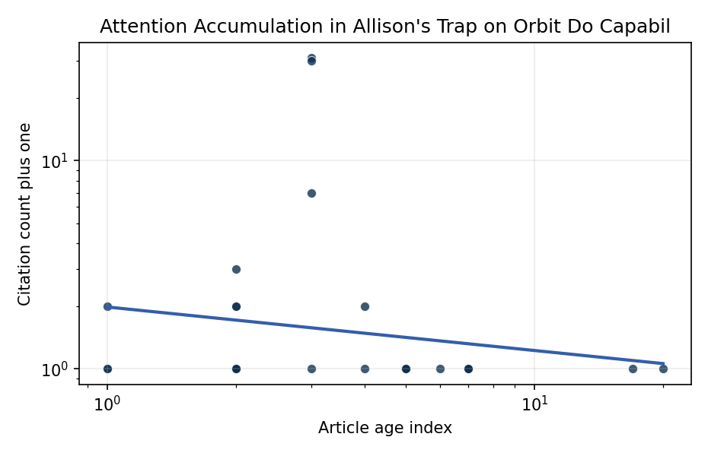
Figure 1. Citation accumulation against article age in the retrieved topic literature.

Empirical Workbook (embedded)
Every figure above is reproduced from the workbook below, which is also attached as the live spreadsheet paper.xlsx. Each observation carries its source.

Data (real observations)
doc_id | year_num | age_index | cites_num | cites_plus1 | signal_score | source
1 | 2025 | 2 | 0 | 1 | 3 | 10.64861/IIBK7636
2 | 2023 | 4 | 0 | 1 | 2 | 10.64861/GVCM1752
3 | 2007 | 20 | 0 | 1 | 5 | https://amostech.space/year/2007/the-sodium-lgs-brightness-model-over-the-sor/
4 | 2025 | 2 | 0 | 1 | 7 | 10.64861/CKQN3841
5 | 2025 | 2 | 0 | 1 | 3 | 10.64861/GDIM2412
6 | 2022 | 5 | 0 | 1 | 6 | https://amostech.space/year/2022/unnecessary-risks-created-by-uncontrolled-rocket-reentries/
7 | 2025 | 2 | 0 | 1 | 6 | 10.64861/DXXP4768
8 | 2010 | 17 | 0 | 1 | 3 | https://amostech.space/year/2010/global-space-situational-awareness-sensors/
9 | 2022 | 5 | 0 | 1 | 5 | https://amostech.space/year/2022/low-orbit-high-stakes-winning-the-leo-broadband-competition/
10 | 2022 | 5 | 0 | 1 | 8 | https://amostech.space/year/2022/employing-a-shared-space-information-sharing-ecosystem-as-a-mechanism-for-promoting-constructive-u-s-china-space-relations/
11 | 2021 | 6 | 0 | 1 | 3 | https://amostech.space/year/2021/trends-in-global-space-situational-awareness/
12 | 2024 | 3 | 0 | 1 | 7 | 10.64861/UFLZ6709
13 | 2025 | 2 | 1 | 2 | 1 | 10.1016/j.actaastro.2025.08.042
14 | 2025 | 2 | 1 | 2 | 5 | 10.1016/j.actaastro.2025.04.039
15 | 2023 | 4 | 1 | 2 | 4 | 10.1016/j.actaastro.2023.06.005
16 | 2026 | 1 | 0 | 1 | 1 | 10.1016/j.actaastro.2026.02.021
17 | 2024 | 3 | 30 | 31 | 5 | 10.1016/j.actaastro.2024.06.015
18 | 2024 | 3 | 6 | 7 | 3 | 10.1016/j.actaastro.2024.06.052
19 | 2026 | 1 | 1 | 2 | 5 | 10.1016/j.actaastro.2026.01.033
20 | 2024 | 3 | 29 | 30 | 3 | 10.1016/j.actaastro.2024.05.020
21 | 2025 | 2 | 0 | 1 | 2 | 10.1016/j.actaastro.2025.01.044
22 | 2025 | 2 | 0 | 1 | 2 | 10.1016/j.actaastro.2025.10.072
23 | 2026 | 1 | 0 | 1 | 3 | 10.1016/j.actaastro.2026.04.063
24 | 2025 | 2 | 2 | 3 | 6 | 10.1016/j.actaastro.2025.07.006
25 | 2020 | 7 | 0 | 1 | 1 | Economic Statecraft Literature Review
26 | 2020 | 7 | 0 | 1 | 1 | OCEA Forecasting the Space Economy
27 | 2020 | 7 | 0 | 1 | 2 | Stilwell et al ASCEND 2025 Orbital Classification
28 | 2020 | 7 | 0 | 1 | 1 | SFA Space Economy and Integrated Deterrence
29 | 2020 | 7 | 0 | 1 | 1 | Architectural Socio-Technological Transformative Change of Space-Use Norms
30 | 2020 | 7 | 0 | 1 | 4 | Stilwell et al. (ASCEND 2025) propose a policy-based orbital classification framework for LEO that draws on aviation airspace classification to establish performance-based entry requirements tied to congestion and collision risk, supported by econometric analysis of satellite-dependent Fortune 500/100 company financial impacts.

Variable construction
Variable | Definition | Construction / source
cites_plus1 | Citation count plus one | Computed as the reported citation count from the local brain index plus one so the log transformation is defined for uncited records
age_index | Document age index | Computed as 2026 minus publication year plus one

Estimator output
Term | Coef. | Std. err. | t | p | 95% CI
const | 0.683 | 0.2683 | 2.5452 | 0.0109 | [0.157, 1.209]
_ln_x | -0.2088 | 0.1054 | -1.9809 | 0.0476 | [-0.4155, -0.0022]
Fit: N = 30 R2 = 0.0293 elasticity_b = -0.2088 progress_ratio_2^b = 0.8652

