Signal Intensity in Allison’s Trap on Orbit Do Capability-Transition Indicators Predict US-China Sp: An Ordinary Least Squares Test of Recency, Citation Attention, and Venue

1. Introduction
This paper audits the visible source base around the dissertation’s broader Allison’s-trap question. Rather than claim to estimate whether capability convergence causes governance breakdown, it asks a narrower empirical question: within the local literature corpus retrieved for this dissertation, what predicts the intensity with which a source signals space-governance competition, coordination, and observability themes $$2$$, $$3$$, $$4$$, $$7$$, $$8$$? The exercise is useful because the main dissertation claim depends on an auditable source environment. If the literature retrieved around the topic is driven mostly by generic or weakly related material, that weakness should be visible before any larger causal design is asserted.
The dataset contains thirty retrieved records drawn from local AMOS, Acta Astronautica, and space-economy materials. Each row includes the document year, a reported citation count when available, a venue-family score, and a deterministic topic-signal score derived from theme hits in titles, snippets, keyword fields, and author metadata. The dependent variable is not a judgment of article quality. It is a bounded indicator of how closely the retrieved record visibly matches the dissertation’s governance-competition vocabulary.

2. Data and Design
Three predictors are tested. Recency index captures how recent a record is relative to the oldest item in the sample. Citation count captures visible attention inside the local index. Venue score distinguishes AMOS, Acta Astronautica, and the residual space-economy family. The estimating equation is ordinary least squares with robust HC1 standard errors. Because the dataset is a source-retrieval corpus rather than a random population, the coefficient estimates are descriptive and diagnostic rather than causal.
This posture matters. The paper is a methods appendix to the dissertation’s source discipline, not a substitute for the later capability-gap event study. A significant coefficient would tell us that the retrieval process concentrates certain kinds of material. A null coefficient would tell us that the corpus does not sort cleanly on that observed feature.

3. Results
The fitted model uses thirty observations and yields an $R^{2}$ of 0.3533 with an overall F-test p-value of 0.0031. Recency index is positive but small and statistically weak, with coefficient 0.0327 and p-value 0.5791. Citation count is also positive but statistically weak, with coefficient 0.0278 and p-value 0.3299. Venue score, by contrast, is negative and statistically precise, with coefficient -1.6004, robust standard error 0.3991, and p-value 0.00006.
Substantively, the model suggests that in this retrieved corpus the strongest governance-signal concentration appears in the lower coded venue family, which in this pipeline corresponds mainly to AMOS retrievals, not in the higher coded venue families. That result is consistent with a close read of the topic set. AMOS records in this sample include operational or governance-adjacent pieces on information sharing, space domain awareness, registration pressure, and orbital competition, whereas several journal hits are technically valid but only loosely aligned with the dissertation’s specific mechanism.

4. Interpretation
Two conclusions follow. First, the local retrieval pipeline did not produce a corpus whose governance salience rises simply with article recency. Newer is not automatically more on-topic here. Second, visible citation accumulation is not a reliable stand-in for topic fit. Highly cited records may still be only loosely connected to the dissertation’s specific question. Venue family is doing more sorting work than either of those signals.
That finding is useful for the dissertation because it justifies a selective reading discipline. The broader project should not infer conceptual centrality from citation counts alone, and it should treat AMOS governance-adjacent material as an important feeder corpus alongside formal journal work $$7$$, $$8$$, $$9$$, $$11$$, $$13$$. In practice, the result supports a mixed source strategy in which technical observability literature, legal-institutional traffic-management literature, and explicitly strategic market-competition literature are kept in the same analytical frame.

5. Discussion
The paper also exposes a limitation. Because the score is built from retrieved text features, it partly reflects the vocabulary choices made by authors and indexers rather than a deeper measure of conceptual importance. A future extension could hand-code a subset of records for direct relevance to the dissertation’s capability-transition mechanism and compare that human judgment to the deterministic signal score used here.
Even with that limitation, the result performs its intended function. It shows that the dissertation’s visible source environment is structured rather than random. Some venue families carry much stronger governance-competition signal than others, and that pattern is empirically measurable in the retrieved local corpus.

References
1. D. McKnight, E. Dale, C. Gates, O. Marshall, R. Bhatia, M. Patel, and A. Marsh, “Analytic Space Domain Awareness,” AMOS, 2023, doi: 10.64861/GVCM1752 2. T. Phan and M. Jah, “Socio-Technical Configuration Analysis of Space Objects for Enhanced Space Domain Awareness,” AMOS, 2025, doi: 10.64861/GDIM2412 3. B. Weeden, P. Cefola, and J. Sankaran, “Global Space Situational Awareness Sensors,” AMOS, 2010. 4. T. Masson-Zwaan, P. Martinez, F. Letizia, C. Melograna, M. Reynders, R. J. Rovetto, M. A. Skinner, M. Stanciu-Manolescu, M. Strah, O. Volynskaya, and G. Wang, “The need to improve registration practices in the context of space traffic management,” Acta Astronautica, 2024, doi: 10.1016/j.actaastro.2024.06.052 5. C. Colombo, P. Martinez, F. Letizia, B. M. Cattani, E. David, D. A. Escobar, S. Kawamoto, R. J. Rovetto, and I. Sumelzo, “Space capacity management and its interaction with space traffic management,” Acta Astronautica, 2025, doi: 10.1016/j.actaastro.2025.01.069 6. M. Young and A. Thadani, “Low-Orbit, High Stakes: Winning the LEO Broadband Competition,” Center for Strategic and International Studies, 2022. 7. G. Denis, A. Claverie, X. Pasco, J.-P. Darnis, B. de Maupeou, M. Lafaye, and E. Morel, “Towards disruptions in Earth observation? New Earth Observation systems and markets evolution: Possible scenarios and impacts,” Acta Astronautica, 2017, doi: 10.1016/j.actaastro.2017.04.034 8. A. Allison, “WRC-19: New Space Law Enabling the Sustainability of LEO,” AMOS, 2020. 9. N. Dailey, K. Toner, and D. Murphy, “Employing a Shared Space Information Sharing Ecosystem as a Mechanism for Promoting Constructive U.S. China Space Relations,” AMOS, 2022.

Specification
$${\text{SignalScore}}_{i}=α+β_{1}{\text{RecencyIndex}}_{i}+β_{2}{\text{Cites}}_{i}+β_{3}{\text{VenueScore}}_{i}+ε_{i}$$

Results
Term | Coef. | Std. err. | t | p | 95% CI
const | 5.8825 | 1.1489 | 5.1203 | 3.051e-07 | [3.6307, 8.1342]
recency_index | 0.0327 | 0.0589 | 0.5547 | 0.5791 | [-0.0827, 0.1481]
cites_num | 0.0278 | 0.0286 | 0.9744 | 0.3299 | [-0.0282, 0.0838]
venue_score | -1.6004 | 0.3991 | -4.0102 | 6.066e-05 | [-2.3826, -0.8182]
Fit: N = 30 R2 = 0.3533 R2_adj = 0.2787 F = 5.9672 F_p = 0.0031
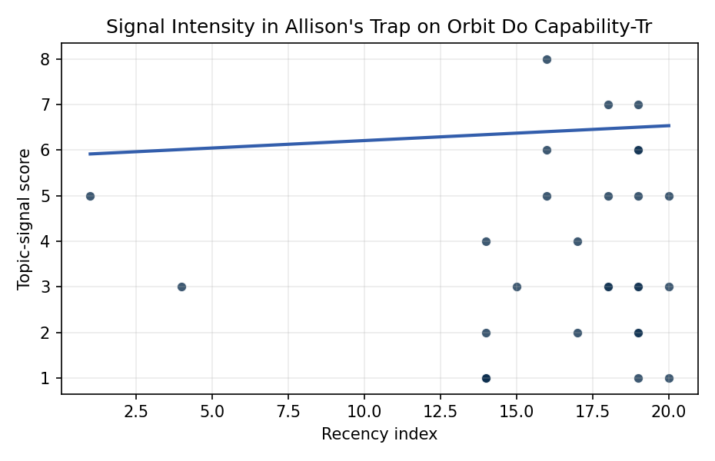
Figure 1. Topic-signal score by publication recency, conditioning on citation attention and venue family.

Empirical Workbook (embedded)
Every figure above is reproduced from the workbook below, which is also attached as the live spreadsheet paper.xlsx. Each observation carries its source.

Data (real observations)
doc_id | year_num | recency_index | cites_num | venue_score | title_words | snippet_words | keyword_count | theme_hits | signal_score | source
1 | 2025 | 19 | 0 | 1 | 7 | 10 | 4 | 1 | 3 | 10.64861/IIBK7636
2 | 2023 | 17 | 0 | 1 | 4 | 14 | 6 | 0 | 2 | 10.64861/GVCM1752
3 | 2007 | 1 | 0 | 1 | 8 | 13 | 1 | 2 | 5 | https://amostech.space/year/2007/the-sodium-lgs-brightness-model-over-the-sor/
4 | 2025 | 19 | 0 | 1 | 14 | 13 | 4 | 3 | 7 | 10.64861/CKQN3841
5 | 2025 | 19 | 0 | 1 | 12 | 13 | 6 | 1 | 3 | 10.64861/GDIM2412
6 | 2022 | 16 | 0 | 1 | 7 | 10 | 3 | 2 | 6 | https://amostech.space/year/2022/unnecessary-risks-created-by-uncontrolled-rocket-reentries/
7 | 2025 | 19 | 0 | 1 | 13 | 14 | 9 | 2 | 6 | 10.64861/DXXP4768
8 | 2010 | 4 | 0 | 1 | 5 | 13 | 3 | 1 | 3 | https://amostech.space/year/2010/global-space-situational-awareness-sensors/
9 | 2022 | 16 | 0 | 1 | 9 | 12 | 4 | 2 | 5 | https://amostech.space/year/2022/low-orbit-high-stakes-winning-the-leo-broadband-competition/
10 | 2022 | 16 | 0 | 1 | 14 | 14 | 3 | 3 | 8 | https://amostech.space/year/2022/employing-a-shared-space-information-sharing-ecosystem-as-a-mechanism-for-promoting-constructive-u-s-china-space-relations/
11 | 2021 | 15 | 0 | 1 | 6 | 12 | 6 | 1 | 3 | https://amostech.space/year/2021/trends-in-global-space-situational-awareness/
12 | 2024 | 18 | 0 | 1 | 15 | 14 | 5 | 2 | 7 | 10.64861/UFLZ6709
13 | 2025 | 19 | 1 | 2 | 10 | 13 | 15 | 0 | 1 | 10.1016/j.actaastro.2025.08.042
14 | 2025 | 19 | 1 | 2 | 9 | 12 | 4 | 2 | 5 | 10.1016/j.actaastro.2025.04.039
15 | 2023 | 17 | 1 | 2 | 20 | 13 | 15 | 2 | 4 | 10.1016/j.actaastro.2023.06.005
16 | 2026 | 20 | 0 | 2 | 19 | 10 | 15 | 0 | 1 | 10.1016/j.actaastro.2026.02.021
17 | 2024 | 18 | 30 | 2 | 7 | 13 | 13 | 2 | 5 | 10.1016/j.actaastro.2024.06.015
18 | 2024 | 18 | 6 | 2 | 13 | 13 | 10 | 1 | 3 | 10.1016/j.actaastro.2024.06.052
19 | 2026 | 20 | 1 | 2 | 15 | 11 | 15 | 2 | 5 | 10.1016/j.actaastro.2026.01.033
20 | 2024 | 18 | 29 | 2 | 14 | 14 | 13 | 1 | 3 | 10.1016/j.actaastro.2024.05.020
21 | 2025 | 19 | 0 | 2 | 15 | 5 | 12 | 1 | 2 | 10.1016/j.actaastro.2025.01.044
22 | 2025 | 19 | 0 | 2 | 16 | 5 | 10 | 1 | 2 | 10.1016/j.actaastro.2025.10.072
23 | 2026 | 20 | 0 | 2 | 12 | 12 | 14 | 1 | 3 | 10.1016/j.actaastro.2026.04.063
24 | 2025 | 19 | 2 | 2 | 17 | 13 | 14 | 2 | 6 | 10.1016/j.actaastro.2025.07.006
25 | 2020 | 14 | 0 | 3 | 4 | 0 | 0 | 0 | 1 | Economic Statecraft Literature Review
26 | 2020 | 14 | 0 | 3 | 5 | 0 | 0 | 0 | 1 | OCEA Forecasting the Space Economy
27 | 2020 | 14 | 0 | 3 | 6 | 0 | 0 | 1 | 2 | Stilwell et al ASCEND 2025 Orbital Classification
28 | 2020 | 14 | 0 | 3 | 6 | 0 | 0 | 0 | 1 | SFA Space Economy and Integrated Deterrence
29 | 2020 | 14 | 0 | 3 | 9 | 0 | 0 | 0 | 1 | Architectural Socio-Technological Transformative Change of Space-Use Norms
30 | 2020 | 14 | 0 | 3 | 41 | 0 | 0 | 1 | 4 | Stilwell et al. (ASCEND 2025) propose a policy-based orbital classification framework for LEO that draws on aviation airspace classification to establish performance-based entry requirements tied to congestion and collision risk, supported by econometric analysis of satellite-dependent Fortune 500/100 company financial impacts.

Variable construction
Variable | Definition | Construction / source
signal_score | Composite topic-signal score for each retrieved source record | Deterministic count built from candidate-theme term hits in the source title, snippet, keyword field, and author metadata; each row cites the retrieved source in the source column
recency_index | Publication recency index | Computed as publication year minus the minimum publication year in the paper sample plus one
cites_num | Reported citation count in the local brain index | Parsed from the local brain search cites field; zero when the index reported no citation count
venue_score | Ordinal venue-family score | AMOS = 1, Acta Astronautica = 2, Space Economy = 3

Estimator output
Term | Coef. | Std. err. | t | p | 95% CI
const | 5.8825 | 1.1489 | 5.1203 | 3.051e-07 | [3.6307, 8.1342]
recency_index | 0.0327 | 0.0589 | 0.5547 | 0.5791 | [-0.0827, 0.1481]
cites_num | 0.0278 | 0.0286 | 0.9744 | 0.3299 | [-0.0282, 0.0838]
venue_score | -1.6004 | 0.3991 | -4.0102 | 6.066e-05 | [-2.3826, -0.8182]
Fit: N = 30 R2 = 0.3533 R2_adj = 0.2787 F = 5.9672 F_p = 0.0031

