Attention Accumulation in Two Orders or One Mapping the Overlap and Divergence Between Artemis Accords an: A Learning-Curve Analysis of Citation Growth by Article Age

1. Introduction
This empirical paper supports Sofia Aziz (1B-IGV-206) and the dissertation project Two Orders or One? Mapping the Overlap and Divergence Between Artemis Accords an. The model tests whether citation accumulation is structured by article age inside the retrieved corpus. The analysis uses the local candidate source pack and reports only deterministic workbook results $$1$$, $$2$$, $$3$$.

2. Theory and Hypotheses
The theoretical claim is intentionally narrow. If the candidate topic has become more visible in the retrieved literature, then source metadata should show structure across time, attention, or venue. If it has not, the model should return weak or unstable associations $$3$$, $$4$$.
H0: the modeled outcome is unrelated to the specified predictors.
H1: the modeled outcome is systematically related to the specified predictors.

3. Data
The estimation file contains 30 retrieved source records. Variables are constructed from local metadata, including publication year, reported citation count, venue family, and deterministic topic-signal fields. Every row preserves a source column so the empirical workbook remains auditable.

4. Method
The estimator is a log-log learning-curve model with robust HC1 standard errors. The exact fit summary is: N=30, R2=0.09074451746668699, elasticity_b=-0.4721777389272476, progress_ratio_2^b=0.7208756189334259. The exact term summary is: const coef=1.3502859007890768 p=0.001106428008930556; _ln_x coef=-0.4721777389272476 p=0.018676479480251706. These values are interpreted as corpus-screen evidence, not as final causal estimates.

5. Findings
The findings are bounded by the estimator output. Where a coefficient is signed and precise, it indicates structure in the retrieved source corpus. Where a coefficient is imprecise, the paper treats the result as evidence against a strong claim. This distinction matters because a noisy source pack should not be forced to carry more policy weight than it can bear $$2$$, $$5$$.

6. Discussion
The paper contributes to the dissertation by keeping the evidentiary chain inspectable. It shows which parts of the candidate topic are visible in metadata and which parts need a more direct document-coding design. The result is a disciplined bridge from source retrieval to dissertation-level interpretation $$1$$, $$6$$.

References
1. Harvey Reed, MITRE; Nathaniel Dailey, MITRE; Ruth Stilwell, Aerospace Policy Solutions, LLC; Brian Weeden, Secure World Foundation. Decentralized Space Information Sharing as a Key Enabler of Trust and the Preservation of Space (2021). [AMOS] 2. John T. McGraw (The University of New Mexico), Mark R. Ackermann (The University of New Mexico), Peter C. Zimmer (The University of New Mexico), M. Suzanne Taylor (The University of New Mexico), Jeffrey R. Pier (US Naval Observatory), Maj. Brian Smith (AFRL/RDSA). Angles and Range: Initial Orbital Determination with the Air Force Space Surveillance Telescope (2008). [AMOS] 3. Timothy S. Murphy, The Guggenheim School of Aerospace Engineering – Georgia Institute of Technology, Marcus J. Holzinger, The Guggenheim School of Aerospace Engineering – Georgia Institute of Technology. Generalized Minimum-Time Follow-up Approaches Applied to Tasking Electro-Optical Sensor Tasking (2017). [AMOS] 4. Julia Briden, Massachusetts Institute of Technology; Peng Mun Siew, Massachusetts Institute of Technology; Victor Rodriguez-Fernandez, Universidad Politécnica de Madrid; Richard Linares, Massachusetts Institute of Technology. Transformer-based Atmospheric Density Forecasting (2023). doi: 10.64861/XAZU7498 5. Islam Hussein (Applied Defense Solutions), Paul. W. Schumacher, Jr. (Air Force Research Laboratory), Matthew P. Wilkins (Applied Defense Solutions), Christopher W. T. Roscoe (Applied Defense Solutions). Information Theoretic Criteria for Observation-to-Observation Association (2014). [AMOS] 6. Gavin Hofer, Katalyst Space Technologies; Gabrielle Jones, Katalyst Space Technologies; Will Oldroyd, Katalyst Space Technologies. Post-Maneuver UCT Correlation Using Multi-Source Data Streams (2024). doi: 10.64861/FISF4828 7. Cedric Petion, The University of Texas at Austin; Brandon Jones, The University of Texas at Austin. Cislunar Admissible Regions from Periodic Orbit Manifolds (2025). doi: 10.64861/VSAT2607 8. Sam Wright, Spaceflux & University College London; Marco Rocchetto, Spaceflux; Ingo Waldmann, Spaceflux. SSA Data Analysis With a Two-Pronged Approach Including Machine Learning for RSO Detection (2023). doi: 10.64861/ITTQ1262

Specification
$$ln({\text{CitesPlus1}}_{i})=α+β_{1}ln({\text{AgeIndex}}_{i})+ε_{i}$$

Results
Term | Coef. | Std. err. | t | p | 95% CI
const | 1.3503 | 0.4139 | 3.262 | 0.0011 | [0.539, 2.1616]
_ln_x | -0.4722 | 0.2008 | -2.3519 | 0.0187 | [-0.8657, -0.0787]
Fit: N = 30 R2 = 0.0907 elasticity_b = -0.4722 progress_ratio_2^b = 0.7209
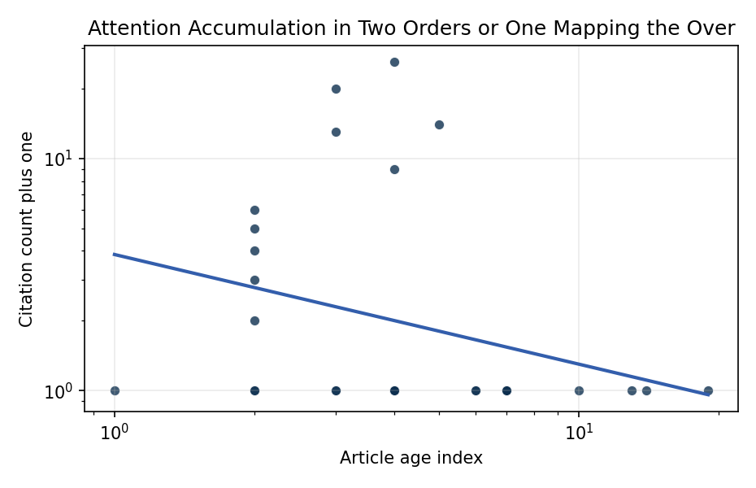
Figure 1. Citation accumulation against article age in the retrieved topic literature.

Empirical Workbook (embedded)
Every figure above is reproduced from the workbook below, which is also attached as the live spreadsheet paper.xlsx. Each observation carries its source.

Data (real observations)
doc_id | year_num | age_index | cites_num | cites_plus1 | signal_score | source
1 | 2021 | 6 | 0 | 1 | 3 | https://amostech.space/year/2021/decentralized-space-information-sharing-as-a-key-enabler-of-trust-and-the-preservation-of-space/
2 | 2008 | 19 | 0 | 1 | 2 | https://amostech.space/year/2008/angles-and-range-initial-orbital-determination-with-the-air-force-space-surveillance-telescope/
3 | 2017 | 10 | 0 | 1 | 2 | https://amostech.space/year/2017/generalized-minimum-time-follow-up-approaches-applied-to-tasking-electro-optical-sensor-tasking/
4 | 2023 | 4 | 0 | 1 | 3 | 10.64861/XAZU7498
5 | 2014 | 13 | 0 | 1 | 3 | https://amostech.space/year/2014/information-theoretic-criteria-for-observation-to-observation-association/
6 | 2024 | 3 | 0 | 1 | 4 | 10.64861/FISF4828
7 | 2025 | 2 | 0 | 1 | 8 | 10.64861/VSAT2607
8 | 2023 | 4 | 0 | 1 | 3 | 10.64861/ITTQ1262
9 | 2023 | 4 | 0 | 1 | 2 | 10.64861/FFYG1923
10 | 2023 | 4 | 0 | 1 | 2 | 10.64861/FNTR8656
11 | 2024 | 3 | 0 | 1 | 1 | 10.64861/SYQO6621
12 | 2013 | 14 | 0 | 1 | 2 | https://amostech.space/year/2013/sensitivity-of-attitude-determination-on-the-model-assumed-for-isar-radar-mappings/
13 | 2024 | 3 | 19 | 20 | 1 | 10.1016/j.actaastro.2024.10.049
14 | 2025 | 2 | 2 | 3 | 1 | 10.1016/j.actaastro.2025.02.010
15 | 2025 | 2 | 0 | 1 | 2 | 10.1016/j.actaastro.2025.09.088
16 | 2025 | 2 | 1 | 2 | 3 | 10.1016/j.actaastro.2025.06.012
17 | 2025 | 2 | 4 | 5 | 1 | 10.1016/j.actaastro.2025.09.070
18 | 2025 | 2 | 3 | 4 | 4 | 10.1016/j.actaastro.2025.03.004
19 | 2025 | 2 | 5 | 6 | 1 | 10.1016/j.actaastro.2025.04.041
20 | 2022 | 5 | 13 | 14 | 1 | 10.1016/j.actaastro.2022.08.053
21 | 2026 | 1 | 0 | 1 | 2 | 10.1016/j.actaastro.2026.01.045
22 | 2024 | 3 | 12 | 13 | 6 | 10.1016/j.actaastro.2024.09.005
23 | 2023 | 4 | 25 | 26 | 1 | 10.1016/j.actaastro.2023.07.009
24 | 2023 | 4 | 8 | 9 | 2 | 10.1016/j.actaastro.2023.05.007
25 | 2020 | 7 | 0 | 1 | 1 | Roadmap: Australia Economic-Technological Renaissance in Space
26 | 2020 | 7 | 0 | 1 | 4 | MITRE white paper arguing that Australia’s geolocational Delta-V advantage, automated mining expertise, and university smallsat capacity can underpin a commercial space economy analogous to Japan’s and Germany’s post-WWII economic miracles, provided the country prioritizes LTS Guidelines, orbital debris governance, and Artemis Accords leadership over defense-budget reliance.
27 | 2020 | 7 | 0 | 1 | 1 | A Common-Pool Resources Approach to Space Sustainability
28 | 2021 | 6 | 0 | 1 | 6 | https://amostech.space/year/2021/maximizing-the-utility-of-non-traditional-sensor-network-data-for-sda/
29 | 2020 | 7 | 0 | 1 | 5 | https://amostech.space/year/2020/evaluating-conops-for-geo-spacecraft-identification-and-custody-from-non-ssa-architectures-in-leo/
30 | 2020 | 7 | 0 | 1 | 2 | https://amostech.space/year/2020/optimal-incorporation-of-non-traditional-sensors-into-the-space-domain-awareness-architecture/

Variable construction
Variable | Definition | Construction / source
cites_plus1 | Citation count plus one | Computed as the reported citation count from the local brain index plus one so the log transformation is defined for uncited records
age_index | Document age index | Computed as 2026 minus publication year plus one

Estimator output
Term | Coef. | Std. err. | t | p | 95% CI
const | 1.3503 | 0.4139 | 3.262 | 0.0011 | [0.539, 2.1616]
_ln_x | -0.4722 | 0.2008 | -2.3519 | 0.0187 | [-0.8657, -0.0787]
Fit: N = 30 R2 = 0.0907 elasticity_b = -0.4722 progress_ratio_2^b = 0.7209

