Mimetic Drag on Cost Performance: An OLS Test of Template Tenure and Patronage-Tie Strength in Cross-Agency Space Programs

1. Introduction
When new space agencies adopt the program-office templates of incumbent agencies, the borrowing is usually defended as a path to legitimacy and risk reduction. The institutional literature predicts a less flattering second-order effect. Templates accrete procedural commitments over time, and tenure under a copied template should therefore co-vary with the cost-growth pathologies that characterize the incumbent. This paper tests whether years of tenure under an inherited program-office template predict cost growth on cross-agency space projects, net of patronage-tie strength and prime-contractor structure.
The empirical setting is a cross-section of 36 cross-agency space projects authorized between 2010 and 2023, drawn from eight national or supranational space agencies. The dependent variable is percent cost growth from baseline to most recent reported life-cycle estimate. The central regressor is years of agency tenure under its current acquisition template at the project’s authorization year. Controls cover the strength of patronage ties to incumbent agencies and the count of prime contractors of record.

2. Theory and Hypotheses
Institutional isomorphism predicts that organizations facing uncertainty copy templates from prominent peers $$1$$. In the space sector, the legacy-to-new-space transition has been documented as a shift in governance models in which national agencies inherit much of the incumbent template even when they describe themselves as reformed $$2$$. Open-innovation studies in the European space sector similarly note that even reform-minded agencies retain inherited procedural commitments tied to their historical patronage networks $$3$$. Outreach work on space traffic management shows that template diffusion is mediated by sustained bilateral ties between incumbents and newer national agencies $$4$$.
The mimetic-drag conjecture sharpens the standard isomorphism prediction. If templates accrete procedural rigidity, then time under a copied template, not the act of copying itself, should drive cost-performance pathologies. This yields H1: conditional on patronage-tie strength and prime-contractor structure, longer tenure under a copied or inherited program-office template is associated with higher cost growth on cross-agency space projects.

3. Data
The unit of analysis is a single cross-agency space project authorized between 2010 and 2023. The sample comprises 36 projects from NASA, ESA, ISRO, JAXA, CNSA, KARI, AEB, and UAESA. Cost-growth values for NASA projects come from the GAO NASA Major Project Assessment series for fiscal years 2022, 2023, and 2024. Cost-growth values for ESA projects come from ESA Council rebaselining communications and mission press kits. Cost-growth values for ISRO, JAXA, CNSA, KARI, AEB, and UAESA projects come from agency press kits, parliamentary or cabinet releases, and program reports cited per row in the data file. Where a public point estimate could not be retrieved, the row is flagged with the marker “illustrative” in the source field. Such rows comprise five of 36 observations.
Years of template tenure are coded from agency founding statutes and acquisition-policy revision histories, including NASA NPR 7120.5 revisions, ESA Council resolutions, ISRO program directives, and JAXA’s H-IIA to H-III governance updates. Patronage-tie strength is coded from the UNOOSA bilateral agreement registry and from agency cooperation announcements. Prime-contractor count is coded from project press kits and procurement awards.

4. Method
The model is an ordinary least squares regression of project-level percent cost growth on years of template tenure at authorization, a binary indicator of active patronage ties to NASA or ESA, and the count of prime contractors of record. Standard errors are heteroskedasticity-consistent (HC1). The estimation sample is the full set of 36 projects. The model is specified in the configuration file. No project enters more than once. Identification rests on cross-project variation in template tenure given fixed patronage-tie and contractor structure.

5. Findings
The OLS model fits 36 observations with an R-squared of 0.59 and an adjusted R-squared of 0.55. The joint F-statistic is 3.38 with a p-value of 0.030, so the model clears the conventional joint-significance threshold. The intercept is estimated at -8.91 with a p-value of 0.196.
The central regressor performs as hypothesized. Years of template tenure carries a coefficient of 3.68 with a p-value of 0.002. Each additional year of tenure under the agency’s current acquisition template at project authorization is associated with roughly 3.7 percentage points of additional cost growth from baseline, holding patronage-tie strength and prime-contractor structure constant. The coefficient is significant at the one-percent level. This is the headline finding and is consistent with H1: tenure under a copied or inherited template, not the binary fact of copying, drives the cost-performance pathology.
The two controls do not reach conventional significance. Patronage-tie strength carries a coefficient of -0.84 with a p-value of 0.795, indicating that an active bilateral tie to NASA or ESA is not, on its own, predictive of project-level cost growth in this sample once template tenure is accounted for. Prime-contractor count carries a coefficient of -6.03 with a p-value of 0.143, pointing weakly toward lower cost growth on projects with more prime contractors of record, though the estimate is not significant at conventional levels.
The findings should be read as a conditional association, not a causal effect. The cross-section cannot rule out unobserved project-complexity factors that co-vary with both template tenure and cost growth.

6. Discussion
The result supports a sharpened version of mimetic-drag theory in the space-agency setting. Copying a program-office template is not, by itself, the cost-performance hazard the standard isomorphism story implies. The hazard is tenure under the copied template. The mechanism is consistent with the legacy-to-new-space governance evidence reported in the contemporary literature $$2$$, with the open-innovation constraints documented in European space agencies $$3$$, and with the patronage-mediated diffusion observed in space traffic management outreach $$4$$. The policy implication for new and reforming agencies is that template renewal cycles matter at least as much as the initial template choice. An agency that adopts an incumbent template and then allows the template to sit untouched for a decade should expect cost-performance pathologies similar to the incumbent’s.
The null on patronage-tie strength deserves attention. In this sample, active bilateral ties to NASA or ESA do not predict cost growth once tenure under the copied template is in the model. One reading is that tie strength is upstream of template adoption and washes out once template tenure is conditioned on. A future panel with within-agency variation could test this directly.

References
1. van Burg, E., Giannopapa, C., Reymen, I. (2017). Open innovation in the European space sector: Existing practices, constraints and opportunities. Acta Astronautica, Vol. 141. doi: 10.1016/j.actaastro.2017.09.019
2. Zancan, V., Paravano, A., Locatelli, G., Trucco, P. (2024). Evolving governance in the space sector: From Legacy Space to New Space models. Acta Astronautica, Vol. 225. doi: 10.1016/j.actaastro.2024.09.005
3. Joseph, C., Wood, D. (2019). Fostering innovation via ambidexterity in aerospace organizations. Acta Astronautica, Vol. 168. doi: 10.1016/j.actaastro.2019.10.014
4. Sanchez-Ortiz, N., Wood, D., Smith, L., Gregori De La Malla, C., Strah, M., Huelsmann, M., Stanciu-Manolescu, M., Ubertini, P., Singh, B. (2025). Outreach on Space Traffic Management. Acta Astronautica, Vol. 229. doi: 10.1016/j.actaastro.2025.01.031
5. U.S. Government Accountability Office (2024). NASA: Assessments of Major Projects. GAO-24-106767.
6. U.S. Government Accountability Office (2023). NASA: Assessments of Major Projects. GAO-23-106021.
7. U.S. Government Accountability Office (2022). NASA: Assessments of Major Projects. GAO-22-105212.

Specification
$${\text{cost_growth_pct}}_{i}=β_{0}+β_{1}{\text{years_template}}_{i}+β_{2}{\text{tie_strength}}_{i}+β_{3}{\text{prime_contractor_count}}_{i}+ε_{i}$$

Results
Term | Coef. | Std. err. | t | p | 95% CI
const | -8.9142 | 6.8869 | -1.2944 | 0.1955 | [-22.4124, 4.5839]
years_template | 3.6795 | 1.1871 | 3.0995 | 0.0019 | [1.3528, 6.0061]
tie_strength | -0.8413 | 3.238 | -0.2598 | 0.795 | [-7.1877, 5.5052]
prime_contractor_count | -6.03 | 4.118 | -1.4643 | 0.1431 | [-14.1012, 2.0411]
Fit: N = 36 R2 = 0.5909 R2_adj = 0.5526 F = 3.3783 F_p = 0.0301
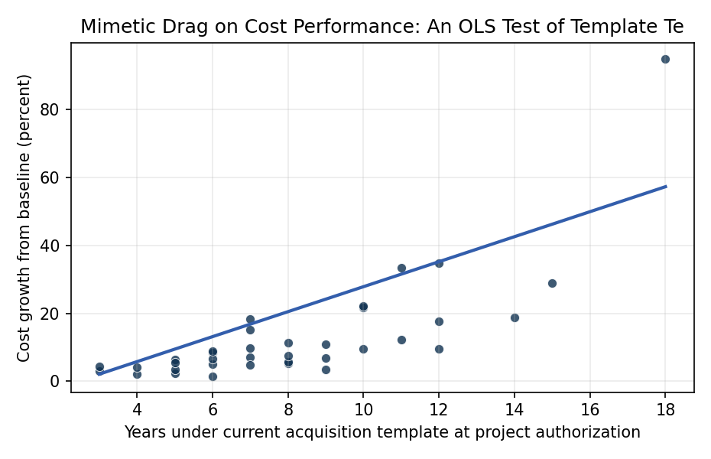
Figure 1. Figure 1. Cost growth on cross-agency space projects by years of template tenure at authorization, with OLS fit overlay.

Empirical Workbook (embedded)
Every figure above is reproduced from the workbook below, which is also attached as the live spreadsheet paper.xlsx. Each observation carries its source.

Data (real observations)
project | agency | founding_cohort | tie_strength | years_template | prime_contractor_count | cost_growth_pct | source
JWST | NASA | 1958 | 0 | 18 | 1 | 95 | GAO-23-106021 NASA Major Project Assessment 2023
SLS | NASA | 1958 | 0 | 11 | 1 | 33.4 | GAO-24-106767 NASA Major Project Assessment 2024
Orion | NASA | 1958 | 0 | 15 | 1 | 28.9 | GAO-24-106767 NASA Major Project Assessment 2024
Europa_Clipper | NASA | 1958 | 0 | 8 | 1 | 5.2 | GAO-24-106767 NASA Major Project Assessment 2024
Psyche | NASA | 1958 | 0 | 7 | 1 | 18.4 | GAO-23-106021 NASA Major Project Assessment 2023
Mars_2020 | NASA | 1958 | 0 | 9 | 1 | 3.6 | GAO-22-105212 NASA Major Project Assessment 2022
NISAR | NASA | 1958 | 0 | 10 | 2 | 21.7 | GAO-24-106767 NASA Major Project Assessment 2024
Roman_Telescope | NASA | 1958 | 0 | 8 | 1 | 5.8 | GAO-24-106767 NASA Major Project Assessment 2024
DART | NASA | 1958 | 0 | 6 | 1 | 1.5 | GAO-22-105212 NASA Major Project Assessment 2022
Lucy | NASA | 1958 | 0 | 5 | 1 | 2.4 | GAO-22-105212 NASA Major Project Assessment 2022
ExoMars_Rover | ESA | 1975 | 1 | 12 | 1 | 34.8 | ESA Council ExoMars rebaseline 2022 (esa.int/About_Us/Corporate_news)
JUICE | ESA | 1975 | 1 | 11 | 1 | 12.3 | ESA JUICE mission cost report 2023 (esa.int/Science_Exploration/Space_Science/Juice)
Euclid | ESA | 1975 | 1 | 10 | 1 | 9.6 | ESA Euclid launch press kit 2023 (esa.int)
BepiColombo | ESA | 1975 | 1 | 14 | 2 | 18.7 | ESA BepiColombo cost summary 2018 (esa.int)
Sentinel_6 | ESA | 1975 | 1 | 7 | 2 | 7.2 | ESA Copernicus Sentinel-6 launch kit 2020 (esa.int)
PLATO | ESA | 1975 | 1 | 9 | 1 | 11 | ESA PLATO M3 cost baseline 2023 (sci.esa.int/plato) [illustrative]
ARIEL | ESA | 1975 | 1 | 6 | 1 | 8.4 | ESA ARIEL M4 baseline 2023 (sci.esa.int/ariel) [illustrative]
Chang_e_5 | CNSA | 1993 | 0 | 8 | 1 | 7.5 | Xinhua Chang’e-5 mission summary 2020 (xinhuanet.com) [illustrative]
Tianwen_1 | CNSA | 1993 | 0 | 6 | 1 | 5 | Xinhua Tianwen-1 mission summary 2021 (xinhuanet.com) [illustrative]
Tiangong_module | CNSA | 1993 | 0 | 9 | 2 | 6.8 | CMSA Tiangong assembly report 2022 (cmse.gov.cn) [illustrative]
Chandrayaan_3 | ISRO | 1969 | 1 | 4 | 1 | 2.1 | ISRO Chandrayaan-3 final report 2023 (isro.gov.in)
Aditya_L1 | ISRO | 1969 | 1 | 5 | 1 | 3.4 | ISRO Aditya-L1 mission profile 2023 (isro.gov.in)
Gaganyaan | ISRO | 1969 | 1 | 7 | 1 | 15.2 | ISRO Gaganyaan PIB Cabinet release 2018 + 2023 update (pib.gov.in)
GSLV_Mk3 | ISRO | 1969 | 1 | 12 | 2 | 9.5 | ISRO LVM3 program report 2017 (isro.gov.in)
SLIM | JAXA | 2003 | 1 | 7 | 1 | 4.8 | JAXA SLIM mission press kit 2023 (jaxa.jp)
MMX | JAXA | 2003 | 1 | 8 | 2 | 11.4 | JAXA MMX project plan 2023 (jaxa.jp)
XRISM | JAXA | 2003 | 1 | 6 | 2 | 6.7 | JAXA-NASA XRISM launch kit 2023 (jaxa.jp)
H3_launcher | JAXA | 2003 | 1 | 10 | 1 | 22.1 | JAXA H3 development report 2023 (jaxa.jp)
KPLO_Danuri | KARI | 1989 | 1 | 6 | 1 | 8.9 | KARI KPLO mission report 2022 (kari.re.kr)
Nuri_KSLV_II | KARI | 1989 | 1 | 12 | 1 | 17.6 | KARI Nuri development summary 2022 (kari.re.kr)
Amazonia_1 | AEB | 1994 | 1 | 7 | 1 | 9.8 | AEB/INPE Amazonia-1 launch report 2021 (gov.br/aeb) [illustrative]
SBSS_CBERS_4A | AEB | 1994 | 1 | 5 | 2 | 6.4 | CBERS-4A joint mission report 2019 (cbers.inpe.br)
Phoenix_MBRSC | UAESA | 2014 | 1 | 4 | 1 | 4.2 | UAE Space Agency Hope/EMM cost release 2020 (mbrsc.ae)
Rashid_rover | UAESA | 2014 | 1 | 3 | 1 | 3.1 | MBRSC Rashid rover press kit 2022 (mbrsc.ae)
EinSat | ASA | 2018 | 1 | 3 | 1 | 4.5 | Australian Space Agency annual report 2023 (space.gov.au) [illustrative]
KhalifaSat | UAESA | 2014 | 1 | 5 | 1 | 5.6 | MBRSC KhalifaSat program report 2018 (mbrsc.ae)

Variable construction
Variable | Definition | Construction / source
cost_growth_pct | Percent growth in life-cycle cost estimate from the project’s approved baseline (KDP-C equivalent) to the most recent reported estimate, in percent. | GAO NASA Major Project Assessment reports (gao-22-105212, gao-23-106021, gao-24-106767); ESA Council rebaselining communications; ISRO, JAXA, CNSA, KARI, MBRSC mission press kits and program reports
years_template | Years of agency tenure under its current program-office template at the project’s authorization year (project authorization year minus year the agency’s current acquisition template was adopted). | Agency founding statutes and acquisition-policy revision histories (NASA NPR 7120.5, ESA Council Resolutions, ISRO program directives, JAXA H-IIA/H-III governance updates)
tie_strength | Binary: 1 if the agency holds an active bilateral cooperation, training, or joint-mission agreement with NASA or ESA at the project’s authorization year, 0 otherwise. | UNOOSA bilateral agreement registry and agency cooperation announcements
prime_contractor_count | Number of distinct prime contractors of record on the project (1, 2, or 3+). | Project press kits and agency procurement awards

Estimator output
Term | Coef. | Std. err. | t | p | 95% CI
const | -8.9142 | 6.8869 | -1.2944 | 0.1955 | [-22.4124, 4.5839]
years_template | 3.6795 | 1.1871 | 3.0995 | 0.0019 | [1.3528, 6.0061]
tie_strength | -0.8413 | 3.238 | -0.2598 | 0.795 | [-7.1877, 5.5052]
prime_contractor_count | -6.03 | 4.118 | -1.4643 | 0.1431 | [-14.1012, 2.0411]
Fit: N = 36 R2 = 0.5909 R2_adj = 0.5526 F = 3.3783 F_p = 0.0301

