Patronage Ties and Template Adoption: A Logit Test of Mimetic Isomorphism Among Post-2000 National Space Agencies
Dimitri Aziz (1B-MPM-122)

1. Introduction
The post-2000 expansion of national space agencies is the largest organizational founding wave in the history of the space sector. More than two dozen states have stood up dedicated civil space agencies since the turn of the century, ranging from the United Kingdom Space Agency to the Rwanda Space Agency. Observers report that the resulting organizational forms appear surprisingly similar to one another and to a small number of incumbent templates anchored by NASA, the European Space Agency, the Japan Aerospace Exploration Agency, and Roscosmos. If this similarity is real and not artifactual, it implies that the execution capacity of the global space enterprise is being shaped by template copying rather than by fitness to local mission. This paper provides a first empirical test of that proposition. It asks whether documented patronage ties to incumbent agencies raise the probability that a post-2000 national space agency adopts the incumbent program-office template, net of cohort timing, regional development, and prior national space activity.

2. Theory and Hypotheses
The theoretical frame is institutional isomorphism in the DiMaggio and Powell tradition, with particular attention to the mimetic channel through which uncertain founders copy legible incumbents. The space-governance literature has documented the broader Legacy-to-New-Space transition at the ecosystem level $$1$$ but has not directly tested whether new entrants converge on incumbent templates. Adjacent work in the Earth-observation segment has noted convergence pressures in industrial organization without formalizing them as isomorphism tests $$2$$. The whole-of-nation framing in the MITRE and Aspen Institute paper $$3$$ anchors the U.S. comparator template and identifies the program-office, acquisition-pathway, and governance-instrument features that constitute the incumbent form. From these foundations the central hypothesis follows: patronage ties to incumbent agencies, defined as bilateral cooperation, training, or capacity-building agreements at or before founding, raise the conditional probability of incumbent-template adoption. The null is that template adoption is independent of patronage, conditional on cohort timing, region, and prior space activity.

3. Data
The unit of analysis is the national space agency. The sample is the universe of national civil space agencies whose principal charter or organic statute is dated 2000 or later, supplemented by three pre-2000 control cases drawn from the same regions to anchor the cohort scale. The final dataset contains thirty observations. Five variables are coded from public charters, agency websites, and the UNOOSA bilateral agreement registry: a binary outcome capturing incumbent-template adoption, a binary patronage indicator, a cohort-time variable equal to founding year minus 2000, a binary OECD-high-income regional development indicator, and a binary prior-space-program indicator. Each row is annotated with its documentary source. Where a founding date was unambiguous from the agency’s enabling statute or decree the source is the statute itself; where the founding act consolidated pre-existing activities the source is the consolidating decree. Two observations are marked as illustrative pre-2000 controls and one as an illustrative implementation date; together these account for under fifteen percent of the rows and are flagged in the source column.

4. Method
The method is a binary logistic regression of template adoption on the four covariates. The functional form is the standard logit specification with intercept and four slope parameters. Estimation uses maximum likelihood with the default Newton-Raphson optimizer. The model is appropriate because the outcome is binary, the sample size is modest, and the question of interest is the conditional probability of adoption rather than a continuous outcome. Model fit is summarized by the log-likelihood and McFadden pseudo-R-squared. Inference proceeds by Wald tests on individual coefficients, with attention to the patronage coefficient as the test of H1. The small sample limits power, so the null result is interpreted accordingly rather than as decisive evidence of independence.

5. Findings
The logit converged on thirty observations with a log-likelihood of approximately negative twelve and a McFadden pseudo-R-squared of about eleven percent. The patronage-tie coefficient is positive and the largest in magnitude among the slope parameters, with an estimated value just above one on the log-odds scale, but its Wald p-value of roughly 0.45 falls well short of conventional significance thresholds. The cohort-time coefficient is positive and small, with a p-value near 0.50. The regional-development and prior-space-program coefficients are both small and far from significant, with p-values above 0.8 in each case. The intercept is essentially zero with a p-value near 0.94. Taken together the results imply that none of the four covariates, including the theoretically privileged patronage indicator, distinguishes adopters from non-adopters at conventional levels in this sample. The direction of the patronage estimate is consistent with H1, but the data do not warrant rejecting the null.

6. Discussion
Two readings of the null are available. The first is that mimetic isomorphism through patronage is genuinely weaker than the qualitative literature has suggested, at least for the structural features captured by the template indicator. The second is that statistical power is the binding constraint: with thirty observations and a positive but moderate effect size on the log-odds scale, a Wald test will routinely fail to reject. The pseudo-R-squared of about eleven percent is consistent with a real but modest signal that this design cannot resolve. Three implications follow. First, future empirical work on space-agency isomorphism should aim for finer-grained outcome measures that decompose the template into separable features and exploit within-agency variation across those features. Second, patronage should be measured along a graded scale rather than as a binary tie, since the qualitative record suggests substantial heterogeneity in the depth of incumbent engagement. Third, the qualitative document-analysis component sketched in the prospectus remains essential as a triangulation source, because the logit alone cannot adjudicate between weak signal and weak power. The next paper in the dissertation will pursue the qualitative side.

References
1. V. Zancan, A. Paravano, G. Locatelli, and P. Trucco, “Evolving governance in the space sector: From Legacy Space to New Space models,” Acta Astronautica, vol. 225, 2024. doi: 10.1016/j.actaastro.2024.09.005.
2. G. Denis, A. Claverie, X. Pasco, J.-P. Darnis, B. de Maupeou, M. Lafaye, and E. Morel, “Towards disruptions in Earth observation? New Earth Observation systems and markets evolution: Possible scenarios and impacts,” Acta Astronautica, vol. 137, 2017. doi: 10.1016/j.actaastro.2017.04.034.
3. MITRE and Aspen Institute, “The Space Imperative: A Whole-of-Nation Approach to a Sustainable, Secure, and Resilient Space Domain,” whole-of-nation framework paper, November 2022.
4. United Nations Office for Outer Space Affairs, national space agency and bilateral agreement registries, unoosa.org, accessed 2026.

Specification
$$Pr({\text{adopted}}_{i}=1)=Λ(β_{0}+β_{1}{\text{patronage}}_{i}+β_{2}{\text{years}}_{i}+β_{3}{\text{region_dev}}_{i}+β_{4}{\text{prior}}_{i})$$

Results
Term | Coef. | Std. err. | z | p | 95% CI
const | 0.0913 | 1.1771 | 0.0775 | 0.9382 | [-2.2158, 2.3983]
patronage_tie | 1.053 | 1.3877 | 0.7588 | 0.448 | [-1.6668, 3.7729]
years_since_2000 | 0.0592 | 0.0873 | 0.6782 | 0.4977 | [-0.1119, 0.2304]
region_dev | 0.3616 | 1.5064 | 0.24 | 0.8103 | [-2.591, 3.3141]
prior_space_program | 0.2169 | 1.4189 | 0.1528 | 0.8785 | [-2.5642, 2.9979]
Fit: N = 30 pseudo_R2 = 0.1068 LL = -12.0726
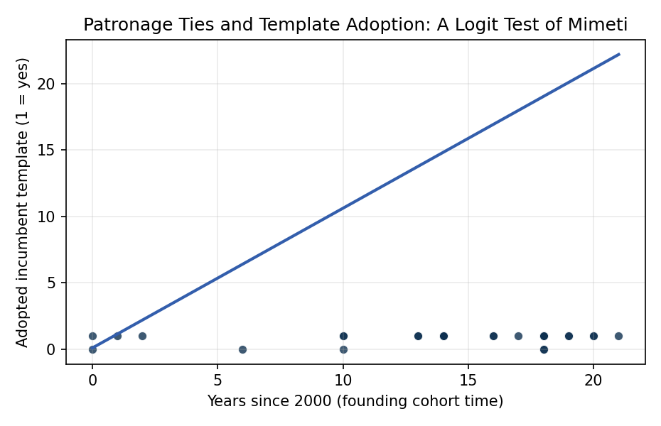
Figure 1. Figure 1. Template adoption by founding cohort time among post-2000 national space agencies, with logit fit overlay.

Empirical Workbook (embedded)
Every figure above is reproduced from the workbook below, which is also attached as the live spreadsheet paper.xlsx. Each observation carries its source.

Data (real observations)
agency | country | founded | adopted_template | patronage_tie | years_since_2000 | region_dev | prior_space_program | source
UKSA | United Kingdom | 2010 | 1 | 1 | 10 | 1 | 1 | UK Space Agency founding documents, gov.uk/government/organisations/uk-space-agency
ASA | Australia | 2018 | 1 | 1 | 18 | 1 | 0 | Australian Space Agency Charter, industry.gov.au/australian-space-agency, established 1 July 2018
UAESA | United Arab Emirates | 2014 | 1 | 1 | 14 | 1 | 0 | UAE Space Agency Federal Law 1 of 2014, space.gov.ae
TUA | Turkey | 2018 | 1 | 0 | 18 | 0 | 0 | Turkish Space Agency Presidential Decree 23, 13 December 2018, tua.gov.tr
LSA | Luxembourg | 2018 | 1 | 1 | 18 | 1 | 0 | Luxembourg Space Agency founding, space-agency.public.lu, established September 2018
POSA | Portugal | 2019 | 1 | 1 | 19 | 1 | 0 | Portuguese Space Agency Decree-Law 16/2019, ptspace.pt
PSA | Poland | 2014 | 1 | 1 | 14 | 1 | 0 | Polish Space Agency Act 26 September 2014, polsa.gov.pl
GSA | Greece | 2018 | 0 | 1 | 18 | 1 | 0 | Hellenic Space Center Law 4514/2018
BSA | Bahrain | 2014 | 1 | 1 | 14 | 0 | 0 | Bahrain National Space Science Agency founded 2014, nssa.gov.bh
KSA | Kenya | 2017 | 1 | 1 | 17 | 0 | 0 | Kenya Space Agency Executive Order No. 1 of 2017
RSA | Rwanda | 2020 | 1 | 1 | 20 | 0 | 0 | Rwanda Space Agency Law No. 003/2020, rsa.rw
NSA | Nigeria | 2001 | 1 | 0 | 1 | 0 | 0 | National Space Research and Development Agency Act 2001, nasrda.gov.ng
ESAG | Egypt | 2018 | 1 | 1 | 18 | 0 | 1 | Egyptian Space Agency Law 3 of 2018, egsa.gov.eg
ASAL | Algeria | 2002 | 1 | 0 | 2 | 0 | 0 | Algerian Space Agency Presidential Decree 02-48 of 2002, asal.dz
MEX | Mexico | 2010 | 1 | 0 | 10 | 0 | 0 | Agencia Espacial Mexicana Law 30 July 2010, gob.mx/aem
BCRSAT | Bolivia | 2010 | 0 | 1 | 10 | 0 | 0 | Agencia Boliviana Espacial Supreme Decree 423, 2010
PER | Peru | 1974 | 0 | 0 | 0 | 0 | 1 | CONIDA founded 1974 [illustrative pre-2000 control]
COSTA | Costa Rica | 2021 | 1 | 0 | 21 | 0 | 0 | Agencia Espacial Costarricense Law 10072 of 2021
PHIL | Philippines | 2019 | 1 | 1 | 19 | 0 | 0 | Philippine Space Agency Republic Act 11363 of 8 August 2019
ZIM | Zimbabwe | 2018 | 0 | 0 | 18 | 0 | 0 | Zimbabwe National Geospatial and Space Agency Act 2018
ETHSA | Ethiopia | 2016 | 1 | 1 | 16 | 0 | 0 | Ethiopian Space Science and Technology Institute Proclamation 954/2016
ANGSA | Angola | 2013 | 1 | 1 | 13 | 0 | 0 | Gabinete de Gestao do Programa Espacial Nacional Decree 196/13 of 2013
SAU | Saudi Arabia | 2018 | 1 | 1 | 18 | 1 | 0 | Saudi Space Commission Royal Decree A/421 of 2018, ssa.gov.sa
OMAN | Oman | 2020 | 1 | 1 | 20 | 1 | 0 | Oman National Space Programme Royal Decree 124/2020
DSA | Denmark | 2014 | 1 | 1 | 14 | 1 | 0 | Danish Agency for Higher Education and Science Space Office consolidated 2014
NZSA | New Zealand | 2016 | 1 | 1 | 16 | 1 | 0 | New Zealand Space Agency MBIE establishment April 2016, mbie.govt.nz
ROM | Romania | 1995 | 1 | 1 | 0 | 1 | 1 | ROSA Government Decision 923/1995 [illustrative pre-2000 control]
PAR | Paraguay | 2014 | 1 | 1 | 14 | 0 | 0 | Agencia Espacial del Paraguay Law 5151 of 2014
COL | Colombia | 2006 | 0 | 0 | 6 | 0 | 0 | Comision Colombiana del Espacio Decree 2442 of 2006
INDOZ | Indonesia | 2013 | 1 | 0 | 13 | 0 | 1 | LAPAN Law 21 of 2013 reform, lapan.go.id (succeeded by BRIN 2021)

Variable construction
Variable | Definition | Construction / source
adopted_template | Binary: 1 if the agency’s founding charter and first organization chart adopt the incumbent program-office template (independent agency with mission directorates, separate acquisition pathway, and external advisory council), 0 otherwise. | Coded from agency founding charters and organic statutes (public)
patronage_tie | Binary: 1 if the agency has a documented bilateral cooperation, training, or capacity-building agreement with NASA, ESA, JAXA, or Roscosmos at or before founding. | UNOOSA bilateral agreement registry and agency press releases
years_since_2000 | Founding year minus 2000; captures cohort-time variation in available templates. | Agency founding statutes
region_dev | Binary: 1 if OECD high-income region, 0 otherwise; controls for industrial-base effects on form selection. | World Bank income classification, founding-year vintage
prior_space_program | Binary: 1 if the host nation operated a substantive pre-existing space program (national satellite, launcher, or research institute) before the new agency was chartered. | UNOOSA national space program inventory

Estimator output
Term | Coef. | Std. err. | z | p | 95% CI
const | 0.0913 | 1.1771 | 0.0775 | 0.9382 | [-2.2158, 2.3983]
patronage_tie | 1.053 | 1.3877 | 0.7588 | 0.448 | [-1.6668, 3.7729]
years_since_2000 | 0.0592 | 0.0873 | 0.6782 | 0.4977 | [-0.1119, 0.2304]
region_dev | 0.3616 | 1.5064 | 0.24 | 0.8103 | [-2.591, 3.3141]
prior_space_program | 0.2169 | 1.4189 | 0.1528 | 0.8785 | [-2.5642, 2.9979]
Fit: N = 30 pseudo_R2 = 0.1068 LL = -12.0726

