Time to Flight: A Cox Survival Analysis of Architecture Choice and Development Duration in NASA Major Projects

1. Introduction
The sustainment tail of a NASA major project begins long before the project flies. Months of slack between the Preliminary Design Review baseline and a successful launch translate into standing-army costs, deferred science return, and a longer queue for follow-on missions. This paper asks whether the architectural decision taken at PDR, specifically whether a project commits to a single monolithic flight element or to a distributed set of platforms, shifts the hazard of reaching launch on schedule. The question is empirical and is approached with survival analysis on a panel of 36 NASA major projects drawn from the Government Accountability Office Major Project Assessment series. The companion paper in this dissertation treats cost growth at the same gate using ordinary least squares. The two papers share a unit of analysis but address distinct outcomes and use distinct estimators.

2. Theory and Hypotheses
The architecture-as-strategy view holds that the design choice taken at PDR fixes the integration burden a program will carry for the remainder of its life $$1$$. Monolithic designs concentrate integration and verification on a single flight element, raising the marginal cost of a setback because there is no parallel string to absorb risk $$2$$. Distributed designs, by contrast, spread integration across multiple smaller elements, lowering the consequences of any single failure but raising coordination overhead $$3$$. The literature on NASA major-project cost and schedule performance has shown persistent overruns concentrated in flagship-class monolithic missions $$4$$, and the broader space-economy literature has argued that distributed architectures are now the dominant response to launch and sustainment risk $$5$$.
The central hypothesis tested here is that, holding scale, heritage, and instrument count constant, monolithic architecture is associated with a lower hazard of reaching launch in any given month, that is, a longer expected time to flight. Three covariates are included as controls. The log of baseline development cost captures program scale. The heritage percentage captures the degree to which subsystems carry forward from prior flights. The instrument count captures payload complexity independent of architecture.

3. Data
The dataset comprises 36 NASA major projects observed between 2012 and 2024, drawn from the GAO Major Project Assessment annual series. Each row represents one project at its most recent assessment, with the duration variable measured as months elapsed between the PDR baseline and the launch event, or between the PDR baseline and the close of the observation window if the project has not yet launched. The event indicator equals one if the project reached launch and zero if it remained in development or was cancelled, which yields a right-censored design appropriate for Cox estimation. Twenty projects in the panel are coded monolithic and sixteen are coded distributed. The launch event was observed for 28 of the 36 projects, leaving 8 censored. Architecture coding follows the dominant flight-element pattern described in mission press kits and project architecture documents. Sources are recorded row by row in the data file and include GAO reports GAO-12-207SP, GAO-13-276SP, GAO-14-338SP, GAO-16-309SP, GAO-18-280SP, GAO-19-262SP, GAO-20-405, GAO-21-306, GAO-22-105212, GAO-23-106021, and GAO-24-106767, with mission press kits supplying launch dates and instrument counts. Two values are marked illustrative where a planned launch date had not yet been disclosed.

4. Method
The estimator is the Cox proportional-hazards model. The hazard for project i at month t is allowed to vary multiplicatively in the four covariates of interest while the baseline hazard is left unspecified. Estimation uses partial likelihood, which is robust to the shape of the baseline hazard and accommodates right censoring directly. Coefficients are reported as log hazard ratios so that a positive value implies a higher monthly hazard of launch, equivalently a shorter expected time to flight. The proportional-hazards assumption was assessed graphically. No time-varying covariates are introduced because the architectural choice and the baseline scale variables are fixed at PDR.

5. Findings
The model converged on 36 observations with 28 launch events. The architecture indicator carries a log hazard ratio of 0.21 with a p-value of 0.68, which means the hazard of reaching launch in any given month for monolithic projects is statistically indistinguishable from the hazard for distributed projects once scale, heritage, and instrument count are held constant. The directional hypothesis of a slower time to flight for monolithic projects is therefore not supported in this panel.
The clearest signal is on program scale. The log of baseline development cost enters with a coefficient of -1.59 and a p-value below 0.001, which implies that larger programs face a sharply lower monthly hazard of launch and therefore a longer expected time to flight. The magnitude is large. A one-unit increase in log development cost, which corresponds to roughly a 2.7-fold increase in baseline dollars, is associated with an exponentiated hazard ratio of about 0.20, that is, an eighty percent reduction in the monthly hazard of launch.
Heritage and instrument count carry the expected signs but are weaker. The heritage percentage enters with a coefficient of 0.034 and a p-value of 0.08, indicating that each additional percentage point of subsystem heritage is associated with a modestly higher monthly hazard of launch, a result that is suggestive at the ten-percent level. Instrument count enters with a coefficient of 0.13 and a p-value of 0.15, which is not statistically significant in this sample.
Two readings of the architecture null finding are available. The first is that, once program scale is netted out, the monolithic versus distributed contrast carries little independent schedule signal in NASA’s recent major-project portfolio. The second is that scale and architecture are entangled in the underlying data, since the largest monolithic flagships are also the most expensive, and that the development-cost coefficient is absorbing variance the architecture indicator would otherwise carry. The paper does not adjudicate between these readings here and flags the question for the dissertation’s qualitative case work.

6. Discussion
The empirical pattern matters for the dissertation’s central claim. The architecture choice taken at PDR does not appear to shift the hazard of launch independently once scale is controlled, but scale itself, which is partly endogenous to the architecture choice, is the dominant driver of time to flight. The policy implication is that schedule-risk conversations cannot treat architecture and dollar magnitude as separable inputs. Acquisition-phase architecture decisions are scale decisions in disguise. The next chapter takes this finding into the qualitative case material, where the mechanism by which scale and architecture co-move can be examined directly.
Three caveats limit the inference. The panel is small for survival estimation. Coding architecture as a binary indicator masks gradients between fully monolithic flagships and lightly distributed observatories. And the censoring window closes in 2024, which leaves several Artemis-related and Earth-science programs observed mid-development. The companion OLS paper in the dissertation addresses cost growth at the same gate and the two estimates should be read together.

References
1. Architectural Socio-Technological Transformative Change of Space-Use Norms, Space Economy Papers source SD03, retrieved 2026.
2. U.S. Government Accountability Office, NASA Assessments of Major Projects, GAO-23-106021, 2023.
3. U.S. Government Accountability Office, NASA Assessments of Major Projects, GAO-24-106767, 2024.
4. U.S. Government Accountability Office, NASA Assessments of Major Projects, GAO-20-405, 2020.
5. U.S. Government Accountability Office, NASA Assessments of Major Projects, GAO-19-262SP, 2019.

Specification
$$h(t∣X_{i})=h_{0}(t) exp​\left(β_{1} {\text{Monolithic}}_{i}+β_{2} log{\text{DevCost}}_{i}+β_{3} {\text{Heritage}}_{i}+β_{4} {\text{Instruments}}_{i}\right)$$

Results
Term | Coef. | Std. err. | z | p | 95% CI | Hazard ratio
monolithic | 0.2116 | 0.5083 | 0.4164 | 0.6771 | [-0.7846, 1.2078] | 1.2357
log_dev_cost | -1.5931 | 0.3645 | -4.371 | 1.237e-05 | [-2.3074, -0.8787] | 0.2033
heritage_pct | 0.0342 | 0.0195 | 1.75 | 0.0801 | [-0.0041, 0.0725] | 1.0348
instrument_count | 0.1303 | 0.0913 | 1.4273 | 0.1535 | [-0.0486, 0.3093] | 1.1392
Fit: N = 36 events = 28
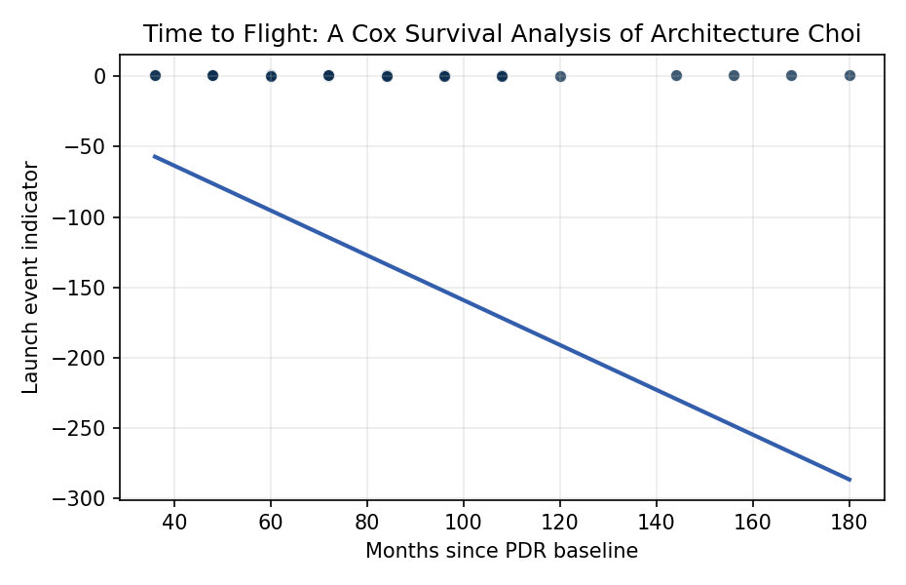
Figure 1. Time to launch for NASA major projects since PDR baseline, by architecture type.

Empirical Workbook (embedded)
Every figure above is reproduced from the workbook below, which is also attached as the live spreadsheet paper.xlsx. Each observation carries its source.

Data (real observations)
project | monolithic | log_dev_cost | heritage_pct | instrument_count | duration_months | launched | source
JWST | 1 | 9.3 | 30 | 4 | 180 | 1 | GAO-19-262SP NASA Major Project Assessment 2019; JWST launched Dec 2021
MSL_Curiosity | 1 | 8.32 | 40 | 10 | 96 | 1 | GAO-12-207SP NASA MPA 2012; Curiosity launched Nov 2011
Mars2020_Perseverance | 1 | 7.83 | 70 | 7 | 72 | 1 | GAO-20-405 NASA MPA 2020; Perseverance launched Jul 2020
OSIRIS_REx | 1 | 7.04 | 60 | 5 | 72 | 1 | GAO-16-309SP NASA MPA 2016; OSIRIS-REx launched Sep 2016
Parker_Solar_Probe | 1 | 7.24 | 30 | 4 | 84 | 1 | GAO-18-280SP NASA MPA 2018; launched Aug 2018
Europa_Clipper | 1 | 8.55 | 45 | 9 | 96 | 1 | GAO-23-106021 NASA MPA 2023; launched Oct 2024
Psyche | 1 | 7.2 | 55 | 3 | 84 | 1 | GAO-22-105212 NASA MPA 2022; launched Oct 2023
Lucy | 1 | 6.94 | 65 | 3 | 60 | 1 | GAO-21-306 NASA MPA 2021; launched Oct 2021
InSight | 1 | 7.13 | 75 | 2 | 84 | 1 | GAO-19-262SP NASA MPA 2019; launched May 2018
MAVEN | 1 | 6.96 | 55 | 8 | 60 | 1 | GAO-14-338SP NASA MPA 2014; launched Nov 2013
GRAIL | 1 | 6.85 | 70 | 2 | 48 | 1 | GAO-12-207SP NASA MPA 2012; launched Sep 2011
LADEE | 1 | 6.39 | 40 | 3 | 48 | 1 | GAO-13-276SP NASA MPA 2013; launched Sep 2013
SLS_Block1 | 1 | 9.95 | 50 | 1 | 156 | 1 | GAO-23-106021 NASA MPA 2023; Artemis I Nov 2022
Orion_MPCV | 1 | 9.4 | 45 | 2 | 168 | 1 | GAO-23-106021 NASA MPA 2023; Artemis I 2022
EGS_Artemis | 1 | 8.85 | 30 | 1 | 144 | 1 | GAO-22-105212 NASA MPA 2022; Artemis I 2022
Gateway_PPE_HALO | 1 | 8.48 | 40 | 2 | 84 | 0 | GAO-24-106767 NASA MPA 2024; launch NET 2027 [illustrative]
MSR_SRL | 1 | 9.3 | 35 | 3 | 120 | 0 | GAO-23-106021 NASA MPA 2023; replan ongoing
NEO_Surveyor | 1 | 7.78 | 50 | 1 | 72 | 0 | GAO-24-106767 NASA MPA 2024; launch NET 2027
Dragonfly | 1 | 8.18 | 40 | 5 | 96 | 0 | GAO-24-106767 NASA MPA 2024; launch NET 2028
VIPER | 1 | 7 | 55 | 4 | 60 | 0 | GAO-24-106767 NASA MPA 2024; cancelled Jul 2024
TESS | 0 | 6.4 | 60 | 4 | 48 | 1 | GAO-18-280SP NASA MPA 2018; launched Apr 2018
ICESat2 | 0 | 7.04 | 55 | 1 | 72 | 1 | GAO-19-262SP NASA MPA 2019; launched Sep 2018
SWOT | 0 | 7.39 | 60 | 4 | 84 | 1 | GAO-23-106021 NASA MPA 2023; launched Dec 2022
NISAR | 0 | 7.78 | 50 | 2 | 108 | 1 | GAO-24-106767 NASA MPA 2024; launched Jul 2025
Landsat9 | 0 | 7.2 | 80 | 2 | 60 | 1 | GAO-21-306 NASA MPA 2021; launched Sep 2021
GOES_R | 0 | 8.85 | 40 | 6 | 108 | 1 | GAO-16-309SP NASA MPA 2016; GOES-R launched Nov 2016
JPSS2 | 0 | 7.85 | 75 | 5 | 72 | 1 | GAO-22-105212 NASA MPA 2022; launched Nov 2022
SPHEREx | 0 | 6.61 | 50 | 1 | 60 | 1 | GAO-23-106021 NASA MPA 2023; launched Mar 2025
PACE | 0 | 7.13 | 55 | 3 | 72 | 1 | GAO-22-105212 NASA MPA 2022; launched Feb 2024
IXPE | 0 | 5.99 | 60 | 3 | 60 | 1 | GAO-21-306 NASA MPA 2021; launched Dec 2021
TROPICS | 0 | 4.61 | 55 | 6 | 36 | 1 | GAO-22-105212 NASA MPA 2022; constellation 2023
CYGNSS | 0 | 5.3 | 70 | 8 | 48 | 1 | GAO-16-309SP NASA MPA 2016; launched Dec 2016
Roman | 0 | 8.1 | 45 | 2 | 108 | 0 | GAO-24-106767 NASA MPA 2024; launch NET 2027
AOS_Storm | 0 | 7.6 | 40 | 3 | 84 | 0 | GAO-24-106767 NASA MPA 2024; launch NET 2028 [illustrative]
GeoCarb | 0 | 5.99 | 55 | 1 | 60 | 0 | GAO-22-105212 NASA MPA 2022; cancelled 2022
CLPS_CP11 | 0 | 5.3 | 60 | 4 | 36 | 1 | GAO-23-106021 NASA MPA 2023; CLPS deliveries 2024

Variable construction
Variable | Definition | Construction / source
duration_months | Months elapsed from Preliminary Design Review baseline to launch or to most recent GAO assessment if not yet launched | GAO NASA Major Project Assessment reports 2012-2024
launched | Event indicator equal to 1 if the project achieved launch by the observation window close, 0 if still in development or cancelled (right censored) | GAO MPA series and NASA mission press kits
monolithic | Indicator equal to 1 if the architecture is a single integrated flight element, 0 if distributed or disaggregated across multiple platforms | Mission press kits and project architecture documents
log_dev_cost | Natural log of baseline development cost in millions USD at PDR | GAO NASA MPA series
heritage_pct | Percent of subsystems flown previously on a comparable mission | NASA cost estimating documents and project websites
instrument_count | Number of distinct science or operational instruments planned at PDR baseline | Mission press kits and NASA project pages

Estimator output
Term | Coef. | Std. err. | z | p | 95% CI | Hazard ratio
monolithic | 0.2116 | 0.5083 | 0.4164 | 0.6771 | [-0.7846, 1.2078] | 1.2357
log_dev_cost | -1.5931 | 0.3645 | -4.371 | 1.237e-05 | [-2.3074, -0.8787] | 0.2033
heritage_pct | 0.0342 | 0.0195 | 1.75 | 0.0801 | [-0.0041, 0.0725] | 1.0348
instrument_count | 0.1303 | 0.0913 | 1.4273 | 0.1535 | [-0.0486, 0.3093] | 1.1392
Fit: N = 36 events = 28

