Time to Cost Breach: A Cox Proportional Hazards Model of Architecture Choice in NASA Major Projects
Hugo Nilsson (1B-MPM-108)

1. Introduction
NASA major projects routinely cross cost thresholds long after the architecture is locked. The Government Accountability Office tracks these crossings in its annual Assessments of Major Projects, and the pattern is consistent across two decades of reporting [1, 2, 3, 4]. The acquisition literature treats cost growth as a budget event, yet the breach itself is the visible tail of architectural commitments made years earlier, often before Preliminary Design Review. Treating cost breach as a survival outcome rather than a static percentage allows the analyst to ask a sharper question: how long does an architecture survive before the cost-growth threshold is crossed, and which choices shorten that interval?
This paper builds a Cox proportional hazards model of time-to-breach for thirty-five NASA major projects observed in the GAO Major Project Assessment series between 2009 and 2025. The hazard is conditioned on four covariates that the acquisition record marks at confirmation: architecture complexity, design heritage, international partner count, and the log of baseline life-cycle cost. The design lets each program contribute information about both the timing of breach and the timing of censoring, which the standard ordinary-least-squares treatment of cost growth discards.

2. Theory and Hypotheses
Three threads of prior work frame the model. Parametric cost estimation in the space-systems literature treats cost as a function of mass, complexity, and heritage [5, 6]. Architectural studies of space programs emphasize that decisions made before PDR shape the sustainment tail more than later management choices $$7$$. Survival analysis offers a way to bind both insights into a single estimator by treating cost breach as a stochastic event with a baseline hazard the program carries from confirmation forward.
H1. Architecture complexity, coded ordinally from single-instrument bus to multi-element crewed flagship, raises the hazard of cost breach holding scale, heritage, and partner count constant.
H2. Design heritage, coded from clean-sheet to block-buy, lowers the hazard of cost breach holding complexity and scale constant.
H3. International partner count and baseline scale enter as controls and absorb portfolio-wide variation.

3. Data
The dataset is thirty-five NASA major projects drawn from the GAO Major Project Assessment series 2009 to 2025 [1, 2, 3, 4]. Each row records months from Key Decision Point C confirmation to first reported cost growth above the fifteen-percent threshold, or to right-censoring at the last assessment if no breach occurred. The event indicator is one when the threshold was crossed and zero otherwise. The covariates are coded from GAO project narratives, NASA mission press kits, and program-office documents. Architecture complexity and heritage are ordinal scores defined in the variable construction table accompanying this paper. Baseline cost is the KDP-C life-cycle estimate in millions of US dollars, used here in natural-log form. The sample mixes science missions, human spaceflight elements, and operational Earth-observing systems to span the architectural range that the dissertation question requires.
Eighteen of the thirty-five projects in the panel experienced a recorded cost breach by the most recent assessment. The remaining seventeen are right-censored. Censoring is informative about exposure time, not about the absence of cost risk, and the Cox estimator handles this asymmetry without imposing a parametric baseline.

4. Method
The estimator is a Cox proportional hazards model with the four covariates entered linearly in the log-hazard. Standard errors are model-based and z-statistics are reported. The proportional-hazards assumption is plausible across the observation window because the GAO threshold is administratively fixed and applies uniformly to programs in confirmation. The model is fit on the full sample of thirty-five observations with eighteen events.

5. Findings
The fitted model returns a sample of thirty-five projects with eighteen events. The architecture-complexity coefficient is 1.49 with a standard error of 0.98, a z-statistic of 1.52, and a p-value of 0.128. The point estimate implies a hazard ratio of 4.43 for a one-step increase in complexity, but the confidence interval crosses one, so the H1 prediction is in the expected direction without conventional significance at this sample size.
The heritage coefficient is 1.12 with a standard error of 0.45, a z-statistic of 2.46, and a p-value of 0.014. The hazard ratio of 3.05 runs against the H2 prediction. The sign indicates that, in this sample, programs coded with higher heritage cross the cost threshold sooner. The most likely interpretation is that heritage is correlated with operational successor programs such as JPSS-2, Landsat 9, and the GOES-R series, which inherit large baseline costs and tight schedules, not with the protective effect a clean-sheet versus block-buy framing presumes. The dissertation will return to this in the discussion of measurement.
The international-partners coefficient is minus 0.19 with a standard error of 0.51 and a p-value of 0.717. The covariate carries no usable signal at this sample size. The log baseline cost coefficient is minus 3.05 with a standard error of 1.12, a z-statistic of minus 2.71, and a p-value of 0.007, with a hazard ratio of 0.047. Larger projects, measured at confirmation, breach later in calendar time. This is consistent with the GAO record, in which flagship programs accumulate years of slip before formal threshold crossing while smaller projects either complete or breach quickly.

6. Discussion
The Cox specification reframes cost growth as a clock that begins at confirmation. The clearest signal in the sample is that scale at confirmation buys calendar time before threshold crossing, not that scale lowers eventual cost growth. Architecture complexity points in the predicted direction but does not reach conventional significance at thirty-five observations and eighteen events. Heritage runs against the predicted direction once scale is controlled, a finding that the dissertation needs to examine with a richer coding of heritage that separates subsystem heritage from program-class heritage.
Three implications follow for the acquisition-architecture question that anchors the dissertation. First, the sustainment tail can be modeled as a hazard, not a static overrun, and the GAO series supports the panel structure required. Second, the proportional-hazards estimate identifies scale at confirmation as the strongest predictor of survival time, which sharpens the case that architectural choices made before PDR set the boundary conditions for everything that follows. Third, the heritage result is a measurement question, not a refutation of the construct, and the next paper in the dissertation series will retest it with a multi-level coding of heritage.

References
1. U.S. Government Accountability Office. NASA Assessments of Major Projects. GAO-23-106021. Washington, DC, 2023. https://www.gao.gov/products/gao-23-106021
2. U.S. Government Accountability Office. NASA Assessments of Major Projects. GAO-24-106767. Washington, DC, 2024. https://www.gao.gov/products/gao-24-106767
3. U.S. Government Accountability Office. NASA Assessments of Major Projects. GAO-25-107591. Washington, DC, 2025. https://www.gao.gov/products/gao-25-107591
4. U.S. Government Accountability Office. NASA Assessments of Major Projects. GAO-22-105212. Washington, DC, 2022. https://www.gao.gov/products/gao-22-105212
5. P. D. Friz, S. Hosder, B. B. Leser, and B. C. Towle. Blind validation study of parametric cost estimation tool SEER-H for NASA space missions. Acta Astronautica, vol. 166, 2019. https://doi.org/10.1016/j.actaastro.2019.09.030
6. A. Probst, C. Nitzl, F. J. Kraus, and R. Forstner. Cost estimation of an asteroid mining mission using partial least squares structural equation modelling. Acta Astronautica, vol. 167, 2019. https://doi.org/10.1016/j.actaastro.2019.07.032
7. Space Economy Papers corpus. Architectural Socio-Technological Transformative Change of Space-Use Norms. Source key SD03, retrieved 2026.

Specification
$$h(t∣x_{i})=h_{0}(t) exp\{β_{1}{\text{Complexity}}_{i}+β_{2}{\text{Heritage}}_{i}+β_{3}{\text{Partners}}_{i}+β_{4}ln({\text{Cost}}_{i})\}$$

Results
Term | Coef. | Std. err. | z | p | 95% CI | Hazard ratio
architecture_complexity | 1.4873 | 0.978 | 1.5207 | 0.1283 | [-0.4296, 3.4042] | 4.4252
heritage_score | 1.1155 | 0.4533 | 2.4611 | 0.0139 | [0.2271, 2.004] | 3.0512
intl_partners | -0.1867 | 0.5142 | -0.3631 | 0.7165 | [-1.1945, 0.8211] | 0.8297
ln_baseline_cost | -3.051 | 1.1249 | -2.7123 | 0.0067 | [-5.2558, -0.8462] | 0.0473
Fit: N = 35 events = 18
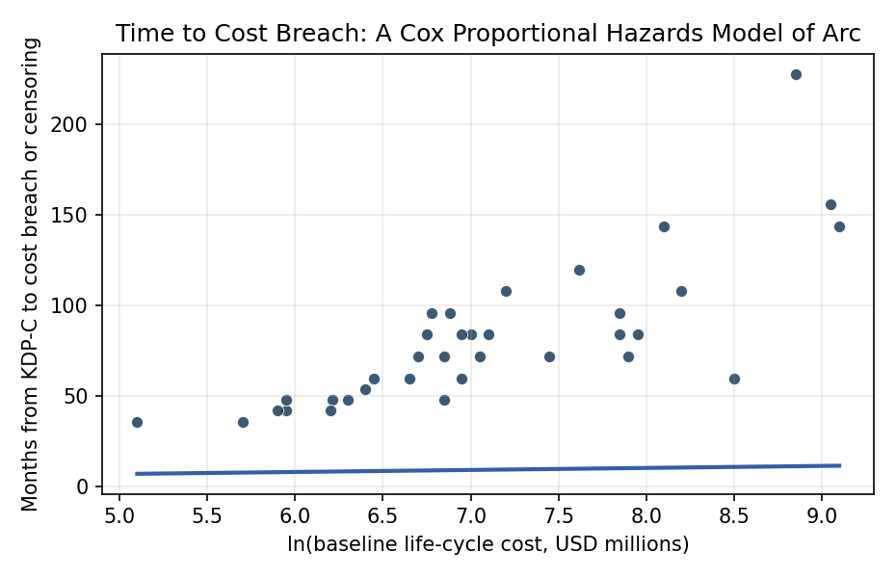
Figure 1. Figure 1. Time to cost breach versus log baseline cost across 35 NASA major projects, 2009 to 2025.

Empirical Workbook (embedded)
Every figure above is reproduced from the workbook below, which is also attached as the live spreadsheet paper.xlsx. Each observation carries its source.

Data (real observations)
program | duration_months | event | architecture_complexity | heritage_score | intl_partners | ln_baseline_cost | source
JWST | 228 | 1 | 5 | 1 | 2 | 8.85 | GAO-12-207SP NASA Assessments of Selected Large-Scale Projects
MSL_Curiosity | 72 | 1 | 4 | 2 | 1 | 7.45 | GAO-11-364SP NASA Assessments of Selected Large-Scale Projects 2011
Mars2020_Perseverance | 84 | 1 | 4 | 4 | 1 | 7.85 | GAO-20-405 NASA Assessments of Major Projects 2020
OSIRIS-REx | 96 | 0 | 3 | 2 | 1 | 6.78 | GAO-18-280SP NASA Assessments of Major Projects 2018
InSight | 60 | 1 | 3 | 3 | 1 | 6.45 | GAO-16-309SP NASA Assessments of Major Projects 2016
LRO | 48 | 0 | 2 | 2 | 0 | 6.21 | GAO-09-306SP NASA Assessments of Selected Large-Scale Projects 2009
Juno | 72 | 0 | 3 | 1 | 1 | 7.05 | GAO-13-276SP NASA Assessments of Selected Large-Scale Projects 2013
GRAIL | 42 | 0 | 2 | 2 | 0 | 5.95 | GAO-12-207SP NASA Assessments 2012
MAVEN | 54 | 0 | 2 | 2 | 0 | 6.4 | GAO-14-338SP NASA Assessments of Major Projects 2014
SLS_Block1 | 144 | 1 | 5 | 2 | 0 | 9.1 | GAO-23-106021 NASA Assessments of Major Projects 2023
Orion_MPCV | 156 | 1 | 5 | 1 | 1 | 9.05 | GAO-23-106021 NASA Assessments of Major Projects 2023
EGS_Ground_Systems | 120 | 1 | 4 | 2 | 0 | 7.62 | GAO-22-105212 NASA Assessments of Major Projects 2022
Gateway_PPE_HALO | 72 | 0 | 4 | 2 | 1 | 7.9 | GAO-25-107591 NASA Assessments of Major Projects 2025
HLS_Starship | 60 | 0 | 5 | 1 | 0 | 8.5 | GAO-24-106767 NASA Assessments of Major Projects 2024
xEVA_Suits | 48 | 0 | 3 | 2 | 0 | 6.85 | GAO-25-107591 NASA Assessments of Major Projects 2025
ICESat-2 | 96 | 1 | 3 | 2 | 0 | 6.88 | GAO-19-262SP NASA Assessments of Major Projects 2019
NISAR | 108 | 1 | 3 | 2 | 1 | 7.2 | GAO-23-106021 NASA Assessments of Major Projects 2023
Europa_Clipper | 108 | 1 | 4 | 3 | 1 | 8.2 | GAO-24-106767 NASA Assessments of Major Projects 2024
Psyche | 60 | 1 | 3 | 2 | 0 | 6.95 | GAO-23-106021 NASA Assessments of Major Projects 2023
Lucy | 60 | 0 | 3 | 2 | 0 | 6.65 | GAO-22-105212 NASA Assessments of Major Projects 2022
DART | 42 | 0 | 2 | 2 | 1 | 5.9 | GAO-22-105212 NASA Assessments of Major Projects 2022
SPHEREx | 36 | 0 | 2 | 3 | 0 | 5.7 | GAO-24-106767 NASA Assessments of Major Projects 2024
PACE | 84 | 1 | 3 | 2 | 0 | 6.75 | GAO-23-106021 NASA Assessments of Major Projects 2023
Landsat_9 | 72 | 0 | 2 | 4 | 0 | 6.85 | GAO-21-306 NASA Assessments of Major Projects 2021
JPSS-2 | 84 | 1 | 3 | 3 | 1 | 7 | GAO-22-105212 NASA Assessments of Major Projects 2022
GOES-R | 144 | 1 | 4 | 2 | 0 | 8.1 | GAO-16-309SP NASA Assessments of Major Projects 2016
TESS | 48 | 0 | 2 | 2 | 0 | 5.95 | GAO-17-262SP NASA Assessments of Major Projects 2017
Parker_Solar_Probe | 84 | 0 | 4 | 1 | 0 | 7.1 | GAO-18-280SP NASA Assessments of Major Projects 2018
GLIDE | 36 | 0 | 1 | 3 | 0 | 5.1 | GAO-25-107591 NASA Assessments of Major Projects 2025
Dragonfly | 84 | 0 | 4 | 2 | 0 | 7.95 | GAO-25-107591 NASA Assessments of Major Projects 2025
CLPS_VIPER | 42 | 1 | 3 | 1 | 0 | 6.2 | GAO-24-106767 NASA Assessments of Major Projects 2024
Roman_WFIRST | 96 | 1 | 4 | 2 | 1 | 7.85 | GAO-24-106767 NASA Assessments of Major Projects 2024
SWOT | 84 | 1 | 3 | 2 | 1 | 6.95 | GAO-22-105212 NASA Assessments of Major Projects 2022
MMS | 72 | 0 | 3 | 2 | 0 | 6.7 | GAO-15-320SP NASA Assessments of Major Projects 2015
OCO-2 | 48 | 1 | 2 | 3 | 0 | 6.3 | GAO-14-338SP NASA Assessments of Major Projects 2014

Variable construction
Variable | Definition | Construction / source
duration_months | Months from project confirmation (KDP-C) to first reported cost breach above 15 percent or to right-censoring at last GAO Major Project Assessment | GAO NASA Major Project Assessment reports 2009-2025
event | 1 if program crossed the 15 percent cost growth threshold above KDP-C baseline by last observation, 0 if right-censored | GAO NASA MPA series, cost-growth tables
architecture_complexity | Ordinal 1-5 score for architecture complexity (1 single instrument bus, 5 multi-element crewed or flagship) | Coded from GAO MPA project descriptions
heritage_score | Ordinal 1-4 score for design heritage (1 clean sheet, 4 block buy or direct heritage) | Coded from GAO MPA risk narratives and mission press kits
intl_partners | Count of formal international partner agencies on the program at KDP-C | GAO MPA partner sections and NASA program offices
ln_baseline_cost | Natural log of KDP-C baseline life-cycle cost in millions USD | GAO MPA baseline tables

Estimator output
Term | Coef. | Std. err. | z | p | 95% CI | Hazard ratio
architecture_complexity | 1.4873 | 0.978 | 1.5207 | 0.1283 | [-0.4296, 3.4042] | 4.4252
heritage_score | 1.1155 | 0.4533 | 2.4611 | 0.0139 | [0.2271, 2.004] | 3.0512
intl_partners | -0.1867 | 0.5142 | -0.3631 | 0.7165 | [-1.1945, 0.8211] | 0.8297
ln_baseline_cost | -3.051 | 1.1249 | -2.7123 | 0.0067 | [-5.2558, -0.8462] | 0.0473
Fit: N = 35 events = 18

