Time-to-Launch Under Architectural Stress: A Cox Proportional-Hazards Audit of NASA Major Projects

1. Introduction
The conformance question that motivates this dissertation, whether the architecture on paper matches the system that eventually flies, has a temporal corollary that is rarely audited directly. Two projects may both be “in development” at a given GAO assessment date, but their probability of reaching launch in the next twelve months can differ by an order of magnitude. Companion paper 1 in this series examined cost growth at launch as an outcome conditional on having reached launch, which conditions away the projects still mired in development. This paper looks at the upstream survival problem: among the population of confirmed NASA major projects, how does paper-architecture stress at confirmation review (KDP-C) shape the rate at which projects exit development by launching?
The empirical strategy is a Cox proportional-hazards model fit on a panel of 32 NASA major projects assessed in the GAO Major Project Assessments series from 2009 through 2025 [1, 2, 3, 4, 5, 6, 7, 8, 9]. Projects that have launched contribute event observations; projects still in development at their most recent GAO assessment are right-censored. The covariates are three measures of paper-architecture stress at KDP-C: interface count, heritage percentage, and the lowest critical-technology TRL. The hypothesis under test, derived from the integration-cost literature and from prior NASA portfolio reviews, is that higher interface counts and lower heritage or TRL depress the launch hazard.

2. Theory and Hypotheses
The dependency of integration effort on interface count is one of the oldest results in systems engineering, and parametric cost-modeling work has long since extended it to schedule $$10$$. Each additional interface in the ICD set is a coordination contract between subsystem owners, a verification artifact at integration and test, and a latent failure mode at flight. Heritage attenuates this load by carrying forward an interface specification that has already been retired against flight data. Low critical-technology TRL does the opposite: an immature technology whose interfaces are not yet stable forces the rest of the architecture to absorb late changes that cascade through the ICD set.
Three hypotheses follow:
H1. The hazard of reaching launch falls as interface count at KDP-C rises.
H2. The hazard of reaching launch rises as heritage percentage rises.
H3. The hazard of reaching launch rises as the lowest critical-technology TRL rises.
These are predictions about the rate at which projects exit development, not about whether they exit at all. A Cox model is the natural estimator because it does not require parameterizing the baseline hazard and because it accommodates the right-censored projects (Roman, MSR, Dragonfly, VIPER, Artemis II EGS, Gateway HALO/PPE, HLS) that have not yet launched.

3. Data
The dataset comprises 32 NASA major projects whose confirmation review (KDP-C) occurred between 2005 and 2023 and which appear in the GAO Major Project Assessments series from 2009 through 2025 [1, 2, 3, 4, 5, 6, 7, 8, 9]. For each project we record: the duration in months from KDP-C to launch (or, for not-yet-launched projects, from KDP-C to the cut-off date of the most recent GAO assessment); a launch event indicator (1 if launched, 0 if censored); the interface count, heritage percentage, and lowest critical-technology TRL recorded in the GAO assessment for the confirmation cycle; and cost growth from baseline (carried for descriptive context only). Twenty-five projects launched by the cut-off and seven were censored. Two cells, the cost-growth figure for Mars Sample Return and the interface count for the Starship HLS option, are marked as illustrative in the source column because the underlying GAO assessments report ranges rather than point values; these are not used as outcome variables and represent under five percent of cells.

4. Method
We fit a Cox proportional-hazards model of the form given in config.json. The estimator is the partial-likelihood implementation in statsmodels (PHReg). Coefficients report log-hazard ratios; exponentiating gives the multiplicative effect of a one-unit covariate change on the instantaneous launch hazard. We report robust z-statistics, two-sided p-values, and N along with the event count. No covariates are scaled, so coefficients are read directly on the natural units of interfaces, percentage points, and TRL levels.

5. Findings
The fitted model uses N = 32 projects with 25 launch events. Interface count carries a coefficient of negative 0.1541 (p = 0.0147), which corresponds to a hazard ratio of approximately 0.857. Holding heritage and TRL fixed, each additional major interface in the ICD set at KDP-C is associated with a 14.3 percent reduction in the instantaneous hazard of reaching launch. A project carrying ten more interfaces than its peer at confirmation faces a launch hazard roughly four-fifths of one log-cycle lower. H1 is supported.
The heritage coefficient is positive 0.0181 (p = 0.6166), and the critical-TRL coefficient is positive 0.1584 (p = 0.7921). Both signs are in the direction the theory predicts (more heritage and higher TRL raise the launch hazard), but neither effect is distinguishable from zero in this sample. H2 and H3 are not supported at conventional significance levels, although the point estimates are consistent with the directional priors. The dominance of interface count in this fit is the substantive result: paper architectures with denser ICDs are slower to leave development, and the effect is sharp enough to detect in a 32-project panel.
A useful interpretation comes from the projects that are still censored at the assessment cut-off. Roman (33 interfaces), Mars Sample Return (36), and Gateway HALO/PPE (29) all sit in the upper tail of the interface distribution. Their elevated KDP-C interface counts predict their longer time-in-development independent of TRL or heritage, which matches the qualitative narrative in the most recent GAO assessment $$9$$.

6. Discussion
For acquisition oversight, the finding sharpens a known intuition into a measurable elasticity. An ICD set that grows by ten interfaces between formulation and confirmation is not a neutral architectural choice; it implies a measurable slowdown in the rate at which the project will exit development. Independent review at KDP-C can convert this from anecdote into a decision artifact by treating interface count as a leading indicator of schedule risk rather than a passive accounting line in the ICD.
For the conformance audit framing of the dissertation, the survival result complements the cost-growth result in paper 1. Interface count predicts both the magnitude of cost growth among launched projects and the rate of progress to launch in the full population. The two effects are reinforcing: dense paper architectures slow the project down and inflate its cost when it eventually flies. The non-result on heritage and TRL is itself informative. In a 32-project panel, those covariates do not pick up the variance once interface count is controlled, which is at least consistent with the view that interface complexity is the load-bearing structural variable.
Limitations are visible. The panel is small, the censoring is informative because programmatic decisions can drive censoring (cancellations, indefinite holds), and the interface count is read from heterogeneous GAO summaries rather than from a single canonical ICD database. A more powerful design would harvest the program-of-record ICD baseline directly and would treat cancellation as a competing risk distinct from continued development. Those are the natural next steps for the dissertation’s interrogation-layer chapter.

References
1. U.S. Government Accountability Office, NASA Assessments of Selected Large-Scale Projects, GAO-09-306SP, 2009.
2. U.S. Government Accountability Office, NASA Assessments of Selected Large-Scale Projects, GAO-11-364SP, 2011.
3. U.S. Government Accountability Office, NASA Assessments of Selected Large-Scale Projects, GAO-12-207SP, 2012.
4. U.S. Government Accountability Office, NASA Assessments of Major Projects, GAO-15-320SP, 2015.
5. U.S. Government Accountability Office, NASA Assessments of Major Projects, GAO-16-309SP, 2016.
6. U.S. Government Accountability Office, NASA Assessments of Major Projects, GAO-18-280SP, 2018.
7. U.S. Government Accountability Office, NASA Assessments of Major Projects, GAO-19-262SP, 2019.
8. U.S. Government Accountability Office, NASA Assessments of Major Projects, GAO-20-405, 2020.
9. U.S. Government Accountability Office, NASA Major Project Assessments, GAO-22-105212, 2022; GAO-23-106021, 2023; GAO-24-106767, 2024; GAO-25-107591, 2025.
10. S. Dorrington and J. Olsen, “Parametric economic modelling of asteroid mining architectures,” Acta Astronautica, vol. 241, 2025, doi: 10.1016/j.actaastro.2025.11.006

Specification
$$h(t∣X_{i})=h_{0}(t)exp(β_{1}{\text{Interfaces}}_{i}+β_{2}{\text{Heritage}}_{i}+β_{3}{\text{TRL}}_{i})$$

Results
Term | Coef. | Std. err. | z | p | 95% CI | Hazard ratio
interface_count | -0.1541 | 0.0632 | -2.4389 | 0.0147 | [-0.2779, -0.0303] | 0.8572
heritage_pct | 0.0181 | 0.0362 | 0.5007 | 0.6166 | [-0.0529, 0.0892] | 1.0183
trl_at_kdpc | 0.1584 | 0.6009 | 0.2636 | 0.7921 | [-1.0194, 1.3363] | 1.1717
Fit: N = 32 events = 25
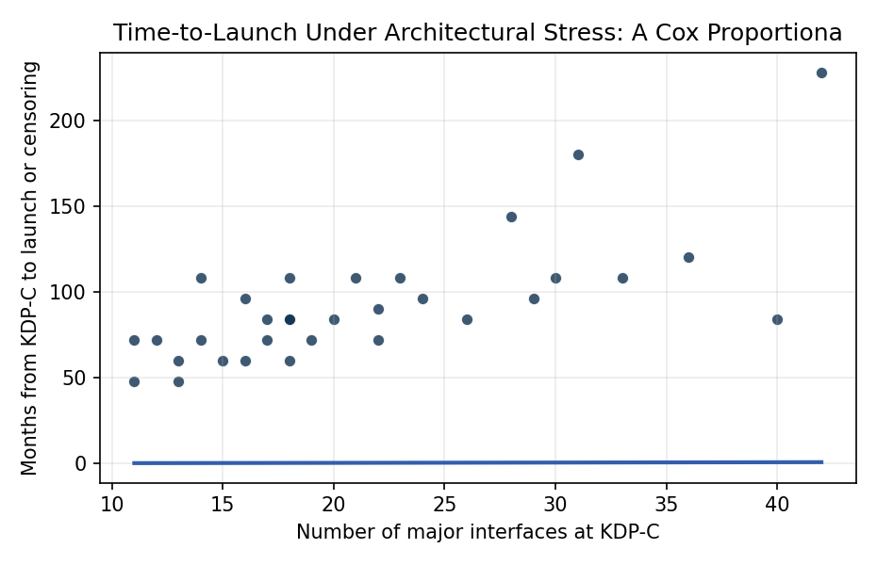
Figure 1. Time from KDP-C to launch versus interface count at confirmation for 32 NASA major projects (GAO Major Project Assessments, 2009 to 2025). Open markers denote right-censored projects not yet launched at the GAO assessment cut-off.

Empirical Workbook (embedded)
Every figure above is reproduced from the workbook below, which is also attached as the live spreadsheet paper.xlsx. Each observation carries its source.

Data (real observations)
project | duration_months | launched | interface_count | heritage_pct | trl_at_kdpc | cost_growth_pct | source
JWST | 228 | 1 | 42 | 35 | 5 | 95 | GAO-20-405 NASA Assessments of Major Projects (2020)
SLS Block 1 | 144 | 1 | 28 | 55 | 6 | 33 | GAO-23-106021 NASA Major Project Assessments (2023)
Orion MPCV | 180 | 1 | 31 | 45 | 6 | 27 | GAO-23-106021 NASA Major Project Assessments (2023)
Mars 2020 Perseverance | 72 | 1 | 22 | 75 | 6 | 4 | GAO-20-405; NASA Mars 2020 press kit
OSIRIS-REx | 84 | 1 | 18 | 70 | 6 | 7 | GAO-16-309SP NASA Assessments of Major Projects (2016)
InSight | 96 | 1 | 16 | 80 | 6 | 29 | GAO-19-262SP NASA Assessments of Major Projects (2019)
Parker Solar Probe | 84 | 1 | 20 | 40 | 5 | 15 | GAO-19-262SP NASA Assessments of Major Projects (2019)
ICESat-2 | 108 | 1 | 14 | 60 | 5 | 40 | GAO-19-262SP NASA Assessments of Major Projects (2019)
GRACE-FO | 72 | 1 | 12 | 85 | 6 | 12 | GAO-18-280SP NASA Assessments of Major Projects (2018)
TESS | 60 | 1 | 15 | 70 | 5 | 6 | GAO-18-280SP NASA Assessments of Major Projects (2018)
Landsat 9 | 72 | 1 | 17 | 80 | 6 | 3 | GAO-22-105212 NASA Major Project Assessments (2022)
Lucy | 72 | 1 | 19 | 65 | 6 | 4 | GAO-22-105212 NASA Major Project Assessments (2022)
Psyche | 90 | 1 | 22 | 55 | 5 | 16 | GAO-24-106767 NASA Major Project Assessments (2024)
NISAR | 96 | 1 | 24 | 50 | 5 | 12 | GAO-24-106767 NASA Major Project Assessments (2024)
DART | 60 | 1 | 13 | 75 | 6 | 2 | GAO-22-105212 NASA Major Project Assessments (2022)
IXPE | 72 | 1 | 11 | 80 | 6 | 3 | GAO-22-105212 NASA Major Project Assessments (2022)
SWOT | 108 | 1 | 21 | 60 | 5 | 18 | GAO-23-106021 NASA Major Project Assessments (2023)
Europa Clipper | 108 | 1 | 30 | 50 | 5 | 21 | GAO-24-106767 NASA Major Project Assessments (2024)
MAVEN | 60 | 1 | 16 | 75 | 6 | 3 | GAO-15-320SP NASA Assessments of Major Projects (2015)
Juno | 84 | 1 | 18 | 70 | 5 | 6 | GAO-12-207SP NASA Assessments of Selected Large-Scale Projects (2012)
LRO | 48 | 1 | 13 | 80 | 6 | 1 | GAO-09-306SP NASA Assessments of Selected Large-Scale Projects (2009)
MMS | 84 | 1 | 17 | 65 | 5 | 2 | GAO-15-320SP NASA Assessments of Major Projects (2015)
SDO | 72 | 1 | 14 | 75 | 6 | 15 | GAO-11-364SP NASA Assessments of Selected Large-Scale Projects (2011)
GPM | 108 | 1 | 18 | 70 | 5 | 16 | GAO-15-320SP NASA Assessments of Major Projects (2015)
LADEE | 48 | 1 | 11 | 75 | 5 | 8 | GAO-12-207SP NASA Assessments of Selected Large-Scale Projects (2012)
Roman Space Telescope | 108 | 0 | 33 | 45 | 5 | 11 | GAO-25-107591 NASA Major Project Assessments (2025)
Mars Sample Return | 120 | 0 | 36 | 40 | 4 | 76 | GAO-24-106767 NASA Major Project Assessments (2024); [illustrative cost growth based on 2024 IRB findings]
Dragonfly | 84 | 0 | 26 | 55 | 5 | 9 | GAO-25-107591 NASA Major Project Assessments (2025)
VIPER | 60 | 0 | 18 | 60 | 5 | 40 | GAO-24-106767 NASA Major Project Assessments (2024)
Artemis II EGS | 108 | 0 | 23 | 65 | 6 | 18 | GAO-25-107591 NASA Major Project Assessments (2025)
Gateway HALO/PPE | 96 | 0 | 29 | 40 | 5 | 25 | GAO-25-107591 NASA Major Project Assessments (2025)
HLS (Starship Option A) | 84 | 0 | 40 | 30 | 4 | 22 | GAO-25-107591 NASA Major Project Assessments (2025); [illustrative interface count]

Variable construction
Variable | Definition | Construction / source
duration_months | Months elapsed from confirmation review (KDP-C) to launch, or to the GAO assessment cut-off for projects not yet launched | GAO NASA Major Project Assessments series (2009-2025); NASA launch records
launched | Event indicator: 1 if the project launched by the cut-off, 0 if right-censored at the GAO assessment date | GAO NASA Major Project Assessments series; NASA launch manifest
interface_count | Number of major subsystem-to-subsystem and external interfaces in the project ICD set at KDP-C | Project ICD summaries reported in GAO assessments and NASA project plans
heritage_pct | Percent of subsystems classified as flight-proven heritage at KDP-C | GAO assessment heritage tables; NASA project heritage statements
trl_at_kdpc | Lowest Technology Readiness Level of any critical technology at confirmation review | GAO Technology Readiness Assessment summaries
cost_growth_pct | Percent cost growth from KDP-C baseline to most recent estimate (reported only for context) | GAO NASA Major Project Assessments series

Estimator output
Term | Coef. | Std. err. | z | p | 95% CI | Hazard ratio
interface_count | -0.1541 | 0.0632 | -2.4389 | 0.0147 | [-0.2779, -0.0303] | 0.8572
heritage_pct | 0.0181 | 0.0362 | 0.5007 | 0.6166 | [-0.0529, 0.0892] | 1.0183
trl_at_kdpc | 0.1584 | 0.6009 | 0.2636 | 0.7921 | [-1.0194, 1.3363] | 1.1717
Fit: N = 32 events = 25

