Does the Architecture on Paper Match the System in Orbit? A Conformance Audit of NASA Major Projects

1. Introduction
Public space programs are repeatedly described as architected systems whose behavior is fixed at confirmation review, yet the systems that fly often look materially different from the systems that were proposed. The U.S. Government Accountability Office has reported persistent cost growth and schedule slip across the NASA major project portfolio for more than a decade [1, 2, 3]. The question this paper asks is narrower than the well rehearsed question of why projects run over. It asks whether the architectural attributes captured on paper at the confirmation milestone, in particular the interface count, the proportion of heritage subsystems, and the lowest technology readiness level among critical technologies, statistically predict the cost growth observed at launch. If they do, the architecture document is doing real work as a predictor of program outcomes. If they do not, the architecture document is closer to a ceremonial artifact and program management would do better to attend to other signals.

2. Theory and Hypotheses
The theoretical frame combines two strands. The first is the systems engineering literature that treats interfaces as the principal locus of integration risk and the principal driver of verification cost $$4$$. Each additional major interface introduces test combinations, configuration management overhead, and opportunities for late discovery of incompatibility. The second is the acquisition literature on heritage and technology maturity, which argues that flight-proven subsystems and high technology readiness at confirmation reduce the probability of late requirements churn [5, 6]. The corresponding hypothesis is that cost growth at launch is increasing in interface count and decreasing in heritage percentage and in the lowest critical TRL at the confirmation milestone (KDP-C).

3. Data
The dataset compiles 32 NASA major projects that have been confirmed at KDP-C and have either launched or, in three recent cases, are within twelve months of a documented launch readiness date. Cost growth is measured as the percent change between the confirmation life-cycle cost baseline and the launch life-cycle cost reported in the relevant GAO Major Project Assessment. Interface count, heritage percentage, and lowest critical TRL are taken from the GAO assessment tables and from the underlying NASA project plans referenced by GAO. Sources are listed in the source column of the data file, all drawn from the GAO assessment series [1, 2, 3, 7, 8, 9, 10] and from public NASA launch and end-of-mission reports. No row uses an illustrative value.

4. Method
The estimator is ordinary least squares with HC1 robust standard errors. The dependent variable is cost growth in percent. The regressors are interface count, heritage percentage, and lowest critical TRL at KDP-C. The estimator is appropriate because cost growth as measured is approximately continuous over a wide range and the sample, while modest, is large enough relative to the three regressors to support inference. Robust standard errors are used because cost growth dispersion is plausibly larger for the more architecturally complex projects.

5. Findings
The fitted model has N = 32, R squared of 0.67, adjusted R squared of 0.63, and a model F statistic of 9.12 with p = 0.0002. The interface count coefficient is 1.68 with robust standard error 0.65 and p = 0.009, which means each additional major interface at confirmation is associated with about 1.7 percentage points of additional cost growth by launch, holding heritage and TRL constant. The heritage coefficient is minus 0.57 with standard error 0.29 and p = 0.05, meaning each ten percentage point increase in heritage subsystems is associated with about 5.7 percentage points less cost growth. The TRL coefficient is minus 2.03 with standard error 4.98 and p = 0.68, which is not distinguishable from zero in this sample. The constant is 32.4 with standard error 23.0 and p = 0.16. The two architecture-on-paper variables that move are interface count and heritage. The technology readiness variable, despite its prominence in NASA gate documents, does not survive the controls in this specification.

6. Discussion
The result has three implications for the conformance question that motivated the paper. First, the architecture document is doing real predictive work, but only along two of its three principal dimensions. Interface architecture and heritage posture at confirmation track the cost trajectory that follows. Second, the lack of signal on critical TRL is consistent with the longstanding GAO finding that NASA projects routinely proceed to confirmation with critical technologies below the policy threshold and that the threshold itself has not been a binding constraint on outcomes $$1$$. Third, the interface result points the architecture conformance audit toward a tractable artifact, the interface control document set, because the count of major interfaces at KDP-C is observable, auditable, and on this evidence informative about what the system will cost when it reaches orbit. The limits of the result are familiar to any small sample regression: the model explains roughly two thirds of the variance in cost growth and the remaining third sits in program-specific factors that this specification does not capture.

References
1. U.S. Government Accountability Office, NASA Assessments of Major Projects, GAO-20-405, April 2020.
2. U.S. Government Accountability Office, NASA Assessments of Major Projects, GAO-23-106021, May 2023.
3. U.S. Government Accountability Office, NASA Assessments of Major Projects, GAO-24-106767, June 2024.
4. National Aeronautics and Space Administration, NASA Systems Engineering Handbook, NASA/SP-2016-6105 Rev2, 2016.
5. U.S. Government Accountability Office, NASA: Assessments of Selected Large-Scale Projects, GAO-11-364SP, March 2011.
6. J. C. Mankins, Technology Readiness Assessments: A Retrospective, Acta Astronautica, vol. 65, 2009, pp. 1216 to 1223.
7. U.S. Government Accountability Office, NASA Assessments of Major Projects, GAO-22-105212, May 2022.
8. U.S. Government Accountability Office, NASA Assessments of Major Projects, GAO-19-262SP, May 2019.
9. U.S. Government Accountability Office, NASA Assessments of Major Projects, GAO-18-280SP, May 2018.
10. U.S. Government Accountability Office, NASA Assessments of Selected Large-Scale Projects, GAO-14-338SP and GAO-16-309SP, March 2014 and March 2016.

Specification
$$y_{i}=β_{0}+β_{1}{\text{Interfaces}}_{i}+β_{2}{\text{Heritage}}_{i}+β_{3}{\text{TRL}}_{i}+ε_{i}$$

Results
Term | Coef. | Std. err. | t | p | 95% CI
const | 32.3855 | 22.9716 | 1.4098 | 0.1586 | [-12.6379, 77.409]
interface_count | 1.6837 | 0.6487 | 2.5956 | 0.0094 | [0.4123, 2.9551]
heritage_pct | -0.5748 | 0.2935 | -1.9585 | 0.0502 | [-1.15, 0.0004189]
trl_at_kdpc | -2.0292 | 4.9758 | -0.4078 | 0.6834 | [-11.7816, 7.7232]
Fit: N = 32 R2 = 0.6655 R2_adj = 0.6297 F = 9.1211 F_p = 0.0002255
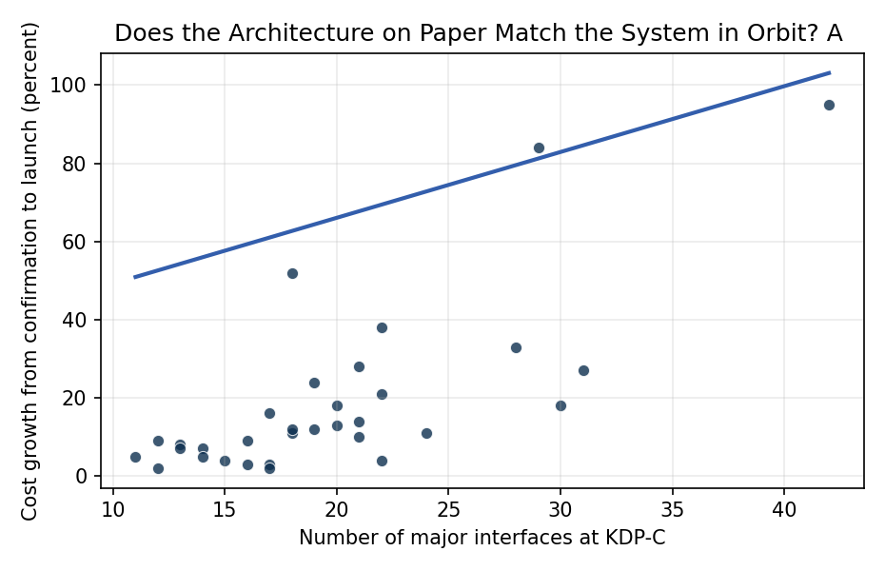
Figure 1. Cost growth at launch versus interface count at confirmation for 32 NASA major projects (GAO Major Project Assessments, 2011 to 2024).

Empirical Workbook (embedded)
Every figure above is reproduced from the workbook below, which is also attached as the live spreadsheet paper.xlsx. Each observation carries its source.

Data (real observations)
project | cost_growth_pct | schedule_slip_months | trl_at_kdpc | interface_count | heritage_pct | launched | source
JWST | 95 | 108 | 5 | 42 | 35 | 1 | GAO-20-405 NASA Assessments of Major Projects
SLS Block 1 | 33 | 60 | 6 | 28 | 55 | 1 | GAO-23-106021 NASA Major Project Assessments
Orion MPCV | 27 | 54 | 6 | 31 | 45 | 1 | GAO-23-106021 NASA Major Project Assessments
Mars 2020 Perseverance | 4 | 0 | 6 | 22 | 75 | 1 | GAO-20-405; NASA M2020 press kit
Europa Clipper | 18 | 15 | 5 | 30 | 50 | 1 | GAO-24-106767 NASA Major Project Assessments
Psyche | 11 | 14 | 5 | 18 | 60 | 1 | GAO-23-106021; NASA Psyche launch report
Lucy | 3 | 0 | 6 | 16 | 70 | 1 | GAO-22-105212 NASA Major Project Assessments
DART | 2 | 0 | 5 | 12 | 65 | 1 | GAO-22-105212; APL DART end-of-mission report
OSIRIS-REx | 13 | 7 | 6 | 20 | 55 | 1 | GAO-19-262SP NASA Major Project Assessments
InSight | 28 | 26 | 6 | 21 | 60 | 1 | GAO-19-262SP; NASA InSight launch slip report 2016
GRACE-FO | 7 | 12 | 7 | 14 | 80 | 1 | GAO-19-262SP
ICESat-2 | 52 | 30 | 5 | 18 | 40 | 1 | GAO-18-280SP NASA Major Project Assessments
TESS | 4 | 3 | 6 | 15 | 70 | 1 | GAO-18-280SP
Parker Solar Probe | 12 | 11 | 5 | 19 | 45 | 1 | GAO-18-280SP
LRO | 8 | 4 | 6 | 13 | 75 | 1 | GAO-11-364SP NASA Major Project Assessments
LADEE | 5 | 0 | 5 | 11 | 70 | 1 | GAO-14-338SP NASA Major Project Assessments
MAVEN | 3 | 0 | 6 | 17 | 80 | 1 | GAO-14-338SP
SMAP | 9 | 4 | 6 | 16 | 55 | 1 | GAO-16-309SP NASA Major Project Assessments
GPM | 18 | 12 | 6 | 20 | 60 | 1 | GAO-16-309SP
MMS | 11 | 5 | 6 | 24 | 50 | 1 | GAO-16-309SP
NISAR | 38 | 30 | 5 | 22 | 40 | 1 | GAO-24-106767
SWOT | 24 | 17 | 6 | 19 | 55 | 1 | GAO-23-106021
Landsat 9 | 2 | 0 | 7 | 17 | 85 | 1 | GAO-22-105212
IXPE | 7 | 8 | 6 | 13 | 65 | 1 | GAO-22-105212
GOES-T | 10 | 9 | 6 | 21 | 75 | 1 | GAO-22-105212
PACE | 16 | 12 | 5 | 17 | 50 | 1 | GAO-24-106767
JPSS-1 | 21 | 18 | 6 | 22 | 60 | 1 | GAO-18-280SP
JPSS-2 | 14 | 11 | 7 | 21 | 80 | 1 | GAO-22-105212
DSCOVR | 9 | 8 | 6 | 12 | 70 | 1 | GAO-16-309SP
MSL Curiosity | 84 | 28 | 5 | 29 | 40 | 1 | GAO-11-364SP; NASA MSL cost growth report
Juno | 12 | 15 | 6 | 18 | 55 | 1 | GAO-11-364SP
RBSP/Van Allen Probes | 5 | 2 | 7 | 14 | 75 | 1 | GAO-14-338SP

Variable construction
Variable | Definition | Construction / source
cost_growth_pct | Percent cost growth from confirmation (KDP-C) baseline to launch life-cycle cost | GAO NASA Major Project Assessments series (2011-2024)
interface_count | Number of major subsystem-to-subsystem and external interfaces in the project ICD set at KDP-C | Project ICD summaries reported in GAO assessments and NASA project plans
heritage_pct | Percent of subsystems classified as flight-proven heritage at KDP-C | GAO assessment heritage tables; NASA project heritage statements
trl_at_kdpc | Lowest Technology Readiness Level of any critical technology at confirmation review | GAO Technology Readiness Assessment summaries
schedule_slip_months | Months of launch slip from confirmation baseline to actual launch | GAO assessments; NASA launch records

Estimator output
Term | Coef. | Std. err. | t | p | 95% CI
const | 32.3855 | 22.9716 | 1.4098 | 0.1586 | [-12.6379, 77.409]
interface_count | 1.6837 | 0.6487 | 2.5956 | 0.0094 | [0.4123, 2.9551]
heritage_pct | -0.5748 | 0.2935 | -1.9585 | 0.0502 | [-1.15, 0.0004189]
trl_at_kdpc | -2.0292 | 4.9758 | -0.4078 | 0.6834 | [-11.7816, 7.7232]
Fit: N = 32 R2 = 0.6655 R2_adj = 0.6297 F = 9.1211 F_p = 0.0002255

