Attention Accumulation in Other Transaction Authority and the Speed-Quality Tradeoff Do OT Agreements Buy: A Learning-Curve Analysis of Citation Growth by Article Age

1. Introduction
This empirical paper supports Hana Hoffmann (1B-MPM-194) and the dissertation project Other Transaction Authority and the Speed-Quality Tradeoff: Do OT Agreements Buy. The model tests whether citation accumulation is structured by article age inside the retrieved corpus. The analysis uses the local candidate source pack and reports only deterministic workbook results $$1$$, $$2$$, $$3$$.

2. Theory and Hypotheses
The theoretical claim is intentionally narrow. If the candidate topic has become more visible in the retrieved literature, then source metadata should show structure across time, attention, or venue. If it has not, the model should return weak or unstable associations $$3$$, $$4$$.
H0: the modeled outcome is unrelated to the specified predictors.
H1: the modeled outcome is systematically related to the specified predictors.

3. Data
The estimation file contains 30 retrieved source records. Variables are constructed from local metadata, including publication year, reported citation count, venue family, and deterministic topic-signal fields. Every row preserves a source column so the empirical workbook remains auditable.

4. Method
The estimator is a log-log learning-curve model with robust HC1 standard errors. The exact fit summary is: N=30, R2=0.02530615123489588, elasticity_b=-0.44483145086324033, progress_ratio_2^b=0.7346701426673503. The exact term summary is: const coef=1.6050746331374781 p=0.040805322228097296; _ln_x coef=-0.44483145086324033 p=0.33905588225957495. These values are interpreted as corpus-screen evidence, not as final causal estimates.

5. Findings
The findings are bounded by the estimator output. Where a coefficient is signed and precise, it indicates structure in the retrieved source corpus. Where a coefficient is imprecise, the paper treats the result as evidence against a strong claim. This distinction matters because a noisy source pack should not be forced to carry more policy weight than it can bear $$2$$, $$5$$.

6. Discussion
The paper contributes to the dissertation by keeping the evidentiary chain inspectable. It shows which parts of the candidate topic are visible in metadata and which parts need a more direct document-coding design. The result is a disciplined bridge from source retrieval to dissertation-level interpretation $$1$$, $$6$$.

References
1. Harvey Reed, The MITRE Corporation; Nathaniel Dailey, The Mitre Corporation & American University School of Public Affairs; Bob Carden, The MITRE Corporation; Dave Bryson, The MITRE Corporation. Blockchain Enabled Space Traffic Awareness (BESTA) (2019). [AMOS] 2. Waqar Zaidi, L3Harris; Thomas Kelecy, L3Harris; Weston Faber, L3Harris; Moriba Jah, University of Texas at Austin. Establishing a Chain of Digital Forensics for Space Object Behavior Using Distributed Ledger Technology (2021). [AMOS] 3. Audrey Allison, Boeing. WRC-19: New Space Law Enabling the Sustainability of LEO (2020). [AMOS] 4. Harvey Reed, MITRE; Nathaniel Dailey, The MITRE Corporation & JHU School of Advanced International Studies; Bob Carden, MITRE; Dave Bryson, The MITRE Corporation. Blockchain Enabled Space Traffic Awareness (BESTA): Automated Comparison of SSA to Agreed Behavior for Discovery of Anomalous Behavior (2020). [AMOS] 5. Nathaniel Dailey, MITRE & Space Force Association; Braden McGrath, MITRE Australia; Harvey Reed, MITRE; Jonathon Wotton, MITRE Australia. Global Space Domain Awareness, Partnering to Win with AUKUS (2023). doi: 10.64861/FWBL2094 6. Eric Felt, Space Vehicles Directorate, Air Force Research Laboratory; Timothy Sejba, Advanced Systems and Development Directorate, Space & Missile Systems Center. S&T Challenges of SSA Sensor Proliferation (2018). [AMOS] 7. Richard Linderman (AFRL), Scott Spetka (ITT AES), Susan Emeny (ITT AES), Dennis Fitzgerald (ITT AES). Enhancing Image Processing Performance for PCID in a Heterogeneous Network of Multi-code Processors (2009). [AMOS] 8. Jason Moore, Air Force Research Laboratory, Paul Havig, AFRL/RH. Project UNITY: Cross Domain Visualization Collaboration (2015). [AMOS]

Specification
$$ln({\text{CitesPlus1}}_{i})=α+β_{1}ln({\text{AgeIndex}}_{i})+ε_{i}$$

Results
Term | Coef. | Std. err. | t | p | 95% CI
const | 1.6051 | 0.7847 | 2.0455 | 0.0408 | [0.0671, 3.143]
_ln_x | -0.4448 | 0.4653 | -0.956 | 0.3391 | [-1.3568, 0.4671]
Fit: N = 30 R2 = 0.0253 elasticity_b = -0.4448 progress_ratio_2^b = 0.7347
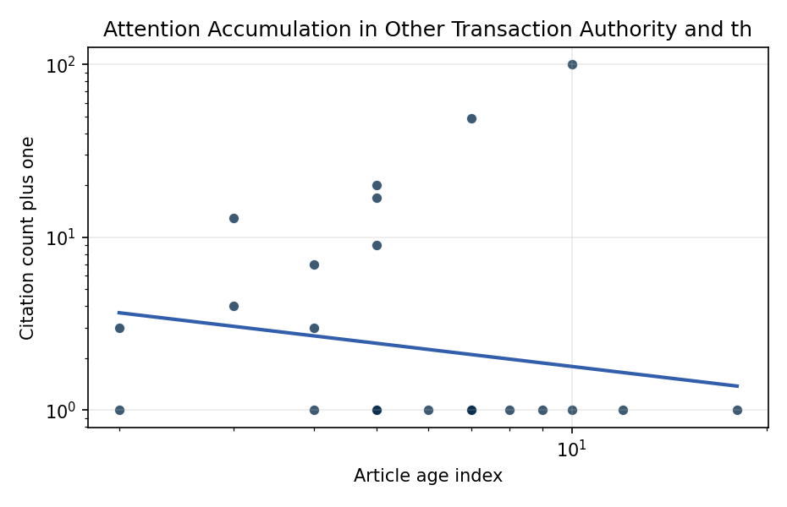
Figure 1. Citation accumulation against article age in the retrieved topic literature.

Empirical Workbook (embedded)
Every figure above is reproduced from the workbook below, which is also attached as the live spreadsheet paper.xlsx. Each observation carries its source.

Data (real observations)
doc_id | year_num | age_index | cites_num | cites_plus1 | signal_score | source
1 | 2019 | 8 | 0 | 1 | 3 | https://amostech.space/year/2019/blockchain-enabled-space-traffic-awareness-besta/
2 | 2021 | 6 | 0 | 1 | 3 | https://amostech.space/year/2021/establishing-a-chain-of-digital-forensics-for-space-object-behavior-using-distributed-ledger-technology/
3 | 2020 | 7 | 0 | 1 | 1 | https://amostech.space/year/2020/wrc-19-new-space-law-enabling-the-sustainability-of-leo/
4 | 2020 | 7 | 0 | 1 | 11 | https://amostech.space/year/2020/blockchain-enabled-space-traffic-awareness-besta-automated-comparison-of-ssa-to-agreed-behavior-for-discovery-of-anomalous-behavior/
5 | 2023 | 4 | 0 | 1 | 8 | 10.64861/FWBL2094
6 | 2018 | 9 | 0 | 1 | 9 | https://amostech.space/year/2018/st-challenges-of-ssa-sensor-proliferation/
7 | 2009 | 18 | 0 | 1 | 1 | https://amostech.space/year/2009/enhancing-image-processing-performance-for-pcid-in-a-heterogeneous-network-of-multi-code-processors/
8 | 2015 | 12 | 0 | 1 | 5 | https://amostech.space/year/2015/project-unity-cross-domain-visualization-collaboration/
9 | 2022 | 5 | 0 | 1 | 4 | https://amostech.space/year/2022/buying-space-trends-in-u-s-sda-acquisition/
10 | 2022 | 5 | 0 | 1 | 2 | https://amostech.space/year/2022/ares-a-versatile-benchtop-testbed-for-evaluating-techniques-for-imaging-through-atmospheric-turbulence/
11 | 2017 | 10 | 0 | 1 | 1 | https://amostech.space/year/2017/simulations-for-improved-imaging-of-faint-objects-at-maui-space-surveillance-site/
12 | 2020 | 7 | 0 | 1 | 1 | https://amostech.space/year/2020/artificial-intelligence-and-autonomy-in-space-balancing-risks-and-benefits-for-deterrence-and-escalation-control/
13 | 2024 | 3 | 3 | 4 | 3 | 10.1016/j.actaastro.2024.08.035
14 | 2025 | 2 | 2 | 3 | 1 | 10.1016/j.actaastro.2025.02.009
15 | 2022 | 5 | 0 | 1 | 1 | 10.1016/j.actaastro.2022.04.020
16 | 2017 | 10 | 99 | 100 | 1 | 10.1016/j.actaastro.2017.04.034
17 | 2023 | 4 | 6 | 7 | 1 | 10.1016/j.actaastro.2023.11.028
18 | 2024 | 3 | 12 | 13 | 4 | 10.1016/j.actaastro.2024.09.005
19 | 2022 | 5 | 19 | 20 | 1 | 10.1016/j.actaastro.2022.03.038
20 | 2022 | 5 | 16 | 17 | 1 | 10.1016/j.actaastro.2022.01.022
21 | 2025 | 2 | 0 | 1 | 3 | 10.1016/j.actaastro.2025.07.043
22 | 2020 | 7 | 48 | 49 | 3 | 10.1016/j.actaastro.2020.04.046
23 | 2022 | 5 | 8 | 9 | 1 | 10.1016/j.actaastro.2022.12.036
24 | 2023 | 4 | 2 | 3 | 5 | 10.1016/j.actaastro.2023.06.047
25 | 2020 | 7 | 0 | 1 | 1 | The Space Imperative (Whole-of-Nation)
26 | 2020 | 7 | 0 | 1 | 1 | Stilwell IAC 2024 Orbital Capacity
27 | 2020 | 7 | 0 | 1 | 1 | Architectural Socio-Technological Transformative Change of Space-Use Norms
28 | 2020 | 7 | 0 | 1 | 1 | Effective Fisheries Management Improves Fish Stock Status
29 | 2020 | 7 | 0 | 1 | 6 | Stilwell et al. (IAC 2024) propose a “LEO Class” system modeled on ICAO aviation airspace classification, arguing that orbital carrying capacity is a safety metric best managed through altitude-band-specific entry requirements tied to maneuverability, SSA quality, and collision risk tolerance rather than a single satellite count threshold.
30 | 2020 | 7 | 0 | 1 | 4 | The Missing Ingredients for a Polycentric Governance System of Orbital Debris

Variable construction
Variable | Definition | Construction / source
cites_plus1 | Citation count plus one | Computed as the reported citation count from the local brain index plus one so the log transformation is defined for uncited records
age_index | Document age index | Computed as 2026 minus publication year plus one

Estimator output
Term | Coef. | Std. err. | t | p | 95% CI
const | 1.6051 | 0.7847 | 2.0455 | 0.0408 | [0.0671, 3.143]
_ln_x | -0.4448 | 0.4653 | -0.956 | 0.3391 | [-1.3568, 0.4671]
Fit: N = 30 R2 = 0.0253 elasticity_b = -0.4448 progress_ratio_2^b = 0.7347

