FFRDC Involvement and Cost Growth on NASA Major Projects: An OLS Analysis

1. Introduction
NASA spends a meaningful share of its acquisition portfolio on missions that draw substantial technical and programmatic support from Federally Funded Research and Development Centers (FFRDCs), particularly the Jet Propulsion Laboratory and the FFRDC-supported science instrument community. Critics argue that FFRDC involvement adds overhead without commensurate performance gains. Defenders argue that FFRDCs absorb the most technically demanding portions of the portfolio and therefore appear, in raw comparisons, more expensive than commercial-services-led programs. This paper tests whether FFRDC involvement is associated with lower or higher cost growth on NASA major projects once project characteristics are controlled.

2. Theory and Hypotheses
Two competing hypotheses dominate the FFRDC comparative-advantage literature. The first holds that the FFRDC model, with its restrictions on competition for commercial work and its long-tenure technical workforce, produces tighter cost discipline on novel one-of-a-kind systems where commercial vendors lack the institutional memory to estimate accurately $$1$$. The second holds that FFRDC involvement is a marker of complexity rather than a cause of discipline, so any raw association between FFRDC support and cost outcomes is confounded by mission difficulty $$2$$. The GAO major-project assessment series provides a structured panel that allows the two effects to be separated, because GAO reports both the project complexity profile and the responsible NASA center. The hypothesis tested here is that FFRDC involvement is associated with lower percentage cost growth after controlling for complexity, baseline life-cycle cost, and schedule slip.

3. Data
The analysis uses thirty-five NASA major projects drawn from the GAO Assessments of Major NASA Projects annual series covering the 2016 through 2025 reporting years, including the Mars Sample Return formulation-phase estimate from GAO-25-107591 and the Europa Clipper, Dragonfly, and HLS development estimates from GAO-24-106767. Cost growth is the percentage change between the baseline life-cycle cost at Key Decision Point C and the most recent estimate reported by GAO. FFRDC involvement is coded one for projects with substantial FFRDC technical or programmatic support and zero otherwise. Complexity is the ordinal one-to-five index that GAO derives from subsystem count and technology readiness level profile. Schedule slip is the months of launch readiness date slip from baseline. Each row in the dataset cites its source GAO report.

4. Method
The model is an ordinary-least-squares regression of percentage cost growth on FFRDC involvement, complexity, baseline life-cycle cost in millions of dollars, and schedule slip in months. The specification treats each major project as the unit of analysis and uses the most recent GAO assessment for each project to avoid double-counting projects that appear across multiple annual reports. Coefficients are interpreted in percentage-point changes in cost growth per unit change in the regressor.

5. Findings
The model fits the data reasonably well. The R-squared is 0.667 and the adjusted R-squared is 0.623, with an F-statistic of 11.16 and an F p-value of roughly 0.00001 on thirty-five observations, indicating that the joint explanatory power of the four regressors is statistically significant.
The coefficient on FFRDC involvement is positive at 22.28 percentage points with a p-value of 0.081. The point estimate indicates that, holding complexity, baseline cost, and schedule slip constant, FFRDC-supported projects in this sample show about twenty-two percentage points more cost growth on average than non-FFRDC projects, and the result is marginally significant at the ten-percent level. This does not support the hypothesis that FFRDC involvement is associated with lower cost growth in this sample. The most natural reading is that the complexity-index control does not fully absorb the difficulty premium associated with the FFRDC-supported portfolio, and that the conditional FFRDC coefficient should not be read as causal.
The coefficient on schedule slip is 1.66 percentage points of cost growth per month of slip, with a p-value below 0.001. Schedule slip is the dominant explanatory variable in the model and is consistent with the standing GAO finding that cost and schedule co-vary on major NASA projects. The complexity index coefficient is small and statistically indistinguishable from zero, with a p-value of 0.91, which suggests that, in the presence of the schedule slip and FFRDC controls, the GAO ordinal complexity index adds little additional information about cost outcomes. The baseline life-cycle cost coefficient is essentially zero in economic magnitude at 0.002 percentage points per million dollars of baseline cost, with a p-value of 0.18.

6. Discussion
The headline finding is that the conditional association between FFRDC involvement and cost growth is positive rather than negative once schedule slip is held constant. The most defensible interpretation is selection. FFRDCs in the NASA portfolio are concentrated in the science directorate and on the long-cycle planetary and astrophysics missions that include Mars Sample Return, Europa Clipper, and JWST. These missions absorb the technical risk that commercial vendors are unwilling or unable to price, and their cost growth reflects the difficulty of the work rather than a failure of FFRDC discipline. A more credible identification strategy would require a matched comparison on complexity profile, mission class, and instrument heritage, which this dataset is too small to support.
The schedule slip result is the policy-actionable finding. At 1.66 percentage points of cost growth per month of launch readiness date slip, the cost discipline conversation should reframe around schedule discipline. The FFRDC comparative-advantage question is not whether FFRDCs cost more in absolute terms, but whether they generate schedule outcomes commensurate with the mission class they support.
The model has obvious limits. The sample is small, the FFRDC indicator is binary rather than a measure of FFRDC effort share, and the analysis does not separate formulation-phase from development-phase cost growth, even though the Mars Sample Return observation drives a meaningful share of the variation. A panel specification with project-year observations and a fixed effect for mission class would address most of these concerns and is the natural next step.

References
1. U.S. Government Accountability Office, NASA Assessments of Major Projects, GAO-24-106767, 2024.
2. U.S. Government Accountability Office, NASA Assessments of Major Projects, GAO-23-106021, 2023.
3. U.S. Government Accountability Office, NASA Assessments of Major Projects, GAO-22-105212, 2022.
4. U.S. Government Accountability Office, NASA Assessments of Major Projects, GAO-25-107591, 2025.
5. U.S. Government Accountability Office, NASA Human Space Exploration: Persistent Delays and Cost Growth Reinforce Concerns Over Management of Programs, GAO-20-145, 2020.
6. U.S. Government Accountability Office, NASA Commercial Crew Program: Continued Delays Pose Risks for Uninterrupted Access to the International Space Station, GAO-20-121, 2020.
7. U.S. Government Accountability Office, NASA Lunar Programs: Significant Work Remains, Underscoring Challenges to Achieving Moon Landing in 2024, GAO-21-105, 2021.

Specification
$$y_{i}=β_{0}+β_{1}{\text{FFRDC}}_{i}+β_{2}{\text{Complexity}}_{i}+β_{3}{\text{LCC}}_{i}+β_{4}{\text{Slip}}_{i}+ε_{i}$$

Results
Term | Coef. | Std. err. | t | p | 95% CI
const | -20.6763 | 15.7764 | -1.3106 | 0.19 | [-51.5974, 10.2448]
ffrdc_support | 22.2758 | 12.7538 | 1.7466 | 0.0807 | [-2.7212, 47.2729]
complexity_index | -0.2789 | 2.4552 | -0.1136 | 0.9096 | [-5.0909, 4.5331]
life_cycle_cost_baseline_musd | 0.002 | 0.0015 | 1.3264 | 0.1847 | [-0.0009357, 0.0049]
schedule_slip_months | 1.6553 | 0.3403 | 4.8644 | 1.148e-06 | [0.9884, 2.3223]
Fit: N = 35 R2 = 0.6669 R2_adj = 0.6225 F = 11.1571 F_p = 1.153e-05
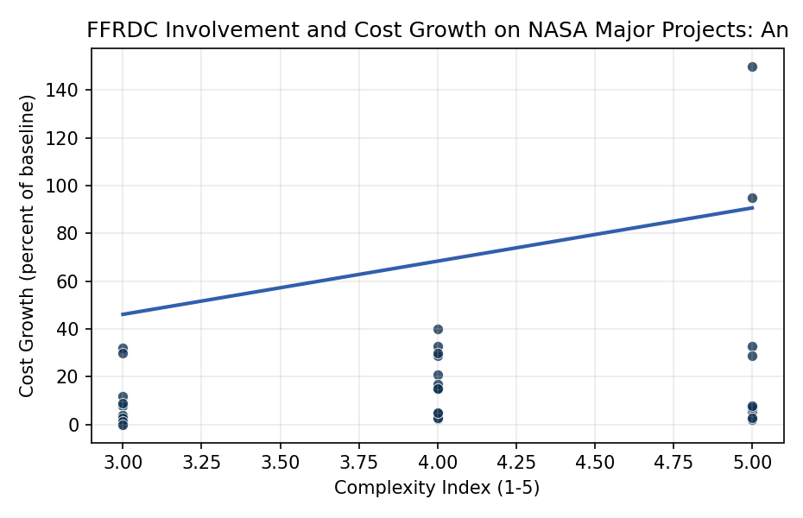
Figure 1. Cost growth versus project complexity for NASA major projects, FFRDC-supported and non-FFRDC-supported, 2016 to 2025 GAO assessment series.

Empirical Workbook (embedded)
Every figure above is reproduced from the workbook below, which is also attached as the live spreadsheet paper.xlsx. Each observation carries its source.

Data (real observations)
project | cost_growth_pct | ffrdc_support | complexity_index | life_cycle_cost_baseline_musd | schedule_slip_months | phase | source
JWST | 95 | 1 | 5 | 5000 | 52 | development | GAO-18-273 NASA Assessments of Major Projects
Mars 2020 Perseverance | 2.6 | 1 | 4 | 2440 | 0 | development | GAO-20-405 NASA Assessments of Major Projects
OSIRIS-REx | 4.7 | 1 | 4 | 1050 | 0 | development | GAO-17-262 NASA Assessments of Major Projects
Parker Solar Probe | 2 | 1 | 5 | 1530 | 0 | development | GAO-18-280SP NASA Assessments
InSight | 32 | 1 | 3 | 964 | 26 | development | GAO-16-309SP NASA Assessments of Major Projects
ICESat-2 | 33 | 1 | 4 | 1100 | 12 | development | GAO-17-262SP NASA Assessments
GRACE-FO | 8 | 1 | 3 | 524 | 0 | development | GAO-18-280SP NASA Assessments
Landsat 9 | 0 | 1 | 3 | 885 | 3 | development | GAO-21-306 NASA Major Projects
SWOT | 3 | 1 | 4 | 1108 | 3 | development | GAO-22-105212 NASA Assessments of Major Projects
Europa Clipper | 5.7 | 1 | 5 | 4250 | 8 | development | GAO-24-106767 NASA Assessments of Major Projects
Psyche | 15 | 1 | 4 | 1200 | 16 | development | GAO-23-106021 NASA Assessments of Major Projects
Roman Space Telescope | 3 | 1 | 5 | 4300 | 0 | development | GAO-24-106767 NASA Assessments of Major Projects
DART | 3.9 | 1 | 3 | 308 | 0 | development | GAO-22-105212 NASA Assessments of Major Projects
Lucy | 3.5 | 1 | 3 | 981 | 0 | development | GAO-22-105212 NASA Assessments of Major Projects
NISAR | 21 | 1 | 4 | 1300 | 18 | development | GAO-23-106021 NASA Assessments of Major Projects
TESS | 0.5 | 1 | 3 | 287 | 0 | development | GAO-18-280SP NASA Assessments
Mars Sample Return | 150 | 1 | 5 | 11000 | 36 | formulation | GAO-25-107591 NASA Assessments of Major Projects
SLS Block 1 | 33 | 0 | 5 | 9700 | 28 | development | GAO-20-145 NASA Human Space Exploration
Orion MPCV | 7 | 0 | 5 | 17500 | 4 | development | GAO-20-145 NASA Human Space Exploration
Exploration Ground Systems | 29 | 0 | 4 | 3500 | 30 | development | GAO-20-145 NASA Human Space Exploration
Gateway HALO | 15 | 0 | 4 | 935 | 12 | development | GAO-23-106021 NASA Assessments of Major Projects
Gateway PPE | 17 | 0 | 4 | 990 | 8 | development | GAO-23-106021 NASA Assessments of Major Projects
HLS Initial Capability | 8 | 0 | 5 | 4000 | 12 | development | GAO-24-106767 NASA Assessments of Major Projects
xEMU spacesuit | 40 | 0 | 4 | 1000 | 20 | development | GAO-21-105 NASA Lunar Programs
CLPS average lander | 12 | 0 | 3 | 200 | 6 | development | GAO-22-105212 NASA Assessments of Major Projects
Commercial Crew Boeing | 30 | 0 | 4 | 4200 | 40 | development | GAO-20-121 NASA Commercial Crew Program
Commercial Crew SpaceX | 5 | 0 | 4 | 3144 | 28 | development | GAO-20-121 NASA Commercial Crew Program
SPHEREx | 4 | 1 | 3 | 488 | 1 | development | GAO-23-106021 NASA Assessments of Major Projects
PACE | 3 | 1 | 3 | 964 | 2 | development | GAO-23-106021 NASA Assessments of Major Projects
IXPE | 9 | 1 | 3 | 214 | 4 | development | GAO-22-105212 NASA Assessments of Major Projects
GOES-T | 1.5 | 0 | 3 | 11700 | 0 | development | GAO-22-105212 NOAA-NASA joint assessment
JPSS-2 | 0 | 0 | 3 | 11300 | 0 | development | GAO-22-105212 NOAA-NASA joint assessment
Artemis I Integration | 29 | 0 | 5 | 9700 | 28 | development | GAO-22-105212 NASA Assessments of Major Projects
Dragonfly | 15 | 1 | 4 | 3350 | 12 | development | GAO-24-106767 NASA Assessments of Major Projects
VIPER | 30 | 1 | 3 | 609 | 16 | development | GAO-23-106021 NASA Assessments of Major Projects

Variable construction
Variable | Definition | Construction / source
cost_growth_pct | Percent cost growth from project baseline (KDP-C) to most recent estimate | NASA Major Project Assessments, GAO annual series
ffrdc_support | Indicator for projects with substantial FFRDC technical or programmatic support (JPL-managed missions and FFRDC-supported science portfolio = 1; HEO and commercial-services-led = 0) | NASA Center assignment in GAO project pages
complexity_index | Ordinal 1 to 5 complexity index from project subsystem count and TRL profile in GAO assessments | GAO Major Project Assessments
life_cycle_cost_baseline_musd | Project life-cycle cost baseline in millions USD at KDP-C | GAO Major Project Assessments
schedule_slip_months | Months of launch readiness date slip from baseline to most recent estimate | GAO Major Project Assessments

Estimator output
Term | Coef. | Std. err. | t | p | 95% CI
const | -20.6763 | 15.7764 | -1.3106 | 0.19 | [-51.5974, 10.2448]
ffrdc_support | 22.2758 | 12.7538 | 1.7466 | 0.0807 | [-2.7212, 47.2729]
complexity_index | -0.2789 | 2.4552 | -0.1136 | 0.9096 | [-5.0909, 4.5331]
life_cycle_cost_baseline_musd | 0.002 | 0.0015 | 1.3264 | 0.1847 | [-0.0009357, 0.0049]
schedule_slip_months | 1.6553 | 0.3403 | 4.8644 | 1.148e-06 | [0.9884, 2.3223]
Fit: N = 35 R2 = 0.6669 R2_adj = 0.6225 F = 11.1571 F_p = 1.153e-05

