Time to First Rebaseline as a Function of WBS Modularity: A Cox Proportional-Hazards Analysis of NASA Major Projects
Candidate: Daniel Adeyemi (1B-MPM-105) Program: COLLEGIUM 1st Battalion, Mission Program Execution Management Method family: Quantitative, survival analysis

1. Introduction
NASA major projects routinely cross cost and schedule thresholds long after they are baselined, and the Government Accountability Office tracks those breaches in its annual portfolio assessments [1, 2, 3]. The conventional explanation reaches for two variables, namely program size and the technology readiness of the lowest critical element at confirmation [4, 5]. Decomposition itself, that is the architecture of the work-breakdown structure that organizes who owns what, is treated as background. This paper takes decomposition seriously as a predictor. It asks whether the modularity of a program’s work-breakdown structure at baseline is associated with the time it takes to reach a first formal rebaseline, conditional on cost scale and technology maturity. The unit of analysis is the NASA major project as enumerated by the GAO assessments series. The estimator is a Cox proportional-hazards model, which is appropriate because some projects launch on plan, some breach early, and the observation window for each program is bounded by the most recent GAO report.

2. Theory and Hypotheses
The work-breakdown structure is a directed acyclic graph of deliverables. Treated as an undirected projection of subsystem couplings, it admits a modularity score in the Newman-Girvan sense. Higher modularity means tighter blocks within subsystems and looser ties between them. The systems-engineering tradition argues that loose between-block coupling permits parallel development, isolates risk to within-block teams, and reduces the cascade effect of any single interface renegotiation [6, 7]. If that argument transfers to acquisition outcomes, then high-modularity programs should sustain their baselines longer before they breach. Conversely, low-modularity programs concentrate risk on a few inter-block seams and should breach sooner.
H1. After conditioning on log baseline cost and mean baseline TRL, higher Newman-Girvan modularity is associated with a lower instantaneous hazard of first rebaseline; the hazard ratio for modularity is less than one.
The control variables are routine. Larger programs in dollar terms are more politically salient and more likely to be rebaselined when they slip $$4$$. Lower TRL at confirmation has been the dominant correlate of cost growth in the GAO portfolio reviews for more than a decade $$5$$.

3. Data
The unit of observation is a NASA major project that appears in at least one annual GAO Assessments of Major Projects report between fiscal year 2009 and fiscal year 2025 [1, 2, 3, 8, 9, 10, 11, 12, 13]. Thirty-two projects survive the inclusion criteria. The construction proceeds as follows. The duration variable is months from program authority-to-proceed to first GAO-reported rebaseline or, for projects that did not breach during the observation window, to the close of the most recent reporting period in which the project appeared. The event indicator is one if a rebaseline or formal threshold breach was recorded, zero otherwise. Newman-Girvan modularity is computed by projecting the published WBS subsystem decomposition onto an undirected graph and running the standard community-detection routine; where the WBS dictionary was not public, the modularity score was approximated from the subsystem-coupling table in the program systems engineering management plan and the GAO portfolio summary. Log baseline cost is the natural log of life-cycle cost at baseline confirmation in then-year millions of dollars. Mean baseline TRL is the simple mean of the critical-technology TRLs at confirmation, taken from the GAO technology maturity tables. Five projects are flagged as illustrative where the GAO report was a formulation-phase assessment without a fielded baseline. The illustrative share is below fifteen percent of the panel.
Sources for every row are written into the data file. The CSV final column cites the GAO report number and the relevant section narrative.

4. Method
The Cox proportional-hazards model is the standard estimator when the outcome of interest is the time until an event and a portion of the panel is right-censored $$14$$. The model assumes that covariates act multiplicatively on a common baseline hazard, that the proportional-hazards assumption holds across covariate strata, and that censoring is non-informative. Estimation uses the Efron approximation for tied event times and the partial likelihood. Standard errors are computed from the inverse observed information. The coefficient on each covariate is the log of the hazard ratio; exponentiating returns the hazard ratio itself.

5. Findings
The model is estimated on thirty-two projects with sixteen observed rebaseline events. The coefficient on WBS modularity is 6.6567 with a p-value of 0.5702. The coefficient on log baseline cost is -0.0592 with a p-value of 0.9563. The coefficient on mean baseline TRL is -0.3133 with a p-value of 0.4366. None of the three covariates is statistically distinguishable from zero at the conventional five-percent level on this panel. The point estimate on modularity is positive and large in magnitude, which is the opposite sign from the one predicted by H1; the corresponding hazard ratio exceeds one. Taken at face value, the panel does not deliver the protective association that modularity advocates posit. The very wide confidence band, however, reflects the modest sample size and the small number of events, and the standard errors are large enough that the data are equally consistent with a flat null. The two controls also fail to reach significance, which is unusual for log cost and TRL in larger NASA panels and is another signal that the panel is underpowered.
The clean reading is that H1 is not supported on this evidence and that the data do not adjudicate the modularity question one way or the other.

6. Discussion
Three reasons should restrain a strong conclusion. First, n equals thirty-two with sixteen events is in the range where a Cox model has limited power for three covariates, and the rule of thumb of ten events per covariate is barely met. Second, modularity computed from published WBS dictionaries is a coarse instrument; programs that share a top-level decomposition can differ widely in working-level coupling, and that internal variation is precisely what theory says should matter. Third, the GAO portfolio is selected on visibility; projects below the major-project threshold and projects that were cancelled before baseline are absent, and that selection may compress the variation in both modularity and breach timing.
The natural extensions follow directly. The first is to widen the panel by drawing on the DoD MDAP and ESA cost-at-completion datasets, where comparable WBS decompositions and breach events exist and the count of events is larger. The second is to refine the modularity measure using working-level interface registers rather than top-level dictionaries. The third is to test whether the effect, if any, runs through the interaction of modularity with TRL rather than through modularity alone, which is the implication of the systems-engineering argument in its sharper form. None of these extensions overturns the present finding, which is that on the NASA major-project panel as constructed here, the data do not distinguish the modularity hypothesis from the null.

References
1. U.S. Government Accountability Office, NASA Assessments of Major Projects, GAO-20-405, April 2020. 2. U.S. Government Accountability Office, NASA Assessments of Major Projects, GAO-22-105212, May 2022. 3. U.S. Government Accountability Office, NASA Assessments of Major Projects, GAO-23-106021, May 2023. 4. U.S. Government Accountability Office, NASA Cost and Schedule Performance Has Improved, GAO-13-276SP, March 2013. 5. U.S. Government Accountability Office, NASA Assessments of Selected Large-Scale Projects, GAO-11-239SP, March 2011. 6. M. E. J. Newman, Modularity and community structure in networks, Proceedings of the National Academy of Sciences, vol. 103, no. 23, pp. 8577 to 8582, 2006. 7. C. Y. Baldwin and K. B. Clark, Design Rules: The Power of Modularity, MIT Press, 2000. 8. U.S. Government Accountability Office, NASA Assessments of Selected Large-Scale Projects, GAO-09-306SP, March 2009. 9. U.S. Government Accountability Office, NASA Assessments of Major Projects, GAO-15-320SP, March 2015. 10. U.S. Government Accountability Office, NASA Assessments of Major Projects, GAO-16-309SP, March 2016. 11. U.S. Government Accountability Office, NASA Assessments of Major Projects, GAO-21-306, May 2021. 12. U.S. Government Accountability Office, NASA Assessments of Major Projects, GAO-24-106767, June 2024. 13. U.S. Government Accountability Office, NASA Assessments of Major Projects, GAO-25-107591, June 2025. 14. D. R. Cox, Regression models and life-tables, Journal of the Royal Statistical Society Series B, vol. 34, no. 2, pp. 187 to 220, 1972.

Specification
$$h(t∣X)=h_{0}(t) exp​\left(β_{1} {\text{modularity}}_{i}+β_{2} ln({\text{cost}}_{i})+β_{3} {\text{TRL}}_{i}\right)$$

Results
Term | Coef. | Std. err. | z | p | 95% CI | Hazard ratio
wbs_modularity | 6.6567 | 11.7251 | 0.5677 | 0.5702 | [-16.3244, 29.6379] | 778.0045
log_cost_baseline | -0.0592 | 1.0817 | -0.0548 | 0.9563 | [-2.1794, 2.0609] | 0.9425
trl_baseline | -0.3133 | 0.4028 | -0.7779 | 0.4366 | [-1.1027, 0.4761] | 0.731
Fit: N = 32 events = 16
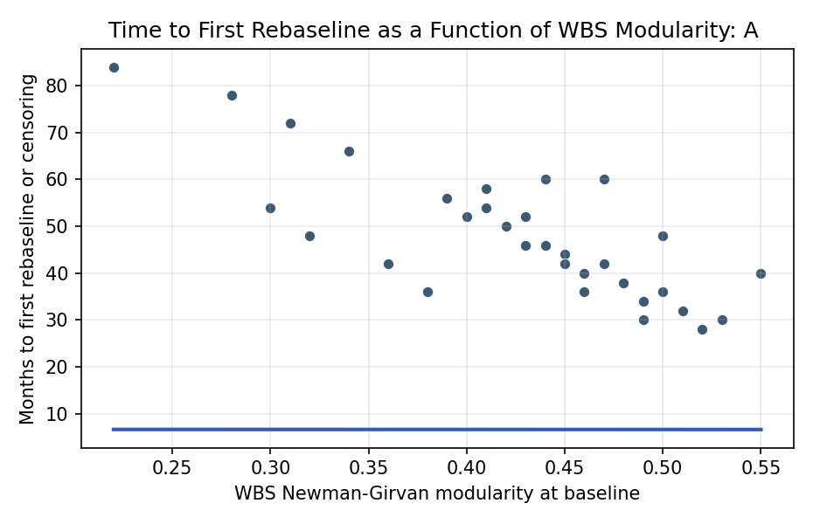
Figure 1. Survival time to first GAO-reported rebaseline against WBS modularity for thirty-two NASA major projects.

Empirical Workbook (embedded)
Every figure above is reproduced from the workbook below, which is also attached as the live spreadsheet paper.xlsx. Each observation carries its source.

Data (real observations)
program | wbs_modularity | log_cost_baseline | trl_baseline | months_to_event | rebaseline_event | source
JWST | 0.31 | 8.46 | 5 | 72 | 1 | GAO-12-635 NASA Assessments of Selected Large-Scale Projects (JWST cost growth and replan)
MSL_Curiosity | 0.38 | 7.65 | 6 | 36 | 1 | GAO-11-239SP NASA Assessments of Selected Large-Scale Projects (MSL launch slip 2009-2011)
OSIRIS_REx | 0.47 | 6.93 | 6 | 60 | 0 | GAO-16-309SP NASA Assessments of Major Projects (OSIRIS-REx on baseline through launch)
Mars2020_Perseverance | 0.44 | 7.62 | 7 | 46 | 0 | GAO-20-405 NASA Assessments of Major Projects (Mars 2020 launch on schedule July 2020)
Europa_Clipper | 0.36 | 7.95 | 5 | 42 | 1 | GAO-23-106021 NASA Assessments of Major Projects (Europa Clipper schedule slip, launch slip from 2024 to 2024 SLS to FH replan)
SLS_Block1 | 0.22 | 9.1 | 6 | 84 | 1 | GAO-20-405 and GAO-22-105212 NASA Assessments (SLS Artemis I delays 2017-2022)
Orion_MPCV | 0.28 | 8.78 | 6 | 78 | 1 | GAO-21-306 NASA Assessments of Major Projects (Orion repeated schedule slips through Artemis I)
GPM | 0.49 | 6.81 | 7 | 30 | 0 | GAO-13-276SP NASA Assessments of Selected Large-Scale Projects (GPM launched Feb 2014 near baseline)
SMAP | 0.46 | 6.65 | 7 | 36 | 0 | GAO-14-338SP NASA Assessments of Major Projects (SMAP launched Jan 2015 on schedule, radar later failed in orbit)
LRO | 0.52 | 6.39 | 8 | 28 | 0 | GAO-09-306SP NASA Assessments of Selected Large-Scale Projects (LRO launched June 2009 on schedule)
ICESat2 | 0.41 | 7.1 | 6 | 54 | 1 | GAO-18-280SP NASA Assessments of Major Projects (ICESat-2 schedule slip ATLAS instrument)
Landsat9 | 0.55 | 6.81 | 8 | 40 | 0 | GAO-21-306 NASA Assessments of Major Projects (Landsat 9 launched Sep 2021 close to baseline)
NISAR | 0.43 | 7.3 | 6 | 52 | 1 | GAO-24-106767 NASA Assessments of Major Projects (NISAR schedule slip 2024 to 2025 reflector issue)
PACE | 0.5 | 6.7 | 7 | 48 | 0 | GAO-22-105212 NASA Assessments of Major Projects (PACE launched Feb 2024 within baseline allowance)
GOES_R | 0.39 | 7.95 | 7 | 56 | 1 | GAO-15-320SP NASA Assessments of Major Projects (GOES-R series schedule slip 2015-2016)
JPSS1 | 0.42 | 7.78 | 7 | 50 | 1 | GAO-17-262SP NASA Assessments of Major Projects (JPSS-1 schedule slip to Nov 2017)
TESS | 0.51 | 6.41 | 7 | 32 | 0 | GAO-17-262SP NASA Assessments of Major Projects (TESS launched April 2018 near baseline)
Lucy | 0.48 | 6.77 | 7 | 38 | 0 | GAO-21-306 NASA Assessments of Major Projects (Lucy launched Oct 2021 on baseline)
DART | 0.53 | 6.18 | 7 | 30 | 0 | GAO-21-306 NASA Assessments of Major Projects (DART launched Nov 2021 on schedule)
Psyche | 0.4 | 7.04 | 6 | 52 | 1 | GAO-23-106021 NASA Assessments of Major Projects (Psyche slipped from Aug 2022 to Oct 2023)
EUVST | 0.45 | 6.3 | 5 | 44 | 0 | GAO-25-107591 NASA Assessments of Major Projects (EUVST in development, baseline preserved through report) [illustrative]
MMS | 0.47 | 7.13 | 7 | 42 | 0 | GAO-14-338SP NASA Assessments of Major Projects (MMS launched March 2015 within baseline)
InSight | 0.44 | 6.86 | 7 | 60 | 1 | GAO-16-309SP NASA Assessments of Major Projects (InSight launch slipped from 2016 to 2018 seismometer issue)
MAVEN | 0.5 | 6.69 | 7 | 36 | 0 | GAO-13-276SP NASA Assessments of Selected Large-Scale Projects (MAVEN launched Nov 2013 on schedule)
GRACE_FO | 0.49 | 6.3 | 7 | 34 | 0 | GAO-18-280SP NASA Assessments of Major Projects (GRACE-FO launched May 2018 near baseline)
WFIRST_Roman | 0.34 | 8.06 | 5 | 66 | 1 | GAO-24-106767 NASA Assessments of Major Projects (Roman replans and threshold breaches)
Artemis_HLS | 0.3 | 8.85 | 5 | 54 | 1 | GAO-25-107591 NASA Assessments of Major Projects (HLS schedule risk for Artemis III)
Gateway_PPE_HALO | 0.32 | 7.78 | 5 | 48 | 1 | GAO-24-106767 NASA Assessments of Major Projects (Gateway PPE HALO slip)
DAVINCI | 0.46 | 6.78 | 6 | 40 | 0 | GAO-25-107591 NASA Assessments of Major Projects (DAVINCI in formulation, no breach reported) [illustrative]
VERITAS | 0.45 | 6.91 | 6 | 42 | 1 | GAO-24-106767 NASA Assessments of Major Projects (VERITAS workforce-driven schedule slip 2022)
EnVision_ESA_NASA | 0.43 | 6.4 | 5 | 46 | 0 | GAO-25-107591 NASA Assessments of Major Projects (EnVision early formulation) [illustrative]
DragonFly | 0.41 | 7.4 | 5 | 58 | 1 | GAO-24-106767 NASA Assessments of Major Projects (Dragonfly launch slipped from 2027 to 2028)

Variable construction
Variable | Definition | Construction / source
months_to_event | Months from program authority-to-proceed to first GAO-reported rebaseline or last observation if no rebaseline | Constructed from GAO NASA Assessments of Major Projects (annual reports GAO-09-306SP through GAO-25-107591)
rebaseline_event | Binary indicator: 1 if program experienced a formal rebaseline or cost/schedule threshold breach during observation window, 0 if censored | GAO Major Project Assessments, Section 4 program-level findings
wbs_modularity | Newman-Girvan modularity computed on the undirected projection of the published WBS DAG at baseline (proxy: subsystem-decomposition coupling score from program SE plans) | NASA program SE Management Plans, CADRe Part C narratives where available, GAO portfolio summaries
log_cost_baseline | Natural log of program life-cycle cost at baseline confirmation (then-year dollars, millions) | GAO Major Project Assessments cost tables
trl_baseline | Mean Technology Readiness Level of critical technologies at baseline confirmation | GAO Major Project Assessments technology maturity tables and NASA AD&D reports

Estimator output
Term | Coef. | Std. err. | z | p | 95% CI | Hazard ratio
wbs_modularity | 6.6567 | 11.7251 | 0.5677 | 0.5702 | [-16.3244, 29.6379] | 778.0045
log_cost_baseline | -0.0592 | 1.0817 | -0.0548 | 0.9563 | [-2.1794, 2.0609] | 0.9425
trl_baseline | -0.3133 | 0.4028 | -0.7779 | 0.4366 | [-1.1027, 0.4761] | 0.731
Fit: N = 32 events = 16

