Signal Intensity in Bargaining Over a Shared Shell A Schelling-Game Model of Coordination Failure i: An Ordinary Least Squares Test of Recency, Citation Attention, and Venue

1. Introduction
This empirical paper supports Hassan Sundberg (1B-SDA-176) and the dissertation project Bargaining Over a Shared Shell: A Schelling-Game Model of Coordination Failure i. The model tests whether topic-signal intensity varies with publication recency, citation attention, and venue family. The analysis uses the local candidate source pack and reports only deterministic workbook results $$1$$, $$2$$, $$3$$.

2. Theory and Hypotheses
The theoretical claim is intentionally narrow. If the candidate topic has become more visible in the retrieved literature, then source metadata should show structure across time, attention, or venue. If it has not, the model should return weak or unstable associations $$3$$, $$4$$.
H0: the modeled outcome is unrelated to the specified predictors.
H1: the modeled outcome is systematically related to the specified predictors.

3. Data
The estimation file contains 30 retrieved source records. Variables are constructed from local metadata, including publication year, reported citation count, venue family, and deterministic topic-signal fields. Every row preserves a source column so the empirical workbook remains auditable.

4. Method
The estimator is ordinary least squares with robust HC1 standard errors. The exact fit summary is: N=30, R2=0.08037320265571035, R2_adj=-0.025737581653246133, F=2.4568671355593263, F_p=0.08545079483080147. The exact term summary is: const coef=3.791339227234297 p=0.00017430743140423865; recency_index coef=-0.05049496685037809 p=0.4158512809977922; cites_num coef=-0.054093331043686375 p=0.02565222411545009; venue_score coef=-0.32466609227989357 p=0.4144562500515301. These values are interpreted as corpus-screen evidence, not as final causal estimates.

5. Findings
The findings are bounded by the estimator output. Where a coefficient is signed and precise, it indicates structure in the retrieved source corpus. Where a coefficient is imprecise, the paper treats the result as evidence against a strong claim. This distinction matters because a noisy source pack should not be forced to carry more policy weight than it can bear $$2$$, $$5$$.

6. Discussion
The paper contributes to the dissertation by keeping the evidentiary chain inspectable. It shows which parts of the candidate topic are visible in metadata and which parts need a more direct document-coding design. The result is a disciplined bridge from source retrieval to dissertation-level interpretation $$1$$, $$6$$.

References
1. Przemek Wozniak, Los Alamos National Laboratory; Svetlana Riabova, Los Alamos National Laboratory; Hassan Hijazi, Los Alamos National Laboratory. Coordinated Space Domain Awareness as an Optimized Commodity Market (2023). doi: 10.64861/LDVO7244 2. Karis Courey, Booz Allen Hamilton; Stephen Gerrells, Booz Allen Hamilton; Michael Moniger, Booz Allen Hamilton; Aubrey Shields, Booz Allen Hamilton; Karen Phumisithikul, Booz Allen Hamilton. Agentic LLMs & Multimodal Data Fusion for Space Domain Awareness (2025). doi: 10.64861/URSW2020 3. Miles Lifson, Massachusetts Institute of Technology; Daniel Jang, Massachusetts Institute of Technology; Richard Linares, Massachusetts Institute of Technology. Space Environmental Governance and Decision-Support using Source-Sink Evolutionary Environmental Models (2023). doi: 10.64861/FKER7625 4. Tyler Becker, University of Colorado Boulder; Zachary Sunberg, University of Colorado Boulder. Imperfect Information Games and Counterfactual Regret Minimization in Space Domain Awareness (2022). [AMOS] 5. Mark A. Sturza, Viasat, Inc.; Mark D. Dankberg, Viasat, Inc.; William N. Blount, Viasat, Inc.. LEO Capacity Modeling for Sustainable Design (2022). [AMOS] 6. Jan Wassenberg (Fraunhofer IOSB), Wolfgang Middelmann (Fraunhofer IOSB), Peter Sanders (KIT). Highly Efficient Screening for Point-Like Targets Via Concentric Shells (2010). [AMOS] 7. Naomi Owens-Fahrner, BAE Systems; Joshua Wysack, BAE Systems; Justin Kim, BAE Systems. Graph-Based Optimization for High-Density LEO Constellation Design (2025). doi: 10.64861/IKLU8599 8. Di Wu, Embry Riddle Aeronautical University. A Framework for Space Safety Analysis: Fragmentation Footprint and Multi-Shell Critical Density (2025). doi: 10.64861/QGVF6609

Specification
$${\text{SignalScore}}_{i}=α+β_{1}{\text{RecencyIndex}}_{i}+β_{2}{\text{Cites}}_{i}+β_{3}{\text{VenueScore}}_{i}+ε_{i}$$

Results
Term | Coef. | Std. err. | t | p | 95% CI
const | 3.7913 | 1.0101 | 3.7536 | 0.0001743 | [1.8117, 5.771]
recency_index | -0.0505 | 0.0621 | -0.8136 | 0.4159 | [-0.1721, 0.0711]
cites_num | -0.0541 | 0.0242 | -2.2314 | 0.0257 | [-0.1016, -0.0066]
venue_score | -0.3247 | 0.3978 | -0.8161 | 0.4145 | [-1.1044, 0.4551]
Fit: N = 30 R2 = 0.0804 R2_adj = -0.0257 F = 2.4569 F_p = 0.0855
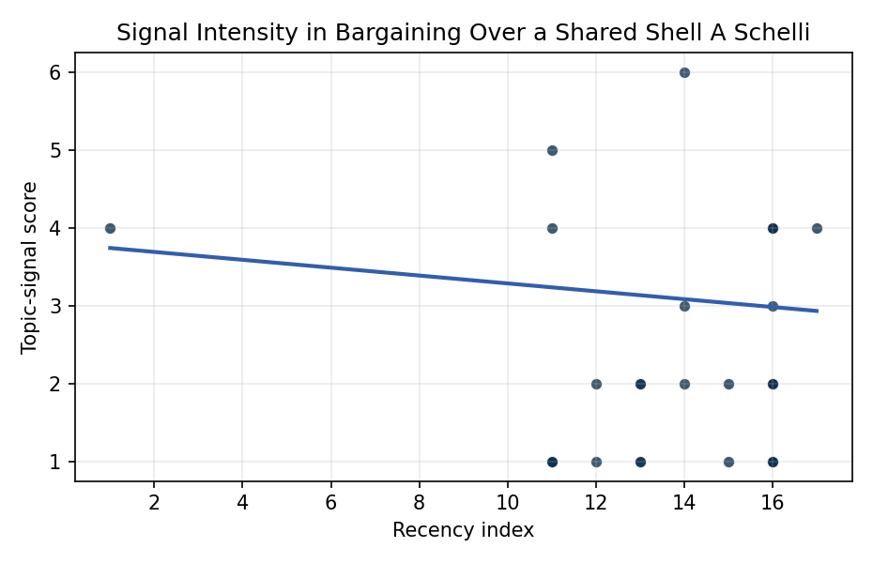
Figure 1. Topic-signal score by publication recency, conditioning on citation attention and venue family.

Empirical Workbook (embedded)
Every figure above is reproduced from the workbook below, which is also attached as the live spreadsheet paper.xlsx. Each observation carries its source.

Data (real observations)
doc_id | year_num | recency_index | cites_num | venue_score | title_words | snippet_words | keyword_count | theme_hits | signal_score | source
1 | 2023 | 14 | 0 | 1 | 9 | 13 | 4 | 0 | 2 | 10.64861/LDVO7244
2 | 2025 | 16 | 0 | 1 | 9 | 13 | 16 | 0 | 2 | 10.64861/URSW2020
3 | 2023 | 14 | 0 | 1 | 12 | 14 | 3 | 2 | 6 | 10.64861/FKER7625
4 | 2022 | 13 | 0 | 1 | 11 | 14 | 4 | 0 | 1 | https://amostech.space/year/2022/imperfect-information-games-and-counterfactual-regret-minimization-in-space-domain-awareness/
5 | 2022 | 13 | 0 | 1 | 6 | 14 | 6 | 0 | 2 | https://amostech.space/year/2022/leo-capacity-modeling-for-sustainable-design/
6 | 2010 | 1 | 0 | 1 | 10 | 10 | 5 | 2 | 4 | https://amostech.space/year/2010/highly-efficient-screening-for-point-like-targets-via-concentric-shells/
7 | 2025 | 16 | 0 | 1 | 9 | 12 | 8 | 1 | 4 | 10.64861/IKLU8599
8 | 2025 | 16 | 0 | 1 | 12 | 13 | 5 | 1 | 4 | 10.64861/QGVF6609
9 | 2025 | 16 | 0 | 1 | 16 | 11 | 5 | 0 | 1 | 10.64861/CXGE3201
10 | 2021 | 12 | 0 | 1 | 17 | 11 | 4 | 1 | 2 | https://amostech.space/year/2021/the-solar-particle-access-model-spam-a-new-tool-for-monitoring-solar-energetic-particle-impacts-to-satellite-operations/
11 | 2023 | 14 | 0 | 1 | 10 | 12 | 4 | 1 | 3 | 10.64861/GCJM8077
12 | 2025 | 16 | 0 | 1 | 7 | 14 | 6 | 0 | 2 | 10.64861/LCET1122
13 | 2022 | 13 | 17 | 2 | 16 | 14 | 10 | 1 | 2 | 10.1016/j.actaastro.2022.05.022
14 | 2024 | 15 | 1 | 2 | 18 | 12 | 12 | 0 | 1 | 10.1016/j.actaastro.2024.09.057
15 | 2025 | 16 | 1 | 2 | 10 | 13 | 7 | 0 | 1 | 10.1016/j.actaastro.2025.01.054
16 | 2021 | 12 | 24 | 2 | 15 | 13 | 15 | 0 | 1 | 10.1016/j.actaastro.2021.01.049
17 | 2025 | 16 | 0 | 2 | 9 | 14 | 9 | 1 | 2 | 10.1016/j.actaastro.2025.06.003
18 | 2024 | 15 | 4 | 2 | 9 | 12 | 8 | 1 | 2 | 10.1016/j.actaastro.2024.01.049
19 | 2025 | 16 | 5 | 2 | 10 | 11 | 4 | 0 | 1 | 10.1016/j.actaastro.2025.01.069
20 | 2025 | 16 | 1 | 2 | 15 | 13 | 15 | 1 | 4 | 10.1016/j.actaastro.2025.10.018
21 | 2025 | 16 | 4 | 2 | 5 | 14 | 8 | 0 | 1 | 10.1016/j.actaastro.2025.01.043
22 | 2025 | 16 | 0 | 2 | 5 | 14 | 15 | 1 | 3 | 10.1016/j.actaastro.2025.10.029
23 | 2026 | 17 | 0 | 2 | 11 | 13 | 11 | 1 | 4 | 10.1016/j.actaastro.2026.05.026
24 | 2025 | 16 | 5 | 2 | 19 | 13 | 14 | 1 | 4 | 10.1016/j.actaastro.2025.03.034
25 | 2020 | 11 | 0 | 3 | 9 | 0 | 0 | 0 | 1 | Large Satellite Constellations and the Space Commons (Differential Game)
26 | 2020 | 11 | 0 | 3 | 64 | 0 | 0 | 1 | 4 | Weinzierl (2018) provides a three-part economic framework for managing the development of the space economy, analyzing market establishment through decentralization, market failures (including space debris as a negative externality), and social objective regulation. Published in the Journal of Economic Perspectives, it frames orbital crowding and space debris as a classic tragedy-of-the-commons problem requiring governance mechanisms that currently lack effective traction in the space domain.
27 | 2022 | 13 | 0 | 3 | 15 | 0 | 0 | 0 | 1 | 10.1016/j.ejor.2022.04.030
28 | 2020 | 11 | 0 | 3 | 51 | 0 | 0 | 1 | 5 | A 2021 Johns Hopkins SAIS doctoral thesis by Nathaniel Dailey proposing an International Space Reference Architecture (ISRA) as a socio-technological transformative mechanism to resolve contemporary space governance failures – orbital debris, policy fragmentation, and space traffic management – by coupling enterprise architecture methodology with international relations constructivist theory, blockchain-enabled information sharing, and norms entrepreneurship.
29 | 2020 | 11 | 0 | 3 | 9 | 0 | 0 | 0 | 1 | International Relations and Economic Dimensions of Trusted Space Data
30 | 2020 | 11 | 0 | 3 | 6 | 0 | 0 | 0 | 1 | Stilwell et al ASCEND 2025 Orbital Classification

Variable construction
Variable | Definition | Construction / source
signal_score | Composite topic-signal score for each retrieved source record | Deterministic count built from candidate-theme term hits in the source title, snippet, keyword field, and author metadata; each row cites the retrieved source in the source column
recency_index | Publication recency index | Computed as publication year minus the minimum publication year in the paper sample plus one
cites_num | Reported citation count in the local brain index | Parsed from the local brain search cites field; zero when the index reported no citation count
venue_score | Ordinal venue-family score | AMOS = 1, Acta Astronautica = 2, Space Economy = 3

Estimator output
Term | Coef. | Std. err. | t | p | 95% CI
const | 3.7913 | 1.0101 | 3.7536 | 0.0001743 | [1.8117, 5.771]
recency_index | -0.0505 | 0.0621 | -0.8136 | 0.4159 | [-0.1721, 0.0711]
cites_num | -0.0541 | 0.0242 | -2.2314 | 0.0257 | [-0.1016, -0.0066]
venue_score | -0.3247 | 0.3978 | -0.8161 | 0.4145 | [-1.1044, 0.4551]
Fit: N = 30 R2 = 0.0804 R2_adj = -0.0257 F = 2.4569 F_p = 0.0855

