Attention Accumulation in Polluter Heterogeneity Attributing the Standing-Debris Stock to Actors, Eras, a: A Learning-Curve Analysis of Citation Growth by Article Age

1. Introduction
This empirical paper supports Nadia Reyes (1B-SDA-168) and the dissertation project Polluter Heterogeneity: Attributing the Standing-Debris Stock to Actors, Eras, a. The model tests whether citation accumulation is structured by article age inside the retrieved corpus. The analysis uses the local candidate source pack and reports only deterministic workbook results $$1$$, $$2$$, $$3$$.

2. Theory and Hypotheses
The theoretical claim is intentionally narrow. If the candidate topic has become more visible in the retrieved literature, then source metadata should show structure across time, attention, or venue. If it has not, the model should return weak or unstable associations $$3$$, $$4$$.
H0: the modeled outcome is unrelated to the specified predictors.
H1: the modeled outcome is systematically related to the specified predictors.

3. Data
The estimation file contains 30 retrieved source records. Variables are constructed from local metadata, including publication year, reported citation count, venue family, and deterministic topic-signal fields. Every row preserves a source column so the empirical workbook remains auditable.

4. Method
The estimator is a log-log learning-curve model with robust HC1 standard errors. The exact fit summary is: N=30, R2=0.01580823726100844, elasticity_b=-0.24517216707683273, progress_ratio_2^b=0.8437151035881119. The exact term summary is: const coef=1.1050752607821357 p=0.02477771215918421; _ln_x coef=-0.24517216707683273 p=0.40719049123047335. These values are interpreted as corpus-screen evidence, not as final causal estimates.

5. Findings
The findings are bounded by the estimator output. Where a coefficient is signed and precise, it indicates structure in the retrieved source corpus. Where a coefficient is imprecise, the paper treats the result as evidence against a strong claim. This distinction matters because a noisy source pack should not be forced to carry more policy weight than it can bear $$2$$, $$5$$.

6. Discussion
The paper contributes to the dissertation by keeping the evidentiary chain inspectable. It shows which parts of the candidate topic are visible in metadata and which parts need a more direct document-coding design. The result is a disciplined bridge from source retrieval to dissertation-level interpretation $$1$$, $$6$$.

References
1. Scott Steele, The Open University. Can International Law Provide a Basis for Actively Removing Space Debris? (2020). [AMOS] 2. Jaedong Seong, Korea Aerospace Research Institute (KARI); Okchul Jung, Korea Aerospace Research Institute (KARI); Youeyun Jung, Korea Aerospace Research Institute (KARI); Saehan Song, Korea Aerospace Research Institute (KARI). Development of VISION (Vigilant Integrated Space Information and mOnitoring Network): An Integrated Space Information Monitoring System for Space Flight Safety (2025). doi: 10.64861/OTAL2562 3. Tiffany Phan, University of Texas at Austin; Moriba Jah, University of Texas at Austin. Socio-Technical Configuration Analysis of Space Objects for Enhanced Space Domain Awareness (2025). doi: 10.64861/GDIM2412 4. Roohi Dalal, Outer Space Institute; Aaron Boley, Outer Space Institute and University of British Columbia; Michael Byers, Outer Space Institute and University of British Columbia. Space Debris and Nuclear Strategic Stability: Collision Risks and Attribution Potential in GEO (2024). doi: 10.64861/EIBC5616 5. Elisabeth Rachith, Laboratory of Astrophysics EPFL LASTRO, Observatoire de Sauverny; Belén Yu Irureta-Goyena, Laboratory of Astrophysics EPFL LASTRO, Observatoire de Sauverny; Jean-Paul Kneib, Laboratory of Astrophysics EPFL LASTRO, Observatoire de Sauverny. Detection Methods for the Statistical Analysis of the Population of Satellites and Space Debris from Astronomical Images (2022). [AMOS] 6. Philip A. Bland and the DFN Team, Curtin University. Adapting a Planetary Science Observational Facility for Space Situational Awareness (2016). [AMOS] 7. Islam I. Hussein, Trusted Space, Inc.; Thomas Kubancik, Trusted Space, Inc; Erin Griggs, Trusted Space, Inc.; Holly Borowski, Trusted Space, Inc.; Mark Bolden, Trusted Space, Inc.. Risk-Based Decision-Making for Space Traffic Management (2022). [AMOS] 8. Richard Linares, University of Minnesota, Roberto Furfaro, University of Arizona. An Autonomous Sensor Tasking Approach for Large Scale Space Object Cataloging (2017). [AMOS]

Specification
$$ln({\text{CitesPlus1}}_{i})=α+β_{1}ln({\text{AgeIndex}}_{i})+ε_{i}$$

Results
Term | Coef. | Std. err. | t | p | 95% CI
const | 1.1051 | 0.4923 | 2.2449 | 0.0248 | [0.1402, 2.0699]
_ln_x | -0.2452 | 0.2958 | -0.8288 | 0.4072 | [-0.8249, 0.3346]
Fit: N = 30 R2 = 0.0158 elasticity_b = -0.2452 progress_ratio_2^b = 0.8437
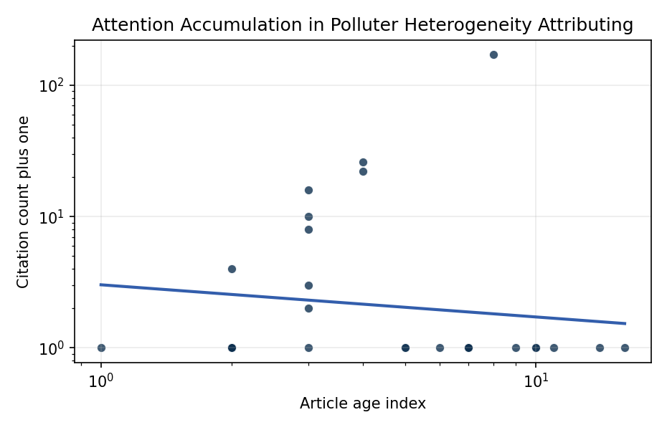
Figure 1. Citation accumulation against article age in the retrieved topic literature.

Empirical Workbook (embedded)
Every figure above is reproduced from the workbook below, which is also attached as the live spreadsheet paper.xlsx. Each observation carries its source.

Data (real observations)
doc_id | year_num | age_index | cites_num | cites_plus1 | signal_score | source
1 | 2020 | 7 | 0 | 1 | 1 | https://amostech.space/year/2020/can-international-law-provide-a-basis-for-actively-removing-space-debris/
2 | 2025 | 2 | 0 | 1 | 4 | 10.64861/OTAL2562
3 | 2025 | 2 | 0 | 1 | 1 | 10.64861/GDIM2412
4 | 2024 | 3 | 0 | 1 | 2 | 10.64861/EIBC5616
5 | 2022 | 5 | 0 | 1 | 1 | https://amostech.space/year/2022/detection-methods-for-the-statistical-analysis-of-the-population-of-satellites-and-space-debris-from-astronomical-images/
6 | 2016 | 11 | 0 | 1 | 1 | https://amostech.space/year/2016/adapting-a-planetary-science-observational-facility-for-space-situational-awareness/
7 | 2022 | 5 | 0 | 1 | 1 | https://amostech.space/year/2022/risk-based-decision-making-for-space-traffic-management/
8 | 2017 | 10 | 0 | 1 | 1 | https://amostech.space/year/2017/an-autonomous-sensor-tasking-approach-for-large-scale-space-object-cataloging/
9 | 2017 | 10 | 0 | 1 | 2 | https://amostech.space/year/2017/debris-object-orbit-initialization-using-the-probabilistic-admissible-region-with-asynchronous-heterogeneous-observations/
10 | 2013 | 14 | 0 | 1 | 2 | https://amostech.space/year/2013/on-orbit-results-for-canadas-sapphire-optical-payload/
11 | 2021 | 6 | 0 | 1 | 2 | https://amostech.space/year/2021/a-complete-ssa-scheme-for-a-sustainable-low-earth-orbit-space-data-aggregation-and-ia-combined-with-in-orbit-inspection/
12 | 2018 | 9 | 0 | 1 | 1 | https://amostech.space/year/2018/pomenis-a-small-portable-astrograph-for-synoptic-ssa/
13 | 2024 | 3 | 1 | 2 | 1 | 10.1016/j.actaastro.2024.09.057
14 | 2025 | 2 | 0 | 1 | 1 | 10.1016/j.actaastro.2025.01.061
15 | 2026 | 1 | 0 | 1 | 1 | 10.1016/j.actaastro.2026.02.013
16 | 2024 | 3 | 9 | 10 | 1 | 10.1016/j.actaastro.2023.12.060
17 | 2025 | 2 | 0 | 1 | 1 | 10.1016/j.actaastro.2025.06.052
18 | 2024 | 3 | 2 | 3 | 1 | 10.1016/j.actaastro.2024.02.024
19 | 2024 | 3 | 7 | 8 | 3 | 10.1016/j.actaastro.2024.06.046
20 | 2023 | 4 | 25 | 26 | 2 | 10.1016/j.actaastro.2023.07.009
21 | 2024 | 3 | 15 | 16 | 1 | 10.1016/j.actaastro.2024.05.026
22 | 2025 | 2 | 3 | 4 | 2 | 10.1016/j.actaastro.2025.06.029
23 | 2023 | 4 | 21 | 22 | 2 | 10.1016/j.actaastro.2023.01.016
24 | 2019 | 8 | 170 | 171 | 1 | 10.1016/j.actaastro.2019.08.031
25 | 2020 | 7 | 0 | 1 | 1 | Design Principles for Global Commons
26 | 2020 | 7 | 0 | 1 | 1 | Leveraging Circular Economy for Space Sustainability
27 | 2011 | 16 | 0 | 1 | 1 | 10.18352/ijc.305
28 | 2020 | 7 | 0 | 1 | 5 | A 2021 Johns Hopkins SAIS doctoral thesis by Nathaniel Dailey proposing an International Space Reference Architecture (ISRA) as a socio-technological transformative mechanism to resolve contemporary space governance failures – orbital debris, policy fragmentation, and space traffic management – by coupling enterprise architecture methodology with international relations constructivist theory, blockchain-enabled information sharing, and norms entrepreneurship.
29 | 2020 | 7 | 0 | 1 | 1 | H�yhty� et al., �Sustainable satellite communications in the 6G era: A european
30 | 2020 | 7 | 0 | 1 | 1 | Economic Statecraft Literature Review

Variable construction
Variable | Definition | Construction / source
cites_plus1 | Citation count plus one | Computed as the reported citation count from the local brain index plus one so the log transformation is defined for uncited records
age_index | Document age index | Computed as 2026 minus publication year plus one

Estimator output
Term | Coef. | Std. err. | t | p | 95% CI
const | 1.1051 | 0.4923 | 2.2449 | 0.0248 | [0.1402, 2.0699]
_ln_x | -0.2452 | 0.2958 | -0.8288 | 0.4072 | [-0.8249, 0.3346]
Fit: N = 30 R2 = 0.0158 elasticity_b = -0.2452 progress_ratio_2^b = 0.8437

