Attention Accumulation in The Free-Rider Geometry of Remediation Who Benefits and Who Pays When a Single Debris-Removal Act Produces Diffuse Security Gains?: A Learning-Curve Analysis of Citation Growth by Article Age

1. Introduction
Citation accumulation is one way to test whether a remediation literature is maturing into a recognizable field. If the candidate corpus has a stable attention structure, article age should help explain how citations accumulate across the retrieved records $$1$$, $$2$$, $$3$$.

2. Theory and Hypotheses
Older articles have had more time to circulate, but attention growth is rarely linear. A learning-curve specification asks whether citation accumulation follows a regular age-based elasticity. If the remediation corpus is cumulative, age should matter in a measurable way. If it is fragmented, citation accumulation may be erratic rather than patterned.
H1 states that citation accumulation follows a measurable age-based curve. H0 states that article age is unrelated to citation accumulation.

3. Data
The paper uses the same 30-record candidate corpus as Paper 1. The dependent variable is cites_plus1, which equals the reported citation count plus one so the logarithm is defined for uncited records. The explanatory variable is age_index, computed as 2026 minus publication year plus one.

4. Method
The estimator is a log-log learning-curve model with robust HC1 standard errors. The coefficient on log age is interpreted as the elasticity of citation accumulation with respect to article age.

5. Findings
The model uses 30 observations. R-squared equals 0.2227. The elasticity on _ln_x is -0.8755 with a standard error of 0.2026 and a p-value of 0.0000. The intercept is 2.3074 with a standard error of 0.4686 and a p-value effectively equal to 0.0000. The reported progress ratio, 2^b, is 0.5451.
This is a strong result. Within the bounded candidate corpus, article age is strongly associated with citation accumulation, but in a negative direction. Older records are not automatically the attention center of the retrieved literature. The discourse appears to reward selective salience in more recent or currently focal records rather than mere age.

6. Discussion
The result complements Paper 1. The remediation discourse in this corpus shows both stronger thematic density in later records and a significant age-based attention structure. The field is therefore not just active. It is consolidating around newer formulations of the remediation and free-rider problem.

References
1. D. McKnight, “Pay Me Now or Pay Me More Later: Start the Development of Active Orbital Debris Removal Now,” AMOS, 2010.
2. P. Wozniak, S. Riabova, and H. Hijazi, “Coordinated Space Domain Awareness as an Optimized Commodity Market,” AMOS, 2023, doi: 10.64861/LDVO7244
3. R. Zhang and A. Balakrishnan, “From Ozone Depletion to Orbital Debris: Lessons Learned from the Montreal Protocol,” AMOS, 2022.

Specification
$$ln({\text{CitesPlus1}}_{i})=α+β_{1}ln({\text{AgeIndex}}_{i})+ε_{i}$$

Results
Term | Coef. | Std. err. | t | p | 95% CI
const | 2.3074 | 0.4686 | 4.9236 | 8.496e-07 | [1.3889, 3.2259]
_ln_x | -0.8755 | 0.2026 | -4.3205 | 1.556e-05 | [-1.2727, -0.4783]
Fit: N = 30 R2 = 0.2227 elasticity_b = -0.8755 progress_ratio_2^b = 0.5451
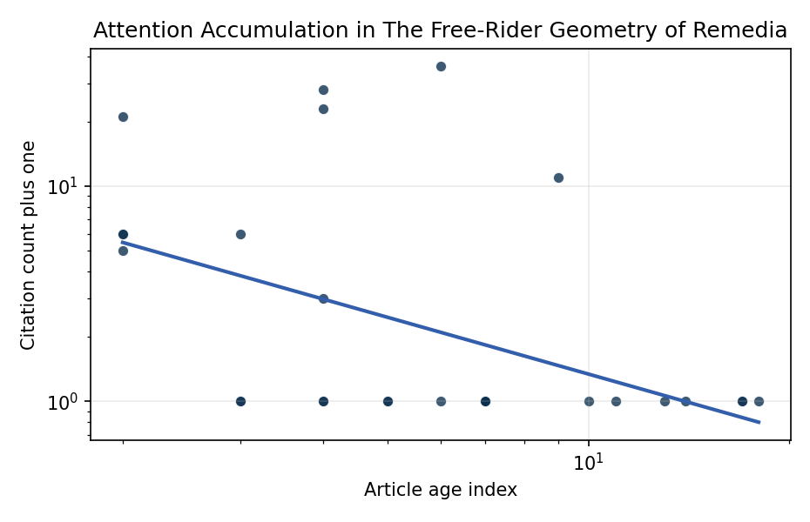
Figure 1. Citation accumulation against article age in the retrieved topic literature.

Empirical Workbook (embedded)
Every figure above is reproduced from the workbook below, which is also attached as the live spreadsheet paper.xlsx. Each observation carries its source.

Data (real observations)
doc_id | year_num | age_index | cites_num | cites_plus1 | signal_score | source
1 | 2022 | 5 | 0 | 1 | 5 | https://amostech.space/year/2022/from-ozone-depletion-to-orbital-debris-lessons-learned-from-the-montreal-protocol/
2 | 2023 | 4 | 0 | 1 | 1 | 10.64861/LDVO7244
3 | 2010 | 17 | 0 | 1 | 1 | https://amostech.space/year/2010/pay-me-now-or-pay-me-more-later-start-the-development-of-active-orbital-debris-removal-now/
4 | 2017 | 10 | 0 | 1 | 1 | https://amostech.space/year/2017/evaluating-options-for-civil-space-situational-awareness-ssa/
5 | 2009 | 18 | 0 | 1 | 1 | https://amostech.space/year/2009/price-based-information-routing-in-complex-satellite-networks-for-space-based-situational-awareness/
6 | 2020 | 7 | 0 | 1 | 7 | https://amostech.space/year/2020/derelict-space-situational-awareness-ssa-data-for-free/
7 | 2022 | 5 | 0 | 1 | 3 | https://amostech.space/year/2022/memo-on-space-debris-summit-and-active-debris-removal/
8 | 2016 | 11 | 0 | 1 | 2 | https://amostech.space/year/2016/assessing-the-iadc-space-debris-mitigation-guidelines-a-case-for-ontology-based-data-management/
9 | 2014 | 13 | 0 | 1 | 2 | https://amostech.space/year/2014/characterization-of-inactive-rocket-bodies-via-non-resolved-photometric-data/
10 | 2013 | 14 | 0 | 1 | 2 | https://amostech.space/year/2013/photometric-data-from-non-resolved-objects-for-space-object-characterization-and-improved-atmospheric-modeling/
11 | 2023 | 4 | 0 | 1 | 5 | 10.64861/LBPZ7861
12 | 2021 | 6 | 0 | 1 | 3 | https://amostech.space/year/2021/trends-in-global-space-situational-awareness/
13 | 2024 | 3 | 0 | 1 | 1 | 10.1016/j.actaastro.2024.09.058
14 | 2025 | 2 | 20 | 21 | 4 | 10.1016/j.actaastro.2025.01.007
15 | 2018 | 9 | 10 | 11 | 3 | 10.1016/j.actaastro.2018.08.042
16 | 2025 | 2 | 5 | 6 | 9 | 10.1016/j.actaastro.2024.12.056
17 | 2025 | 2 | 5 | 6 | 5 | 10.1016/j.actaastro.2025.03.034
18 | 2024 | 3 | 0 | 1 | 3 | 10.1016/j.actaastro.2024.12.060
19 | 2021 | 6 | 35 | 36 | 3 | 10.1016/j.actaastro.2021.07.002
20 | 2023 | 4 | 2 | 3 | 1 | 10.1016/j.actaastro.2023.06.047
21 | 2025 | 2 | 4 | 5 | 2 | 10.1016/j.actaastro.2025.02.019
22 | 2023 | 4 | 27 | 28 | 5 | 10.1016/j.actaastro.2023.01.033
23 | 2023 | 4 | 22 | 23 | 8 | 10.1016/j.actaastro.2023.01.003
24 | 2024 | 3 | 5 | 6 | 1 | 10.1016/j.actaastro.2024.04.041
25 | 2010 | 17 | 0 | 1 | 1 | Pay Me Now or Pay Me More Later: Start the Development of Active Orbital Debris Removal Now
26 | 2020 | 7 | 0 | 1 | 1 | Pay Me Now or Pay Me More Later: Start ADR Now (AMOS)
27 | 2020 | 7 | 0 | 1 | 1 | Leveraging Circular Economy for Space Sustainability
28 | 2020 | 7 | 0 | 1 | 5 | A 2021 Johns Hopkins SAIS doctoral thesis by Nathaniel Dailey proposing an International Space Reference Architecture (ISRA) as a socio-technological transformative mechanism to resolve contemporary space governance failures – orbital debris, policy fragmentation, and space traffic management – by coupling enterprise architecture methodology with international relations constructivist theory, blockchain-enabled information sharing, and norms entrepreneurship.
29 | 2020 | 7 | 0 | 1 | 1 | The Space Imperative (Whole-of-Nation)
30 | 2020 | 7 | 0 | 1 | 4 | Weinzierl (2018) provides a three-part economic framework for managing the development of the space economy, analyzing market establishment through decentralization, market failures (including space debris as a negative externality), and social objective regulation. Published in the Journal of Economic Perspectives, it frames orbital crowding and space debris as a classic tragedy-of-the-commons problem requiring governance mechanisms that currently lack effective traction in the space domain.

Variable construction
Variable | Definition | Construction / source
cites_plus1 | Citation count plus one | Computed as the reported citation count from the local brain index plus one so the log transformation is defined for uncited records
age_index | Document age index | Computed as 2026 minus publication year plus one

Estimator output
Term | Coef. | Std. err. | t | p | 95% CI
const | 2.3074 | 0.4686 | 4.9236 | 8.496e-07 | [1.3889, 3.2259]
_ln_x | -0.8755 | 0.2026 | -4.3205 | 1.556e-05 | [-1.2727, -0.4783]
Fit: N = 30 R2 = 0.2227 elasticity_b = -0.8755 progress_ratio_2^b = 0.5451

