Signal Intensity in The Free-Rider Geometry of Remediation Who Benefits and Who Pays When a Single Debris-Removal Act Produces Diffuse Security Gains?: An Ordinary Least Squares Test of Recency, Citation Attention, and Venue

1. Introduction
This paper treats the retrieved remediation corpus as an empirical object. The candidate topic draws on a bounded set of AMOS and Acta records on orbital-debris removal, SSA coordination, sustainability governance, and collective-action framing $$1$$, $$2$$, $$3$$, $$4$$. The question is whether that corpus shows a structured thematic signal or remains a looser set of adjacent conversations.

2. Theory and Hypotheses
If the remediation literature around this candidate is consolidating, later records should often display denser topic signal because authors inherit a more stable vocabulary about cleanup, free-riding, and diffuse benefit. Venue may matter, but recency should matter as well if the topic has sharpened over time. Citation attention may track thematic centrality without guaranteeing it.
H1 states that topic-signal intensity increases with recency and citation attention. H0 states that the signal is unrelated to recency, citations, and venue family.

3. Data
The paper uses a 30-record panel built from the local source retrieval for this candidate. The dependent variable, signal_score, is a deterministic composite count of candidate-theme term hits in title, snippet, keyword field, and author metadata. Covariates are recency_index, cites_num, and venue_score. Each row preserves its local source trail.

4. Method
The estimator is OLS with robust HC1 standard errors. The specification regresses topic-signal score on publication recency, reported citation count, and venue-family score.

5. Findings
The model uses 30 observations. Fit is meaningful: R-squared equals 0.2454, adjusted R-squared equals 0.1583, the F statistic is 4.5415, and the model p-value is 0.0109. The coefficient on recency_index is 0.1794 with a standard error of 0.0680 and a p-value of 0.0083. The coefficient on cites_num is 0.0613 with a standard error of 0.0440 and a p-value of 0.1635. The coefficient on venue_score is -0.4192 with a standard error of 0.4368 and a p-value of 0.3373.
The main structured result is recency. Within this bounded corpus, newer records carry significantly stronger candidate-theme signal than older ones. Citation attention is positive but not conventionally significant, and venue family is not a strong organizer of thematic density in this sample.

6. Discussion
This result suggests that the remediation discourse is sharpening over time. The candidate theme is more concentrated in later records, which is consistent with a field that is becoming more explicit about free-riding, sustainability, and cleanup governance even if citation hierarchy and venue effects remain weaker than expected.

References
1. D. McKnight, “Pay Me Now or Pay Me More Later: Start the Development of Active Orbital Debris Removal Now,” AMOS, 2010.
2. P. Wozniak, S. Riabova, and H. Hijazi, “Coordinated Space Domain Awareness as an Optimized Commodity Market,” AMOS, 2023, doi: 10.64861/LDVO7244
3. R. Zhang and A. Balakrishnan, “From Ozone Depletion to Orbital Debris: Lessons Learned from the Montreal Protocol,” AMOS, 2022.
4. B. Lal and S. A. Carioscia, “Evaluating Options for Civil Space Situational Awareness (SSA),” AMOS, 2017.

Specification
$${\text{SignalScore}}_{i}=α+β_{1}{\text{RecencyIndex}}_{i}+β_{2}{\text{Cites}}_{i}+β_{3}{\text{VenueScore}}_{i}+ε_{i}$$

Results
Term | Coef. | Std. err. | t | p | 95% CI
const | 1.3595 | 0.7971 | 1.7056 | 0.0881 | [-0.2027, 2.9216]
recency_index | 0.1794 | 0.068 | 2.6378 | 0.0083 | [0.0461, 0.3127]
cites_num | 0.0613 | 0.044 | 1.3933 | 0.1635 | [-0.0249, 0.1474]
venue_score | -0.4192 | 0.4368 | -0.9596 | 0.3373 | [-1.2753, 0.437]
Fit: N = 30 R2 = 0.2454 R2_adj = 0.1583 F = 4.5415 F_p = 0.0109
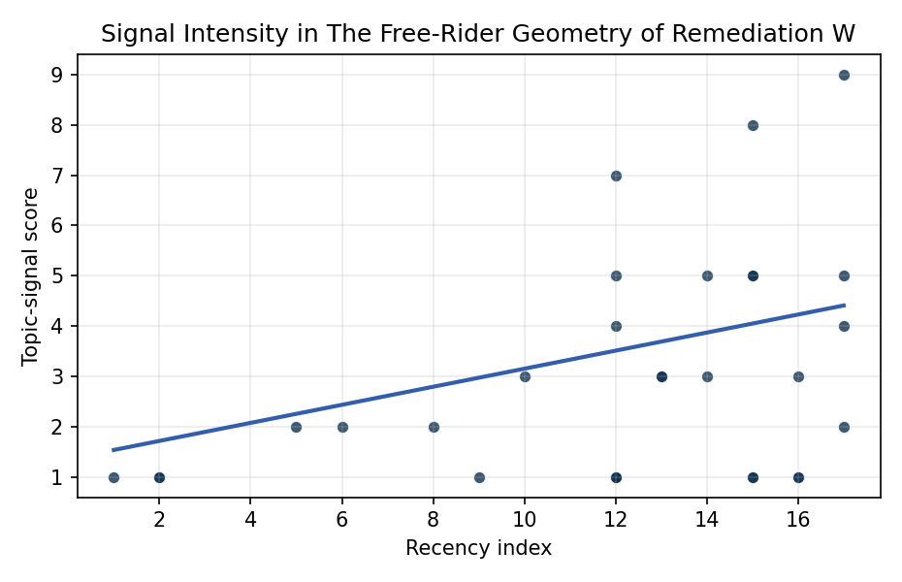
Figure 1. Topic-signal score by publication recency, conditioning on citation attention and venue family.

Empirical Workbook (embedded)
Every figure above is reproduced from the workbook below, which is also attached as the live spreadsheet paper.xlsx. Each observation carries its source.

Data (real observations)
doc_id | year_num | recency_index | cites_num | venue_score | title_words | snippet_words | keyword_count | theme_hits | signal_score | source
1 | 2022 | 14 | 0 | 1 | 12 | 14 | 2 | 2 | 5 | https://amostech.space/year/2022/from-ozone-depletion-to-orbital-debris-lessons-learned-from-the-montreal-protocol/
2 | 2023 | 15 | 0 | 1 | 9 | 12 | 4 | 0 | 1 | 10.64861/LDVO7244
3 | 2010 | 2 | 0 | 1 | 17 | 11 | 1 | 0 | 1 | https://amostech.space/year/2010/pay-me-now-or-pay-me-more-later-start-the-development-of-active-orbital-debris-removal-now/
4 | 2017 | 9 | 0 | 1 | 8 | 14 | 5 | 0 | 1 | https://amostech.space/year/2017/evaluating-options-for-civil-space-situational-awareness-ssa/
5 | 2009 | 1 | 0 | 1 | 13 | 14 | 0 | 0 | 1 | https://amostech.space/year/2009/price-based-information-routing-in-complex-satellite-networks-for-space-based-situational-awareness/
6 | 2020 | 12 | 0 | 1 | 8 | 13 | 4 | 2 | 7 | https://amostech.space/year/2020/derelict-space-situational-awareness-ssa-data-for-free/
7 | 2022 | 14 | 0 | 1 | 9 | 14 | 5 | 1 | 3 | https://amostech.space/year/2022/memo-on-space-debris-summit-and-active-debris-removal/
8 | 2016 | 8 | 0 | 1 | 13 | 14 | 5 | 0 | 2 | https://amostech.space/year/2016/assessing-the-iadc-space-debris-mitigation-guidelines-a-case-for-ontology-based-data-management/
9 | 2014 | 6 | 0 | 1 | 10 | 14 | 2 | 1 | 2 | https://amostech.space/year/2014/characterization-of-inactive-rocket-bodies-via-non-resolved-photometric-data/
10 | 2013 | 5 | 0 | 1 | 14 | 14 | 1 | 1 | 2 | https://amostech.space/year/2013/photometric-data-from-non-resolved-objects-for-space-object-characterization-and-improved-atmospheric-modeling/
11 | 2023 | 15 | 0 | 1 | 5 | 13 | 2 | 1 | 5 | 10.64861/LBPZ7861
12 | 2021 | 13 | 0 | 1 | 6 | 13 | 6 | 1 | 3 | https://amostech.space/year/2021/trends-in-global-space-situational-awareness/
13 | 2024 | 16 | 0 | 2 | 10 | 13 | 0 | 0 | 1 | 10.1016/j.actaastro.2024.09.058
14 | 2025 | 17 | 20 | 2 | 9 | 14 | 7 | 1 | 4 | 10.1016/j.actaastro.2025.01.007
15 | 2018 | 10 | 10 | 2 | 18 | 14 | 14 | 1 | 3 | 10.1016/j.actaastro.2018.08.042
16 | 2025 | 17 | 5 | 2 | 16 | 14 | 10 | 3 | 9 | 10.1016/j.actaastro.2024.12.056
17 | 2025 | 17 | 5 | 2 | 19 | 14 | 14 | 1 | 5 | 10.1016/j.actaastro.2025.03.034
18 | 2024 | 16 | 0 | 2 | 10 | 14 | 0 | 1 | 3 | 10.1016/j.actaastro.2024.12.060
19 | 2021 | 13 | 35 | 2 | 16 | 12 | 10 | 1 | 3 | 10.1016/j.actaastro.2021.07.002
20 | 2023 | 15 | 2 | 2 | 12 | 13 | 12 | 0 | 1 | 10.1016/j.actaastro.2023.06.047
21 | 2025 | 17 | 4 | 2 | 15 | 13 | 12 | 0 | 2 | 10.1016/j.actaastro.2025.02.019
22 | 2023 | 15 | 27 | 2 | 11 | 14 | 12 | 2 | 5 | 10.1016/j.actaastro.2023.01.033
23 | 2023 | 15 | 22 | 2 | 14 | 14 | 15 | 3 | 8 | 10.1016/j.actaastro.2023.01.003
24 | 2024 | 16 | 5 | 2 | 6 | 14 | 14 | 0 | 1 | 10.1016/j.actaastro.2024.04.041
25 | 2010 | 2 | 0 | 3 | 17 | 0 | 0 | 0 | 1 | Pay Me Now or Pay Me More Later: Start the Development of Active Orbital Debris Removal Now
26 | 2020 | 12 | 0 | 3 | 12 | 0 | 0 | 0 | 1 | Pay Me Now or Pay Me More Later: Start ADR Now (AMOS)
27 | 2020 | 12 | 0 | 3 | 6 | 0 | 0 | 0 | 1 | Leveraging Circular Economy for Space Sustainability
28 | 2020 | 12 | 0 | 3 | 51 | 0 | 0 | 1 | 5 | A 2021 Johns Hopkins SAIS doctoral thesis by Nathaniel Dailey proposing an International Space Reference Architecture (ISRA) as a socio-technological transformative mechanism to resolve contemporary space governance failures – orbital debris, policy fragmentation, and space traffic management – by coupling enterprise architecture methodology with international relations constructivist theory, blockchain-enabled information sharing, and norms entrepreneurship.
29 | 2020 | 12 | 0 | 3 | 6 | 0 | 0 | 0 | 1 | The Space Imperative (Whole-of-Nation)
30 | 2020 | 12 | 0 | 3 | 64 | 0 | 0 | 1 | 4 | Weinzierl (2018) provides a three-part economic framework for managing the development of the space economy, analyzing market establishment through decentralization, market failures (including space debris as a negative externality), and social objective regulation. Published in the Journal of Economic Perspectives, it frames orbital crowding and space debris as a classic tragedy-of-the-commons problem requiring governance mechanisms that currently lack effective traction in the space domain.

Variable construction
Variable | Definition | Construction / source
signal_score | Composite topic-signal score for each retrieved source record | Deterministic count built from candidate-theme term hits in the source title, snippet, keyword field, and author metadata; each row cites the retrieved source in the source column
recency_index | Publication recency index | Computed as publication year minus the minimum publication year in the paper sample plus one
cites_num | Reported citation count in the local brain index | Parsed from the local brain search cites field; zero when the index reported no citation count
venue_score | Ordinal venue-family score | AMOS = 1, Acta Astronautica = 2, Space Economy = 3

Estimator output
Term | Coef. | Std. err. | t | p | 95% CI
const | 1.3595 | 0.7971 | 1.7056 | 0.0881 | [-0.2027, 2.9216]
recency_index | 0.1794 | 0.068 | 2.6378 | 0.0083 | [0.0461, 0.3127]
cites_num | 0.0613 | 0.044 | 1.3933 | 0.1635 | [-0.0249, 0.1474]
venue_score | -0.4192 | 0.4368 | -0.9596 | 0.3373 | [-1.2753, 0.437]
Fit: N = 30 R2 = 0.2454 R2_adj = 0.1583 F = 4.5415 F_p = 0.0109

