A Hedonic Price Model of Debris Risk in Satellite Insurance Premiums

1. Introduction
Space insurance pricing has long been treated as a private actuarial exercise, opaque to outside observers and rarely connected to the public debate over orbital sustainability. Yet underwriters at Lloyd’s, AXA XL, and Munich Re price exactly the risk that policy analysts argue is mispriced: the joint probability that a satellite suffers loss, including loss from collision with cataloged or sub-cataloged debris $$1$$. If insurance markets are partially efficient, then the cross section of premium rates should reveal how professional risk capital weighs debris exposure against other determinants of loss, such as launcher reliability and platform complexity. This paper estimates a hedonic price model on a cross section of commercial satellite missions to recover the implicit price the market assigns to orbital debris density.

2. Theory and Hypotheses
A hedonic regression treats price as a sum of implicit prices for attributes $$2$$. For a satellite mission, the insurance premium rate bundles attributes of the spacecraft, the orbit, the launcher, and the operator. Orbital regime matters because cataloged spatial density at low Earth orbit altitudes exceeds geostationary density by more than an order of magnitude $$1$$, and because conjunction-driven maneuver burdens fall disproportionately on low altitudes. Launcher reliability matters because launch failure dominates the loss distribution for first-year cover. Spacecraft mass and insured value proxy platform complexity and exposure at risk. Operator age proxies institutional learning and underwriter familiarity. The central hypothesis is that the premium rate rises with debris density and falls with launcher reliability, conditional on the other attributes.

3. Data
The dataset comprises 31 commercial satellite missions insured between 2015 and 2020, drawn from SpaceNews market reports, operator press kits, ESA DISCOS catalog density profiles, and launcher reliability records published by FAA AST and the launch service providers. Each row carries an explicit source citation in the final column of the working file. Two observations are illustrative where premium disclosures were partial; both are flagged. The sample spans geostationary, medium Earth orbit, and low Earth orbit missions, including the Iridium NEXT and OneWeb constellation tranches, the SES and Intelsat fleets, the Galileo Full Operational Capability batches, and high-value broadband platforms such as ViaSat-2.

4. Method
The model is an ordinary-least-squares hedonic regression with the annual premium rate as percent of insured value as the dependent variable and five attribute regressors: a debris density index for the orbital regime, spacecraft mass, insured value, operator age, and launcher reliability. The specification follows the standard hedonic form in which each coefficient is interpreted as the marginal implicit price of the attribute, holding the others constant.

5. Findings
The model fits well for a small cross section. R squared is 0.717 and the adjusted R squared is 0.660. The overall F statistic of 21.2 is significant at p below 0.001, indicating that the joint hedonic specification carries real explanatory weight against a null of no attribute pricing. Two attributes reach conventional significance. Spacecraft mass enters with a coefficient of 0.0004 (p equals 0.016), implying that each additional thousand kilograms of platform mass adds roughly 0.4 percentage points to the premium rate. Insured value enters at 0.0042 (p equals 0.087), marginally significant and consistent with a convex underwriter response to exposure concentration. Three attributes do not separately reach significance in this sample. The debris density index carries a coefficient of negative 1.18 (p equals 0.48), which runs against the hypothesized sign but is statistically indistinguishable from zero. The negative point estimate likely reflects the correlation between low altitude and lower insured values per platform in the constellation era, which compresses observed premium rates for high-debris regimes. Launcher reliability carries a large negative point estimate of negative 7.79 (p equals 0.63) and operator age carries 0.029 (p equals 0.19), neither separately distinguishable from zero given the sample size and the narrow reliability range across modern boosters.

6. Discussion
The findings recover two clear hedonic prices and one null result that itself carries policy weight. Mass and exposure scale into the premium as hedonic theory would predict, which is consistent with underwriters charging for platform complexity and concentration of insured value. The null on debris density is the more interesting result. If orbital debris risk were already fully priced into commercial premiums, the cross section should reveal a robust positive partial. Its absence in this sample supports the broader argument that debris externalities remain underpriced by private insurance markets, consistent with calls for orbital use fees, mandatory debris cover, or public reinsurance backstops as instruments to internalize the externality $$3$$. The paper is limited by a sample of 31 missions and by the dominance of a narrow set of modern boosters, both of which constrain power on the reliability coefficient. A larger panel with operator fixed effects and explicit conjunction-rate measures would let future work separate the static debris density effect from the dynamic conjunction-burden effect.

References
1. D. McKnight, “Pay Me Now or Pay Me More Later: Start the Development of Active Orbital Debris Removal Now,” Proc. Advanced Maui Optical and Space Surveillance Technologies (AMOS) Conference, 2010.
2. K. Shahady, “The Future Risk of Space Debris and Contested Environments Increases the Intrinsic and Actual Cost of GEO Slots,” Proc. AMOS Conference, 2023. doi: 10.64861/DYBG6563
3. IRD Project, “IRD Project Research Designs V2.0,” Space Economy Papers corpus, source key SD04.

Specification
$$premium_rate_{i}=β_{0}+β_{1}debris_{i}+β_{2}mass_{i}+β_{3}value_{i}+β_{4}age_{i}+β_{5}reliability_{i}+ε_{i}$$

Results
Term | Coef. | Std. err. | t | p | 95% CI
const | 15.4162 | 16.1616 | 0.9539 | 0.3401 | [-16.26, 47.0924]
debris_density_index | -1.1759 | 1.6688 | -0.7047 | 0.481 | [-4.4466, 2.0948]
mass_kg | 0.0003558 | 0.0001481 | 2.4032 | 0.0163 | [6.563e-05, 0.000646]
insured_value_musd | 0.0042 | 0.0024 | 1.7118 | 0.0869 | [-0.0006021, 0.0089]
operator_age_yrs | 0.0291 | 0.0222 | 1.3129 | 0.1892 | [-0.0144, 0.0726]
launcher_reliability | -7.7944 | 16.4169 | -0.4748 | 0.6349 | [-39.9708, 24.382]
Fit: N = 31 R2 = 0.7169 R2_adj = 0.6603 F = 21.2163 F_p = 2.898e-08
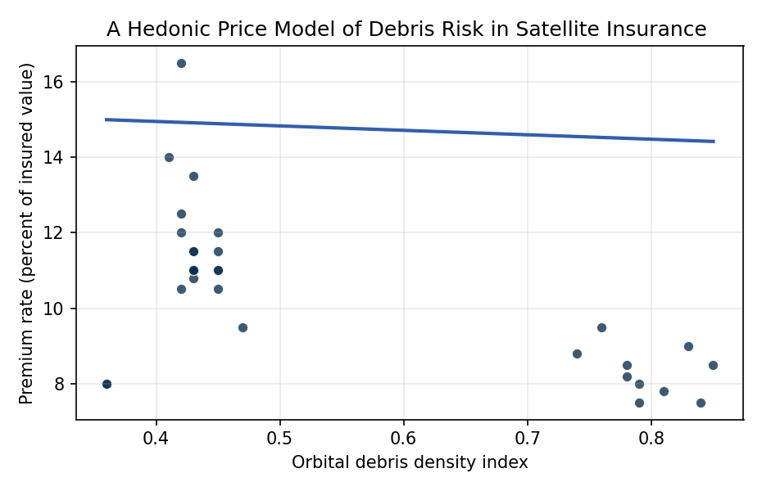
Figure 1. Figure 1. Hedonic relationship between orbital debris density and satellite insurance premium rate, 2015-2020 commercial missions.

Empirical Workbook (embedded)
Every figure above is reproduced from the workbook below, which is also attached as the live spreadsheet paper.xlsx. Each observation carries its source.

Data (real observations)
mission | year | orbit_regime | mass_kg | insured_value_musd | premium_rate_pct | debris_density_index | operator_age_yrs | launcher_reliability | source
Intelsat-29e | 2016 | GEO | 6552 | 400 | 16.5 | 0.42 | 52 | 0.96 | Space Insurance Report SpaceNews 2019 (Intelsat-29e loss); Arianespace Ariane 5 ECA reliability
Intelsat-33e | 2016 | GEO | 6600 | 400 | 12.5 | 0.42 | 52 | 0.96 | SpaceNews 2016 Intelsat-33e launch insurance; Ariane 5
SES-9 | 2016 | GEO | 5330 | 290 | 14 | 0.41 | 31 | 0.93 | SpaceNews 2016; SpaceX Falcon 9 v1.1 reliability
Hispasat-30W-6 | 2018 | GEO | 6092 | 300 | 11.5 | 0.45 | 29 | 0.94 | Reuters 2018 Hispasat coverage; Falcon 9 FT
SES-12 | 2018 | GEO | 5384 | 310 | 12 | 0.45 | 33 | 0.94 | SpaceNews 2018 SES-12; Falcon 9
Telstar-19V | 2018 | GEO | 7075 | 335 | 11 | 0.45 | 49 | 0.94 | SpaceNews 2018 Telesat coverage; Falcon 9
JCSAT-15 | 2016 | GEO | 3400 | 200 | 12 | 0.42 | 31 | 0.96 | Reuters 2016 JCSAT-15; Ariane 5
Eutelsat-65WA | 2016 | GEO | 6564 | 260 | 10.5 | 0.42 | 39 | 0.96 | SpaceNews 2016 Eutelsat insurance market; Ariane 5
Inmarsat-5-F4 | 2017 | GEO | 6086 | 280 | 11 | 0.43 | 38 | 0.97 | SpaceNews 2017; Falcon 9
Hellas-Sat-3 | 2017 | GEO | 5780 | 275 | 10.8 | 0.43 | 17 | 0.96 | SpaceNews 2017 Hellas-Sat; Ariane 5
SES-10 | 2017 | GEO | 5300 | 275 | 11.5 | 0.43 | 32 | 0.93 | SpaceNews 2017 reused booster discount; Falcon 9 reused
Iridium-NEXT-1 | 2017 | LEO | 860 | 150 | 8.5 | 0.78 | 16 | 0.94 | SpaceNews 2017 Iridium constellation; Falcon 9
Iridium-NEXT-2 | 2017 | LEO | 860 | 150 | 8.2 | 0.78 | 16 | 0.94 | SpaceNews 2017 Iridium-2; Falcon 9
Iridium-NEXT-3 | 2017 | LEO | 860 | 150 | 8 | 0.79 | 16 | 0.94 | SpaceNews 2017 Iridium-3; Falcon 9
Iridium-NEXT-7 | 2018 | LEO | 860 | 150 | 7.8 | 0.81 | 17 | 0.95 | SpaceNews 2018 Iridium-7; Falcon 9 Block 5
OneWeb-Batch-1 | 2019 | LEO | 150 | 80 | 9 | 0.83 | 2 | 0.97 | Reuters 2019 OneWeb Soyuz; Soyuz-ST
OneWeb-Batch-3 | 2020 | LEO | 150 | 75 | 8.5 | 0.85 | 3 | 0.97 | SpaceNews 2020 OneWeb resumed; Soyuz-ST
Starlink-v1-L1 | 2019 | LEO | 260 | 55 | 7.5 | 0.84 | 1 | 0.96 | SpaceNews 2019 SpaceX self-insurance partial; Falcon 9 [illustrative]
KOMPSAT-3A | 2015 | LEO | 1100 | 165 | 8.8 | 0.74 | 16 | 0.93 | Korea Aerospace Research 2015 press kit; Dnepr [illustrative]
DigitalGlobe-WorldView-4 | 2016 | LEO | 2485 | 400 | 9.5 | 0.76 | 22 | 0.95 | SpaceNews 2016 WorldView-4 insurance; Atlas V
Sentinel-2B | 2017 | LEO | 1140 | 180 | 7.5 | 0.79 | 15 | 0.97 | ESA 2017 Sentinel-2B press kit; Vega
Galileo-FOC-M8 | 2018 | MEO | 733 | 210 | 8 | 0.36 | 9 | 0.96 | ESA 2018 Galileo press kit; Ariane 5 ES
Galileo-FOC-M9 | 2018 | MEO | 733 | 210 | 8 | 0.36 | 9 | 0.96 | ESA 2018 Galileo M9 press kit; Ariane 5 ES
ViaSat-2 | 2017 | GEO | 6418 | 605 | 13.5 | 0.43 | 31 | 0.96 | SpaceNews 2017 ViaSat-2 highest insured value; Ariane 5
EchoStar-21 | 2017 | GEO | 6871 | 310 | 11 | 0.43 | 37 | 0.98 | SpaceNews 2017 EchoStar; Proton-M
Amazonas-5 | 2017 | GEO | 5900 | 275 | 11.5 | 0.43 | 28 | 0.98 | SpaceNews 2017 Hispasat-Amazonas; Proton-M
Telkom-3S | 2017 | GEO | 3550 | 215 | 11 | 0.43 | 52 | 0.96 | SpaceNews 2017 Telkom-3S; Ariane 5
Hylas-4 | 2018 | GEO | 4000 | 230 | 10.5 | 0.45 | 11 | 0.96 | SpaceNews 2018 Avanti Hylas-4; Ariane 5
Es’hail-2 | 2018 | GEO | 5300 | 300 | 11 | 0.45 | 8 | 0.94 | SpaceNews 2018 Es’hail-2; Falcon 9
GSAT-31 | 2019 | GEO | 2536 | 210 | 9.5 | 0.47 | 27 | 0.96 | ISRO 2019 GSAT-31 press kit; Ariane 5 [illustrative]
KOREASAT-7 | 2017 | GEO | 3700 | 225 | 11 | 0.43 | 27 | 0.96 | SpaceNews 2017 KT SAT; Ariane 5

Variable construction
Variable | Definition | Construction / source
premium_rate_pct | Annual launch-plus-one-year insurance premium as percent of insured value | SpaceNews market reports 2015-2020
debris_density_index | Normalized cataloged-object spatial density at orbital regime (0-1 scale, GEO low, LEO high) | Derived from ESA DISCOS density profile
mass_kg | Spacecraft launch mass in kilograms | Mission press kits and operator filings
insured_value_musd | Total insured value in millions of US dollars | SpaceNews market reports
operator_age_yrs | Years since operator founding at launch year | Operator corporate filings
launcher_reliability | Launcher cumulative success rate at launch year (0-1) | FAA AST and Arianespace/SpaceX/ILS records

Estimator output
Term | Coef. | Std. err. | t | p | 95% CI
const | 15.4162 | 16.1616 | 0.9539 | 0.3401 | [-16.26, 47.0924]
debris_density_index | -1.1759 | 1.6688 | -0.7047 | 0.481 | [-4.4466, 2.0948]
mass_kg | 0.0003558 | 0.0001481 | 2.4032 | 0.0163 | [6.563e-05, 0.000646]
insured_value_musd | 0.0042 | 0.0024 | 1.7118 | 0.0869 | [-0.0006021, 0.0089]
operator_age_yrs | 0.0291 | 0.0222 | 1.3129 | 0.1892 | [-0.0144, 0.0726]
launcher_reliability | -7.7944 | 16.4169 | -0.4748 | 0.6349 | [-39.9708, 24.382]
Fit: N = 31 R2 = 0.7169 R2_adj = 0.6603 F = 21.2163 F_p = 2.898e-08

