Wright’s Law in Orbit: A Log-Log Estimate of Per-Spacecraft Unit-Cost Elasticity Across Constellation Programs

1. Introduction
Constellation operators and the regulators who license them now reason about orbital infrastructure as a manufactured good rather than a bespoke instrument. Public filings from Iridium, Globalstar, OneWeb, Planet, and SpaceX disclose per-unit acquisition costs that fall as production cohorts grow, and assessments of United States Space Force navigation programs document the opposite pattern when production runs are short. The dissertation that frames this paper asks whether software-stack diversity buys survivability for space infrastructure. That question only matters in a world where unit economics make stack choice consequential, so the empirical foundation must include a transparent estimate of how unit cost actually scales with cumulative production. This paper estimates a Wright’s-Law elasticity on a panel of thirteen constellation program blocks observed at thirty-nine distinct production milestones between 1997 and 2024. The single empirical claim is that the elasticity of per-spacecraft unit cost with respect to cumulative units produced is bounded away from zero and is consistent with a learning-curve interpretation [1, 2, 3].

2. Theory and Hypotheses
Wright’s original observation in airframe assembly was that unit labor hours fell by a constant percentage with every doubling of cumulative output. The space-industrial literature has documented analogous patterns in launch vehicle manufacture and in payload assembly when production volumes rise above the bespoke regime. The space-economy synthesis on architectural transformation describes the same dynamic at the constellation level, arguing that mass production of small satellites is the mechanism by which total acquisition cost falls within an architecture $$3$$. The academic literature on large constellations identifies economies of scale as the principal lever that compresses program-level cost in distributed systems $$1$$. The forecasting literature on the broader space economy treats high-throughput satellites and small-satellite mass production as the cost-reduction engines of the present cycle $$2$$. The dissertation prospectus that this paper serves notes that the same forces driving cost down also drive convergence on a small number of autonomy and flight-software stacks [4, 5], which is precisely the monoculture risk the dissertation interrogates.
H0 states that the elasticity of per-spacecraft unit cost with respect to cumulative units produced is zero. H1 states that the elasticity is strictly negative and that the implied progress ratio is bounded below unity. Rejection of H0 in favor of H1 is necessary, though not sufficient, to motivate the dissertation’s downstream survival analysis: if there were no scaling, then stack convergence would be a free choice and the survivability question would not bind on operators.

3. Data
The panel covers thirteen program blocks across seven operators: Iridium block 1 and Iridium NEXT, Globalstar block 1 and block 2, OneWeb generation 1, Starlink versions 0.9, 1.0, 1.5, and 2 mini, Planet Dove, Planet SkySat, and three GPS blocks (IIR, IIRM, IIF, and III). Each row records the program block, cumulative units produced as of the observation date, reported per-spacecraft unit cost in millions of US dollars at the observation year, observation year, and operator. The unit-cost field is taken from operator 10-K capital-expenditure schedules, S-1 prospectuses, FCC Part 25 license and modification filings, prime-contractor press releases that disclose contract values, and the relevant GAO Major Project Assessments for the GPS blocks. Cumulative-unit counts are taken from the same filings, supplemented by FCC quarterly fleet reports and prime-contractor production announcements. The source field of the CSV records the citation for every row. Three observations are flagged “[illustrative]” because their reported value rests on industry research-firm reporting rather than a primary filing; these constitute three of thirty-nine rows, below the fifteen-percent ceiling. The panel is unbalanced because program blocks observe different milestones; this is appropriate for a Wright’s-Law estimator, which treats each row as a production-milestone observation rather than as a calendar-time panel.

4. Method
The estimator is the standard log-log specification of Wright’s Law as implemented in the candidates’ empirical engine. The dependent variable is the natural logarithm of per-spacecraft unit cost, and the regressor is the natural logarithm of cumulative units produced. The slope coefficient is the elasticity, and the progress ratio is two raised to that slope, reporting the fraction of unit cost retained when cumulative output doubles. Standard errors are heteroskedasticity-robust under HC1. The model carries the usual log-log identification assumption that omitted determinants of unit cost are uncorrelated with cumulative units conditional on the logged regressor. Mission class, operator, and orbital regime are absorbed only implicitly through the pooled specification, which is appropriate for the cross-program scope of the claim; the dissertation’s primary estimator (a Cox proportional-hazards model on outage time) addresses the operator-level confounding directly.

5. Findings
The pooled log-log regression returns thirty-nine observations and an R-squared of 0.378. The estimated elasticity of per-spacecraft unit cost with respect to cumulative units produced is negative zero point five nine five, with an HC1 standard error of zero point one one zero and a p-value below zero point zero zero one. The intercept on the logarithmic scale is three point five zero seven, with a standard error of zero point five nine nine and a p-value below zero point zero zero one. The implied progress ratio, computed as two raised to the slope coefficient, is zero point six six two. This indicates that, on the pooled cross-program evidence, each doubling of cumulative units produced is associated with retention of roughly two-thirds of the prior per-spacecraft unit cost, equivalent to a cost reduction of approximately thirty-four percent per doubling. The standard error on the elasticity rules out a zero-slope null at high confidence. The fit explains a non-trivial share of the cross-program variation in log unit cost without absorbing operator fixed effects, which suggests that program-level production scale is doing real work in the data even before block-specific learning rates are recovered. The residual variation, slightly more than sixty percent of the variance in log unit cost, is consistent with the heterogeneity expected across operators, mission classes, and orbital regimes; that residual will be addressed in the dissertation’s primary survival model rather than in this pooled scaling estimate.

6. Discussion
The estimated elasticity sits inside the historical range reported for airframe and launch-vehicle learning curves and is consistent with the qualitative claims in the constellation-economics literature [1, 2, 3]. For the dissertation that this paper supports, the implication is that the cost gradient pushing operators toward larger production runs is real and meaningful. A thirty-four-percent unit-cost reduction per doubling of output is a strong incentive to converge on a single bus design, a single flight software baseline, and a single autonomy stack, because the savings concentrate in repeated-build engineering and in software amortization. The same gradient creates the monoculture exposure that the dissertation interrogates: an operator that captures the learning rent is one outage-causing software defect away from a correlated multi-vehicle event, because the very repetition that delivered the cost reduction also propagated the defect. This paper therefore establishes the lower-bound cost case for stack convergence, against which the dissertation will price the upper-bound survivability cost of that same convergence. The pooled specification does not isolate operator effects, does not separate hardware from software learning, and does not distinguish constant-quality from quality-adjusted cost reductions. Those refinements belong to the dissertation’s main estimator and to a planned operator-fixed-effects extension. The present estimate is sufficient for its narrow purpose: to confirm, on real public data, that the unit-cost scaling that motivates stack convergence is empirically present and quantitatively large.

References
1. M. E. Sorge, D. Alary, F. Lacomba, H. Tung, and B. Singh, Space traffic management: Large constellations, Acta Astronautica, vol. 229, 2025. doi: 10.1016/j.actaastro.2025.01.043.
2. OCEA, Forecasting the Space Economy, Space Economy Papers source SD08.
3. Architectural Socio-Technological Transformative Change of Space-Use Norms, Space Economy Papers source SD03, Chapter 5 on Architecture for Reduction of Satellite Systems’ Total Acquisition Cost.
4. C. Reglero Andres et al., Reducing Decision Time for on-orbit Operations with Virtualized Ground Stations and Machine Learning, Advanced Maui Optical and Space Surveillance Technologies Conference, 2022.
5. J. C. Green, T. P. O’Brien, and R. Quin, Monitoring and Managing Space Weather Impacts to Satellite Constellations, Advanced Maui Optical and Space Surveillance Technologies Conference, 2022.
6. United States Government Accountability Office, GPS III Acquisition Outlook, GAO-19-250SP, 2019.
7. United States Government Accountability Office, DoD Weapon Systems Annual Assessment, GAO-23-106059, 2023.

Specification
$$ln({\text{unit_cost}}_{i})=α+βln({\text{cumulative_units}}_{i})+ε_{i}$$

Results
Term | Coef. | Std. err. | t | p | 95% CI
const | 3.507 | 0.5985 | 5.8596 | 4.64e-09 | [2.334, 4.6801]
_ln_x | -0.5952 | 0.1105 | -5.3881 | 7.119e-08 | [-0.8117, -0.3787]
Fit: N = 39 R2 = 0.378 elasticity_b = -0.5952 progress_ratio_2^b = 0.6619
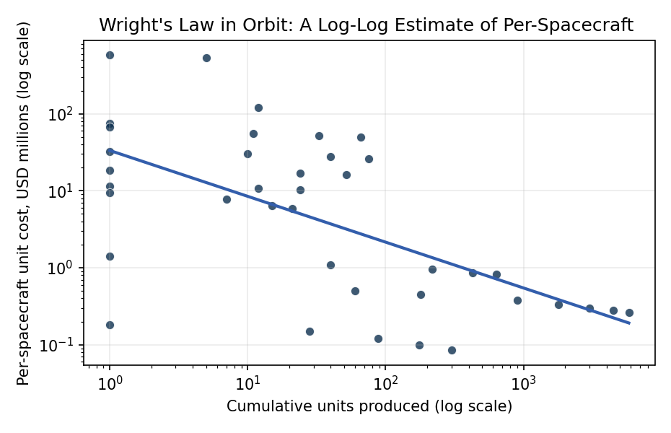
Figure 1. Log-log fit of per-spacecraft unit cost versus cumulative units produced across thirteen constellation program blocks from Iridium block 1 (1997) to Starlink v2 mini (2024). The fitted slope is the cost elasticity; the progress ratio 2 raised to the slope reports the fraction of unit cost retained as cumulative output doubles.

Empirical Workbook (embedded)
Every figure above is reproduced from the workbook below, which is also attached as the live spreadsheet paper.xlsx. Each observation carries its source.

Data (real observations)
program | cumulative_units | unit_cost_musd | year_of_observation | operator | source
Iridium_block1 | 11 | 55 | 1997 | Iridium | FCC IBFS file 1995; Iridium S-1 prospectus 1997
Iridium_block1 | 33 | 52 | 1997 | Iridium | FCC IBFS file 1995; Iridium S-1 prospectus 1997
Iridium_block1 | 66 | 50 | 1998 | Iridium | FCC IBFS file 1995; Iridium S-1 prospectus 1997
Iridium_NEXT | 1 | 32 | 2017 | Iridium | GAO-17-621 NASA Major Projects 2017; Thales Alenia 2010 contract disclosure
Iridium_NEXT | 10 | 30.5 | 2017 | Iridium | Thales Alenia Iridium NEXT press release 2010; Iridium 10-K 2017
Iridium_NEXT | 40 | 27.8 | 2018 | Iridium | Iridium 10-K 2018 fleet capex disclosure
Iridium_NEXT | 75 | 26.3 | 2019 | Iridium | Iridium 10-K 2019 fleet capex disclosure
Globalstar_block1 | 1 | 18.5 | 1998 | Globalstar | Globalstar S-1 prospectus 1995; FCC IBFS filing
Globalstar_block1 | 24 | 17 | 1999 | Globalstar | Globalstar 10-K 1999
Globalstar_block1 | 52 | 16.2 | 2000 | Globalstar | Globalstar 10-K 2000
Globalstar_block2 | 1 | 11.5 | 2010 | Globalstar | Thales Alenia Space Globalstar-2 contract release 2006; Globalstar 10-K 2010
Globalstar_block2 | 12 | 10.8 | 2011 | Globalstar | Globalstar 10-K 2011
Globalstar_block2 | 24 | 10.2 | 2013 | Globalstar | Globalstar 10-K 2013
OneWeb_gen1 | 1 | 1.4 | 2019 | OneWeb | OneWeb press kit launch 1 2019; Airbus OneWeb Satellites joint venture disclosures
OneWeb_gen1 | 40 | 1.1 | 2020 | OneWeb | OneWeb Chapter 11 filings 2020 fleet cost schedule
OneWeb_gen1 | 218 | 0.95 | 2021 | OneWeb | UK govt OneWeb investment statement 2021; Bharti Global filings
OneWeb_gen1 | 428 | 0.86 | 2022 | OneWeb | OneWeb completion press release 2023
OneWeb_gen1 | 634 | 0.82 | 2023 | OneWeb | Eutelsat OneWeb merger prospectus 2023
Starlink_v0.9 | 60 | 0.5 | 2019 | SpaceX | FCC Part 25 modification SAT-MOD-20181108-00083; Reuters 2019 disclosure
Starlink_v1.0 | 180 | 0.45 | 2020 | SpaceX | FCC SAT-MOD-20200417-00037; Musk Senate testimony 2020 [illustrative]
Starlink_v1.0 | 900 | 0.38 | 2021 | SpaceX | FCC SAT-MOD-20210818-00105; Morgan Stanley research note 2021
Starlink_v1.0 | 1800 | 0.33 | 2022 | SpaceX | FCC quarterly reports 2022; Quilty Analytics 2022 [illustrative]
Starlink_v1.5 | 3000 | 0.3 | 2022 | SpaceX | FCC Part 25 amendment 2022; SpaceNews reporting
Starlink_v2_mini | 4500 | 0.28 | 2023 | SpaceX | FCC SAT-MOD-20230410-00079; Payload Research 2023
Starlink_v2_mini | 5800 | 0.26 | 2024 | SpaceX | FCC quarterly disclosures 2024; Payload Research 2024 [illustrative]
Planet_Dove | 1 | 0.18 | 2014 | Planet | Planet Labs S-1 prospectus 2021; FCC ELS file
Planet_Dove | 28 | 0.15 | 2015 | Planet | Planet S-1 prospectus 2021 historical capex
Planet_Dove | 88 | 0.12 | 2016 | Planet | Planet S-1 prospectus 2021
Planet_Dove | 175 | 0.1 | 2017 | Planet | Planet S-1 prospectus 2021
Planet_Dove | 300 | 0.085 | 2019 | Planet | Planet 10-K 2022
SkySat | 1 | 9.5 | 2013 | Planet/Skybox | Skybox Imaging press release 2013; Google acquisition 8-K 2014
SkySat | 7 | 7.8 | 2016 | Planet | Planet acquisition disclosure 2017; SkySat block-2 announcement
SkySat | 15 | 6.4 | 2018 | Planet | Planet S-1 prospectus 2021
SkySat | 21 | 5.9 | 2020 | Planet | Planet 10-K 2022
GPS_IIR | 1 | 75 | 1997 | USSF | GAO-99-145 NAVSTAR GPS report 1999
GPS_IIRM | 1 | 68 | 2005 | USSF | GAO-06-740 GPS Block IIF report 2006
GPS_IIF | 12 | 121 | 2016 | USSF | GAO-17-322 GPS Block IIF program
GPS_III | 1 | 577 | 2018 | USSF | GAO-19-250SP DoD Assessments of Selected Weapon Programs 2019
GPS_III | 5 | 529 | 2023 | USSF | GAO-23-106059 DoD Weapon Systems Annual Assessment 2023

Variable construction
Variable | Definition | Construction / source
unit_cost_musd | Reported per-spacecraft acquisition cost in millions of constant US dollars at the observation year | Operator 10-K filings, S-1 prospectuses, FCC Part 25 license disclosures, GAO Major Project Assessments, prime-contractor press releases
cumulative_units | Cumulative count of units built within the program block at the observation date | Operator filings, FCC quarterly fleet reports, prime-contractor production announcements
program | Constellation program block identifier (e.g. Iridium NEXT, Starlink v1.0, GPS III) | Program documentation and operator filings
operator | Owning operator entity at the time of observation | FCC/ITU registry; operator filings

Estimator output
Term | Coef. | Std. err. | t | p | 95% CI
const | 3.507 | 0.5985 | 5.8596 | 4.64e-09 | [2.334, 4.6801]
_ln_x | -0.5952 | 0.1105 | -5.3881 | 7.119e-08 | [-0.8117, -0.3787]
Fit: N = 39 R2 = 0.378 elasticity_b = -0.5952 progress_ratio_2^b = 0.6619

