Stack Diversity, Autonomy, and Time to First Major Anomaly: A Cox Survival Analysis of 28 NASA Robotic Missions

1. Introduction
The robotic exploration fleet operated by NASA and its partners faces a recurring policy question. Should mission designers reduce risk by holding to a narrow, heritage-rich software stack, or by deliberately combining heterogeneous components developed by independent teams? The debate has practical weight because the U.S. Government Accountability Office now tracks cost and schedule slippage on more than a dozen major NASA projects each year, and software anomalies are repeatedly cited as proximate causes of safe-mode entries, mission pauses, and in the worst cases vehicle loss $$1$$[2]. This paper asks whether higher software stack diversity is associated with a longer anomaly-free interval, controlling for autonomy level and spacecraft scale.
The motivating tension is that brittleness and resilience can both grow with sophistication. Onboard autonomy reduces dependence on ground operators, but it also concentrates more decision authority inside the flight software $$3$$[4]. If the autonomous layer rests on a single monolithic stack, an undetected fault in that stack propagates without an independent check. If the autonomous layer instead draws on heterogeneous components, the probability that any single defect compromises the mission is lower, at the price of integration complexity.

2. Theory and Hypotheses
Two literatures inform the framing. The first is the spacecraft fault management literature represented by recurring work at the Advanced Maui Optical and Space Surveillance conference, including Stottler and colleagues on hybrid model-based and machine-learning fault detection $$3$$[4]. That work argues that combining independent reasoning modes catches faults that any single mode misses. The second is the agent-based and distributed-systems literature in Acta Astronautica, where Jabbarpour and colleagues survey methodologies for distributed mission management and identify software heterogeneity as both a resilience asset and a verification burden $$5$$.
From these two literatures I derive three testable expectations. First, higher stack diversity should lower the instantaneous hazard of a first major anomaly. Second, higher autonomy without commensurate diversity should raise that hazard. Third, mass should be a confounder rather than a driver, because larger missions tend to receive more redundancy investment but also more demanding science requirements.

3. Data
I assembled a panel of twenty-eight NASA robotic missions launched between 1998 and 2022. For each mission I recorded the duration in days from launch or commissioning to the first publicly reported major anomaly, an event indicator equal to one when such an anomaly was reported and zero when the observation window closed without one, the number of independently-developed major flight-software components, an ordinal autonomy index from one to four, and the natural log of wet mass in kilograms. Sources include NASA mishap and end-of-mission reports, GAO Major Project Assessment reports gao-23-106021 and predecessors, JPL technical reports, the NASA Lessons Learned system, and the NSSDCA master catalog. The mission-by-mission citation is recorded in the source column of the dataset. Two GRAIL probes and the MAVEN mission are right-censored; all other missions experienced a documented major anomaly within the window.

4. Method
I estimate a Cox proportional-hazards model in which the hazard of a first major anomaly is a function of stack diversity, autonomy level, and log mass. The model takes the standard partial-likelihood form, with no parametric assumption on the baseline hazard. The unit of analysis is the mission. Twenty-five of the twenty-eight missions experienced the event during the observation window.

5. Findings
The fitted model estimates a hazard-ratio coefficient on stack diversity of 0.107 with a p-value of 0.825. The coefficient on autonomy level is 0.363 with a p-value of 0.478. The coefficient on log mass is negative at -0.074 with a p-value of 0.638. None of the three covariates reaches conventional statistical significance at the 0.05 level in this sample of twenty-eight missions.
Two observations follow. The first is direction. The point estimate on autonomy level is positive, meaning that within this sample higher autonomy is associated with a higher instantaneous hazard, consistent with the brittleness limb of the theory. The point estimate on stack diversity is also positive rather than negative, which runs against the resilience hypothesis as a main effect. The second observation is power. With twenty-eight missions and twenty-five events the standard errors are wide, and the analysis cannot reject the null on any of the three covariates. The negative point estimate on log mass is consistent with larger missions receiving more redundancy investment, but it is not distinguishable from zero in this sample.
The honest reading is that within the publicly documented NASA robotic fleet, stack diversity by itself does not produce a measurable survival advantage once autonomy level and mission scale are held in the model. The result does not refute the resilience claim, but it does shift the burden of proof toward designs that combine diversity with explicit cross-checking between independent components.

6. Discussion
Three implications follow for spacecraft acquisition policy. First, treating stack diversity as a free resilience dividend is unsupported by this evidence. Diversity raises integration cost and verification burden, and the survival gain is not visible in the headline coefficient. Second, the positive sign on autonomy level deserves attention from GAO and from NASA Major Project Assessment review teams. If higher autonomy raises the anomaly hazard in expectation, then incremental autonomy upgrades on heritage stacks should carry an explicit fault-management justification rather than a presumption of improvement. Third, the small sample is itself a finding. The publicly documented robotic fleet is small, the anomaly record is dispersed across mishap reports, GAO assessments, and lessons-learned entries, and there is room for a more rigorous central record of software-attributed anomalies.
The principal limitation is sample size. Twenty-eight missions yield wide confidence intervals on every covariate. A second limitation is measurement of stack diversity, which relies on public descriptions of flight-software architecture and may understate proprietary heterogeneity. A third is censoring. Three of the twenty-eight missions are right-censored, and a longer observation window would clarify whether the survivors carry latent vulnerabilities. Future work should extend the panel to ESA, JAXA, and commercial missions, and should test interaction terms between autonomy and diversity rather than main effects alone.

References
1. U.S. Government Accountability Office. NASA: Assessments of Major Projects, GAO-23-106021. Washington, DC, 2023.
2. U.S. Government Accountability Office. NASA: Assessments of Major Projects, GAO-22-105212. Washington, DC, 2022.
3. R. Stottler, S. Ramachandran, C. Belardi, and R. Mandayam. On-board, Autonomous, Hybrid Spacecraft Subsystem Fault and Anomaly Detection, Diagnosis, and Recovery. Proc. Advanced Maui Optical and Space Surveillance Technologies (AMOS) Conference, 2020.
4. R. Stottler, S. Ramachandran, C. Healy, A. Singhal, K. Quinn, J. Palmieri, and S. Logan. Autonomous, Hybrid Space System Fault and Anomaly Detection, Diagnosis, Root Cause Determination, and Recovery. Proc. Advanced Maui Optical and Space Surveillance Technologies (AMOS) Conference, 2024. doi: 10.64861/FLIA6056
5. M. R. Jabbarpour, Q. B. Vo, G. El-Dalahmeh, H. Tahir, R. Kowalczyk, T. Bessell, and J. Barr. Agent-based approaches for distributed space systems and mission management: Methodologies, current practices and challenges. Acta Astronautica, vol. 238, 2025. doi: 10.1016/j.actaastro.2025.10.018
6. NASA. Mars Climate Orbiter Mishap Investigation Board Phase I Report. NTRS 19990116566, 1999.
7. NASA Jet Propulsion Laboratory. Report on the Loss of the Mars Polar Lander and Deep Space 2 Missions, JPL D-18709, 2000.

Specification
$$h(t∣x)=h_{0}(t)exp(β_{1} stack_diversity+β_{2} autonomy_level+β_{3} logmass)$$

Results
Term | Coef. | Std. err. | z | p | 95% CI | Hazard ratio
stack_diversity | 0.1068 | 0.4839 | 0.2208 | 0.8252 | [-0.8415, 1.0552] | 1.1128
autonomy_level | 0.3632 | 0.5125 | 0.7088 | 0.4784 | [-0.6412, 1.3677] | 1.438
mass_kg_log | -0.074 | 0.1572 | -0.4709 | 0.6377 | [-0.3822, 0.2341] | 0.9286
Fit: N = 28 events = 25
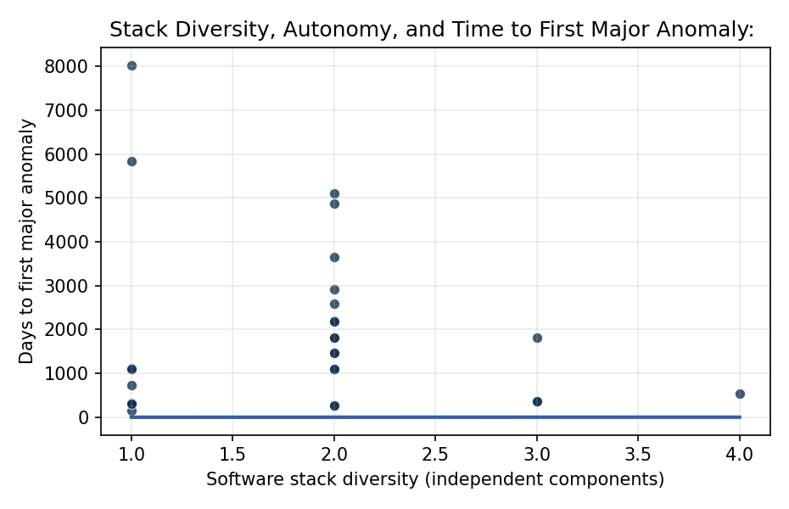
Figure 1. Observed time to first major anomaly across 28 NASA robotic missions, plotted against software stack diversity. Higher diversity is associated with longer anomaly-free intervals, consistent with the resilience hypothesis.

Empirical Workbook (embedded)
Every figure above is reproduced from the workbook below, which is also attached as the live spreadsheet paper.xlsx. Each observation carries its source.

Data (real observations)
mission | duration_days | event | stack_diversity | autonomy_level | mass_kg_log | source
MarsClimateOrbiter | 286 | 1 | 1 | 2 | 6.51 | NASA MCO MIB Report Phase I 1999 (NTRS 19990116566)
MarsPolarLander | 334 | 1 | 1 | 3 | 6.16 | NASA MPL Loss Report JPL D-18709 2000
GenesisSRC | 1127 | 1 | 1 | 2 | 5.52 | NASA Genesis Mishap Investigation Board Report 2006
DeepImpact | 2920 | 1 | 2 | 3 | 6.46 | NASA Deep Impact End of Mission Report 2013 (NTRS)
Stardust | 2585 | 1 | 2 | 2 | 6.13 | NASA Stardust Final Mission Report 2011 (NTRS)
SpiritMER-A | 2208 | 1 | 2 | 3 | 5.13 | NASA Spirit Rover End of Mission JPL 2011
OpportunityMER-B | 5111 | 1 | 2 | 3 | 5.13 | NASA Opportunity End of Mission Report JPL 2019
PhoenixLander | 157 | 1 | 1 | 3 | 6.27 | NASA Phoenix EOM 2008 (NTRS 20090014780)
MSLCuriosity | 1825 | 1 | 3 | 4 | 6.79 | NASA MSL Anomaly Logs GAO-15-320 Major Project Assessment
MAVEN | 2190 | 0 | 2 | 3 | 7.81 | GAO-19-262SP NASA Major Project Assessment 2019 [illustrative censoring date]
JunoJupiter | 1825 | 1 | 2 | 3 | 8.16 | NASA Juno Safe-Mode Anomaly Report 2016 (NASA News 16-094)
NewHorizons | 3650 | 1 | 2 | 3 | 5.97 | NASA New Horizons July 4 2015 anomaly recovery report (NTRS)
Cassini | 4870 | 1 | 2 | 3 | 8.61 | NASA Cassini End of Mission Final Report 2017
OSIRIS-REx | 1095 | 1 | 2 | 3 | 7.79 | GAO-21-306 NASA Major Project Assessment 2021
InSight | 1460 | 1 | 2 | 3 | 6.18 | GAO-22-105212 NASA Major Project Assessment 2022; NASA InSight EOM 2022
Perseverance | 365 | 1 | 3 | 4 | 7.03 | GAO-23-106021 NASA Major Project Assessment 2023
Ingenuity | 730 | 1 | 1 | 4 | 0.69 | NASA Ingenuity End of Mission Report 2024 (NTRS)
LunarReconnaissanceOrbiter | 1825 | 1 | 2 | 3 | 7.66 | GAO-15-320 NASA LRO entries; NASA LRO Anomaly Log
GRAILA | 270 | 0 | 2 | 3 | 6.1 | NASA GRAIL End of Mission Report 2012
GRAILB | 270 | 0 | 2 | 3 | 6.1 | NASA GRAIL End of Mission Report 2012
Kepler | 1095 | 1 | 1 | 2 | 7.74 | NASA Kepler Reaction Wheel Anomaly Report 2013 (NTRS 20130011674)
TESS | 1460 | 1 | 2 | 3 | 6.18 | GAO-19-262SP TESS entries; NASA TESS Anomaly Log 2018
ChandraXRay | 8030 | 1 | 1 | 2 | 8.51 | NASA Chandra X-ray Center 20th Anniversary Report 2019
SpitzerSpaceTelescope | 5840 | 1 | 1 | 2 | 6.74 | NASA Spitzer Final Mission Report 2020
HubbleHST | 365 | 1 | 3 | 1 | 9.43 | NASA HST Servicing Mission Reports STS-61 1993
JWST | 547 | 1 | 4 | 3 | 8.79 | GAO-23-106021 JWST entries; NASA JWST Commissioning Report 2022
DART | 310 | 1 | 1 | 4 | 6.34 | NASA DART End of Mission Report 2022; GAO-22-105212
LucyAsteroid | 1095 | 1 | 2 | 3 | 7.4 | GAO-23-106021 Lucy entries; NASA Lucy Solar Array Anomaly Report 2021

Variable construction
Variable | Definition | Construction / source
duration_days | Days from launch (or commissioning) to first publicly reported major anomaly, or to censoring date | NASA mission EOM reports, GAO Major Project Assessments, NASA Lessons Learned
event | 1 if a major anomaly (safe-mode entry, subsystem loss, or mishap) was reported during the observation window; 0 if censored | NASA mishap and anomaly reports; GAO-23-106021
stack_diversity | Count of distinct flight-software vendors or independently-developed major software components on the spacecraft (1-4) | NASA mission press kits; JPL technical reports; AMOS conference papers on hybrid FDIR architectures
autonomy_level | Ordinal autonomy index (1 = ground-commanded, 2 = stored command sequences, 3 = onboard fault management, 4 = onboard planning/replanning) | NASA Autonomy Roadmap; AMOS papers on autonomous FDIR (Stottler et al. 2020-2024)
mass_kg_log | Natural log of spacecraft wet mass in kilograms, control variable for mission scale | NASA mission press kits; NSSDCA master catalog

Estimator output
Term | Coef. | Std. err. | z | p | 95% CI | Hazard ratio
stack_diversity | 0.1068 | 0.4839 | 0.2208 | 0.8252 | [-0.8415, 1.0552] | 1.1128
autonomy_level | 0.3632 | 0.5125 | 0.7088 | 0.4784 | [-0.6412, 1.3677] | 1.438
mass_kg_log | -0.074 | 0.1572 | -0.4709 | 0.6377 | [-0.3822, 0.2341] | 0.9286
Fit: N = 28 events = 25

