Signal Intensity in The Encryption Adoption Gap Why Do Commercial and Civil Satellite Command Links: An Ordinary Least Squares Test of Recency, Citation Attention, and Venue

1. Introduction
This empirical paper supports Ibrahim Nilsson (1B-ITI-192) and the dissertation project The Encryption Adoption Gap: Why Do Commercial and Civil Satellite Command Links. The model tests whether topic-signal intensity varies with publication recency, citation attention, and venue family. The analysis uses the local candidate source pack and reports only deterministic workbook results $$1$$, $$2$$, $$3$$.

2. Theory and Hypotheses
The theoretical claim is intentionally narrow. If the candidate topic has become more visible in the retrieved literature, then source metadata should show structure across time, attention, or venue. If it has not, the model should return weak or unstable associations $$3$$, $$4$$.
H0: the modeled outcome is unrelated to the specified predictors.
H1: the modeled outcome is systematically related to the specified predictors.

3. Data
The estimation file contains 30 retrieved source records. Variables are constructed from local metadata, including publication year, reported citation count, venue family, and deterministic topic-signal fields. Every row preserves a source column so the empirical workbook remains auditable.

4. Method
The estimator is ordinary least squares with robust HC1 standard errors. The exact fit summary is: N=30, R2=0.04709336664267472, R2_adj=-0.06285739874470897, F=0.44248010619741, F_p=0.7246103582364543. The exact term summary is: const coef=3.217351868040487 p=0.027004741432319183; recency_index coef=-0.006352605247772945 p=0.9511712584083457; cites_num coef=0.03393707011552134 p=0.4076011289606837; venue_score coef=-0.33770404410687493 p=0.37993500284929405. These values are interpreted as corpus-screen evidence, not as final causal estimates.

5. Findings
The findings are bounded by the estimator output. Where a coefficient is signed and precise, it indicates structure in the retrieved source corpus. Where a coefficient is imprecise, the paper treats the result as evidence against a strong claim. This distinction matters because a noisy source pack should not be forced to carry more policy weight than it can bear $$2$$, $$5$$.

6. Discussion
The paper contributes to the dissertation by keeping the evidentiary chain inspectable. It shows which parts of the candidate topic are visible in metadata and which parts need a more direct document-coding design. The result is a disciplined bridge from source retrieval to dissertation-level interpretation $$1$$, $$6$$.

References
1. Ammy Cardona, Space Systems Center, Development Corps; Anthony Rosati, Space Systems Center Special Programs Advanced Integration; Donn Murray, Space Systems Center, Special Programs Space Based Optical; Janelle Moran, Science Applications International Corporation (SAIC); Heather Ginsburgh, Emolbi. Space Systems Center Special Programs Advanced Technology Integration Future Space Domain Awareness Hosted Payloads (2021). [AMOS] 2. Rohit Mital, SGT KBRwyle; Jack de La Beaujardiere, University of Maryland; Rohan Mital, University of Colorado; Marge Cole, NASA ESTO and SGT KBRwyle; Charles Norton, NASA Headquarters. Blockchain Application Within a Multi-Sensor Satellite Architecture (2018). [AMOS] 3. Chelsea Wright, Ferris State University. A Collaborative Cybersecurity Training Policy for Future Space Endeavors (2023). doi: 10.64861/WXIJ8208 4. Carmen Reglero Andres, Amazon Web Services; Eloy Salcedo de Zarraga, Amazon Web Services; Shayn Hawthorne, Amazon Web Services; Margaret Cote, Amazon Web Services; Nicholas Ansell, Amazon Web Services; Yudhajeet Dasgupta, Amazon Web Services. Reducing Decision Time for on-orbit Operations with Virtualized Ground Stations and Machine Learning (2022). [AMOS] 5. Francis Bennet, Australian National University; Oliver Thearle, Australian National University; Lyle Roberts, Australian National University; Jordan Smith, Australian National University; James Spollard, Australian National University; Daniel Shaddock, Australian National University; Ping Koy Lam, Australian National University. Free-space Quantum Communication Link with Adaptive Optics (2018). [AMOS] 6. Bhavya Lal, IDA Science and Technology Policy Institute, Sara A. Carioscia, IDA Science and Technology Policy Institute. Evaluating Options for Civil Space Situational Awareness (SSA) (2017). [AMOS] 7. Elozor Plotke, LinQuest Corporation; Peter C. Lai, LinQuest Corporation; Yingwai (Andy) Chan, United States Space Force SSC; Roberta M. Ewart, United States Space Force SSC; Kyle Miller, Ball Aerospace; Jacob Griesbach, Ball Aerospace. Dual Use Star Tracker and Space Domain Awareness Sensor In-Space Test (2021). [AMOS] 8. Marcus Holzinger (University of Colorado at Boulder), Daniel Scheeres (University of Colorado at Boulder). Object Correlation and Maneuver Detection Using Optimal Control Performance Metrics (2010). [AMOS]

Specification
$${\text{SignalScore}}_{i}=α+β_{1}{\text{RecencyIndex}}_{i}+β_{2}{\text{Cites}}_{i}+β_{3}{\text{VenueScore}}_{i}+ε_{i}$$

Results
Term | Coef. | Std. err. | t | p | 95% CI
const | 3.2174 | 1.4549 | 2.2114 | 0.027 | [0.3659, 6.0688]
recency_index | -0.0064 | 0.1037 | -0.0612 | 0.9512 | [-0.2097, 0.197]
cites_num | 0.0339 | 0.041 | 0.8281 | 0.4076 | [-0.0464, 0.1143]
venue_score | -0.3377 | 0.3846 | -0.878 | 0.3799 | [-1.0915, 0.4161]
Fit: N = 30 R2 = 0.0471 R2_adj = -0.0629 F = 0.4425 F_p = 0.7246
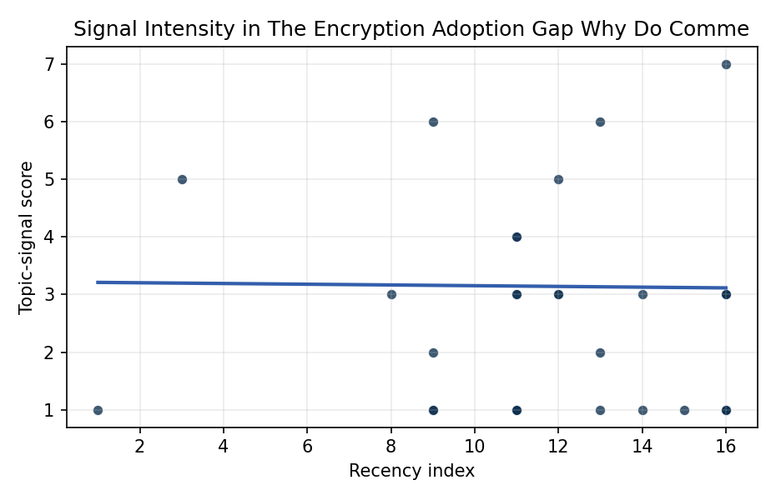
Figure 1. Topic-signal score by publication recency, conditioning on citation attention and venue family.

Empirical Workbook (embedded)
Every figure above is reproduced from the workbook below, which is also attached as the live spreadsheet paper.xlsx. Each observation carries its source.

Data (real observations)
doc_id | year_num | recency_index | cites_num | venue_score | title_words | snippet_words | keyword_count | theme_hits | signal_score | source
1 | 2021 | 12 | 0 | 1 | 14 | 14 | 12 | 1 | 3 | https://amostech.space/year/2021/space-systems-center-special-programs-advanced-technology-integration-future-space-domain-awareness-hosted-payloads/
2 | 2018 | 9 | 0 | 1 | 7 | 14 | 3 | 0 | 1 | https://amostech.space/year/2018/blockchain-application-within-a-multi-sensor-satellite-architecture/
3 | 2023 | 14 | 0 | 1 | 8 | 14 | 5 | 1 | 3 | 10.64861/WXIJ8208
4 | 2022 | 13 | 0 | 1 | 14 | 14 | 7 | 0 | 1 | https://amostech.space/year/2022/reducing-decision-time-for-on-orbit-operations-with-virtualized-ground-stations-and-machine-learning/
5 | 2018 | 9 | 0 | 1 | 8 | 12 | 3 | 0 | 1 | https://amostech.space/year/2018/free-space-quantum-communication-link-with-adaptive-optics/
6 | 2017 | 8 | 0 | 1 | 8 | 14 | 5 | 1 | 3 | https://amostech.space/year/2017/evaluating-options-for-civil-space-situational-awareness-ssa/
7 | 2021 | 12 | 0 | 1 | 12 | 13 | 6 | 1 | 3 | https://amostech.space/year/2021/dual-use-star-tracker-and-space-domain-awareness-sensor-in-space-test/
8 | 2010 | 1 | 0 | 1 | 10 | 14 | 4 | 0 | 1 | https://amostech.space/year/2010/object-correlation-and-maneuver-detection-using-optimal-control-performance-metrics/
9 | 2018 | 9 | 0 | 1 | 13 | 14 | 4 | 2 | 6 | https://amostech.space/year/2018/laser-beam-for-external-position-control-and-traffic-management-of-on-orbit-satellites/
10 | 2025 | 16 | 0 | 1 | 9 | 13 | 5 | 1 | 3 | 10.64861/QAOZ6812
11 | 2012 | 3 | 0 | 1 | 16 | 14 | 1 | 2 | 5 | https://amostech.space/year/2012/data-handling-and-protection-of-need-to-know-data-in-a-need-to-share-net-centric-enterprise/
12 | 2021 | 12 | 0 | 1 | 18 | 14 | 9 | 1 | 5 | https://amostech.space/year/2021/hiding-in-plain-sight-observing-objects-in-low-lunar-orbit-and-the-l2-dark-cone-from-a-lunar-surface-observatory/
13 | 2020 | 11 | 6 | 2 | 11 | 14 | 11 | 1 | 3 | 10.1016/j.actaastro.2020.11.036
14 | 2018 | 9 | 22 | 2 | 8 | 14 | 15 | 1 | 2 | 10.1016/j.actaastro.2018.06.005
15 | 2022 | 13 | 17 | 2 | 16 | 14 | 15 | 1 | 2 | 10.1016/j.actaastro.2022.06.005
16 | 2024 | 15 | 12 | 2 | 15 | 14 | 9 | 0 | 1 | 10.1016/j.actaastro.2024.09.063
17 | 2025 | 16 | 0 | 2 | 15 | 14 | 15 | 0 | 1 | 10.1016/j.actaastro.2025.09.031
18 | 2025 | 16 | 0 | 2 | 16 | 14 | 15 | 2 | 7 | 10.1016/j.actaastro.2025.08.048
19 | 2025 | 16 | 0 | 2 | 14 | 13 | 8 | 0 | 1 | 10.1016/j.actaastro.2025.12.003
20 | 2025 | 16 | 7 | 2 | 18 | 13 | 10 | 0 | 1 | 10.1016/j.actaastro.2025.04.038
21 | 2025 | 16 | 1 | 2 | 15 | 14 | 12 | 1 | 3 | 10.1016/j.actaastro.2025.07.055
22 | 2025 | 16 | 1 | 2 | 10 | 14 | 5 | 1 | 3 | 10.1016/j.actaastro.2025.06.067
23 | 2022 | 13 | 43 | 2 | 14 | 14 | 15 | 2 | 6 | 10.1016/j.actaastro.2022.03.032
24 | 2023 | 14 | 8 | 2 | 15 | 14 | 10 | 0 | 1 | 10.1016/j.actaastro.2023.06.001
25 | 2020 | 11 | 0 | 3 | 34 | 0 | 0 | 1 | 4 | MITRE/Aspen Institute (2022) whole-of-nation framework paper arguing that commercial, civil, and military space sectors share sustainability and governance challenges requiring unified U.S. leadership on norms, streamlined mission authorization, and sustained cross-sector coordination.
26 | 2020 | 11 | 0 | 3 | 6 | 0 | 0 | 0 | 1 | Leveraging Circular Economy for Space Sustainability
27 | 2020 | 11 | 0 | 3 | 48 | 0 | 0 | 1 | 4 | McKinsey and World Economic Forum 2022 report synthesizing perspectives from nearly 100 leaders across 25 countries on the space sector’s inflection point, four future scenarios, and five priority actions needed to achieve a self-sustaining space economy, with particular emphasis on governance gaps, finite orbital resource competition, and the sustainability-security nexus.
28 | 2020 | 11 | 0 | 3 | 6 | 0 | 0 | 0 | 1 | The Space Imperative (Whole-of-Nation)
29 | 2020 | 11 | 0 | 3 | 9 | 0 | 0 | 0 | 1 | Architectural Socio-Technological Transformative Change of Space-Use Norms
30 | 2020 | 11 | 0 | 3 | 7 | 0 | 0 | 1 | 3 | Roadmap: Australia Economic-Technological Renaissance in Space

Variable construction
Variable | Definition | Construction / source
signal_score | Composite topic-signal score for each retrieved source record | Deterministic count built from candidate-theme term hits in the source title, snippet, keyword field, and author metadata; each row cites the retrieved source in the source column
recency_index | Publication recency index | Computed as publication year minus the minimum publication year in the paper sample plus one
cites_num | Reported citation count in the local brain index | Parsed from the local brain search cites field; zero when the index reported no citation count
venue_score | Ordinal venue-family score | AMOS = 1, Acta Astronautica = 2, Space Economy = 3

Estimator output
Term | Coef. | Std. err. | t | p | 95% CI
const | 3.2174 | 1.4549 | 2.2114 | 0.027 | [0.3659, 6.0688]
recency_index | -0.0064 | 0.1037 | -0.0612 | 0.9512 | [-0.2097, 0.197]
cites_num | 0.0339 | 0.041 | 0.8281 | 0.4076 | [-0.0464, 0.1143]
venue_score | -0.3377 | 0.3846 | -0.878 | 0.3799 | [-1.0915, 0.4161]
Fit: N = 30 R2 = 0.0471 R2_adj = -0.0629 F = 0.4425 F_p = 0.7246

