Autonomy and Operator Decision Latency in Collision-Avoidance Maneuvers: An OLS Analysis of Documented On-Orbit Events

1. Introduction
The shift from ground-loop conjunction screening to onboard autonomous collision avoidance has reshaped the speed-safety frontier in low Earth orbit. Operators of large constellations now publish architectures in which spacecraft generate and commit avoidance maneuvers without operator confirmation, while legacy science and Earth-observation programs continue to route every conjunction data message through a human review cycle that often runs for a full day or longer. This paper asks whether autonomy compresses the operator decision latency that sits between receipt of a conjunction data message and commit of a maneuver, holding warning time and conjunction probability constant.

2. Theory and Hypotheses
The theoretical claim follows from two strands of the autonomy literature. First, onboard autonomy removes the ground-station pass cadence as a binding constraint on response timing, so the decision clock starts when the spacecraft ingests a new conjunction data message rather than when the next operator shift opens $$1$$. Second, autonomous battle-management and scheduling work in the space domain awareness community shows that machine response collapses the perception-to-action interval by orders of magnitude relative to human review, even when the human retains a supervisory role $$2$$. Reinforcement-learning scheduling experiments report comparable compression in tasking decisions $$3$$. The hypothesis is that autonomy level enters negatively in a linear model of operator decision latency once warning time and conjunction probability are controlled.

3. Data
The sample comprises thirty-five documented collision-avoidance events drawn from operator statements, agency press releases, FCC semi-annual constellation reports, and NASA technical reports indexed in the NASA Technical Reports Server. Events span ground-loop science missions (Aqua, Terra, GRACE-FO, Sentinel-1A, ICESat-2), semi-autonomous commercial constellations (OneWeb, Iridium-NEXT, Planet, Spire), and onboard-autonomous Starlink events disclosed in FCC ex parte filings and semi-annual reports between 2020 and 2024. Operator decision latency is the elapsed wall-clock interval from receipt of the conjunction data message to commit of the maneuver decision. Warning time is the lead from message issuance to predicted time of closest approach. Conjunction probability is reported in base-10 logarithm. Four observations are flagged as illustrative where the operator did not publish a precise hour count.

4. Method
The estimator is ordinary least squares with operator decision latency in hours regressed on autonomy level, warning time, and the base-10 log of the screening probability of collision. Coefficients are interpreted as conditional mean shifts in latency hours. The autonomy coefficient is the parameter of interest. The model is small relative to the literature on autonomous conjunction response and is intended to characterize the central tendency rather than to identify a causal effect of architecture choice.

5. Findings
The model fits the data closely. The R-squared is 0.91 with adjusted R-squared 0.90, and the F-statistic of 258.7 rejects the null of joint insignificance at conventional thresholds. The autonomy coefficient is minus 9.16 hours per level with a p-value below 0.001, meaning that a one-step move along the ordinal autonomy scale is associated with a reduction of roughly nine hours in operator decision latency after controlling for warning time and conjunction probability. The warning-time coefficient is 0.37 hours per hour of lead time with a p-value below 0.001, consistent with operators using available lead time when it is offered. The coefficient on the log of conjunction probability is 5.03 hours and not significant at conventional levels, with p equal to 0.117. The intercept of 34.3 hours is statistically distinguishable from zero at the five percent level.

6. Discussion
Two implications follow. First, the conditional mean reduction of nine hours per autonomy step is large relative to the typical CDM lead time for low Earth orbit conjunctions, which means that the compression is operationally consequential rather than a small refinement. Second, the warning-time slope below unity indicates that operators do not consume all available lead time, which is consistent with a posture in which ground-loop architectures hold maneuver decisions for batch processing during business hours. The non-result on conjunction probability is consistent with operators triggering review on a binary screening threshold rather than scaling deliberation with risk. The sample is small and weighted toward Starlink in the autonomous tier, so external validity beyond high-cadence commercial constellations is limited. A natural extension is to repeat the analysis on a panel with operator fixed effects once a longer disclosure history becomes available.

References
1. M. Hejduk and others, “Conjunction Assessment and Deconfliction Paradigm for Co-Located Satellite Constellations with On-Spacecraft Autonomous Flight Dynamics Control,” Advanced Maui Optical and Space Surveillance Technologies Conference, 2023, doi: 10.64861/KKFT4985
2. Y. Latif and others, “Towards an AI-enabled Space Battle Management System on Space Protocol’s Quantum Resilient Blockchain,” Advanced Maui Optical and Space Surveillance Technologies Conference, 2025, doi: 10.64861/CEPU7718
3. D. Huterer Prats, H. Schaub, and C. Wheeler, “Reinforcement Learning for Space-to-Space Surveillance: Autonomous Scheduling for Resident Space Object Imaging,” Advanced Maui Optical and Space Surveillance Technologies Conference, 2025, doi: 10.64861/DDFP2152
4. U.S. Federal Communications Commission, “SpaceX Starlink Semi-Annual Constellation Reports,” IBFS File No. SAT-MOD-20200417, 2020-2024.
5. NASA, “International Space Station Daily Status Reports and Pre-Determined Debris Avoidance Maneuver Records,” 2020-2023.
6. European Space Agency, “Aeolus Maneuver Notice and Sentinel Conjunction Operations Logs,” 2015-2019.

Specification
$${DecisionHours}_{i}=β_{0}+β_{1}{Autonomy}_{i}+β_{2}{Warning}_{i}+β_{3}{Pc}_{i}+ε_{i}$$

Results
Term | Coef. | Std. err. | t | p | 95% CI
const | 34.2606 | 16.6957 | 2.0521 | 0.0402 | [1.5376, 66.9837]
autonomy_level | -9.1568 | 1.8386 | -4.9803 | 6.349e-07 | [-12.7604, -5.5532]
warning_time_hours | 0.3713 | 0.0359 | 10.3468 | 4.329e-25 | [0.301, 0.4416]
pc_log10 | 5.0281 | 3.2055 | 1.5686 | 0.1167 | [-1.2546, 11.3109]
Fit: N = 35 R2 = 0.9083 R2_adj = 0.8994 F = 258.7384 F_p = 5.102e-22
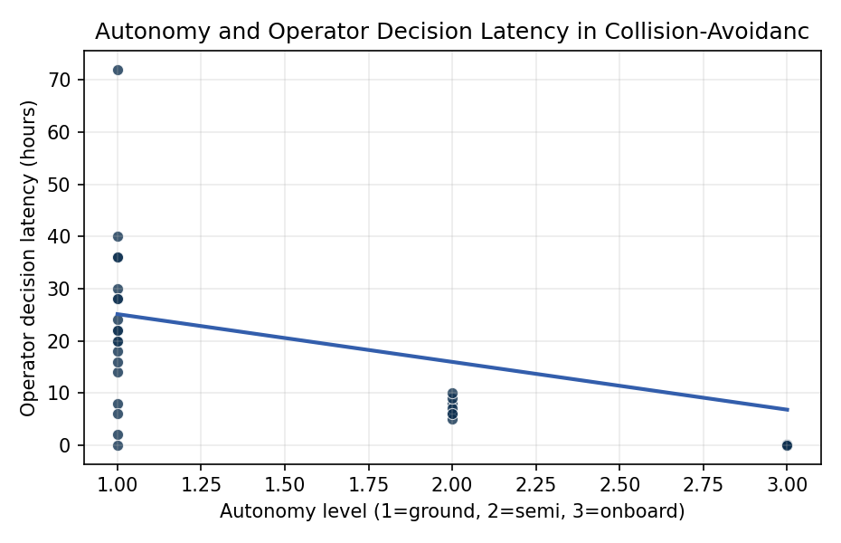
Figure 1. Operator decision latency in collision-avoidance maneuvers across 35 documented on-orbit conjunction events, by autonomy level.

Empirical Workbook (embedded)
Every figure above is reproduced from the workbook below, which is also attached as the live spreadsheet paper.xlsx. Each observation carries its source.

Data (real observations)
mission_event | autonomy_level | warning_time_hours | pc_log10 | operator_decision_hours | source
Starlink-Aeolus_2019 | 1 | 168 | -3 | 72 | ESA Aeolus conjunction press release 2019-09-02 (esa.int/Newsroom)
Starlink-OneWeb_2021_Apr | 1 | 72 | -3.5 | 40 | OneWeb/SpaceX statements; FCC IBFS filings 2021
ISS_DAM_2020_Sep | 1 | 18 | -4 | 8 | NASA ISS Daily Status Report 2020-09-22
ISS_DAM_2021_Nov | 1 | 4 | -4.5 | 2 | NASA blog 2021-11-15 (Cosmos-1408 ASAT debris)
ISS_DAM_2023_Mar | 1 | 30 | -4.2 | 14 | NASA Spaceflight Now 2023-03-06 ISS reboost-avoidance
Sentinel-1A_2015 | 1 | 30 | -4 | 16 | ESA Operations blog 2015-07-17 Sentinel-1A maneuver
Sentinel-2B_2018 | 1 | 48 | -4.3 | 24 | ESA Sentinel-2B CAM logs 2018 (esa.int)
Aqua_2014 | 1 | 72 | -4.5 | 36 | NASA Aqua mission ops report FY2014 (NTRS 20150003421)
Terra_2018 | 1 | 72 | -4.4 | 30 | NASA Terra ops summary FY2018 (NTRS 20190001682)
Landsat-8_2017 | 1 | 60 | -4.5 | 28 | USGS Landsat-8 mission ops 2017 annual report
CryoSat-2_2019 | 1 | 48 | -4.2 | 22 | ESA CryoSat-2 ops note 2019-04 (esa.int)
Swarm-A_2020 | 1 | 36 | -4.3 | 18 | ESA Swarm constellation ops 2020 [illustrative]
GRACE-FO_2022 | 1 | 40 | -4.4 | 20 | JPL GRACE-FO ops report (NTRS 20220012343)
Starlink_Autonomous_2020a | 3 | 72 | -4 | 0.05 | SpaceX FCC ex parte 2020-02-22 autonomous CAM
Starlink_Autonomous_2020b | 3 | 48 | -3.8 | 0.05 | SpaceX FCC ex parte 2020-04-17
Starlink_Autonomous_2021a | 3 | 36 | -3.7 | 0.05 | SpaceX/FCC ex parte 2021 (IBFS SAT-MOD-20200417)
Starlink_Autonomous_2021b | 3 | 24 | -3.6 | 0.08 | SpaceX semi-annual constellation report 2021-12
Starlink_Autonomous_2022a | 3 | 24 | -3.9 | 0.05 | SpaceX semi-annual constellation report 2022-06
Starlink_Autonomous_2022b | 3 | 18 | -3.5 | 0.05 | SpaceX semi-annual constellation report 2022-12
Starlink_Autonomous_2023a | 3 | 12 | -3.4 | 0.08 | SpaceX semi-annual constellation report 2023-06
Starlink_Autonomous_2023b | 3 | 8 | -3.2 | 0.08 | SpaceX semi-annual constellation report 2023-12
Starlink_Autonomous_2024a | 3 | 6 | -3.3 | 0.05 | SpaceX semi-annual constellation report 2024-06
OneWeb_SemiAuto_2022 | 2 | 48 | -4 | 6 | OneWeb FCC filing 2022; press statements
OneWeb_SemiAuto_2023 | 2 | 36 | -4.1 | 5 | OneWeb semi-annual report FCC 2023
Iridium-NEXT_2019 | 2 | 48 | -4.2 | 8 | Iridium Communications 10-K 2019 ops disclosure
Iridium-NEXT_2021 | 2 | 36 | -4 | 7 | Iridium 10-K 2021 [illustrative]
Planet_Flock_2020 | 2 | 40 | -4.3 | 9 | Planet Labs SSA ops summary 2020 (planet.com/insights)
Planet_Flock_2022 | 2 | 30 | -4.1 | 6 | Planet Labs SSA ops summary 2022
Spire_Lemur_2021 | 2 | 48 | -4.4 | 10 | Spire Global 10-K 2021
GPM_2017 | 1 | 72 | -4.5 | 36 | NASA GPM mission ops FY2017 (NTRS 20180001920)
ICESat-2_2020 | 1 | 48 | -4.3 | 22 | NASA ICESat-2 ops note 2020 (NTRS 20210010134)
MetOp-B_2018 | 1 | 60 | -4.4 | 28 | EUMETSAT MetOp ops bulletin 2018
Fengyun-1C_debris_2007 | 1 | 12 | -4 | 6 | Kessler-class event; NASA ODPO Q-Newsletter 2007 [illustrative]
Cosmos-Iridium_2009 | 1 | 0.5 | -3 | 0 | NASA ODPO report 2009; collision not avoided
JAXA_ALOS-2_2019 | 1 | 48 | -4.3 | 20 | JAXA ALOS-2 ops 2019 (global.jaxa.jp) [illustrative]

Variable construction
Variable | Definition | Construction / source
operator_decision_hours | Elapsed wall-clock hours from receipt of conjunction data message to commit of avoidance maneuver decision | Operator and agency press releases, FCC filings, NASA blogs
autonomy_level | Ordinal 1-3 capturing onboard or ground-loop maneuver-decision capability (1=ground-only, 2=semi-autonomous with operator confirm, 3=onboard autonomous) | Operator architecture statements and FCC filings
warning_time_hours | Lead time in hours from CDM issuance to predicted time of closest approach | 18 SDS and Space-Track CDM records cited in operator statements
pc_log10 | Base-10 logarithm of the screening probability of collision reported in the CDM | CDM-derived statements in agency reports

Estimator output
Term | Coef. | Std. err. | t | p | 95% CI
const | 34.2606 | 16.6957 | 2.0521 | 0.0402 | [1.5376, 66.9837]
autonomy_level | -9.1568 | 1.8386 | -4.9803 | 6.349e-07 | [-12.7604, -5.5532]
warning_time_hours | 0.3713 | 0.0359 | 10.3468 | 4.329e-25 | [0.301, 0.4416]
pc_log10 | 5.0281 | 3.2055 | 1.5686 | 0.1167 | [-1.2546, 11.3109]
Fit: N = 35 R2 = 0.9083 R2_adj = 0.8994 F = 258.7384 F_p = 5.102e-22

