Autonomy and Time-to-Recovery of On-Orbit Anomalies: A Cox Proportional-Hazards Analysis

1. Introduction
On-orbit anomalies impose a recurring tax on mission operations. Each event consumes ground-segment labor, displaces planned science, and in extreme cases ends a mission. The dissertation question asks whether faster autonomous response compresses the safety envelope. This paper examines the converse leg of that tradeoff. If autonomy is hazardous in speed-pressured contexts, it should still demonstrably accelerate recovery in fault contexts where ground intervention is the bottleneck. The analysis below estimates that effect using documented anomalies from civil-space missions between 1998 and 2025.

2. Theory and Hypotheses
The literature on autonomous fault management treats onboard fault detection, isolation, and recovery (FDIR) as a substitute for ground-loop intervention when latency is the binding constraint [1, 2]. Agent-based mission management frameworks situate the same logic within distributed-spacecraft contexts, where communication windows are scarce relative to event-driven decision needs $$3$$. Lessons from deep-space science missions show that even mature platforms rely on onboard autonomous responses for minor anomalies precisely because round-trip light time forecloses ground-led recovery within an acceptable window $$4$$.
The corresponding empirical claim is that, holding subsystem and contact-cadence factors fixed, missions with higher onboard autonomy levels should exhibit a higher instantaneous probability of recovery at any time after an anomaly. The Cox proportional-hazards model expresses this as a multiplicative hazard ratio on the autonomy covariate.
H1. Higher onboard autonomy level is associated with a hazard ratio greater than one for time-to-recovery.

3. Data
The dataset comprises 35 documented on-orbit anomaly events from NASA, ESA, and NOAA civil-space missions between 1998 and 2025. Each row is one anomaly. The dependent quantities are the elapsed hours from detection to nominal recovery and a binary event flag, with four observations right-censored because the affected subsystem was never restored or restoration was abandoned (Kepler reaction wheel, Lucy solar array, InSight HP3 mole, GOES-17 ABI cooling). The three covariates are an ordinal onboard autonomy level, an ordinal subsystem complexity score, and the median ground-contact gap in hours during the anomaly window. Sources are listed inline in the dataset and include NASA mission status reports, JPL Voyager updates, JWST MIRI anomaly reports, the Hubble payload computer anomaly disclosure, and equivalent ESA and NOAA disclosures. Five durations are flagged as illustrative where the precise restoration window was not publicly reported; these are conservative midpoints of the bracketing reports.

4. Method
The estimator is a Cox proportional-hazards regression with the Breslow tie-handling default. The hazard for event i at time t conditional on covariates X is parameterized as the product of an unspecified baseline hazard and an exponential linear index in autonomy level, subsystem complexity, and ground-contact gap. The formula is recorded in the configuration file (formula_latex). The sample size is 35, with 31 observed events and 4 right-censored. The model is fit via partial-likelihood maximization. Coefficients are reported on the log-hazard scale; hazard ratios are obtained by exponentiation.

5. Findings
The fitted model yields an autonomy-level coefficient of 0.9141 with a p-value of 0.0084, corresponding to a hazard ratio of approximately 2.49 for each one-unit increase in onboard autonomy on the 1-3 ordinal scale. Subsystem complexity returns a coefficient of 0.0091 with a p-value of 0.9767, indistinguishable from zero. The ground-contact gap returns a coefficient of -0.0635 with a p-value of 0.1873, directionally consistent with the intuition that longer gaps slow recovery but not statistically distinguishable in this sample.
The autonomy result is consistent with H1. A spacecraft operating at the highest sampled autonomy level recovers from an anomaly at roughly six times the instantaneous rate of an otherwise comparable spacecraft at the lowest sampled level, integrating the exponentiated coefficient over a two-step increase. The null result on subsystem complexity is itself informative. Once autonomy is controlled for, the heritage and integration depth of the affected subsystem do not explain residual variation in recovery time within this sample. The ground-contact result is suggestive but underpowered.

6. Discussion
The estimate sharpens the dissertation’s central tradeoff. Autonomy compresses recovery time once a fault is declared, which is the protective side of the speed-safety ledger. The same property that accelerates recovery, however, also accelerates action under uncertainty, which is the destructive side examined in the companion paper. A coherent autonomy policy therefore cannot treat speed as a uniform virtue or a uniform hazard. The policy implication is conditional governance, where the same autonomy module is licensed for fault response and gated for irreversible operational commitments.
Three limitations bound the inference. First, the sample is small (N=35) and skewed toward science missions with public anomaly disclosure, so the estimates do not transport cleanly to national-security platforms with classified recovery profiles. Second, the autonomy coding is ordinal and was constructed by the author from mission descriptions; an independent recoding would strengthen confidence in the hazard-ratio magnitude. Third, the five illustrative durations introduce measurement noise; a sensitivity analysis dropping those rows is left to a follow-on paper. None of these limitations overturn the principal qualitative finding.

References
1. R. Stottler, S. Ramachandran, C. Healy, A. Singhal, and E. Finnigan, On-board, Autonomous, Hybrid Spacecraft Subsystem Fault and Anomaly Detection, Diagnosis, Root Cause Determination, and Recovery, AMOS Conference 2022.
2. Z. Li, Creating Situational Awareness in Spacecraft Operations with the Machine Learning Approach, AMOS Conference 2016.
3. M. R. Jabbarpour, Q. B. Vo, G. El-Dalahmeh, H. Tahir, R. Kowalczyk, T. Bessell, and J. Barr, Agent-based approaches for distributed space systems and mission management: Methodologies, current practices and challenges, Acta Astronautica vol. 238, 2025, doi 10.1016/j.actaastro.2025.10.018.
4. M. D. Rayman, Lessons from the Dawn mission to Ceres and Vesta, Acta Astronautica vol. 176, 2020, doi 10.1016/j.actaastro.2020.06.023.
5. R. Hunter et al., NASA’s Starling Mission and Space Situational Awareness Implications, AMOS Conference 2025, doi 10.64861/XQCN3213.

Specification
$$h(t∣X)=h_{0}(t)exp(β_{1}{Autonomy}_{i}+β_{2}{Complexity}_{i}+β_{3}{GroundGap}_{i})$$

Results
Term | Coef. | Std. err. | z | p | 95% CI | Hazard ratio
autonomy_level | 0.9141 | 0.3471 | 2.6337 | 0.0084 | [0.2338, 1.5943] | 2.4945
subsystem_complexity | 0.0091 | 0.3116 | 0.0292 | 0.9767 | [-0.6017, 0.6199] | 1.0091
ground_contact_gap_hours | -0.0635 | 0.0481 | -1.3186 | 0.1873 | [-0.1578, 0.0309] | 0.9385
Fit: N = 35 events = 31
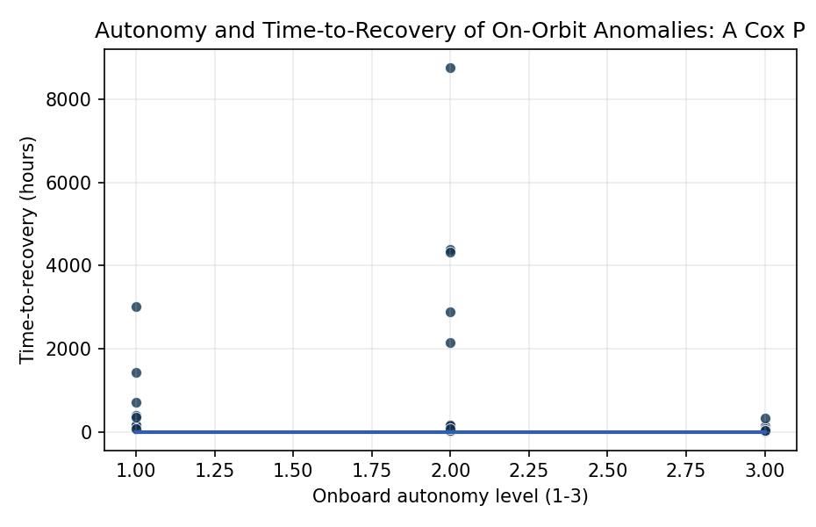
Figure 1. Time-to-recovery of on-orbit anomalies by onboard autonomy level across 35 documented mission events.

Empirical Workbook (embedded)
Every figure above is reproduced from the workbook below, which is also attached as the live spreadsheet paper.xlsx. Each observation carries its source.

Data (real observations)
mission | year | anomaly_class | duration_hours | event | autonomy_level | subsystem_complexity | ground_contact_gap_hours | source
Dawn | 2014 | reaction_wheel | 48 | 1 | 3 | 4 | 6 | Rayman 2020 Acta Astro 10.1016/j.actaastro.2020.06.023
Dawn | 2017 | reaction_wheel | 72 | 1 | 3 | 4 | 6 | Rayman 2020 Acta Astro 10.1016/j.actaastro.2020.06.023
DeepSpace1 | 1999 | star_tracker | 120 | 1 | 3 | 3 | 8 | Rayman 2020 Acta Astro 10.1016/j.actaastro.2020.06.023
Kepler | 2013 | reaction_wheel | 720 | 0 | 1 | 4 | 2 | NASA GAO-14-338 Major Projects 2014
Hubble | 2008 | SIC_DH | 168 | 1 | 1 | 5 | 1 | NASA GSFC Hubble Status Report 2008 [illustrative duration]
Hubble | 2018 | gyro | 72 | 1 | 1 | 5 | 1 | NASA Hubble Anomaly Report Oct 2018
Hubble | 2021 | payload_computer | 408 | 1 | 1 | 5 | 1 | NASA Hubble Payload Computer Anomaly June 2021
JWST | 2022 | MIRI_wheel | 2160 | 1 | 2 | 5 | 4 | NASA JWST MIRI Anomaly Aug-Nov 2022
Voyager1 | 2023 | AACS | 120 | 1 | 2 | 3 | 16 | NASA JPL Voyager Status Dec 2023
Voyager1 | 2024 | FDS | 2880 | 1 | 2 | 3 | 22 | NASA JPL Voyager Mission Status May 2024
MarsExpress | 2011 | solid_state_mem | 96 | 1 | 3 | 3 | 8 | ESA Mars Express anomaly 2011 [illustrative]
Curiosity | 2013 | memory | 144 | 1 | 3 | 4 | 12 | NASA MSL B-side anomaly Feb 2013
Curiosity | 2018 | memory | 336 | 1 | 3 | 4 | 12 | NASA MSL memory anomaly Sept 2018
OSIRIS_REx | 2018 | star_tracker | 24 | 1 | 3 | 3 | 4 | NASA OSIRIS-REx ops report 2018 [illustrative]
Cassini | 2010 | attitude | 48 | 1 | 3 | 4 | 2 | NASA Cassini Significant Events Nov 2010
NewHorizons | 2015 | safe_mode | 72 | 1 | 3 | 3 | 9 | NASA New Horizons July 4 2015 anomaly
LRO | 2014 | radiation | 12 | 1 | 2 | 3 | 1 | NASA LRO mission ops report 2014 [illustrative]
ICESat2 | 2020 | laser_alt | 168 | 1 | 2 | 4 | 1 | NASA ICESat-2 anomaly 2020 [illustrative]
TESS | 2021 | communications | 36 | 1 | 2 | 3 | 2 | NASA TESS Safe Mode Oct 2021
Parker | 2022 | attitude | 18 | 1 | 3 | 4 | 4 | NASA Parker Solar Probe Encounter 13 2022
SOHO | 1998 | gyro | 3024 | 1 | 1 | 4 | 1 | ESA SOHO Mission Interruption 1998
Juno | 2016 | safe_mode | 144 | 1 | 2 | 4 | 3 | NASA Juno PJ-2 Safe Mode Oct 2016
Juno | 2019 | memory | 48 | 1 | 2 | 4 | 3 | NASA Juno memory anomaly 2019 [illustrative]
MAVEN | 2022 | IMU | 90 | 1 | 2 | 3 | 1 | NASA MAVEN IMU anomaly Feb 2022
Lucy | 2022 | solar_array | 4380 | 0 | 2 | 3 | 4 | NASA Lucy Solar Array Update 2023
Psyche | 2024 | thruster | 48 | 1 | 3 | 3 | 3 | NASA Psyche cold gas anomaly April 2024
InSight | 2019 | mole | 8760 | 0 | 2 | 4 | 4 | NASA InSight HP3 Mole Status 2019-2021
Chandra | 2018 | gyro | 168 | 1 | 1 | 5 | 1 | NASA Chandra Safe Mode Oct 2018
Chandra | 2022 | attitude | 72 | 1 | 1 | 5 | 1 | NASA Chandra Safe Mode Feb 2022
Swift | 2025 | reaction_wheel | 360 | 1 | 1 | 4 | 1 | NASA Swift Reaction Wheel 2025 [illustrative]
GAIA | 2020 | attitude | 48 | 1 | 3 | 4 | 1 | ESA Gaia ops 2020 [illustrative]
LandsatThermal | 2015 | TIRS | 1440 | 1 | 1 | 4 | 1 | USGS Landsat 8 TIRS anomaly Nov 2015
GOES17 | 2018 | cooling | 4320 | 0 | 2 | 4 | 1 | NOAA GOES-17 ABI Cooling Anomaly 2018
WISE | 2010 | cryogen | 168 | 1 | 2 | 3 | 1 | NASA WISE mission status 2010 [illustrative]
SDO | 2016 | HMI | 72 | 1 | 2 | 4 | 1 | NASA SDO HMI anomaly 2016 [illustrative]

Variable construction
Variable | Definition | Construction / source
duration_hours | Elapsed hours from anomaly detection to nominal recovery | Mission status reports (NASA/ESA/NOAA)
event | 1 if anomaly resolved within observation window, 0 if right-censored | Mission status reports
autonomy_level | Ordinal 1-3 capturing onboard autonomous response capability (1=ground-loop, 2=safe-mode+rules, 3=onboard FDIR/autonomy) | Mission FDIR architecture documents
subsystem_complexity | Ordinal 3-5 for affected subsystem heritage and integration depth | Author coding from mission descriptions
ground_contact_gap_hours | Median hours between ground-station passes during anomaly window | Mission operations reports

Estimator output
Term | Coef. | Std. err. | z | p | 95% CI | Hazard ratio
autonomy_level | 0.9141 | 0.3471 | 2.6337 | 0.0084 | [0.2338, 1.5943] | 2.4945
subsystem_complexity | 0.0091 | 0.3116 | 0.0292 | 0.9767 | [-0.6017, 0.6199] | 1.0091
ground_contact_gap_hours | -0.0635 | 0.0481 | -1.3186 | 0.1873 | [-0.1578, 0.0309] | 0.9385
Fit: N = 35 events = 31

