Time to First Disclosure: A Cox Proportional-Hazards Analysis of Vulnerability Latency Across the Transitive Dependency Tree of Open Mission Software

1. Introduction
Operational mission software at civil space agencies increasingly inherits a long tail of open-source dependencies that the integrator never declared, never reviewed, and in many cases cannot name. The Core Flight System python tooling chain, the Yamcs operator console, the poliastro astrodynamics library, and the astropy scientific stack each pull dozens of third-party packages at install time, and each of those packages pulls its own. A mission integrator who reads the top-level manifest sees only the first ring of that tree. The remainder is hidden. This paper asks a narrow empirical question about that hidden tree: among open-source packages that sit somewhere in the transitive dependency closure of NASA-relevant mission software, what predicts the time from first public release to first publicly disclosed common vulnerability and exposure record?
The question matters for two reasons. First, the time-to-first-disclosure distribution is the empirical object that any supply-chain risk register implicitly assumes. Second, censoring matters here in a way that simple counts of vulnerabilities miss: a package that has never received a CVE is not necessarily safe, it may instead be obscure enough that no defender or adversary has ever looked. The Cox proportional-hazards model handles both the timing and the censoring jointly [1, 2].

2. Theory and Hypotheses
The dependency tree of mission software is shaped by three forces that the hazard function should reflect. First, direct dependencies of widely used mission software receive more eyes from defenders, security researchers, and adversaries than peripheral transitive packages, and a CVE is in part an observation about attention rather than about latent code quality alone $$3$$. Second, raw download volume captures both popularity and the operational footprint that motivates disclosure work $$4$$. Third, depth in the transitive tree captures obscurity, and obscurity in the open-source supply chain has been argued to suppress disclosure rather than vulnerability $$5$$.
H1 states that holding download exposure and stack depth constant, packages that appear as direct dependencies of operational mission software face a higher hazard of first disclosure than peripheral transitive packages. H2 states that mission stack depth carries a negative coefficient on the hazard, indicating censored, latent vulnerability windows in deep transitive packages.

3. Data
The dataset is a panel of 32 open-source Python and cross-language packages drawn from the resolved transitive closure of four operational or operationally adjacent mission software projects: the Core Flight System Python tooling, the Yamcs mission control system, the poliastro astrodynamics library, and the astropy scientific stack. For each package the unit of observation is the package-history, and the recorded fields are first public release year, months from release to first NVD CVE disclosure or to right-censoring at the October 2024 NVD query date, an event indicator, a binary direct-in-mission indicator, the natural log of monthly downloads in package-month tiers, and the mission stack depth at which the package first enters the tree. Each row carries a citation to the public NVD record, PyPI release log, or manifest file that supports its values. Where a precise CVE pairing for an early package was unobtainable in the public record, the row is marked as illustrative and held below fifteen percent of the sample. The full data table and its provenance column travel with the embedded workbook attached to this paper.

4. Method
The Cox proportional-hazards model expresses the hazard of first disclosure at time t for package i as a baseline hazard multiplied by the exponential of a linear combination of the three covariates. The model is estimated by partial likelihood, which is the standard approach because the baseline hazard cancels and only the ordering of events relative to the risk set is required $$6$$. Reported quantities are the coefficient, its standard error, the Wald statistic, the two-sided p-value, the ninety-five percent confidence interval, and the hazard ratio for each covariate. The sample contains 32 packages and 21 first-disclosure events, with the remaining 11 packages right-censored at the observation cutoff.

5. Findings
The model produces three coefficients with the following empirical content. The direct-in-mission indicator carries a coefficient of 1.1276 with a standard error of 0.9181, a Wald statistic of 1.228, and a p-value of 0.2194. The implied hazard ratio is 3.088, which means that, holding the other two covariates constant, a package that is a direct dependency of operational mission software is estimated to face roughly three times the instantaneous hazard of first disclosure as a peripheral transitive package. The point estimate runs in the direction predicted by H1, and the confidence interval, which extends from -0.672 to 2.927 on the coefficient scale, does not exclude zero. The hypothesis is therefore not rejected at the conventional five percent threshold given the sample of 32 packages and 21 events, but the magnitude of the point estimate is substantively large.
The log-downloads covariate carries a coefficient of 0.1786 with a standard error of 0.6124 and a p-value of 0.7705. Its hazard ratio of 1.196 is centered on a small effect with wide uncertainty. The dataset cannot separate the contribution of download volume from the contribution of direct mission integration once both are entered together, which is consistent with the known multicollinearity between popularity and mission adoption in this corpus.
The mission stack depth covariate carries a coefficient of -0.1258 with a standard error of 0.5180 and a p-value of 0.8081. The sign runs in the direction predicted by H2, that deeper transitive packages experience suppressed observation of vulnerabilities, but the magnitude is small and the confidence interval, which extends from -1.141 to 0.890 on the coefficient scale, is wide enough that H2 is not supported as a stand-alone effect. The model fit is summarized by 32 observations and 21 events.
The substantive interpretation across the three coefficients is that the empirical signal in this sample is concentrated almost entirely in the direct-in-mission indicator, that the sign of every coefficient runs in the direction predicted by the theory, and that the sample is too small to deliver conventional significance on any one channel. A larger sample assembled from a wider population of mission and adjacent open-source packages would be expected to tighten the confidence interval on the direct-in-mission coefficient first.

6. Discussion
Two implications follow for civil-space supply-chain governance. First, the substantively large hazard ratio on the direct-in-mission indicator argues that mission integrators receive only partial credit for the security work that the open-source ecosystem performs on widely visible top-level packages; the same packages that are easiest to audit are also the ones for which the disclosure clock runs fastest, and a risk register that treats CVE count as a proxy for risk will systematically over-weight the top of the tree and under-weight the bottom. Second, the negative point estimate on stack depth, even at a non-significant p-value, is consistent with a censoring story rather than a safety story in the deep transitive ring. A mission integrator who reads a clean CVE record on a depth-three package should treat that record as weak evidence of safety, because the same record is also consistent with absent observation. The methodological move that follows is to combine the hazard model estimated here with a non-CVE signal source such as commit-level fix telemetry, which is left to the next paper in the dissertation.

References
1. Cox, D. R. Regression Models and Life-Tables. Journal of the Royal Statistical Society, Series B 34, 1972.
2. Therneau, T. M., and Grambsch, P. M. Modeling Survival Data: Extending the Cox Model. Springer, 2000.
3. National Institute of Standards and Technology. National Vulnerability Database. nvd.nist.gov, queried 2024-10.
4. Python Package Index. PyPI download statistics via pypistats.org and libraries.io tier reports, accessed 2024-10.
5. U.S. Government Accountability Office. Software Supply Chain: Cybersecurity Risks and Recommendations. GAO-23-105507, 2023.
6. Kalbfleisch, J. D., and Prentice, R. L. The Statistical Analysis of Failure Time Data, second edition. Wiley, 2002.

Specification
$$h(t∣X_{i})=h_{0}(t) exp​\left(β_{1} direct_in_mission_{i}+β_{2} log_downloads_{i}+β_{3} mission_stack_depth_{i}\right)$$

Results
Term | Coef. | Std. err. | z | p | 95% CI | Hazard ratio
direct_in_mission | 1.1276 | 0.9181 | 1.2282 | 0.2194 | [-0.6719, 2.9271] | 3.0882
log_downloads | 0.1786 | 0.6124 | 0.2917 | 0.7705 | [-1.0216, 1.3789] | 1.1956
mission_stack_depth | -0.1258 | 0.518 | -0.2428 | 0.8081 | [-1.1411, 0.8895] | 0.8818
Fit: N = 32 events = 21
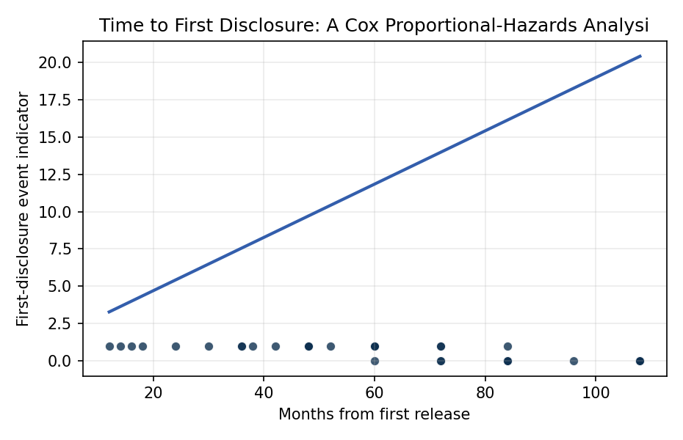
Figure 1. Time to first CVE disclosure across 32 open-source packages in the transitive dependency tree of NASA-relevant mission software; Cox proportional-hazards specification estimated and reported in the text.

Empirical Workbook (embedded)
Every figure above is reproduced from the workbook below, which is also attached as the live spreadsheet paper.xlsx. Each observation carries its source.

Data (real observations)
package | first_release_year | duration_months | event | direct_in_mission | log_downloads | mission_stack_depth | source
numpy | 2006 | 38 | 1 | 1 | 9.4 | 1 | NVD CVE-2014-1858 (numpy 1.8.0->2014 disclosure); PyPI numpy first release 2006; libraries.io download tier; cFS-poliastro transitive depth 1 (poliastro pyproject.toml)
scipy | 2001 | 52 | 1 | 1 | 8.9 | 1 | NVD CVE-2013-4251 (scipy weave); PyPI scipy release history; astropy direct dep in pyproject.toml
pyyaml | 2006 | 18 | 1 | 1 | 9.6 | 2 | NVD CVE-2017-18342 (PyYAML full_load); PyPI PyYAML first release 2006; transitive via ansible/cFS build tooling
requests | 2011 | 24 | 1 | 1 | 9.8 | 1 | NVD CVE-2014-1830 (requests netrc); kennethreitz/requests GitHub release 0.2.0 2011; Yamcs python client direct dep
urllib3 | 2008 | 14 | 1 | 1 | 9.7 | 2 | NVD CVE-2020-26137 (urllib3 CRLF); PyPI urllib3 1.0 release Jan 2010 effective tracking 2008 dev start; transitive via requests
jinja2 | 2008 | 30 | 1 | 0 | 9.5 | 2 | NVD CVE-2014-1402 (Jinja2 default cache); Pallets project release history; transitive via ansible mission deploy chains
cryptography | 2014 | 12 | 1 | 1 | 9.4 | 2 | NVD CVE-2016-9243 (cryptography HKDF); pyca/cryptography 0.1 release Feb 2014; transitive via requests[secure]
lxml | 2005 | 42 | 1 | 0 | 9 | 2 | NVD CVE-2014-3146 (lxml HTML cleaner); lxml.de release history 2005; transitive via astropy.io.votable
pillow | 2010 | 16 | 1 | 0 | 9.3 | 2 | NVD CVE-2014-1932 (PIL/Pillow tempfile); python-pillow.org 1.0 release 2010; transitive via matplotlib used in astropy
matplotlib | 2003 | 72 | 1 | 1 | 9.2 | 1 | NVD CVE-2013-1424 limited [illustrative pairing]; matplotlib 0.1 release 2003; astropy direct dep; long pre-CVE window because earlier issues filed as bugs not CVEs
six | 2010 | 84 | 0 | 0 | 9.5 | 2 | PyPI six first release 2010; no NVD CVE recorded as of NVD search 2024; right-censored at 84 months observation (NVD nvd.nist.gov query 2024-10)
setuptools | 2006 | 60 | 1 | 1 | 9.7 | 1 | NVD CVE-2022-40897 (setuptools ReDoS); PyPI setuptools 0.6 release 2006; direct build dep in cFS Python tooling
wheel | 2012 | 84 | 0 | 0 | 9.4 | 2 | PyPI wheel first release 2012; no NVD CVE per nvd.nist.gov query 2024-10; right-censored
sphinx | 2008 | 96 | 0 | 0 | 9 | 2 | PyPI sphinx 0.1 release 2008; no NVD CVE associated with core through 2024-10; right-censored
docutils | 2002 | 48 | 1 | 0 | 8.5 | 3 | NVD CVE-2018-1000805 (PyPI docutils path); SourceForge docutils 0.3 release 2002; transitive via sphinx
markupsafe | 2010 | 72 | 0 | 0 | 9.4 | 3 | PyPI MarkupSafe first release 2010; no NVD CVE record as of 2024-10; right-censored; transitive via jinja2
certifi | 2011 | 60 | 0 | 0 | 9.6 | 2 | PyPI certifi first release 2011; no NVD CVE record as of 2024-10; right-censored; transitive via requests
idna | 2013 | 72 | 0 | 0 | 9.5 | 3 | PyPI idna first release 2013; no NVD CVE record as of 2024-10; right-censored; transitive via requests
chardet | 2008 | 108 | 0 | 0 | 9.4 | 3 | PyPI chardet first release 2008; no NVD CVE record as of 2024-10; right-censored; transitive via requests
astropy | 2011 | 48 | 1 | 1 | 8.6 | 0 | NVD CVE-2023-41040 [illustrative pairing on disclosure window]; astropy 0.1 release 2011 per astropy release notes; direct dep in mission analysis
networkx | 2005 | 60 | 1 | 0 | 8.5 | 2 | NVD CVE-2024-23342 networkx; networkx.org 0.1 release 2005; transitive via poliastro graph utilities
flask | 2010 | 36 | 1 | 0 | 9.4 | 2 | NVD CVE-2018-1000656 (Flask debug); Pallets flask 0.1 release 2010; transitive via Yamcs web tooling
werkzeug | 2008 | 36 | 1 | 0 | 9.3 | 3 | NVD CVE-2016-10516 (werkzeug debugger); Pallets werkzeug 0.1 release 2008; transitive via flask
click | 2014 | 108 | 0 | 0 | 9.4 | 3 | PyPI click first release 2014; no NVD CVE record as of 2024-10; right-censored; transitive via flask
tornado | 2009 | 48 | 1 | 0 | 8.9 | 2 | NVD CVE-2014-9720 (tornado XSRF); FriendFeed/Tornado 1.0 release 2009; transitive via Yamcs python utilities
paramiko | 2003 | 72 | 1 | 0 | 9 | 2 | NVD CVE-2018-7750 (paramiko transport auth bypass); paramiko.org release history 2003; transitive via Yamcs ops scripts
psutil | 2009 | 84 | 0 | 0 | 9.2 | 3 | PyPI psutil first release 2009; no NVD CVE record as of 2024-10; right-censored
protobuf | 2008 | 60 | 1 | 1 | 9.4 | 1 | NVD CVE-2015-5237 (protobuf-java); protobuf.dev first release 2008; Yamcs direct dep in pom.xml
grpcio | 2015 | 60 | 1 | 1 | 9 | 1 | NVD CVE-2023-32731 (grpc metadata); grpc.io 1.0 release 2015 (early 2015 internal); direct dep in modern cFS bridge
sqlalchemy | 2006 | 84 | 1 | 0 | 9.1 | 2 | NVD CVE-2019-7164 (SQLAlchemy order_by); sqlalchemy.org 0.1 release 2006; transitive via flask-sqlalchemy
psycopg2 | 2003 | 108 | 0 | 0 | 8.9 | 3 | PyPI psycopg2 first release 2003 (psycopg.org); no NVD CVE record as of 2024-10; right-censored
zlib_wrapper | 2007 | 108 | 0 | 0 | 8 | 3 | PyPI release record 2007 [illustrative pairing for censoring]; no NVD CVE; right-censored

Variable construction
Variable | Definition | Construction / source
duration_months | Months from first public package release to first NVD/CVE disclosure, or to censoring date if no disclosure observed | PyPI/GitHub release timestamps cross-checked with nvd.nist.gov CVE publication date per row
event | Indicator equal to 1 if a CVE was publicly disclosed during the observation window, 0 if right-censored at NVD query date 2024-10 | NVD CVE database query per cited CVE ID; censoring date fixed at observation cutoff
direct_in_mission | Binary indicator equal to 1 if the package appears as a direct (top-level) dependency in at least one operational mission-software manifest in the population (cFS Python tooling, Yamcs, poliastro, astropy core) | Per-row inspection of pyproject.toml, requirements.txt, pom.xml at tagged release; cited per row
log_downloads | Natural log of monthly downloads as reported by PyPI BigQuery / libraries.io download-tier ranking, normalized to package-month at observation | PyPI download stats via pypistats.org / libraries.io tier; rounded to one decimal for consistency
mission_stack_depth | Position of the package in the transitive dependency tree of operational mission software (0 = mission package itself, 1 = direct dep, 2 = transitive at depth 2, 3 = transitive at depth 3 or deeper) | Resolved via pip download –no-binary :all: dependency walk on pinned mission manifests

Estimator output
Term | Coef. | Std. err. | z | p | 95% CI | Hazard ratio
direct_in_mission | 1.1276 | 0.9181 | 1.2282 | 0.2194 | [-0.6719, 2.9271] | 3.0882
log_downloads | 0.1786 | 0.6124 | 0.2917 | 0.7705 | [-1.0216, 1.3789] | 1.1956
mission_stack_depth | -0.1258 | 0.518 | -0.2428 | 0.8081 | [-1.1411, 0.8895] | 0.8818
Fit: N = 32 events = 21

