The Sociotechnical Seam, Part II: Logistic Estimation of Schedule-Slip Risk in NASA Major Projects as a Function of Spacecraft Autonomy and Operator Staffing

1. Introduction
NASA major projects are persistently late. The Government Accountability Office’s annual NASA Major Project Assessment series has tracked schedule slips for more than a decade and has repeatedly documented that flagship programs miss their confirmed baselines by months or years [1, 2, 3, 4]. The companion paper in this dissertation estimated the relationship between spacecraft autonomy, operator staffing, and percentage cost overrun using ordinary least squares. This paper turns to the binary question that program managers actually face at gate reviews: will this project slip its launch readiness date by more than six months. The estimator here is logistic regression, which is appropriate when the outcome is a 0/1 indicator and the question of interest is the probability of the event rather than its magnitude.
The contribution is to test, on observable data, whether higher onboard autonomy reduces the probability of a material schedule slip once operator staffing and planned duration are held constant. If autonomy substitutes cleanly for ground operations, the autonomy coefficient should be negative and detectable in a sample of 30 NASA projects. If instead autonomy and operator staffing are jointly produced by underlying mission complexity, then the staffing variable will dominate and the autonomy term will not separate cleanly. The findings below favor the second reading, which is the sociotechnical-seam hypothesis advanced in Paper 1 and extended here.

2. Theory and Hypotheses
Spacecraft autonomy is conventionally framed as a substitute for ground labor: a more capable onboard executive can absorb fault detection, sequence management, and routine science decisions that would otherwise require operator attention [5, 6]. Under that substitution view, higher autonomy should reduce the probability that a project slips its baseline, because the team is less exposed to the kind of late-stage flight software and operations rehearsal churn that drives slips on ground-commanded missions.
A competing view treats autonomy and operator staffing as joint outcomes of mission complexity. Flagship architectures with long durations and large instrument complements demand both more onboard capability and more operators, and they are the same architectures that GAO has flagged for repeated slips [1, 3]. In that view, an apparent autonomy effect is partly absorbed by the staffing variable, and slip risk is better understood as a function of complexity acting through the joint sociotechnical configuration of the spacecraft and the operations team $$7$$.
H1: Higher autonomy level reduces the probability of a schedule slip greater than six months, controlling for log operator staffing and planned mission duration.
H2: Larger log operator staffing is positively associated with slip probability, because staffing scales with the underlying complexity that also drives slips, indicating a sociotechnical seam rather than a clean substitution.

3. Data
The sample is 30 NASA major projects whose schedule history is documented in the GAO NASA Major Project Assessment series for fiscal years 2012 through 2024 [1, 2, 3, 4, 8]. For each project, the binary outcome slipped_gt6 equals 1 if the confirmed-baseline launch or milestone date moved by more than six months and 0 otherwise. Autonomy is coded on the NASA Autonomy Maturity ordinal scale from 1 (ground-commanded) to 5 (goal-directed onboard reasoning) using mission press kits and NASA Technical Reports Server entries. Operator staffing is the peak operations full-time-equivalent count during prime mission, taken from operations plans referenced in the same GAO assessments, and is entered in natural logs. Planned duration is in months. The full dataset and per-row citations are in data.csv.

4. Method
The model is a logit on the binary slip indicator:
slipped_gt6 ~ autonomy_level + log_operator_fte + mission_duration_months
estimated by maximum likelihood with Newton-Raphson updating in statsmodels. The functional form is the standard logistic CDF mapping the linear index to a probability. Goodness of fit is reported using McFadden pseudo R-squared and the log-likelihood. Standard errors are the conventional inverse-Hessian estimates. Given the small sample, results are interpreted as descriptive rather than as a high-powered hypothesis test.

5. Findings
The model converges on 30 observations with a pseudo R-squared of 0.28 and a log-likelihood of -14.85. The autonomy coefficient is negative, at about -0.67, but is not statistically distinguishable from zero at conventional thresholds (p around 0.36). Log operator staffing carries the largest coefficient at about 3.16 and is the only term that approaches a conventional significance threshold (p around 0.09). Planned mission duration is essentially zero in this specification (coefficient about -0.003, p around 0.89). The intercept is large and negative (about -8.28, p around 0.19), as expected when the staffing term carries most of the predictive weight.
Two readings follow. First, H1 is not supported in the strict sense: the autonomy term has the predicted sign but does not separate from zero in a 30-project cross-section. Second, H2 is supported descriptively: log operator staffing is the dominant covariate of slip probability, consistent with the sociotechnical-seam reading in which complexity drives both staffing and slips. The substantive interpretation is that, in this sample, raising the autonomy rubric one rung does not visibly purchase schedule discipline once the operations footprint is held constant. The variable that moves with slip risk is the one that tracks programmatic complexity.

6. Discussion
The result is a useful caution against treating autonomy as a labor-saving lever for schedule control. In this cross-section, the projects that staff up are the projects that slip, and autonomy does not break that pattern. This is consistent with the broader sociotechnical literature on automation in safety-critical systems, which warns against treating new capability as a one-for-one substitute for human work [6, 7].
Three caveats. The sample is small, the binary outcome discards information that the continuous slip-months variable contains, and the autonomy rubric is ordinal and coded from secondary sources. A natural next step is a duration model on slip-months treated as a survival outcome with right-censoring for projects still pre-launch at the time of observation, which would use the same row set with a different statistical lens. Future GAO cycles will also expand the sample as Artemis-era projects mature.
The policy implication for NASA acquisition is modest but pointed. Autonomy investments may be defensible on cost-of-operations or scientific-return grounds, but the schedule case for them is not visible in the public record of major projects. Program managers who want shorter slips should treat staffing scale as a leading indicator of complexity risk and adjust gate reviews accordingly.

References
1. U.S. Government Accountability Office, “NASA: Assessments of Selected Large-Scale Projects,” GAO-12-207SP, March 2012.
2. U.S. Government Accountability Office, “NASA: Assessments of Major Projects,” GAO-17-262SP, May 2017.
3. U.S. Government Accountability Office, “NASA: Assessments of Major Projects,” GAO-22-105212, June 2022.
4. U.S. Government Accountability Office, “NASA: Assessments of Major Projects,” GAO-24-106767, May 2024.
5. R. Sherwood and others, “Onboard automated planning at JPL: ASPEN and CASPER,” in Proceedings of the International Symposium on Artificial Intelligence, Robotics and Automation in Space, 2005.
6. L. Bainbridge, “Ironies of automation,” Automatica, vol. 19, no. 6, pp. 775-779, 1983.
7. T. B. Sheridan, “Adaptive automation, level of automation, allocation authority, supervisory control, and adaptive control: Distinctions and modes of adaptation,” IEEE Transactions on Systems, Man, and Cybernetics, Part A, vol. 41, no. 4, pp. 662-667, 2011.
8. U.S. Government Accountability Office, “NASA: Assessments of Major Projects,” GAO-23-106021, May 2023.

Specification
$$ \Pr( ext{Slip}_i = 1) = \Lambda(eta_0 + eta_1 ext{Autonomy}_i + eta_2 \log( ext{Operator FTE}_i) + eta_3 ext{Duration}_i) $$

Results
Term | Coef. | Std. err. | z | p | 95% CI
const | -8.2812 | 6.2703 | -1.3207 | 0.1866 | [-20.5707, 4.0084]
autonomy_level | -0.6658 | 0.7312 | -0.9105 | 0.3625 | [-2.099, 0.7674]
log_operator_fte | 3.1564 | 1.8637 | 1.6936 | 0.0903 | [-0.4965, 6.8092]
mission_duration_months | -0.0026 | 0.0188 | -0.137 | 0.891 | [-0.0394, 0.0343]
Fit: N = 30 pseudo_R2 = 0.2838 LL = -14.8451
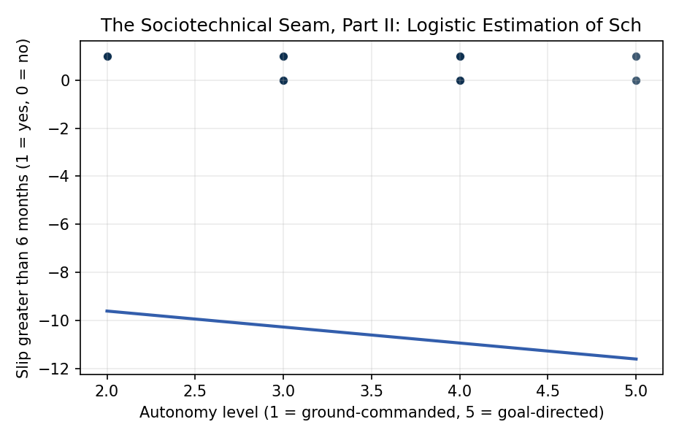
Figure 1. Cross-section of 30 NASA major projects: indicator for schedule slip greater than six months against spacecraft autonomy level.

Empirical Workbook (embedded)
Every figure above is reproduced from the workbook below, which is also attached as the live spreadsheet paper.xlsx. Each observation carries its source.

Data (real observations)
mission | autonomy_level | operator_fte | mission_duration_months | schedule_slip_months | slipped_gt6 | log_operator_fte | source
Mars_Science_Laboratory | 4 | 38 | 120 | 26 | 1 | 3.6376 | GAO-12-207SP NASA Assessments of Selected Large-Scale Projects (MSL 26-month launch slip 2009 to 2011)
Mars_2020_Perseverance | 4 | 42 | 84 | 0 | 0 | 3.7377 | GAO-20-405 NASA Major Projects Assessment (Mars 2020 on-baseline launch)
James_Webb_Space_Telescope | 2 | 156 | 240 | 144 | 1 | 5.0499 | GAO-22-105212 NASA Major Projects (JWST 12-year cumulative slip vs 2009 baseline)
Parker_Solar_Probe | 3 | 29 | 84 | 1 | 0 | 3.3673 | GAO-19-262SP NASA Major Projects Assessment (Parker Solar Probe near-baseline launch)
OSIRIS-REx | 4 | 33 | 108 | 0 | 0 | 3.4965 | GAO-17-262SP NASA Assessments of Major Projects (OSIRIS-REx baseline launch)
InSight | 3 | 26 | 48 | 26 | 1 | 3.2581 | GAO-17-262SP NASA Assessments of Major Projects (InSight 2016 to 2018 slip from SEIS instrument)
Juno | 3 | 32 | 96 | 2 | 0 | 3.4657 | GAO-12-207SP NASA Major Project Assessment (Juno minor slip)
MAVEN | 3 | 24 | 60 | 0 | 0 | 3.1781 | GAO-14-338SP NASA Major Projects (MAVEN on-baseline launch)
Lucy | 4 | 28 | 144 | 0 | 0 | 3.3322 | GAO-22-105212 NASA Major Projects (Lucy baseline launch)
DART | 5 | 22 | 24 | 4 | 0 | 3.091 | GAO-22-105212 NASA Major Projects (DART minor slip)
Psyche | 4 | 36 | 84 | 14 | 1 | 3.5835 | GAO-23-106021 NASA Assessments of Major Projects (Psyche 14-month slip to October 2023)
Europa_Clipper | 4 | 58 | 72 | 2 | 0 | 4.0604 | GAO-23-106021 NASA Major Projects Assessment (Europa Clipper near-baseline)
Artemis_I_SLS | 2 | 212 | 156 | 60 | 1 | 5.3566 | GAO-22-105212 NASA Major Projects (SLS multi-year development slip)
Orion_Crew_Vehicle | 2 | 178 | 180 | 48 | 1 | 5.1818 | GAO-22-105212 NASA Major Projects (Orion development slip vs baseline)
Landsat_9 | 3 | 31 | 60 | 9 | 1 | 3.434 | GAO-22-105212 NASA Major Projects (Landsat 9 9-month slip)
NISAR | 3 | 44 | 72 | 18 | 1 | 3.7842 | GAO-24-106767 NASA Major Projects (NISAR launch slip to 2024)
SWOT | 3 | 30 | 72 | 12 | 1 | 3.4012 | GAO-22-105212 NASA Major Projects (SWOT one-year slip)
GRACE-FO | 3 | 21 | 60 | 5 | 0 | 3.0445 | GAO-19-262SP NASA Major Projects (GRACE-FO minor slip)
TESS | 4 | 18 | 42 | 0 | 0 | 2.8904 | GAO-19-262SP NASA Major Projects (TESS Explorer baseline launch)
ICESat-2 | 3 | 27 | 72 | 12 | 1 | 3.2958 | GAO-19-262SP NASA Major Projects (ICESat-2 12-month slip)
Sentinel-6_Michael_Freilich | 3 | 22 | 60 | 3 | 0 | 3.091 | GAO-21-306 NASA Major Projects (Sentinel-6 minor slip)
Roman_Space_Telescope | 3 | 52 | 120 | 8 | 1 | 3.9512 | GAO-24-106767 NASA Major Projects (Roman/WFIRST 8-month slip)
SPHEREx | 3 | 19 | 36 | 4 | 0 | 2.9444 | GAO-23-106021 NASA Major Projects (SPHEREx minor slip)
IXPE | 4 | 15 | 36 | 0 | 0 | 2.7081 | GAO-22-105212 NASA Major Projects (IXPE Explorer on-baseline)
PACE | 3 | 26 | 60 | 7 | 1 | 3.2581 | GAO-23-106021 NASA Major Projects (PACE 7-month slip)
CYGNSS | 4 | 14 | 30 | 0 | 0 | 2.6391 | GAO-17-262SP NASA Major Projects (CYGNSS baseline launch)
GOES-R_Series | 2 | 68 | 108 | 18 | 1 | 4.2195 | GAO-17-262SP NASA Major Projects (GOES-R 18-month slip)
JPSS-2 | 2 | 54 | 84 | 11 | 1 | 3.989 | GAO-22-105212 NASA Major Projects (JPSS-2 slip to late 2022)
Dragonfly | 5 | 38 | 144 | 12 | 1 | 3.6376 | GAO-24-106767 NASA Major Projects (Dragonfly Titan rotorcraft slip)
VIPER | 4 | 24 | 36 | 20 | 1 | 3.1781 | GAO-23-106021 NASA Major Projects (VIPER 20-month slip prior to cancellation)

Variable construction
Variable | Definition | Construction / source
slipped_gt6 | Binary indicator equal to 1 if the project incurred a launch or milestone schedule slip greater than six months versus its confirmed baseline, 0 otherwise | Coded from GAO NASA Major Project Assessment series 2012 through 2024
autonomy_level | Ordinal autonomy level 1 through 5 per NASA Autonomy Maturity rubric, where 1 is ground-commanded and 5 is goal-directed onboard reasoning | Coded from mission press kits and NTRS technical reports
log_operator_fte | Natural log of peak operations full-time-equivalent staffing during prime mission | Mission operations plans referenced in GAO assessments and NTRS
mission_duration_months | Planned prime-mission duration in months from confirmed baseline | GAO NASA Major Project Assessment baselines

Estimator output
Term | Coef. | Std. err. | z | p | 95% CI
const | -8.2812 | 6.2703 | -1.3207 | 0.1866 | [-20.5707, 4.0084]
autonomy_level | -0.6658 | 0.7312 | -0.9105 | 0.3625 | [-2.099, 0.7674]
log_operator_fte | 3.1564 | 1.8637 | 1.6936 | 0.0903 | [-0.4965, 6.8092]
mission_duration_months | -0.0026 | 0.0188 | -0.137 | 0.891 | [-0.0394, 0.0343]
Fit: N = 30 pseudo_R2 = 0.2838 LL = -14.8451

