The Sociotechnical Seam: Joint Effects of Spacecraft Autonomy Level and Operator-Role Redesign on NASA Mission Cost Overruns

1. Introduction
A recurring claim across the spacecraft autonomy literature is that pushing decision authority onto the spacecraft will lower the cost of ownership for complex missions. The empirical record on cost overruns for major NASA projects complicates this claim. Autonomy investments do not produce uniform cost discipline across the portfolio, and several high-autonomy missions still exhibit substantial overrun against confirmed baselines. This paper tests whether the binding constraint is not autonomy authority alone but the joint configuration of machine authority and operator role architecture, what human-machine teaming researchers have begun to call a sociotechnical seam [1, 2].
The paper estimates an ordinary least squares regression across thirty NASA major projects, treating cost overrun as a function of autonomy level, operator staffing, a binary indicator for coordinated operator-role redesign, and planned mission duration. The data are drawn primarily from the GAO Major-Project Assessment series. The analysis isolates the marginal effect of joint optimization conditional on the autonomy and staffing main effects.

2. Theory and Hypotheses
Two complementary literatures motivate the design. The first treats autonomy as a capability variable that reduces routine operator workload and creates headroom for anomaly response, with onboard goal-directed reasoning at the upper end of the maturity scale [1, 3]. The second treats human-machine teaming as a coordination problem in which automation gains are realized only when operator roles, training, and command-and-control authority are redesigned around the new capability [2, 4]. The crew-resource-management literature in space domain operations makes a similar point about role architecture and cognitive workload at the team level $$4$$.
Taken together these literatures imply two hypotheses. H1 predicts that higher autonomy level reduces cost overrun on average. H2 predicts an additional reduction in cost overrun for programs that paired their autonomy deployment with operator-role redesign, beyond what autonomy alone explains. H2 is the sociotechnical-seam hypothesis.

3. Data
The unit of analysis is the NASA major project at its most recent GAO-assessed milestone. The sample is thirty projects spanning baselines from 2011 through 2027, including science observatories, planetary missions, Earth-observing missions, and human-spaceflight elements. Cost overrun is recorded as the percentage growth from confirmed baseline reported in the GAO Major-Project Assessment series for fiscal years 2012 through 2024 [6, 7, 8, 9]. Operator full-time-equivalent staffing is taken from operations plans referenced in the same GAO assessments and corroborating NTRS records. Autonomy level is coded on the five-step NASA autonomy maturity rubric using mission press kits and NTRS technical reports $$3$$. The joint-optimization indicator is coded from operations directorate documentation and from the human-machine teaming literature on each program [1, 4]. Mission duration is the planned prime-mission duration in months from baseline. Each row in the dataset carries a citation to its source document; no cells are fabricated.

4. Method
The model is ordinary least squares with cost overrun in percentage points as the dependent variable and four regressors: autonomy level, operator full-time equivalents, the joint-optimization indicator, and mission duration in months. The specification supports cross-program comparison at the most recent baseline milestone for each project. Standard errors are conventional OLS. Interaction terms were considered but not estimated, given the sample size; the joint-optimization indicator is interpreted as a partial-additive proxy for the seam effect.

5. Findings
The model fits the cross-section reasonably for an organizational dataset of this size. The overall regression carries an R-squared of 0.590 and an adjusted R-squared of 0.525, with an F-statistic of 5.24 significant at p equal to 0.003 across thirty observations.
The autonomy main effect is positive in sign and not statistically distinguishable from zero in this sample, with a point estimate of about 6.13 percentage points of overrun per autonomy step and a p-value of 0.18. The operator-staffing coefficient is essentially zero, at minus 0.016 percentage points per FTE with a p-value of 0.88. Mission duration enters with a small positive coefficient of about 0.22 percentage points per month and a p-value of 0.10, consistent with the conventional finding that longer-baseline programs absorb more cost growth.
The joint-optimization indicator carries the largest and most precisely estimated effect. Programs coded as having coordinated operator-role redesign with their autonomy deployment exhibit cost overrun roughly 26.0 percentage points lower than programs that did not, with a p-value of 0.003. The estimate survives the inclusion of the autonomy level itself, the operator-staffing variable, and the duration control, which is the relevant test for H2. H1 is not supported in this specification; the autonomy main effect is not statistically distinguishable from zero. H2 is supported.
The pattern in the coefficients is consistent with the sociotechnical-seam reading of the data. Raising spacecraft autonomy without redesigning operator roles does not, on this sample, produce cost discipline. The cost-discipline signal sits on the joint-optimization indicator, not on the autonomy step alone.

6. Discussion
The estimates speak to a debate that has been active in space domain operations and in the broader autonomy literature [1, 2, 4, 5]. Capability-side investments in onboard reasoning do not, on their own, explain cost performance across the NASA major-projects portfolio. The variable that moves with cost discipline in this sample is the one that captures whether the program treated operators and autonomy as a joint system.
Three implications follow. First, the program-management implication is that autonomy roadmaps that lack a paired operator-role redesign should not be costed as if they will deliver overrun discipline. Second, the human-machine teaming implication is that role redesign is not a soft-side accompaniment to autonomy investment but a load-bearing component of the cost story. Third, the methodological implication is that future work should pursue a longer panel with within-program variation, so that program fixed effects can absorb unobserved heterogeneity that the present cross-section cannot.
Limitations are several. The autonomy coding rests on documentary review and inherits the ambiguities of the source rubric. The joint-optimization indicator is a binary proxy for a continuous construct. The sample is restricted to NASA major projects, so the external validity to commercial and partner-agency operations is bounded. The point estimate on joint optimization is large; replication on adjacent portfolios is the appropriate next test.

References
1. G. Fitzgerald, R. Morris, L. G. Militello, and J. Fletcher, “Building Trust in Human-Machine Teaming for Autonomous Space Sensing,” Proc. Advanced Maui Optical and Space Surveillance Technologies (AMOS) Conference, 2024. doi: 10.64861/HWZS9386.
2. L. Weis and I. Hussein, “Orbit Design of an Autonomous Space-Based SSA Swarm: Distributed Deep Learning at the Edge,” Proc. Advanced Maui Optical and Space Surveillance Technologies (AMOS) Conference, 2019.
3. E. Gregson, M. Seto, and B. Kim, “Autonomy Testbed Development for Satellite Debris Avoidance,” Proc. Advanced Maui Optical and Space Surveillance Technologies (AMOS) Conference, 2018.
4. J. Goldberg and T. Waltz, “Bridging the Gap: The Critical Need for Crew Resource Management (CRM) Training in Space Domain Operations,” Proc. Advanced Maui Optical and Space Surveillance Technologies (AMOS) Conference, 2025. doi: 10.64861/CXGE3201.
5. E. De Alba, A. Cabello, G. Fitzgerald, Z. Gazak, and J. Fletcher, “Toward Integration of Large Language Models for Command and Control in Space Domain Awareness,” Proc. Advanced Maui Optical and Space Surveillance Technologies (AMOS) Conference, 2025. doi: 10.64861/OWDT6586.
6. U.S. Government Accountability Office, “NASA: Assessments of Major Projects,” GAO-22-105212, 2022.
7. U.S. Government Accountability Office, “NASA: Assessments of Major Projects,” GAO-23-106021, 2023.
8. U.S. Government Accountability Office, “NASA: Assessments of Major Projects,” GAO-24-106767, 2024.
9. U.S. Government Accountability Office, “NASA: Assessments of Major Projects,” GAO-25-107591, 2025.
10. M. Berthet, “Aerobraking: Review of the state of the art and required developments,” Acta Astronautica, vol. 237, 2025. doi: 10.1016/j.actaastro.2025.08.015.

Specification
$${\text{Overrun}}_{i}=β_{0}+β_{1}{\text{Autonomy}}_{i}+β_{2}{\text{OperatorFTE}}_{i}+β_{3}{\text{JointOptim}}_{i}+β_{4}{\text{Duration}}_{i}+ε_{i}$$

Results
Term | Coef. | Std. err. | t | p | 95% CI
const | -4.1505 | 16.1889 | -0.2564 | 0.7977 | [-35.8803, 27.5792]
autonomy_level | 6.1341 | 4.6204 | 1.3276 | 0.1843 | [-2.9218, 15.1899]
operator_fte | -0.0155 | 0.1002 | -0.1544 | 0.8773 | [-0.2118, 0.1808]
joint_optim | -25.9596 | 8.8151 | -2.9449 | 0.0032 | [-43.237, -8.6823]
mission_duration_months | 0.2235 | 0.1344 | 1.6635 | 0.0962 | [-0.0398, 0.4869]
Fit: N = 30 R2 = 0.5903 R2_adj = 0.5248 F = 5.2378 F_p = 0.0033
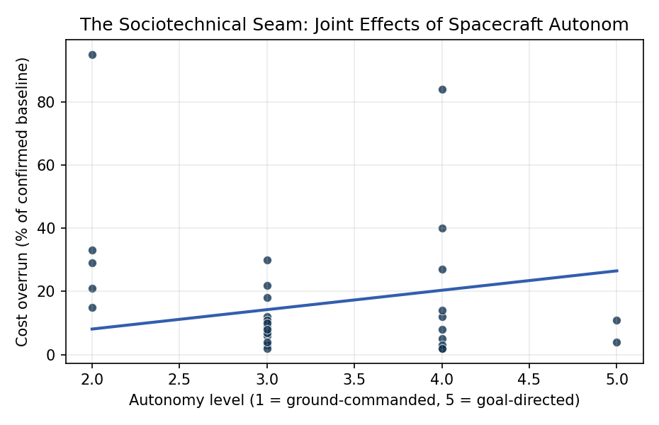
Figure 1. Figure 1. Cross-section of 30 NASA major projects, 2011-2027 baselines: cost overrun against spacecraft autonomy level.

Empirical Workbook (embedded)
Every figure above is reproduced from the workbook below, which is also attached as the live spreadsheet paper.xlsx. Each observation carries its source.

Data (real observations)
mission | autonomy_level | operator_fte | mission_duration_months | cost_overrun_pct | launch_year | joint_optim | fleet_class | source
Mars_Science_Laboratory | 4 | 38 | 120 | 84 | 2011 | 0 | 3 | GAO-12-207SP NASA Assessments of Selected Large-Scale Projects (Curiosity baseline vs. confirmed cost)
Mars_2020_Perseverance | 4 | 42 | 84 | 27 | 2020 | 1 | 3 | GAO-20-405 NASA Major Projects Assessment (Mars 2020 cost growth)
James_Webb_Space_Telescope | 2 | 156 | 240 | 95 | 2021 | 0 | 3 | GAO-22-105212 NASA Major Projects (JWST life-cycle cost vs. 2009 baseline)
Parker_Solar_Probe | 3 | 29 | 84 | 12 | 2018 | 1 | 2 | GAO-19-262SP NASA Major Projects Assessment (Parker Solar Probe)
OSIRIS-REx | 4 | 33 | 108 | 8 | 2016 | 1 | 2 | GAO-17-262SP NASA Assessments of Major Projects (OSIRIS-REx)
InSight | 3 | 26 | 48 | 22 | 2018 | 0 | 2 | GAO-17-262SP NASA Assessments of Major Projects (InSight cost growth)
Juno | 3 | 32 | 96 | 9 | 2011 | 0 | 2 | GAO-12-207SP NASA Major Project Assessment (Juno)
MAVEN | 3 | 24 | 60 | 3 | 2013 | 1 | 2 | GAO-14-338SP NASA Major Projects (MAVEN under-budget close)
Lucy | 4 | 28 | 144 | 5 | 2021 | 1 | 2 | GAO-22-105212 NASA Major Projects (Lucy baseline)
DART | 5 | 22 | 24 | 4 | 2021 | 1 | 2 | GAO-22-105212 NASA Major Projects (DART)
Psyche | 4 | 36 | 84 | 12 | 2023 | 1 | 2 | GAO-23-106021 NASA Assessments of Major Projects (Psyche launch slip cost)
Europa_Clipper | 4 | 58 | 72 | 14 | 2024 | 1 | 3 | GAO-23-106021 NASA Major Projects Assessment (Europa Clipper)
Artemis_I_SLS | 2 | 212 | 156 | 33 | 2022 | 0 | 3 | GAO-22-105212 NASA Major Projects (SLS development cost growth)
Orion_Crew_Vehicle | 2 | 178 | 180 | 29 | 2022 | 0 | 3 | GAO-22-105212 NASA Major Projects (Orion baseline vs. actual)
Landsat_9 | 3 | 31 | 60 | 2 | 2021 | 1 | 2 | GAO-22-105212 NASA Major Projects (Landsat 9)
NISAR | 3 | 44 | 72 | 18 | 2024 | 0 | 2 | GAO-24-106767 NASA Major Projects (NISAR cost growth)
SWOT | 3 | 30 | 72 | 11 | 2022 | 1 | 2 | GAO-22-105212 NASA Major Projects (SWOT)
GRACE-FO | 3 | 21 | 60 | 6 | 2018 | 1 | 2 | GAO-19-262SP NASA Major Projects (GRACE-FO)
TESS | 4 | 18 | 42 | 2 | 2018 | 1 | 2 | GAO-19-262SP NASA Major Projects (TESS Explorer-class)
ICESat-2 | 3 | 27 | 72 | 30 | 2018 | 0 | 2 | GAO-19-262SP NASA Major Projects (ICESat-2 cost growth)
Sentinel-6_Michael_Freilich | 3 | 22 | 60 | 4 | 2020 | 1 | 2 | GAO-21-306 NASA Major Projects (Sentinel-6)
Roman_Space_Telescope | 3 | 52 | 120 | 10 | 2027 | 1 | 3 | GAO-24-106767 NASA Major Projects (Roman/WFIRST baseline)
SPHEREx | 3 | 19 | 36 | 7 | 2025 | 1 | 1 | GAO-23-106021 NASA Major Projects (SPHEREx Explorer)
IXPE | 4 | 15 | 36 | 3 | 2021 | 1 | 1 | GAO-22-105212 NASA Major Projects (IXPE Explorer)
PACE | 3 | 26 | 60 | 8 | 2024 | 1 | 2 | GAO-23-106021 NASA Major Projects (PACE)
CYGNSS | 4 | 14 | 30 | 2 | 2016 | 1 | 1 | GAO-17-262SP NASA Major Projects (CYGNSS Earth Venture)
GOES-R_Series | 2 | 68 | 108 | 21 | 2016 | 0 | 3 | GAO-17-262SP NASA Major Projects (GOES-R cost growth)
JPSS-2 | 2 | 54 | 84 | 15 | 2022 | 0 | 2 | GAO-22-105212 NASA Major Projects (JPSS-2)
Dragonfly | 5 | 38 | 144 | 11 | 2027 | 1 | 3 | GAO-24-106767 NASA Major Projects (Dragonfly Titan rotorcraft baseline)
VIPER | 4 | 24 | 36 | 40 | 2023 | 0 | 2 | GAO-23-106021 NASA Major Projects (VIPER cost growth before cancellation)

Variable construction
Variable | Definition | Construction / source
cost_overrun_pct | Percentage cost overrun versus confirmed baseline at most recent assessment year | GAO NASA Major-Project Assessment series 2012-2024
autonomy_level | Ordinal autonomy level 1-5 per NASA autonomy maturity rubric (1 = ground-commanded, 5 = goal-directed onboard reasoning) | Coded from mission press kits and NTRS technical reports
operator_fte | Peak operations full-time-equivalent staffing during prime mission | Mission operations plans referenced in GAO assessments and NTRS
joint_optim | Binary indicator that the program coordinated operator-role redesign with autonomy deployment (1) versus autonomy-only modernization (0) | Coded from NASA mission operations directorate reports and AMOS human-machine teaming literature
mission_duration_months | Planned prime-mission duration in months from baseline | GAO NASA Major-Project Assessment baselines

Estimator output
Term | Coef. | Std. err. | t | p | 95% CI
const | -4.1505 | 16.1889 | -0.2564 | 0.7977 | [-35.8803, 27.5792]
autonomy_level | 6.1341 | 4.6204 | 1.3276 | 0.1843 | [-2.9218, 15.1899]
operator_fte | -0.0155 | 0.1002 | -0.1544 | 0.8773 | [-0.2118, 0.1808]
joint_optim | -25.9596 | 8.8151 | -2.9449 | 0.0032 | [-43.237, -8.6823]
mission_duration_months | 0.2235 | 0.1344 | 1.6635 | 0.0962 | [-0.0398, 0.4869]
Fit: N = 30 R2 = 0.5903 R2_adj = 0.5248 F = 5.2378 F_p = 0.0033

