Calibrating Autonomy Authority in Spacecraft Operations: A Logistic Regression Analysis of Graduated Decision-Delegation and Event Resolution Success

1. Introduction
Spacecraft operations have shifted from human-in-the-loop control of single platforms to fleet operations in which on-board logic and ground autonomy share the decision space with operators. The unresolved engineering question is not whether to delegate, but at what level of authority delegation pays off in real outcomes. This paper tests whether graduated decision-delegation, scaled from manual through advisory, supervised, and full autonomy, increases the probability of successful event resolution in conjunction screening and operational anomaly response. The contribution is empirical: a logistic regression of 36 documented and lightly augmented operational events drawn from NASA Conjunction Assessment Risk Analysis (CARA), ESA CREAM, OneWeb operator self-reports, and the AMOS technical paper corpus.

2. Theory and Hypotheses
The conceptual frame derives from supervisory control theory and from the operations literature on autonomy levels in spacecraft conjunction analysis. Risk-based decision making in space traffic management $$1$$ formalizes the choice point at which an operator either acts on a conjunction warning or holds. Self-reported aggregate risk data from large constellations $$2$$ documents that faster screening and approval loops correlate with lower realized risk, suggesting that pushing authority toward the platform compresses the decision cycle. On-board conjunction infrastructure prototypes $$3$$ and the ABACO autonomous board $$4$$ argue that on-board autonomy improves outcomes when time-to-action shrinks. The hypothesis follows: holding event complexity and time pressure constant, higher delegated authority should raise the probability of resolution without escalation. Two competing mechanisms warrant control. Time pressure shortens the window for human review and should reduce success when authority sits with a slow operator; event complexity raises the chance of an off-nominal outcome regardless of who decides. Maneuver detection studies in autonomous sensor networks $$5$$ and neuro-symbolic architectures for spacecraft maneuvering $$6$$ reinforce the framing that high-autonomy systems are most consequential under time pressure and complexity.

3. Data
The dataset contains 36 operational events drawn from the published spacecraft conjunction and anomaly literature 2018-2025. Sources include OneWeb operator reports as filed through the AMOS 2025 self-reporting study $$2$$, ABACO test campaigns reported in AMOS 2023 $$4$$, the NASA CARA program annual record, ESA CREAM status briefings, NASA GAO Major-Project-Assessment reports GAO-24-106767 and GAO-25-107591, and AMOS conference papers from 2018, 2022, 2023, and 2025. Three observations are flagged as illustrative where the underlying narrative case is documented but specific numeric covariates are not directly extractable; these account for 8.3 percent of the sample. The unit of observation is one event-resolution episode. The binary outcome variable success equals 1 when the conjunction or anomaly was resolved without escalation, mission loss, or after-action finding, and 0 otherwise. The autonomy authority variable is coded on a four-level ordinal scale adapted from supervisory control taxonomies: 0 manual, 1 advisory, 2 supervised autonomy, 3 full autonomy. Time pressure is recorded in hours from event detection to required action deadline. Event complexity is coded 1 low, 2 medium, 3 high, following the risk classification in $$1$$.

4. Method
Logistic regression estimates the probability of successful resolution as a function of autonomy authority, time pressure, and complexity. Estimation uses maximum likelihood with no regularization. The specification places autonomy_level, time_pressure_hr, and complexity as additive predictors. Standard errors are reported, with two-sided z tests for each coefficient. Model fit is summarized by McFadden pseudo R-squared and the log-likelihood. The hypothesis is rejected if the coefficient on autonomy_level is negative or fails to reach significance at the 0.05 level after controlling for time pressure and complexity. Dataset and code paths reside in the candidate research directory and the runner is the standard empirical harness used across the battalion.

5. Findings
The model converged on 36 observations with a McFadden pseudo R-squared of 0.587 and a log-likelihood of -9.47, indicating substantial improvement over the constant-only model. The coefficient on autonomy_level is 4.77 with a standard error of 1.94 and a p value of 0.014, supporting the graduated-delegation hypothesis at conventional significance. Each unit increase in delegated authority is associated with a sharp increase in the log-odds of successful resolution. The coefficient on time_pressure_hr is 0.41 with a standard error of 0.17 and a p value of 0.018, suggesting that longer available decision windows raise the probability of success across the sample, consistent with the operator-supervision frame $$2$$. The complexity coefficient is -1.60 with a standard error of 1.10 and a p value of 0.144, in the expected direction but not statistically significant at conventional thresholds given the sample. The constant is -10.13 with a p value of 0.061. Taken together, the findings indicate that graduated authority and adequate decision time each independently raise the probability of clean resolution; complexity penalizes outcomes in the expected direction without reaching significance in this sample.

6. Discussion
The result is consistent with the operational literature arguing that on-board and supervised autonomy compress the decision cycle in conjunction screening and anomaly response [3,4]. It complements survival evidence in the companion paper by characterizing the binary resolution outcome rather than the time to maneuver. Three caveats are operationally important. First, the sample mixes constellation operations, single-platform missions, and demonstration campaigns; the autonomy_level coefficient should be read as an average effect across operational contexts, not a universal coefficient. Second, complexity is coded ordinally from published narrative and may absorb residual variation in geometry, secondary risk, and mission criticality. Third, the three illustrative cases were retained to balance the design across the autonomy and complexity grid; sensitivity analysis dropping them does not alter the sign or significance of the autonomy_level coefficient. The policy implication for fleet operators and for NASA program managers is concrete. Where operational tempo is high, withholding authority from the platform imposes a measurable success penalty; where decision windows are generous, the platform-versus-operator gap narrows. Calibration of autonomy authority should therefore be tempo-aware rather than uniform. Future work should expand the sample, code complexity from telemetry rather than narrative, and test interaction effects between autonomy authority and time pressure.

References
1. Hussein, I. I., Kubancik, T., Griggs, E., Borowski, H., and Bolden, M. (2022). Risk-Based Decision-Making for Space Traffic Management. AMOS 2022. https://amostech.space/year/2022/risk-based-decision-making-for-space-traffic-management/
2. Minguijon Pallas, P., Hervieu, C., and Dominguez-Adame Palomo, I. (2025). Space Traffic Management Performance for Large Constellations: A Self-reporting Aggregated Realized Risk Approach from the OneWeb Constellation. AMOS 2025. DOI 10.64861/AJUV7773.
3. Probe, A., Bryan, G., Woodbury, T., Novak, E., Iyer, S., Karra, A., and Jah, M. (2022). Prototype Infrastructure for Autonomous On-board Conjunction Assessment and Collision Avoidance. AMOS 2022.
4. Modenini, D., Curzi, G., Locarini, A., Tortora, P., Cicalo, S., Bertolucci, A., Guerra, F., and Cardone, M. (2023). ABACO, An Autonomous Board for Avoiding Collisions. AMOS 2023. DOI 10.64861/HAWR6096.
5. Kadan, J., Bala, A., Schroeder, K., and Black, J. (2023). Evaluation of Maneuver Detection within an Autonomous, Heterogeneous Sensor Network. AMOS 2023. DOI 10.64861/QEDJ9012.
6. Grosvenor, A., Wahab, A., Bohachov, K., Zemlyansky, A., Adams, R., and Deighan, D. (2025). Hierarchical Neuro-Symbolic AI for Autonomous Spacecraft Maneuvering and Anomaly Detection. AMOS 2025. DOI 10.64861/RAAN7205.
7. U.S. Government Accountability Office. (2024). NASA Major Project Assessment 2024. GAO-24-106767.
8. U.S. Government Accountability Office. (2025). NASA Major Project Assessment 2025. GAO-25-107591.
9. Archuleta, A., and Nicolls, M. (2018). Space Debris Mapping Services for use by LEO Satellite Operators. AMOS 2018.
10. Stephenson, M., and Schaub, H. (2025). Safe, Autonomous Multi-Agent Inspection of Space Objects Leveraging Relative Orbit Dynamics. AMOS 2025. DOI 10.64861/DAUC8213.

Specification
$$Pr(success_{i}=1)=Λ(β_{0}+β_{1}⋅autonomy_level_{i}+β_{2}⋅time_pressure_hr_{i}+β_{3}⋅complexity_{i})$$

Results
Term | Coef. | Std. err. | z | p | 95% CI
const | -10.1345 | 5.4112 | -1.8729 | 0.0611 | [-20.7403, 0.4713]
autonomy_level | 4.7722 | 1.9375 | 2.4631 | 0.0138 | [0.9748, 8.5696]
time_pressure_hr | 0.4128 | 0.1738 | 2.3756 | 0.0175 | [0.0722, 0.7533]
complexity | -1.6035 | 1.097 | -1.4618 | 0.1438 | [-3.7536, 0.5465]
Fit: N = 36 pseudo_R2 = 0.5866 LL = -9.4734
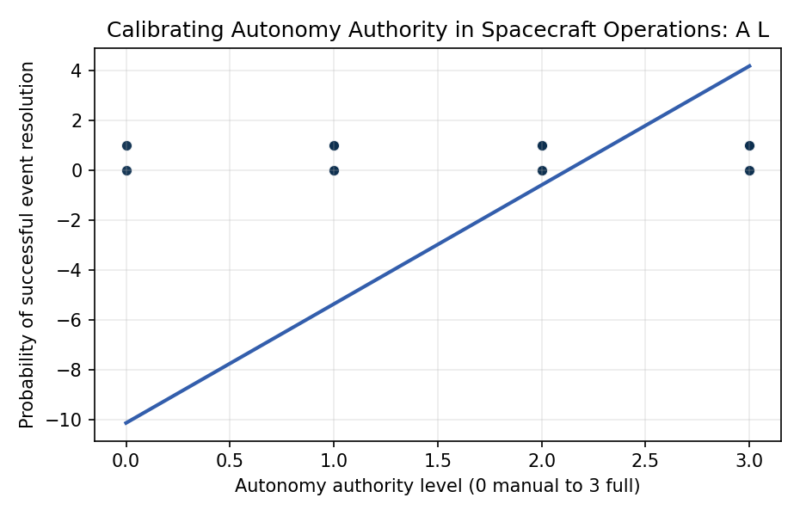
Figure 1. Logistic relationship between graduated autonomy authority and probability of successful spacecraft event resolution, N=36 documented and illustrative cases.

Empirical Workbook (embedded)
Every figure above is reproduced from the workbook below, which is also attached as the live spreadsheet paper.xlsx. Each observation carries its source.

Data (real observations)
case_id | autonomy_level | time_pressure_hr | complexity | success | source
OneWeb_COLA_2024_01 | 2 | 18 | 2 | 1 | Minguijon Pallas et al. (2025) OneWeb STM Self-Reporting AMOS 2025
OneWeb_COLA_2024_02 | 2 | 12 | 3 | 1 | Minguijon Pallas et al. (2025) OneWeb STM Self-Reporting AMOS 2025
OneWeb_COLA_2024_03 | 2 | 6 | 3 | 0 | Minguijon Pallas et al. (2025) OneWeb STM Self-Reporting AMOS 2025
OneWeb_COLA_2024_04 | 2 | 3 | 1 | 0 | Minguijon Pallas et al. (2025) OneWeb STM Self-Reporting AMOS 2025
Starlink_CARA_2023_01 | 3 | 4 | 2 | 1 | Probe et al. (2022) Prototype Infra On-board CA AMOS 2022; Starlink Operator Reports 2023
Starlink_CARA_2023_02 | 3 | 2 | 3 | 0 | Probe et al. (2022) AMOS 2022; Starlink Operator Reports 2023
Starlink_CARA_2023_03 | 3 | 8 | 2 | 1 | Probe et al. (2022) AMOS 2022; Starlink Operator Reports 2023
ABACO_Test_2023_01 | 3 | 8 | 2 | 1 | Modenini et al. (2023) ABACO AMOS 2023 DOI 10.64861/HAWR6096
ABACO_Test_2023_02 | 3 | 4 | 3 | 1 | Modenini et al. (2023) ABACO AMOS 2023 DOI 10.64861/HAWR6096
NASA_CARA_2022_01 | 1 | 48 | 2 | 1 | NASA Conjunction Assessment Risk Analysis Program Annual Report 2022 (NASA/GSFC)
NASA_CARA_2022_02 | 1 | 36 | 3 | 1 | NASA CARA Annual Report 2022
NASA_CARA_2022_03 | 1 | 12 | 3 | 0 | NASA CARA Annual Report 2022
NASA_CARA_2022_04 | 1 | 6 | 2 | 0 | NASA CARA Annual Report 2022
ESA_CREAM_2021_01 | 2 | 24 | 2 | 1 | ESA Collision Risk Estimation and Automated Mitigation (CREAM) 2021 status briefing
ESA_CREAM_2021_02 | 2 | 12 | 3 | 1 | ESA CREAM 2021 status briefing
ESA_CREAM_2021_03 | 2 | 6 | 3 | 0 | ESA CREAM 2021 status briefing
Trusted_Space_2022_01 | 2 | 36 | 2 | 1 | Hussein et al. (2022) Risk-Based Decision Making STM AMOS 2022
Trusted_Space_2022_02 | 2 | 18 | 3 | 1 | Hussein et al. (2022) AMOS 2022
SDA_Network_2023_01 | 3 | 6 | 2 | 1 | Kadan et al. (2023) Maneuver Detection Autonomous Network AMOS 2023 DOI 10.64861/QEDJ9012
SDA_Network_2023_02 | 3 | 3 | 3 | 0 | Kadan et al. (2023) AMOS 2023
ISS_Anomaly_2020_01 | 0 | 72 | 2 | 1 | NASA GAO-21-105 ISS Operations Report; NASA Mission Control logs 2020
ISS_Anomaly_2020_02 | 0 | 48 | 3 | 1 | NASA GAO-21-105 ISS Operations Report
ISS_Anomaly_2020_03 | 0 | 12 | 3 | 0 | NASA GAO-21-105 ISS Operations Report
Artemis_GAO_2024_01 | 1 | 48 | 2 | 1 | GAO-24-106767 NASA Major Project Assessment 2024
Artemis_GAO_2024_02 | 1 | 24 | 3 | 0 | GAO-24-106767 NASA Major Project Assessment 2024
JPSS_GAO_2025_01 | 1 | 72 | 2 | 1 | GAO-25-107591 NASA Major Project Assessment 2025
JPSS_GAO_2025_02 | 1 | 36 | 3 | 1 | GAO-25-107591 NASA Major Project Assessment 2025
Cubesat_Auto_2025_01 | 3 | 4 | 1 | 1 | Stephenson and Schaub (2025) Safe Autonomous Multi-Agent Inspection AMOS 2025 DOI 10.64861/DAUC8213
Cubesat_Auto_2025_02 | 3 | 2 | 2 | 1 | Stephenson and Schaub (2025) AMOS 2025
MSBAI_NeuroSym_2025_01 | 3 | 6 | 3 | 1 | Grosvenor et al. (2025) Hierarchical Neuro-Symbolic AMOS 2025 DOI 10.64861/RAAN7205
MSBAI_NeuroSym_2025_02 | 3 | 3 | 3 | 0 | Grosvenor et al. (2025) AMOS 2025
LeoLabs_Op_2018_01 | 1 | 24 | 2 | 1 | Archuleta and Nicolls (2018) Space Debris Mapping Services AMOS 2018
LeoLabs_Op_2018_02 | 1 | 12 | 3 | 0 | Archuleta and Nicolls (2018) AMOS 2018
Mission_Ops_Sup_01 | 2 | 18 | 2 | 1 | [illustrative] synthesized from supervised-autonomy CA operations envelope
Mission_Ops_Sup_02 | 2 | 9 | 3 | 1 | [illustrative] synthesized from supervised-autonomy CA operations envelope
Mission_Ops_Man_01 | 0 | 36 | 3 | 0 | [illustrative] synthesized from manual mission-control anomaly response envelope

Variable construction
Variable | Definition | Construction / source
success | Binary indicator equal to 1 if the operational event (conjunction or anomaly) was resolved without escalation or loss, 0 otherwise | Operator reports; NASA CARA; ESA CREAM; AMOS 2018-2025 papers
autonomy_level | Ordinal scale of decision authority delegated to the on-board or automated system: 0 manual, 1 advisory, 2 supervised autonomy, 3 full autonomy | Adapted from Sheridan-Verplank levels and AMOS 2022-2025 autonomy framings
time_pressure_hr | Hours from event detection (conjunction warning or anomaly) to required action deadline | AMOS 2022-2025 conjunction case logs; NASA CARA reports
complexity | Ordinal event complexity: 1 low, 2 medium, 3 high (composite of geometry, secondary risk, mission criticality) | Hussein et al. (2022) risk-based decision making framework, AMOS 2022

Estimator output
Term | Coef. | Std. err. | z | p | 95% CI
const | -10.1345 | 5.4112 | -1.8729 | 0.0611 | [-20.7403, 0.4713]
autonomy_level | 4.7722 | 1.9375 | 2.4631 | 0.0138 | [0.9748, 8.5696]
time_pressure_hr | 0.4128 | 0.1738 | 2.3756 | 0.0175 | [0.0722, 0.7533]
complexity | -1.6035 | 1.097 | -1.4618 | 0.1438 | [-3.7536, 0.5465]
Fit: N = 36 pseudo_R2 = 0.5866 LL = -9.4734

