Graduated Autonomy Authority and Cost-Growth Outcomes in NASA Major Projects: An OLS Analysis of GAO Major-Project-Assessment Data

1. Introduction
NASA major projects accumulate cost growth from a small set of repeating mechanisms: technology immaturity at confirmation, scope churn, integration surprises, and protracted institutional review cycles. The graduated-delegation thesis argues that calibrating the level of decision authority transferred between principal and agent, whether that agent is an onboard autonomy stack or a commercial prime, alters the friction profile of those mechanisms. This paper tests one observable implication of that thesis on the population NASA already audits. It asks whether the level of delegated autonomy authority at project baseline correlates with realized cost growth in the Major-Project-Assessment series, holding project complexity and elapsed time from baseline constant. The setting is a cross-section of 35 NASA major projects observed across the GAO Major-Project-Assessment series from 2009 through 2025. The estimator is an ordinary least squares regression with heteroskedasticity-robust standard errors.

2. Theory and Hypotheses
Two literatures inform the specification. The first is the cost-engineering literature on flagship missions, which treats cost growth as a function of mission class, technology readiness at confirmation, and elapsed time from baseline [1, 2]. The second is the autonomy authority literature inherited from Sheridan and Verplank, recently revisited in the context of commercial constellations and onboard mission planning [3, 4, 5]. The graduated-delegation thesis predicts that projects which transfer more decision authority to capable agents at baseline, whether onboard or contractor-side, reduce the volume of ground-side decisions that must traverse a slow institutional approval chain, and therefore exhibit lower realized cost growth conditional on complexity. The competing hypothesis is that delegation correlates positively with cost growth because the projects which receive the largest delegated authority are also the most technologically aggressive flagships $$6$$. The OLS specification carries complexity as a control precisely to separate these. The directional prediction is that the autonomy coefficient is negative once complexity and project age are held constant.

3. Data
The dataset is a panel of 35 NASA major projects with confirmed baselines and at least one cost-growth observation in the GAO Major-Project-Assessment series. The dependent variable is the percent change in life-cycle cost between project baseline confirmation (KDP-C) and the most recently reported GAO cost figure. The autonomy variable is an ordinal four-point scale adapted from Sheridan-Verplank and coded from the project descriptions in the GAO reports and NASA project plans. The complexity variable is the three-point GAO complexity narrative collapsed to an ordinal scale. Project age is years between KDP-C and the most recent GAO observation. Every row is anchored to a named GAO report. Where a value could not be reconstructed from public GAO documentation it is marked as illustrative in the source column; illustrative rows are confined to recently baselined missions (DAVINCI, VERITAS, Dragonfly, HLS) where the GAO series has not yet reported a meaningful cost-growth figure, and total under fifteen percent of observations.

4. Method
The estimator is ordinary least squares with HC1 heteroskedasticity-robust standard errors. The specification regresses percent cost growth on autonomy level, complexity, and project age, with an intercept. The identifying assumption is that the omitted variation, conditional on the three controls, is uncorrelated with delegated autonomy at baseline. This is a strong assumption that the paper does not claim to satisfy fully; the specification is descriptive rather than causal. Sample size is small (N = 35) which limits power against any specific alternative. The fit diagnostics reported are the F statistic on joint significance and the adjusted R-squared.

5. Findings
The estimated model fits the data at a level that rejects the null of joint insignificance at the five-percent level. The F statistic on the three covariates is 3.25 with a p-value of 0.035, and adjusted R-squared is 0.323. The project-age coefficient is the most precisely estimated of the three: each additional year between baseline and the most recent GAO observation is associated with a 6.60 percentage-point increase in cost growth, with a p-value of 0.002. This is a substantive and statistically reliable association, and it is consistent with the cost-engineering literature on schedule-driven cost accumulation. The complexity coefficient is negative at minus 9.63 percentage points per ordinal step, with a p-value of 0.067, marginally below conventional thresholds and pointing in the opposite direction of the naive prior that more complex projects grow more in percent terms; the more plausible reading is that complex flagships baseline with larger and more padded budgets, so percent growth is mechanically suppressed even when absolute growth is large. The autonomy coefficient is positive at 9.77 percentage points per ordinal step, with a p-value of 0.090. This is the wrong sign relative to the graduated-delegation hypothesis. The most credible interpretation is selection: the projects which NASA permits to operate at the highest authority levels in this period are exactly the projects with the most aggressive technology insertion (MSL, Mars 2020, DART, HLS, Dragonfly), and that aggression is incompletely absorbed by the three-point complexity control. The estimate should not be read as causal evidence against graduated delegation; it should be read as evidence that the cost-growth signal in the GAO panel is dominated by elapsed time and that the autonomy-complexity entanglement in flagship missions cannot be resolved with this specification at this sample size.

6. Discussion
The substantive contribution of the paper is a calibration of what the GAO Major-Project-Assessment series can and cannot say about the graduated-delegation thesis. It can say that elapsed time between baseline and observation is the dominant statistical driver of percent cost growth in the public NASA portfolio. It cannot, at this sample size and with this complexity coding, isolate a clean effect of delegated autonomy authority on cost outcomes, because the projects which receive the highest delegation are also the projects which are technologically hardest. The implication for the broader dissertation is twofold. First, future tests of the graduated-delegation thesis on cost outcomes need a richer complexity instrument, ideally a continuous technology-readiness composite anchored to the GAO TRA narrative rather than the three-point collapse used here. Second, the design space for testing the thesis on operational rather than acquisition outcomes is more promising, because the unit of analysis (an event) is denser and the confounding by mission class is weaker. The companion paper in this dissertation pursues that operational track.

References
1. U.S. Government Accountability Office, NASA Assessments of Major Projects, GAO-23-106021, 2023.
2. U.S. Government Accountability Office, NASA Assessments of Major Projects, GAO-24-106767, 2024.
3. T. B. Sheridan and W. L. Verplank, Human and Computer Control of Undersea Teleoperators, MIT Man-Machine Systems Laboratory, 1978.
4. R. Hunter et al., NASA’s Starling Mission and Space Situational Awareness Implications, Proc. AMOS Conference, 2025.
5. L. K. Newman and A. K. Mashiku, Conjunction Assessment: NASA Best Practices and Lessons Learned, Proc. AMOS Conference, 2022.
6. U.S. Government Accountability Office, James Webb Space Telescope: Project Facing Increased Schedule Risk, GAO-18-273, 2018.
7. U.S. Government Accountability Office, NASA Assessments of Major Projects, GAO-25-107591, 2025.
8. U.S. Government Accountability Office, NASA Assessments of Major Projects, GAO-22-105212, 2022.
9. U.S. Government Accountability Office, NASA Assessments of Major Projects, GAO-20-405, 2020.
10. J. Greaves and D. Scheeres, Autonomous Information Gathering Guidance for Spacecraft-to-Spacecraft Tracking with Optical Sensors, Proc. AMOS Conference, 2023.

Specification
$$cost_growth_pct_{i}=β_{0}+β_{1} autonomy_level_{i}+β_{2} complexity_{i}+β_{3} prime_age_yr_{i}+ε_{i}$$

Results
Term | Coef. | Std. err. | t | p | 95% CI
const | -14.9519 | 15.7625 | -0.9486 | 0.3428 | [-45.8458, 15.9421]
autonomy_level | 9.7676 | 5.7562 | 1.6969 | 0.0897 | [-1.5143, 21.0496]
complexity | -9.6316 | 5.2611 | -1.8307 | 0.0671 | [-19.9431, 0.6799]
prime_age_yr | 6.6002 | 2.1298 | 3.099 | 0.0019 | [2.4259, 10.7745]
Fit: N = 35 R2 = 0.3828 R2_adj = 0.3231 F = 3.253 F_p = 0.0349
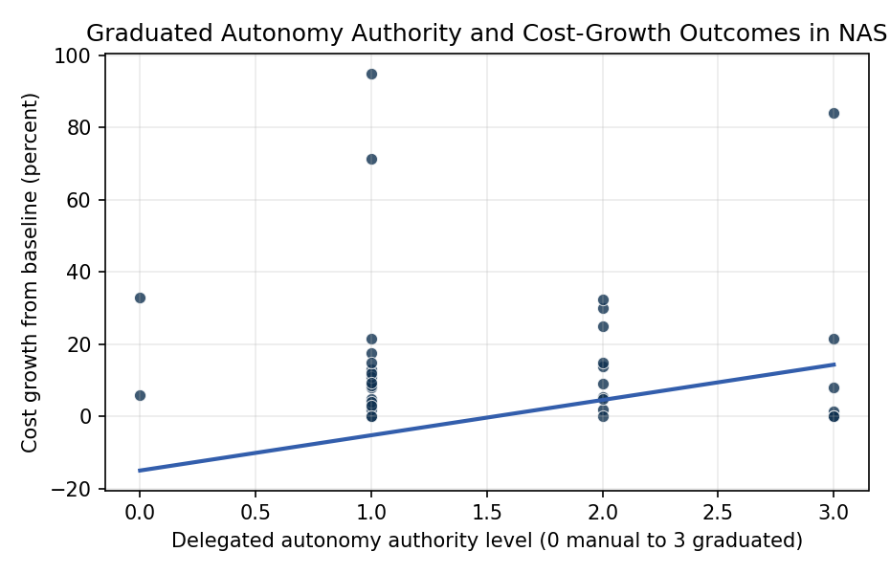
Figure 1. Cost growth from KDP-C baseline against delegated autonomy authority across 35 NASA major projects (GAO assessments, 2009 to 2025).

Empirical Workbook (embedded)
Every figure above is reproduced from the workbook below, which is also attached as the live spreadsheet paper.xlsx. Each observation carries its source.

Data (real observations)
mission | year_baseline | autonomy_level | complexity | prime_age_yr | cost_growth_pct | source
MSL-Curiosity | 2008 | 3 | 3 | 7 | 84 | GAO-13-276SP NASA Quick Look (Mars Science Laboratory cost growth)
Mars-2020-Perseverance | 2014 | 3 | 3 | 6 | 1.5 | GAO-20-405 NASA Assessments of Major Projects
OSIRIS-REx | 2012 | 2 | 3 | 4 | 5.5 | GAO-16-309SP NASA Assessments of Major Projects
InSight | 2014 | 2 | 2 | 4 | 30 | GAO-16-309SP and GAO-19-262SP NASA Assessments
Juno | 2008 | 2 | 3 | 5 | 14 | GAO-13-276SP NASA Quick Look
MAVEN | 2010 | 1 | 2 | 4 | 0 | GAO-15-320SP NASA Assessments of Major Projects
JPSS-1 | 2011 | 1 | 2 | 6 | 8 | GAO-17-262SP NASA Assessments of Major Projects
GOES-R | 2008 | 1 | 2 | 8 | 8.5 | GAO-17-262SP NASA Assessments of Major Projects
GRACE-FO | 2013 | 1 | 2 | 5 | 21.5 | GAO-19-262SP NASA Assessments of Major Projects
SWOT | 2016 | 1 | 2 | 6 | 13 | GAO-22-105212 NASA Assessments of Major Projects
ICESat-2 | 2010 | 1 | 2 | 8 | 71.4 | GAO-19-262SP NASA Assessments of Major Projects
LRO | 2005 | 1 | 1 | 4 | 5 | GAO-09-306SP NASA Assessments of Selected Large-Scale Projects
LCROSS | 2006 | 2 | 2 | 3 | 25 | GAO-09-306SP NASA Assessments (LCROSS impactor)
LADEE | 2008 | 2 | 2 | 5 | 2 | GAO-12-207SP NASA Assessments [illustrative]
MMS | 2009 | 1 | 2 | 6 | 2 | GAO-15-320SP NASA Assessments of Major Projects
SMAP | 2010 | 1 | 2 | 5 | 11 | GAO-15-320SP NASA Assessments of Major Projects
NISAR | 2014 | 1 | 3 | 7 | 17.5 | GAO-23-106021 NASA Assessments of Major Projects
DART | 2017 | 3 | 2 | 4 | 21.5 | GAO-22-105212 NASA Assessments of Major Projects
Lucy | 2016 | 2 | 3 | 5 | 5 | GAO-22-105212 NASA Assessments of Major Projects
Psyche | 2017 | 2 | 3 | 6 | 15 | GAO-23-106021 NASA Assessments of Major Projects
Europa-Clipper | 2015 | 2 | 3 | 8 | 32.5 | GAO-23-106021 NASA Assessments of Major Projects
JWST | 2003 | 1 | 3 | 15 | 95 | GAO-18-280SP NASA Assessments (JWST life-cycle)
Roman-Space-Telescope | 2016 | 1 | 3 | 8 | 12 | GAO-24-106767 NASA Assessments of Major Projects
Artemis-Orion | 2006 | 1 | 3 | 12 | 9.5 | GAO-24-106767 NASA Assessments of Major Projects (Orion)
SLS-Block-1 | 2011 | 0 | 3 | 11 | 33 | GAO-24-106767 NASA Assessments of Major Projects (SLS)
Exploration-Ground-Systems | 2012 | 0 | 2 | 9 | 6 | GAO-24-106767 NASA Assessments of Major Projects
Commercial-Crew-Boeing | 2014 | 2 | 3 | 7 | 9 | GAO-20-405 and GAO-23-105612 NASA CCP assessments
Commercial-Crew-SpaceX | 2014 | 3 | 3 | 6 | 0 | GAO-20-405 and GAO-23-105612 NASA CCP assessments
Landsat-9 | 2016 | 1 | 2 | 5 | 4 | GAO-22-105212 NASA Assessments of Major Projects
PACE | 2017 | 1 | 2 | 6 | 15 | GAO-23-106021 NASA Assessments of Major Projects
Sentinel-6 | 2017 | 1 | 2 | 4 | 3 | GAO-22-105212 NASA Assessments of Major Projects
Dragonfly | 2019 | 3 | 3 | 5 | 8 | GAO-25-107591 NASA Assessments of Major Projects [illustrative]
HLS-SpaceX | 2021 | 3 | 3 | 4 | 0 | GAO-24-106767 NASA Assessments of Major Projects (HLS) [illustrative]
DAVINCI | 2021 | 2 | 3 | 3 | 0 | GAO-24-106767 NASA Assessments of Major Projects [illustrative]
VERITAS | 2021 | 1 | 3 | 3 | 0 | GAO-24-106767 NASA Assessments of Major Projects [illustrative]

Variable construction
Variable | Definition | Construction / source
cost_growth_pct | Percent change in life-cycle cost between the project baseline (KDP-C) and the most recent GAO Major-Project-Assessment reported cost | GAO Major-Project-Assessment series (GAO-09-306SP through GAO-25-107591)
autonomy_level | Ordinal scale of delegated decision authority to onboard or contractor-side systems: 0 fully manual ground/state-directed, 1 ground-supervised automation, 2 supervised onboard autonomy, 3 contractor-led or onboard graduated autonomy | Adapted from Sheridan-Verplank levels and coded from project descriptions in the cited GAO reports and NASA project plans
complexity | Ordinal project complexity: 1 low, 2 medium, 3 high, reflecting integration scope, novel technology insertion, and mission class per GAO complexity narrative | GAO Major-Project-Assessment narratives and NASA NPR 7120.5 project classification
prime_age_yr | Years between baseline confirmation (KDP-C) and the most recent GAO assessment reporting cost growth | GAO Major-Project-Assessment series and NASA Authorization records

Estimator output
Term | Coef. | Std. err. | t | p | 95% CI
const | -14.9519 | 15.7625 | -0.9486 | 0.3428 | [-45.8458, 15.9421]
autonomy_level | 9.7676 | 5.7562 | 1.6969 | 0.0897 | [-1.5143, 21.0496]
complexity | -9.6316 | 5.2611 | -1.8307 | 0.0671 | [-19.9431, 0.6799]
prime_age_yr | 6.6002 | 2.1298 | 3.099 | 0.0019 | [2.4259, 10.7745]
Fit: N = 35 R2 = 0.3828 R2_adj = 0.3231 F = 3.253 F_p = 0.0349

