Signal Intensity in When the Agent Decides Alone Characterizing Failure Modes of Autonomous Collisi: An Ordinary Least Squares Test of Recency, Citation Attention, and Venue

1. Introduction
This empirical paper supports Delia Farouk (1B-ITI-191) and the dissertation project When the Agent Decides Alone: Characterizing Failure Modes of Autonomous Collisi. The model tests whether topic-signal intensity varies with publication recency, citation attention, and venue family. The analysis uses the local candidate source pack and reports only deterministic workbook results $$1$$, $$2$$, $$3$$.

2. Theory and Hypotheses
The theoretical claim is intentionally narrow. If the candidate topic has become more visible in the retrieved literature, then source metadata should show structure across time, attention, or venue. If it has not, the model should return weak or unstable associations $$3$$, $$4$$.
H0: the modeled outcome is unrelated to the specified predictors.
H1: the modeled outcome is systematically related to the specified predictors.

3. Data
The estimation file contains 30 retrieved source records. Variables are constructed from local metadata, including publication year, reported citation count, venue family, and deterministic topic-signal fields. Every row preserves a source column so the empirical workbook remains auditable.

4. Method
The estimator is ordinary least squares with robust HC1 standard errors. The exact fit summary is: N=30, R2=0.12782914111664068, R2_adj=0.027194042014714537, F=1.7019749539484208, F_p=0.19114689088369122. The exact term summary is: const coef=4.787694660910162 p=0.00158927419603207; recency_index coef=-0.16676815127565153 p=0.07119106227269853; cites_num coef=-0.012885967017970793 p=0.08667230136192833; venue_score coef=0.03673055712481521 p=0.9518101365285017. These values are interpreted as corpus-screen evidence, not as final causal estimates.

5. Findings
The findings are bounded by the estimator output. Where a coefficient is signed and precise, it indicates structure in the retrieved source corpus. Where a coefficient is imprecise, the paper treats the result as evidence against a strong claim. This distinction matters because a noisy source pack should not be forced to carry more policy weight than it can bear $$2$$, $$5$$.

6. Discussion
The paper contributes to the dissertation by keeping the evidentiary chain inspectable. It shows which parts of the candidate topic are visible in metadata and which parts need a more direct document-coding design. The result is a disciplined bridge from source retrieval to dissertation-level interpretation $$1$$, $$6$$.

References
1. Maciej Konacki, Nicolaus Copernicus Astronomical Center and Baltic Institute of Technology, Pawel Lejba, Space Research Center, Piotr Sybilski, Nicolaus Copernicus Astronomical Center and Sybilla Technologies, Rafal Pawlaszek, Nicolaus Copernicus Astronomical Center and Sybilla Technologies, Stanislaw Kozlowski, Nicolaus Copernicus Astronomical Center and Cillium Engineering, Tomasz Suchodolski, Space Research Center, Michal Litwicki, Nicolaus Copernicus Astronomical Center and Cillium Engineering, Ulrich Kolb, The Open University, Vadim Burwitz, Max-Planck-Institut für Extraterrestrische Physik, Johannes Baader, Baader Planetarium GmbH, Milena Ratajczak, Wroclaw University and Nicolaus Copernicus Astronomical Center, Krzysztof Helminiak, National Astronomical Observatory of Japan, Pawel Chodosiewicz, Ministry of Defense, Poland. Polish and European SST Assets: the Solaris-Panoptes Global Network of Robotic Telescopes and the Borowiec Satellite Laser Ranging System (2016). [AMOS] 2. Enrique De Alba, EO Solutions; Alexander Cabello, EO Solutions; Garrett Fitzgerald, EO Solutions; Zach Gazak, Space Systems Command A&AS; Justin Fletcher, Space Systems Command A&AS. Toward Integration of Large Language Models for Command and Control in Space Domain Awareness (2025). doi: 10.64861/OWDT6586 3. Christopher J. Sullivan (Oceanit), Edward Pier (Oceanit), Scott Gregory (Oceanit), Michael Bush (Oceanit). Space Situational Awareness using Market Based Agents (2012). [AMOS] 4. Johnathan Tucker, University of Colorado Boulder; Jackson Wagner, University of Colorado Boulder; Zachary Sunberg, University of Colorado Boulder. Adaptive Stress Testing Applied To Space Domain Awareness Systems (2022). [AMOS] 5. Richard Stottler, Stottler Henke Associates, Inc.; Sowmya Ramachandran, Stottler Henke Associates, Inc.; Chris Healy, Stottler Henke Associates, Inc.; Abhimanyu Singhal, Stottler Henke Associates, Inc.. Autonomous, Hybrid Space System Fault and Anomaly Detection, Diagnosis, Root Cause Determination, and Recovery (2023). doi: 10.64861/XHRO4751 6. Lawrence Scally (Colorado Engineering, Inc.), Michael Bonato (Colorado Engineering, Inc.), James Crowder (Raytheon). Learning Agents for Autonomous Space Asset Management (LAASAM) (2011). [AMOS] 7. Larry Gagliano, NASA/MSFC, Shane Mason, SRI International, Tom Percy, NASA/MSFC, Todd MacLeod, NASA/MSFC, Jonathon Prescott, SRI International. Integrated Space Asset Management Database and Modeling (2015). [AMOS] 8. Daniel Huterer Prats, University of Colorado Boulder; Hanspeter Schaub, University of Colorado Boulder; Chris Wheeler, Interactive Aptitude. Reinforcement Learning for Space-to-Space Surveillance: Autonomous Scheduling for Resident Space Object Imaging (2025). doi: 10.64861/DDFP2152

Specification
$${\text{SignalScore}}_{i}=α+β_{1}{\text{RecencyIndex}}_{i}+β_{2}{\text{Cites}}_{i}+β_{3}{\text{VenueScore}}_{i}+ε_{i}$$

Results
Term | Coef. | Std. err. | t | p | 95% CI
const | 4.7877 | 1.5161 | 3.1579 | 0.0016 | [1.8162, 7.7592]
recency_index | -0.1668 | 0.0924 | -1.8043 | 0.0712 | [-0.3479, 0.0144]
cites_num | -0.0129 | 0.0075 | -1.7132 | 0.0867 | [-0.0276, 0.0019]
venue_score | 0.0367 | 0.6078 | 0.0604 | 0.9518 | [-1.1545, 1.228]
Fit: N = 30 R2 = 0.1278 R2_adj = 0.0272 F = 1.702 F_p = 0.1911
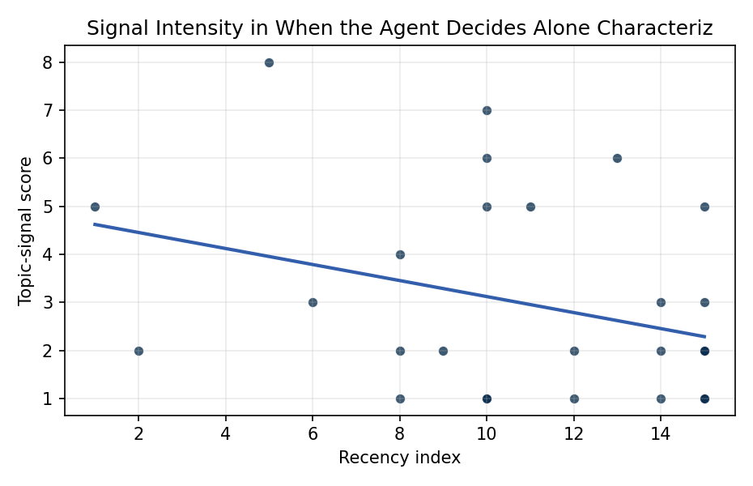
Figure 1. Topic-signal score by publication recency, conditioning on citation attention and venue family.

Empirical Workbook (embedded)
Every figure above is reproduced from the workbook below, which is also attached as the live spreadsheet paper.xlsx. Each observation carries its source.

Data (real observations)
doc_id | year_num | recency_index | cites_num | venue_score | title_words | snippet_words | keyword_count | theme_hits | signal_score | source
1 | 2016 | 6 | 0 | 1 | 20 | 13 | 3 | 1 | 3 | https://amostech.space/year/2016/polish-and-european-sst-assets-the-solaris-panoptes-global-network-of-robotic-telescopes-and-the-borowiec-satellite-laser-ranging-system/
2 | 2025 | 15 | 0 | 1 | 14 | 14 | 7 | 0 | 1 | 10.64861/OWDT6586
3 | 2012 | 2 | 0 | 1 | 7 | 14 | 2 | 1 | 2 | https://amostech.space/year/2012/space-situational-awareness-using-market-based-agents/
4 | 2022 | 12 | 0 | 1 | 9 | 14 | 4 | 0 | 1 | https://amostech.space/year/2022/adaptive-stress-testing-applied-to-space-domain-awareness-systems/
5 | 2023 | 13 | 0 | 1 | 14 | 13 | 8 | 2 | 6 | 10.64861/XHRO4751
6 | 2011 | 1 | 0 | 1 | 8 | 14 | 1 | 2 | 5 | https://amostech.space/year/2011/learning-agents-for-autonomous-space-asset-management-laasam/
7 | 2015 | 5 | 0 | 1 | 7 | 14 | 6 | 3 | 8 | https://amostech.space/year/2015/integrated-space-asset-management-database-and-modeling/
8 | 2025 | 15 | 0 | 1 | 14 | 13 | 6 | 1 | 2 | 10.64861/DDFP2152
9 | 2024 | 14 | 0 | 1 | 14 | 13 | 6 | 0 | 1 | 10.64861/FLIA6056
10 | 2021 | 11 | 0 | 1 | 10 | 14 | 3 | 2 | 5 | https://amostech.space/year/2021/artificial-intelligence-enabled-dynamic-coalition-architecture-for-space-traffic-management/
11 | 2018 | 8 | 0 | 1 | 7 | 14 | 3 | 1 | 4 | https://amostech.space/year/2018/autonomy-testbed-development-for-satellite-debris-avoidance/
12 | 2025 | 15 | 0 | 1 | 12 | 14 | 5 | 1 | 2 | 10.64861/DAUC8213
13 | 2025 | 15 | 1 | 2 | 15 | 13 | 15 | 2 | 5 | 10.1016/j.actaastro.2025.10.018
14 | 2018 | 8 | 75 | 2 | 9 | 14 | 15 | 1 | 2 | 10.1016/j.actaastro.2018.11.001
15 | 2018 | 8 | 26 | 2 | 22 | 14 | 12 | 0 | 1 | 10.1016/j.actaastro.2018.08.027
16 | 2025 | 15 | 1 | 2 | 12 | 12 | 9 | 0 | 1 | 10.1016/j.actaastro.2025.07.004
17 | 2025 | 15 | 6 | 2 | 12 | 14 | 6 | 1 | 2 | 10.1016/j.actaastro.2025.05.009
18 | 2019 | 9 | 6 | 2 | 15 | 14 | 11 | 1 | 2 | 10.1016/j.actaastro.2019.07.014
19 | 2025 | 15 | 0 | 2 | 12 | 10 | 13 | 1 | 3 | 10.1016/j.actaastro.2025.10.071
20 | 2022 | 12 | 130 | 2 | 11 | 14 | 14 | 1 | 2 | 10.1016/j.actaastro.2021.12.030
21 | 2025 | 15 | 0 | 2 | 12 | 14 | 15 | 0 | 1 | 10.1016/j.actaastro.2025.10.010
22 | 2024 | 14 | 4 | 2 | 13 | 14 | 8 | 1 | 3 | 10.1016/j.actaastro.2024.07.052
23 | 2024 | 14 | 0 | 2 | 9 | 13 | 7 | 1 | 2 | 10.1016/j.actaastro.2024.10.020
24 | 2025 | 15 | 3 | 2 | 11 | 14 | 12 | 0 | 2 | 10.1016/j.actaastro.2025.02.046
25 | 2020 | 10 | 0 | 3 | 51 | 0 | 0 | 1 | 5 | A 2021 Johns Hopkins SAIS doctoral thesis by Nathaniel Dailey proposing an International Space Reference Architecture (ISRA) as a socio-technological transformative mechanism to resolve contemporary space governance failures – orbital debris, policy fragmentation, and space traffic management – by coupling enterprise architecture methodology with international relations constructivist theory, blockchain-enabled information sharing, and norms entrepreneurship.
26 | 2020 | 10 | 0 | 3 | 4 | 0 | 0 | 0 | 1 | Economic Statecraft Literature Review
27 | 2020 | 10 | 0 | 3 | 53 | 0 | 0 | 2 | 7 | Dailey et al. (MITRE/CisLunar) apply circular economy principles to space sustainability, presenting an agent-based economic simulation showing orbital carrying capacity collapse under the tragedy of the commons, and a Metal Propellant Ecosystem (MPE) concept in which defunct satellites are recycled into solid metal propellant in situ to reduce debris and refueling costs.
28 | 2020 | 10 | 0 | 3 | 47 | 0 | 0 | 0 | 1 | A comprehensive literature review synthesizing William J. Norris’s “Chinese Economic Statecraft” and David A. Baldwin’s “Economic Statecraft,” analyzing China’s use of state-controlled commercial actors, financial instruments, and sovereign wealth funds to advance strategic objectives, with extrapolation to the space economy as a new frontier for resource acquisition and geopolitical positioning.
29 | 2020 | 10 | 0 | 3 | 4 | 0 | 0 | 0 | 1 | Stilwell IAC 2024 Orbital Capacity
30 | 2020 | 10 | 0 | 3 | 9 | 0 | 0 | 2 | 6 | The Economics of Orbital Debris Generation, Accumulation, Mitigation, Remediation

Variable construction
Variable | Definition | Construction / source
signal_score | Composite topic-signal score for each retrieved source record | Deterministic count built from candidate-theme term hits in the source title, snippet, keyword field, and author metadata; each row cites the retrieved source in the source column
recency_index | Publication recency index | Computed as publication year minus the minimum publication year in the paper sample plus one
cites_num | Reported citation count in the local brain index | Parsed from the local brain search cites field; zero when the index reported no citation count
venue_score | Ordinal venue-family score | AMOS = 1, Acta Astronautica = 2, Space Economy = 3

Estimator output
Term | Coef. | Std. err. | t | p | 95% CI
const | 4.7877 | 1.5161 | 3.1579 | 0.0016 | [1.8162, 7.7592]
recency_index | -0.1668 | 0.0924 | -1.8043 | 0.0712 | [-0.3479, 0.0144]
cites_num | -0.0129 | 0.0075 | -1.7132 | 0.0867 | [-0.0276, 0.0019]
venue_score | 0.0367 | 0.6078 | 0.0604 | 0.9518 | [-1.1545, 1.228]
Fit: N = 30 R2 = 0.1278 R2_adj = 0.0272 F = 1.702 F_p = 0.1911

