Signal Intensity in Command-Link Integrity Under Autonomy Does Onboard Decision Authority Reduce or: An Ordinary Least Squares Test of Recency, Citation Attention, and Venue

1. Introduction
This empirical paper supports Marcus Reinholt (1B-ITI-193) and the dissertation project Command-Link Integrity Under Autonomy: Does Onboard Decision Authority Reduce or. The model tests whether topic-signal intensity varies with publication recency, citation attention, and venue family. The analysis uses the local candidate source pack and reports only deterministic workbook results $$1$$, $$2$$, $$3$$.

2. Theory and Hypotheses
The theoretical claim is intentionally narrow. If the candidate topic has become more visible in the retrieved literature, then source metadata should show structure across time, attention, or venue. If it has not, the model should return weak or unstable associations $$3$$, $$4$$.
H0: the modeled outcome is unrelated to the specified predictors.
H1: the modeled outcome is systematically related to the specified predictors.

3. Data
The estimation file contains 30 retrieved source records. Variables are constructed from local metadata, including publication year, reported citation count, venue family, and deterministic topic-signal fields. Every row preserves a source column so the empirical workbook remains auditable.

4. Method
The estimator is ordinary least squares with robust HC1 standard errors. The exact fit summary is: N=30, R2=0.2086520909455547, R2_adj=0.11734271682388786, F=2.604007187181375, F_p=0.07327646158710832. The exact term summary is: const coef=6.255945518205008 p=0.001121081222194338; recency_index coef=-0.08856988788567317 p=0.4057006341549717; cites_num coef=0.06562253871863537 p=0.08070482042309113; venue_score coef=-1.165461226842032 p=0.032709436165149174. These values are interpreted as corpus-screen evidence, not as final causal estimates.

5. Findings
The findings are bounded by the estimator output. Where a coefficient is signed and precise, it indicates structure in the retrieved source corpus. Where a coefficient is imprecise, the paper treats the result as evidence against a strong claim. This distinction matters because a noisy source pack should not be forced to carry more policy weight than it can bear $$2$$, $$5$$.

6. Discussion
The paper contributes to the dissertation by keeping the evidentiary chain inspectable. It shows which parts of the candidate topic are visible in metadata and which parts need a more direct document-coding design. The result is a disciplined bridge from source retrieval to dissertation-level interpretation $$1$$, $$6$$.

References
1. Roger Hunter, NASA Ames Research Center; Elwood Agasid, NASA Ames Research Center; Samson Phan, NASA Ames Research Center; Nathan Benz, NASA Ames Research Center; Scott Miller, NASA Ames Research Center; Caleb Adams, NASA Ames Research Center; Brian Kempa, NASA Ames Research Center; Jeremy Frank, NASA Ames Research Center; Michael Iatauro, NASA Ames Research Center; Justin Kruger, EraDrive Inc.; Simone D’Amico, EraDrive Inc.; Julianna Fishman, Millenium Engineering & Integration Company; Sasha Weston, Millenium Engineering & Integration Company. NASA’s Starling Mission and Space Situational Awareness Implications (2025). doi: 10.64861/XQCN3213 2. Louis Marketos, Design_Net Engineering. Leveraging the Space Plug-and-Play Avionics (SPA) Standard to Enable Constellation-level Collaborative Autonomy (2009). [AMOS] 3. Edward Gregson, Dalhousie University; Mae Seto, Dalhousie University; Bumsoo Kim, Defence R&D Canada. Autonomy Testbed Development for Satellite Debris Avoidance (2018). [AMOS] 4. Enrique De Alba, EO Solutions; Alexander Cabello, EO Solutions; Garrett Fitzgerald, EO Solutions; Zach Gazak, Space Systems Command A&AS; Justin Fletcher, Space Systems Command A&AS. Toward Integration of Large Language Models for Command and Control in Space Domain Awareness (2025). doi: 10.64861/OWDT6586 5. Dario Modenini, University of Bologna; Giacomo Curzi, University of Bologna; Alfredo Locarini, Alma Mater Studiorum – University of Bologna; Paolo Tortora, University of Bologna; Stefano Cicalò, Space Dynamics Services s.r.l.; Alessia Bertolucci, Space Dynamics Services s.r.l.; Francesca Guerra, Space Dynamics Services s.r.l.; Mauro Cardone, Agenzia Spaziale Italiana. ABACO, An Autonomous Board for Avoiding Collisions (2023). doi: 10.64861/HAWR6096 6. Carmen Reglero Andres, Amazon Web Services; Eloy Salcedo de Zarraga, Amazon Web Services; Shayn Hawthorne, Amazon Web Services; Margaret Cote, Amazon Web Services; Nicholas Ansell, Amazon Web Services; Yudhajeet Dasgupta, Amazon Web Services. Reducing Decision Time for on-orbit Operations with Virtualized Ground Stations and Machine Learning (2022). [AMOS] 7. Rishi P. Patel, United States Air Force; Varlin V. Sheffey, United States Space Force; Joseph D. Gerber, KBR; Riley Burfield, Tech7 Consulting, LLC; Ryan Waterer, Tech7 Consulting, LLC; James Tippets, MITRE Corporation; David Stout, MITRE Corporation; Emily Bohner, United States Space Force. Defense Readiness Agile Gaming Ops Networks (DRAGON) Army (2022). [AMOS] 8. Nathan Golovich, Lawrence Livermore National Laboratory; Robert Armstrong, Lawrence Livermore National Laboratory; Alex Geringer-Sameth, Lawrence Livermore National Laboratory; Benjamin Bahney, Lawrence Livermore National Laboratory; Gary Li, Impulse Space Inc.. XGEOSTARE: Extensible GEO Space-based Telescopes for Actionable Refinement of Ephemeris (2025). doi: 10.64861/RRTQ9485

Specification
$${\text{SignalScore}}_{i}=α+β_{1}{\text{RecencyIndex}}_{i}+β_{2}{\text{Cites}}_{i}+β_{3}{\text{VenueScore}}_{i}+ε_{i}$$

Results
Term | Coef. | Std. err. | t | p | 95% CI
const | 6.2559 | 1.92 | 3.2582 | 0.0011 | [2.4927, 10.0192]
recency_index | -0.0886 | 0.1065 | -0.8315 | 0.4057 | [-0.2973, 0.1202]
cites_num | 0.0656 | 0.0376 | 1.7466 | 0.0807 | [-0.008, 0.1393]
venue_score | -1.1655 | 0.5457 | -2.1356 | 0.0327 | [-2.2351, -0.0959]
Fit: N = 30 R2 = 0.2087 R2_adj = 0.1173 F = 2.604 F_p = 0.0733
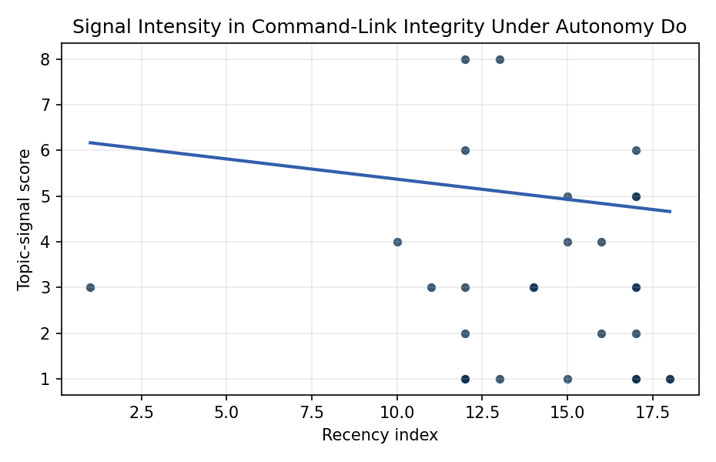
Figure 1. Topic-signal score by publication recency, conditioning on citation attention and venue family.

Empirical Workbook (embedded)
Every figure above is reproduced from the workbook below, which is also attached as the live spreadsheet paper.xlsx. Each observation carries its source.

Data (real observations)
doc_id | year_num | recency_index | cites_num | venue_score | title_words | snippet_words | keyword_count | theme_hits | signal_score | source
1 | 2025 | 17 | 0 | 1 | 8 | 12 | 3 | 2 | 6 | 10.64861/XQCN3213
2 | 2009 | 1 | 0 | 1 | 15 | 12 | 1 | 1 | 3 | https://amostech.space/year/2009/leveraging-the-space-plug-and-play-avionics-spa-standard-to-enable-constellation-level-collaborative-autonomy/
3 | 2018 | 10 | 0 | 1 | 7 | 14 | 3 | 1 | 4 | https://amostech.space/year/2018/autonomy-testbed-development-for-satellite-debris-avoidance/
4 | 2025 | 17 | 0 | 1 | 14 | 14 | 7 | 2 | 5 | 10.64861/OWDT6586
5 | 2023 | 15 | 0 | 1 | 7 | 14 | 6 | 0 | 1 | 10.64861/HAWR6096
6 | 2022 | 14 | 0 | 1 | 14 | 14 | 7 | 1 | 3 | https://amostech.space/year/2022/reducing-decision-time-for-on-orbit-operations-with-virtualized-ground-stations-and-machine-learning/
7 | 2022 | 14 | 0 | 1 | 8 | 12 | 13 | 1 | 3 | https://amostech.space/year/2022/defense-readiness-agile-gaming-ops-networks-dragon-army/
8 | 2025 | 17 | 0 | 1 | 11 | 14 | 4 | 2 | 5 | 10.64861/RRTQ9485
9 | 2021 | 13 | 0 | 1 | 9 | 14 | 4 | 3 | 8 | https://amostech.space/year/2021/flexible-closed-loop-feedback-control-architecture-for-sda-payloads/
10 | 2020 | 12 | 0 | 1 | 12 | 13 | 5 | 3 | 8 | https://amostech.space/year/2020/update-on-esas-space-safety-programme-and-its-cornerstone-on-collision-avoidance/
11 | 2019 | 11 | 0 | 1 | 15 | 11 | 4 | 1 | 3 | https://amostech.space/year/2019/orbit-design-of-an-autonomous-space-based-ssa-swarm-distributed-deep-learning-at-the-edge/
12 | 2025 | 17 | 0 | 1 | 11 | 13 | 10 | 0 | 1 | 10.64861/RAAN7205
13 | 2024 | 16 | 2 | 2 | 12 | 14 | 5 | 1 | 2 | 10.1016/j.actaastro.2024.04.039
14 | 2025 | 17 | 10 | 2 | 9 | 14 | 8 | 0 | 1 | 10.1016/j.actaastro.2025.07.027
15 | 2025 | 17 | 4 | 2 | 13 | 13 | 10 | 0 | 2 | 10.1016/j.actaastro.2025.11.039
16 | 2025 | 17 | 1 | 2 | 15 | 13 | 15 | 1 | 3 | 10.1016/j.actaastro.2025.10.018
17 | 2026 | 18 | 0 | 2 | 9 | 12 | 6 | 0 | 1 | 10.1016/j.actaastro.2026.03.037
18 | 2024 | 16 | 12 | 2 | 13 | 14 | 11 | 1 | 4 | 10.1016/j.actaastro.2024.09.005
19 | 2025 | 17 | 2 | 2 | 14 | 11 | 15 | 0 | 1 | 10.1016/j.actaastro.2025.01.035
20 | 2023 | 15 | 21 | 2 | 12 | 14 | 15 | 2 | 5 | 10.1016/j.actaastro.2023.12.055
21 | 2023 | 15 | 21 | 2 | 14 | 14 | 15 | 1 | 4 | 10.1016/j.actaastro.2023.04.032
22 | 2025 | 17 | 0 | 2 | 15 | 13 | 15 | 1 | 3 | 10.1016/j.actaastro.2025.09.031
23 | 2026 | 18 | 0 | 2 | 10 | 13 | 13 | 0 | 1 | 10.1016/j.actaastro.2026.02.008
24 | 2020 | 12 | 3 | 2 | 13 | 14 | 15 | 1 | 2 | 10.1016/j.actaastro.2020.04.018
25 | 2021 | 13 | 0 | 3 | 7 | 0 | 0 | 0 | 1 | 10.1016/j.actaastro.2020.11.056
26 | 2020 | 12 | 0 | 3 | 64 | 0 | 0 | 2 | 6 | Behavioral Economics in Space: Shaping Normative Behaviors for Stability and Sustainability (white paper, unpublished working paper, N. Dailey or associated author, undated). Proposes applying behavioral economics principles, drawing on Kahneman and Gaddis, to shape normative behavior in space traffic coordination, SSA, and space domain awareness, and further integrates deterrence frameworks and strategic non-kinetic effects (DIME tools) to reinforce responsible conduct and deter adversarial behavior.
27 | 2020 | 12 | 0 | 3 | 10 | 0 | 0 | 1 | 3 | Space Debris Impact on Orbital Resource in Life Cycle Assessment
28 | 2020 | 12 | 0 | 3 | 4 | 0 | 0 | 0 | 1 | Economic Statecraft Literature Review
29 | 2020 | 12 | 0 | 3 | 5 | 0 | 0 | 0 | 1 | Prototyping Operational Autonomy for STM
30 | 2020 | 12 | 0 | 3 | 5 | 0 | 0 | 0 | 1 | Strategic Competition and Economic Innovation

Variable construction
Variable | Definition | Construction / source
signal_score | Composite topic-signal score for each retrieved source record | Deterministic count built from candidate-theme term hits in the source title, snippet, keyword field, and author metadata; each row cites the retrieved source in the source column
recency_index | Publication recency index | Computed as publication year minus the minimum publication year in the paper sample plus one
cites_num | Reported citation count in the local brain index | Parsed from the local brain search cites field; zero when the index reported no citation count
venue_score | Ordinal venue-family score | AMOS = 1, Acta Astronautica = 2, Space Economy = 3

Estimator output
Term | Coef. | Std. err. | t | p | 95% CI
const | 6.2559 | 1.92 | 3.2582 | 0.0011 | [2.4927, 10.0192]
recency_index | -0.0886 | 0.1065 | -0.8315 | 0.4057 | [-0.2973, 0.1202]
cites_num | 0.0656 | 0.0376 | 1.7466 | 0.0807 | [-0.008, 0.1393]
venue_score | -1.1655 | 0.5457 | -2.1356 | 0.0327 | [-2.2351, -0.0959]
Fit: N = 30 R2 = 0.2087 R2_adj = 0.1173 F = 2.604 F_p = 0.0733

