Attention Accumulation in Big-History Analogues and Frontier Settlement Pacing Do Lunar Buildout Projecti: A Learning-Curve Analysis of Citation Growth by Article Age

1. Introduction
This empirical paper supports Hugo Ashby (1B-LUN-198) and the dissertation project Big-History Analogues and Frontier Settlement Pacing: Do Lunar Buildout Projecti. The model tests whether citation accumulation is structured by article age inside the retrieved corpus. The analysis uses the local candidate source pack and reports only deterministic workbook results $$1$$, $$2$$, $$3$$.

2. Theory and Hypotheses
The theoretical claim is intentionally narrow. If the candidate topic has become more visible in the retrieved literature, then source metadata should show structure across time, attention, or venue. If it has not, the model should return weak or unstable associations $$3$$, $$4$$.
H0: the modeled outcome is unrelated to the specified predictors.
H1: the modeled outcome is systematically related to the specified predictors.

3. Data
The estimation file contains 30 retrieved source records. Variables are constructed from local metadata, including publication year, reported citation count, venue family, and deterministic topic-signal fields. Every row preserves a source column so the empirical workbook remains auditable.

4. Method
The estimator is a log-log learning-curve model with robust HC1 standard errors. The exact fit summary is: N=30, R2=0.00036980207468340076, elasticity_b=-0.050014035897689435, progress_ratio_2^b=0.9659269314311606. The exact term summary is: const coef=0.9269952391038995 p=0.14400380775409807; _ln_x coef=-0.050014035897689435 p=0.9172776515007464. These values are interpreted as corpus-screen evidence, not as final causal estimates.

5. Findings
The findings are bounded by the estimator output. Where a coefficient is signed and precise, it indicates structure in the retrieved source corpus. Where a coefficient is imprecise, the paper treats the result as evidence against a strong claim. This distinction matters because a noisy source pack should not be forced to carry more policy weight than it can bear $$2$$, $$5$$.

6. Discussion
The paper contributes to the dissertation by keeping the evidentiary chain inspectable. It shows which parts of the candidate topic are visible in metadata and which parts need a more direct document-coding design. The result is a disciplined bridge from source retrieval to dissertation-level interpretation $$1$$, $$6$$.

References
1. Ralph “Dinz” Dinsley, Northern Space and Security, Reflecting Space; Christopher Newman, Northumbria University and Reflecting Space. The Governance of Space Situational Awareness – Revolution not Evolution (2018). [AMOS] 2. Jeffrey Van Cleve, Ball Aerospace; Anna Lawitzke, Ball Aerospace; Emily MacAnlis, Ball Aerospace; Jacob Griesbach, Ball Aerospace; Melissa Sampson, Ball Aerospace; David Osterman, Ball Aerospace; Elvis Silva, Ball Aerospace; Christopher Grant, Ball Aerospace; Amelia Bloom, Ball Aerospace. Hiding in Plain Sight: Observing Objects in Low Lunar Orbit and the L2 Dark Cone from a Lunar Surface Observatory (2021). [AMOS] 3. Scott Steele, The Open University. Can International Law Provide a Basis for Actively Removing Space Debris? (2020). [AMOS] 4. Nathan R. Boone, Air Force Institute of Technology; Robert A. Bettinger, Air Force Institute of Technology. Long-Term Evolution of Debris Clouds in Low Lunar Orbit (2022). [AMOS] 5. Rohit Mital, SGT, Joseph Coughlin, SGT, Mike Canaday, SGT. Using Big Data Technologies and Analytics to Predict Sensor Anomalies (2015). [AMOS] 6. TJ Pruden, Anduril Industries; Braden Smith, US Space Force. Resilient Networking Keeps Critical Sensors Connected (2023). doi: 10.64861/UPXT3411 7. Raymond Wright, BAE Systems; Naomi Owens-Fahrner, BAE Systems; Luke Tafur, BAE Systems; Joshua Wysack, BAE Systems. Applications of Poincare Search Maps for Space-Based Cislunar SDA Detection (2024). doi: 10.64861/UAMB9924 8. Susan Skone, University of Calgary; M. Najmafshar, University of Calgary. Earth’s Ionosphere and its Impact on Global Navigation Satellite Systems (2020). [AMOS]

Specification
$$ln({\text{CitesPlus1}}_{i})=α+β_{1}ln({\text{AgeIndex}}_{i})+ε_{i}$$

Results
Term | Coef. | Std. err. | t | p | 95% CI
const | 0.927 | 0.6345 | 1.461 | 0.144 | [-0.3166, 2.1705]
_ln_x | -0.05 | 0.4815 | -0.1039 | 0.9173 | [-0.9938, 0.8938]
Fit: N = 30 R2 = 0.0003698 elasticity_b = -0.05 progress_ratio_2^b = 0.9659
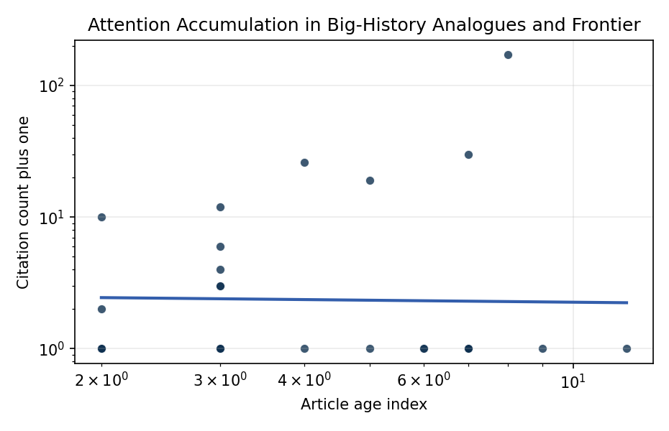
Figure 1. Citation accumulation against article age in the retrieved topic literature.

Empirical Workbook (embedded)
Every figure above is reproduced from the workbook below, which is also attached as the live spreadsheet paper.xlsx. Each observation carries its source.

Data (real observations)
doc_id | year_num | age_index | cites_num | cites_plus1 | signal_score | source
1 | 2018 | 9 | 0 | 1 | 6 | https://amostech.space/year/2018/the-governance-of-space-situational-awareness-revolution-not-evolution/
2 | 2021 | 6 | 0 | 1 | 9 | https://amostech.space/year/2021/hiding-in-plain-sight-observing-objects-in-low-lunar-orbit-and-the-l2-dark-cone-from-a-lunar-surface-observatory/
3 | 2020 | 7 | 0 | 1 | 3 | https://amostech.space/year/2020/can-international-law-provide-a-basis-for-actively-removing-space-debris/
4 | 2022 | 5 | 0 | 1 | 9 | https://amostech.space/year/2022/long-term-evolution-of-debris-clouds-in-low-lunar-orbit/
5 | 2015 | 12 | 0 | 1 | 2 | https://amostech.space/year/2015/using-big-data-technologies-and-analytics-to-predict-sensor-anomalies/
6 | 2023 | 4 | 0 | 1 | 3 | 10.64861/UPXT3411
7 | 2024 | 3 | 0 | 1 | 6 | 10.64861/UAMB9924
8 | 2020 | 7 | 0 | 1 | 2 | https://amostech.space/year/2020/earths-ionosphere-and-its-impact-on-global-navigation-satellite-systems/
9 | 2021 | 6 | 0 | 1 | 9 | https://amostech.space/year/2021/systems-and-methods-for-hybrid-lunar-surface-and-space-domain-situational-awareness/
10 | 2025 | 2 | 0 | 1 | 3 | 10.64861/PAEO6437
11 | 2024 | 3 | 0 | 1 | 6 | 10.64861/WCUO4665
12 | 2024 | 3 | 0 | 1 | 6 | 10.64861/ESVN6806
13 | 2019 | 8 | 170 | 171 | 4 | 10.1016/j.actaastro.2019.08.031
14 | 2025 | 2 | 1 | 2 | 2 | 10.1016/j.actaastro.2025.10.053
15 | 2024 | 3 | 3 | 4 | 4 | 10.1016/j.actaastro.2024.06.001
16 | 2024 | 3 | 2 | 3 | 5 | 10.1016/j.actaastro.2024.05.022
17 | 2020 | 7 | 29 | 30 | 5 | 10.1016/j.actaastro.2020.04.025
18 | 2022 | 5 | 18 | 19 | 8 | 10.1016/j.actaastro.2022.09.021
19 | 2023 | 4 | 25 | 26 | 3 | 10.1016/j.actaastro.2023.07.009
20 | 2024 | 3 | 5 | 6 | 8 | 10.1016/j.actaastro.2024.08.018
21 | 2025 | 2 | 9 | 10 | 3 | 10.1016/j.actaastro.2025.02.030
22 | 2024 | 3 | 11 | 12 | 1 | 10.1016/j.actaastro.2024.11.060
23 | 2025 | 2 | 0 | 1 | 3 | 10.1016/j.actaastro.2025.10.029
24 | 2024 | 3 | 2 | 3 | 3 | 10.1016/j.actaastro.2024.08.030
25 | 2020 | 7 | 0 | 1 | 1 | Roadmap: Australia Economic-Technological Renaissance in Space
26 | 2020 | 7 | 0 | 1 | 2 | Weinzierl 2018: Space the Final Economic Frontier
27 | 2020 | 7 | 0 | 1 | 1 | Orbital Debris Requires Prevention and Mitigation Across the Life Cycle
28 | 2025 | 2 | 0 | 1 | 1 | 10.1038/s44172-025-00430-5
29 | 2020 | 7 | 0 | 1 | 1 | The Role of Space in Driving Sustainability, Security, and Development
30 | 2020 | 7 | 0 | 1 | 1 | The Space Imperative (Whole-of-Nation)

Variable construction
Variable | Definition | Construction / source
cites_plus1 | Citation count plus one | Computed as the reported citation count from the local brain index plus one so the log transformation is defined for uncited records
age_index | Document age index | Computed as 2026 minus publication year plus one

Estimator output
Term | Coef. | Std. err. | t | p | 95% CI
const | 0.927 | 0.6345 | 1.461 | 0.144 | [-0.3166, 2.1705]
_ln_x | -0.05 | 0.4815 | -0.1039 | 0.9173 | [-0.9938, 0.8938]
Fit: N = 30 R2 = 0.0003698 elasticity_b = -0.05 progress_ratio_2^b = 0.9659

