Signal Intensity in Energy Return on Investment of Lunar ISRU Does Producing Propellant on the Moon: An Ordinary Least Squares Test of Recency, Citation Attention, and Venue

1. Introduction
This empirical paper supports Saskia Beckett (1B-LUN-197) and the dissertation project Energy Return on Investment of Lunar ISRU: Does Producing Propellant on the Moon. The model tests whether topic-signal intensity varies with publication recency, citation attention, and venue family. The analysis uses the local candidate source pack and reports only deterministic workbook results $$1$$, $$2$$, $$3$$.

2. Theory and Hypotheses
The theoretical claim is intentionally narrow. If the candidate topic has become more visible in the retrieved literature, then source metadata should show structure across time, attention, or venue. If it has not, the model should return weak or unstable associations $$3$$, $$4$$.
H0: the modeled outcome is unrelated to the specified predictors.
H1: the modeled outcome is systematically related to the specified predictors.

3. Data
The estimation file contains 30 retrieved source records. Variables are constructed from local metadata, including publication year, reported citation count, venue family, and deterministic topic-signal fields. Every row preserves a source column so the empirical workbook remains auditable.

4. Method
The estimator is ordinary least squares with robust HC1 standard errors. The exact fit summary is: N=30, R2=0.7233232038285599, R2_adj=0.6913989581164706, F=51.6526848835112, F_p=4.3319299325856365e-11. The exact term summary is: const coef=10.100484734302308 p=1.7611243097785996e-10; recency_index coef=0.17247735249118298 p=0.055918021029707304; cites_num coef=0.09602941533762174 p=1.6949544546554882e-14; venue_score coef=-3.45027541958142 p=4.3691742110892956e-16. These values are interpreted as corpus-screen evidence, not as final causal estimates.

5. Findings
The findings are bounded by the estimator output. Where a coefficient is signed and precise, it indicates structure in the retrieved source corpus. Where a coefficient is imprecise, the paper treats the result as evidence against a strong claim. This distinction matters because a noisy source pack should not be forced to carry more policy weight than it can bear $$2$$, $$5$$.

6. Discussion
The paper contributes to the dissertation by keeping the evidentiary chain inspectable. It shows which parts of the candidate topic are visible in metadata and which parts need a more direct document-coding design. The result is a disciplined bridge from source retrieval to dissertation-level interpretation $$1$$, $$6$$.

References
1. Harvey Reed, MITRE; Nick Tsamis, MITRE; Nathaniel Dailey, MITRE. Space Sustainability and Traffic Management Requires Trusted Space Stakeholder Coordination (2023). doi: 10.64861/MVHC2799 2. Professor Douglas Currie (University of Maryland, NASA Lunar Science Institute, Istituto Nazionale di Fisica Nucleare Laboratori), Dr. Simone Dell Agnello (Istituto Nazionale di Fisica Nucleare Laboratori, Nazionali di Frascati), Dr. Giovanni Delle Monache (Istituto Nazionale di Fisica Nucleare Laboratori). A Lunar Laser Ranging Retroreflector for the 21st Century (2009). [AMOS] 3. Kaitlyn Raub, InTrack Radar Technologies, Inc.; Tim McLaughlin, InTrack Radar Technologies, Inc.; Nathan Holzrichter, MITRE; Stefan Doucette, MITRE; Francis Chun, United States Air Force Academy. Motion Hypothesis Satellite Detection for Cislunar Spacecraft (2024). doi: 10.64861/PHAC8145 4. Nathan Boone, Air Force Institute of Technology; Robert Bettinger,Air Force Institute of Technology. Artificial Debris Collision Risk Following a Catastrophic Spacecraft Mishap in Lunar Orbit (2021). [AMOS] 5. Adam P. Wilmer, Air Force Institute of Technology; Robert A. Bettinger, U.S. Air Force. Near-Rectilinear Halo Orbit Surveillance using Cislunar Periodic Orbits (2022). [AMOS] 6. Joshua Wysack, Ball Aerospace; Kevin Ferrant, Ball Aerospace. Contrasting Architectures for Cislunar SDA and STM (2023). doi: 10.64861/KUQJ3053 7. Adrienne Rudolph, ExoAnalytic Solutions; Phillip Cunio, ExoAnalytic Solutions; Marcus Bever, ExoAnalytic Solutions; Christopher Bolig, ExoAnalytic Solutions; Doug Hendrix, ExoAnalytic Solutions; Stuart Eves, SJE Space Ltd. Analysis of Spacecraft Propellant Plumes in the GEO Plasma Environment (2023). doi: 10.64861/LPWQ5164 8. Yuri Shimane, Georgia Institute of Technology; Kento Tomita, Georgia Institute of Technology; Koki Ho, Georgia Institute of Technology. Strategic Regions for Monitoring Incoming Low-Energy Transfers to Low-Lunar Orbits (2023). doi: 10.64861/QARN5518

Specification
$${\text{SignalScore}}_{i}=α+β_{1}{\text{RecencyIndex}}_{i}+β_{2}{\text{Cites}}_{i}+β_{3}{\text{VenueScore}}_{i}+ε_{i}$$

Results
Term | Coef. | Std. err. | t | p | 95% CI
const | 10.1005 | 1.5829 | 6.3808 | 1.761e-10 | [6.998, 13.203]
recency_index | 0.1725 | 0.0902 | 1.9117 | 0.0559 | [-0.0044, 0.3493]
cites_num | 0.096 | 0.0125 | 7.6719 | 1.695e-14 | [0.0715, 0.1206]
venue_score | -3.4503 | 0.4245 | -8.1279 | 4.369e-16 | [-4.2823, -2.6183]
Fit: N = 30 R2 = 0.7233 R2_adj = 0.6914 F = 51.6527 F_p = 4.332e-11
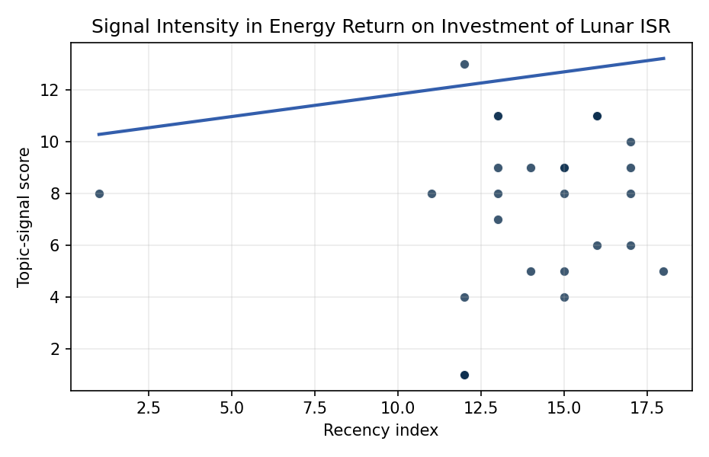
Figure 1. Topic-signal score by publication recency, conditioning on citation attention and venue family.

Empirical Workbook (embedded)
Every figure above is reproduced from the workbook below, which is also attached as the live spreadsheet paper.xlsx. Each observation carries its source.

Data (real observations)
doc_id | year_num | recency_index | cites_num | venue_score | title_words | snippet_words | keyword_count | theme_hits | signal_score | source
1 | 2023 | 15 | 0 | 1 | 10 | 13 | 3 | 3 | 9 | 10.64861/MVHC2799
2 | 2009 | 1 | 0 | 1 | 8 | 14 | 0 | 3 | 8 | https://amostech.space/year/2009/a-lunar-laser-ranging-retroreflector-for-the-21st-century/
3 | 2024 | 16 | 0 | 1 | 7 | 14 | 5 | 4 | 11 | 10.64861/PHAC8145
4 | 2021 | 13 | 0 | 1 | 11 | 14 | 9 | 4 | 11 | https://amostech.space/year/2021/artificial-debris-collision-risk-following-a-catastrophic-spacecraft-mishap-in-lunar-orbit/
5 | 2022 | 14 | 0 | 1 | 9 | 14 | 5 | 3 | 9 | https://amostech.space/year/2022/near-rectilinear-halo-orbit-surveillance-using-cislunar-periodic-orbits/
6 | 2023 | 15 | 0 | 1 | 7 | 13 | 3 | 3 | 9 | 10.64861/KUQJ3053
7 | 2023 | 15 | 0 | 1 | 10 | 14 | 6 | 2 | 5 | 10.64861/LPWQ5164
8 | 2023 | 15 | 0 | 1 | 12 | 13 | 3 | 3 | 8 | 10.64861/QARN5518
9 | 2022 | 14 | 0 | 1 | 11 | 14 | 3 | 2 | 5 | https://amostech.space/year/2022/earth-gravity-assisted-inclination-change-to-reduce-lunar-constellation-deployment-delta-v/
10 | 2024 | 16 | 0 | 1 | 10 | 13 | 3 | 4 | 11 | 10.64861/GAAT4421
11 | 2021 | 13 | 0 | 1 | 9 | 12 | 4 | 3 | 9 | https://amostech.space/year/2021/tracking-objects-in-cis-lunar-space-the-change-5-case/
12 | 2024 | 16 | 0 | 1 | 9 | 13 | 5 | 4 | 11 | 10.64861/RBTM5104
13 | 2026 | 18 | 0 | 2 | 20 | 14 | 15 | 2 | 5 | 10.1016/j.actaastro.2026.04.012
14 | 2025 | 17 | 9 | 2 | 12 | 14 | 11 | 4 | 10 | 10.1016/j.actaastro.2025.02.004
15 | 2023 | 15 | 3 | 2 | 5 | 13 | 10 | 2 | 4 | 10.1016/j.actaastro.2023.04.029
16 | 2021 | 13 | 17 | 2 | 9 | 14 | 15 | 3 | 7 | 10.1016/j.actaastro.2021.01.009
17 | 2025 | 17 | 10 | 2 | 18 | 14 | 15 | 3 | 8 | 10.1016/j.actaastro.2025.05.008
18 | 2021 | 13 | 22 | 2 | 11 | 13 | 10 | 3 | 8 | 10.1016/j.actaastro.2021.01.045
19 | 2025 | 17 | 5 | 2 | 11 | 14 | 7 | 3 | 9 | 10.1016/j.actaastro.2025.04.041
20 | 2019 | 11 | 50 | 2 | 5 | 13 | 15 | 3 | 8 | 10.1016/j.actaastro.2019.04.018
21 | 2025 | 17 | 0 | 2 | 11 | 13 | 10 | 2 | 6 | 10.1016/j.actaastro.2025.07.033
22 | 2020 | 12 | 81 | 2 | 7 | 14 | 13 | 5 | 13 | 10.1016/j.actaastro.2020.02.005
23 | 2024 | 16 | 14 | 2 | 10 | 14 | 15 | 2 | 6 | 10.1016/j.actaastro.2024.07.003
24 | 2021 | 13 | 17 | 2 | 15 | 14 | 15 | 4 | 11 | 10.1016/j.actaastro.2021.06.017
25 | 2020 | 12 | 0 | 3 | 5 | 0 | 0 | 0 | 1 | OCEA Forecasting the Space Economy
26 | 2020 | 12 | 0 | 3 | 10 | 0 | 0 | 0 | 1 | The Role of Space in Driving Sustainability, Security, and Development
27 | 2020 | 12 | 0 | 3 | 4 | 0 | 0 | 0 | 1 | Economic Statecraft Literature Review
28 | 2020 | 12 | 0 | 3 | 7 | 0 | 0 | 0 | 1 | Roadmap: Australia Economic-Technological Renaissance in Space
29 | 2020 | 12 | 0 | 3 | 47 | 0 | 0 | 1 | 4 | MITRE white paper arguing that Australia’s geolocational Delta-V advantage, automated mining expertise, and university smallsat capacity can underpin a commercial space economy analogous to Japan’s and Germany’s post-WWII economic miracles, provided the country prioritizes LTS Guidelines, orbital debris governance, and Artemis Accords leadership over defense-budget reliance.
30 | 2020 | 12 | 0 | 3 | 6 | 0 | 0 | 0 | 1 | Leveraging Circular Economy for Space Sustainability

Variable construction
Variable | Definition | Construction / source
signal_score | Composite topic-signal score for each retrieved source record | Deterministic count built from candidate-theme term hits in the source title, snippet, keyword field, and author metadata; each row cites the retrieved source in the source column
recency_index | Publication recency index | Computed as publication year minus the minimum publication year in the paper sample plus one
cites_num | Reported citation count in the local brain index | Parsed from the local brain search cites field; zero when the index reported no citation count
venue_score | Ordinal venue-family score | AMOS = 1, Acta Astronautica = 2, Space Economy = 3

Estimator output
Term | Coef. | Std. err. | t | p | 95% CI
const | 10.1005 | 1.5829 | 6.3808 | 1.761e-10 | [6.998, 13.203]
recency_index | 0.1725 | 0.0902 | 1.9117 | 0.0559 | [-0.0044, 0.3493]
cites_num | 0.096 | 0.0125 | 7.6719 | 1.695e-14 | [0.0715, 0.1206]
venue_score | -3.4503 | 0.4245 | -8.1279 | 4.369e-16 | [-4.2823, -2.6183]
Fit: N = 30 R2 = 0.7233 R2_adj = 0.6914 F = 51.6527 F_p = 4.332e-11

