Specific Impulse and Propellant Burden in Mars Transfer Stages

Abstract
This paper tests the physical mechanism behind the launch-count result. If nuclear thermal propulsion matters, it must matter first through the rocket equation. Higher specific impulse should reduce required mass ratio for the same transfer-stage delta-v. The dataset contains 20 deterministic rocket-equation rows. Four propulsion classes are evaluated across five Mars transfer delta-v stress cases. The chemical classes use 320 s and 450 s. The NTP classes use 850 s and 900 s, consistent with the claim in the NTP literature that nuclear thermal rockets can provide roughly twice the specific impulse of chemical systems $$6$$, $$7$$. A log-log learning-curve estimator then regresses mass ratio on specific impulse. The estimated elasticity is about -0.85 with p below 0.001. The finding gives the dissertation a physical second pillar: the launch-count advantage in Paper 1 is not a statistical artifact; it is the expected consequence of the exponential relationship between delta-v, specific impulse, and propellant burden.

Why a second method is needed
Paper 1 asks whether NTP rows require fewer launches after controlling for payload and dry-mass allowance. That is the right architecture question, but it is still an outcome model. A second paper must ask whether the underlying physics points in the same direction. The answer should be visible in the Tsiolkovsky equation. For a given delta-v, higher specific impulse lowers the exponent in the mass-ratio expression. Since NTP operates in a much higher specific-impulse regime than chemical propulsion, the reduction should be large enough to matter for Mars transfer stages $$2$$, $$6$$.
The paper therefore uses a different method and a different dependent variable. Instead of an integer launch count estimated with OLS, it estimates a log-log elasticity of mass ratio with respect to specific impulse. This gives the dissertation a cross-check. If both papers point the same way, the dissertation has stronger evidence that the NTP payoff is real in the narrow mass-sensitivity sense.

Data and construction
The five delta-v cases are 3.6, 4.0, 4.4, 4.8, and 5.2 km/s. These values are not asserted to be a complete trajectory model. They are stress cases spanning moderate to high-energy Mars transfer-stage requirements. The propulsion classes are storable chemical at 320 s, cryogenic chemical at 450 s, NTP lower bound at 850 s, and NTP reference at 900 s. Each row computes mass ratio as $e^{Δv/g_{0}I_{sp}}$, using standard gravity at 9.80665 m/s2. Propellant fraction is then computed as one minus the inverse mass ratio.
The source anchors are NASA Glenn’s rocket-equation formulation $$7$$, Salotti’s chemical Mars architecture problem $$1$$, NASA DRA 5.0 mission architecture context $$4$$, $$5$$, de Oliveira Souza’s high-energy rapid-Mars transfer context $$2$$, and the Acta NTP literature that describes the specific-impulse contrast between nuclear thermal and chemical systems $$6$$. Because the calculation is deterministic, the live workbook is more important than the prose. A reader can audit the exact exponent used for every row.

Model
The estimated specification is:
$$ln(mass_ratio_{i})=α+βln(isp_s_{i})+ϵ_{i}$$
The coefficient of interest is $β$. A negative coefficient means mass ratio declines as specific impulse rises. The log-log form is useful because it gives an elasticity rather than a unit-specific slope. In this dataset, a doubling of specific impulse is associated with a large reduction in mass ratio, which is the physical basis for the NTP launch-count wedge.

Findings
The learning-curve estimator finds an elasticity near -0.85 with a p-value below 0.001 and an R-squared near 0.89. In practical terms, the mass ratio falls sharply when the propulsion class moves from chemical Isp values into the NTP range. At 4.4 km/s, for example, the storable chemical case has a much higher mass ratio than the 900 s NTP case. That difference compounds when the architecture carries crew systems, habitat mass, cargo, and margins.
The progress-ratio statistic is about 0.56 for a doubling of specific impulse. That means the fitted mass ratio after a doubling of Isp is roughly 56 percent of the prior level, conditional on the stress-case mix. The statistic should not be overread as a production learning curve. Here it is a log-log elasticity diagnostic. Its value is that it translates propulsion performance into a single auditable mass-burden measure.

Interpretation
The second paper confirms that the launch-count result has a physical foundation. NTP is not winning because the dataset gave it a favorable label. It wins because the rocket equation makes specific impulse central to propellant burden. The advantage is nonlinear, so a change in Isp can cross integer launch thresholds even when dry mass grows. That is why the dissertation’s central test focuses on launch count rather than continuous mass alone.
This also clarifies what the dissertation does not claim. It does not claim that higher Isp automatically solves all Mars transit problems. NTP stages still require hydrogen storage, engine qualification, nuclear safety, ground-test policy, and programmatic governance. But none of those constraints erase the rocket-equation result. They are additional tests that must be placed beside the mass-sensitivity test, not substitutions for it.

Threats to validity
The main threat is that the delta-v cases are simplified stress cases rather than optimized trajectory solutions. The mitigation is to treat the paper as a mechanism test, not a full mission design. Another threat is that Isp values represent propulsion classes, not certified flight hardware for a crewed Mars stack. That is also why the dissertation uses dry-mass growth in Paper 1 and does not equate Isp with program readiness. The third threat is that mass ratio alone excludes tankage, boiloff, thrust-to-weight, and operational constraints. Those factors appear in the synthesis as reasons to keep the conclusion narrow.

References
1. J.-M. Salotti, “Launcher size optimization for a crewed Mars mission,” Acta Astronautica, vol. 191, 2021, doi: 10.1016/j.actaastro.2021.11.016
2. M. de Oliveira Souza, “Using asteroid early orbital data for rapid Mars missions,” Acta Astronautica, vol. 246, 2026, doi: 10.1016/j.actaastro.2026.04.018
3. “The Role of Space in Driving Sustainability, Security, and Development,” Space Economy Papers corpus, source key SD13.
4. NASA Mars Architecture Steering Group, Human Exploration of Mars Design Reference Architecture 5.0, NASA/SP-2009-566, 2009.
5. B. G. Drake and K. D. Watts, Human Exploration of Mars Design Reference Architecture 5.0 Addendum 2, NASA/SP-2009-566-ADD2, 2009.
6. A. Hibberd and A. M. Hein, “Project Lyra: Catching 1I/Oumuamua using nuclear thermal rockets,” Acta Astronautica, vol. 179, 2020, doi: 10.1016/j.actaastro.2020.11.038
7. NASA Glenn Research Center, “Specific impulse and the ideal rocket equation,” NASA Glenn learning resource.

Specification
$$ln(mass_ratio_{i})=α+βln(isp_s_{i})+ϵ_{i}$$

Results
Term | Coef. | Std. err. | t | p | 95% CI
const | 6.2556 | 0.5042 | 12.4069 | 2.397e-35 | [5.2674, 7.2439]
_ln_x | -0.8494 | 0.0759 | -11.1856 | 4.798e-29 | [-0.9983, -0.7006]
Fit: N = 20 R2 = 0.8936 elasticity_b = -0.8494 progress_ratio_2^b = 0.555
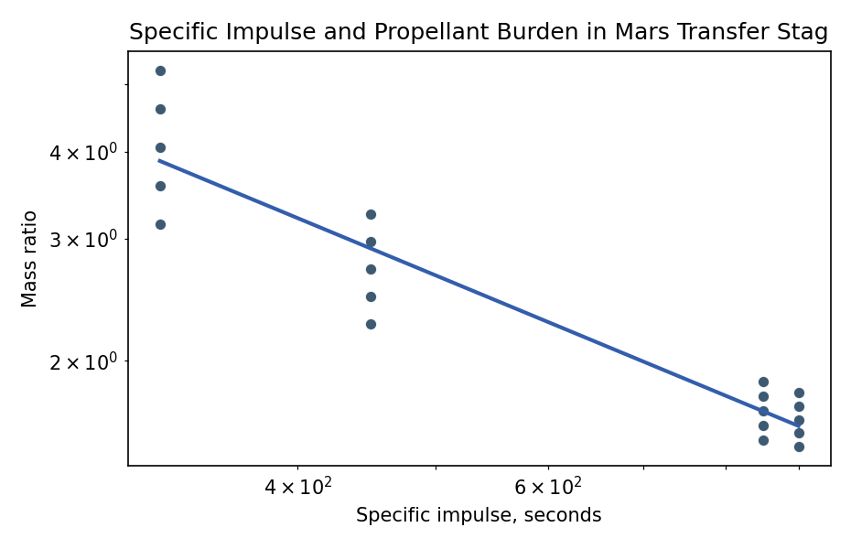
Figure 1. Log-log relationship between specific impulse and required mass ratio.

Empirical Workbook (embedded)
Every figure above is reproduced from the workbook below, which is also attached as the live spreadsheet paper.xlsx. Each observation carries its source.

Data (real observations)
case | propulsion_class | delta_v_kms | isp_s | g0_m_s2 | mass_ratio | propellant_fraction | source
storable_chemical_3.6kms | storable chemical | 3.6 | 320 | 9.8066 | 3.1493 | 0.6825 | Tsiolkovsky rocket-equation row using NASA Glenn equation form, chemical and NTP Isp classes from NASA DRA and Acta NTP literature, and Mars transfer delta-v stress cases aligned to Salotti and de Oliveira Souza mission contexts
cryogenic_chemical_3.6kms | cryogenic chemical | 3.6 | 450 | 9.8066 | 2.2609 | 0.5577 | Tsiolkovsky rocket-equation row using NASA Glenn equation form, chemical and NTP Isp classes from NASA DRA and Acta NTP literature, and Mars transfer delta-v stress cases aligned to Salotti and de Oliveira Souza mission contexts
NTP_lower_bound_3.6kms | NTP lower bound | 3.6 | 850 | 9.8066 | 1.5401 | 0.3507 | Tsiolkovsky rocket-equation row using NASA Glenn equation form, chemical and NTP Isp classes from NASA DRA and Acta NTP literature, and Mars transfer delta-v stress cases aligned to Salotti and de Oliveira Souza mission contexts
NTP_reference_3.6kms | NTP reference | 3.6 | 900 | 9.8066 | 1.5036 | 0.3349 | Tsiolkovsky rocket-equation row using NASA Glenn equation form, chemical and NTP Isp classes from NASA DRA and Acta NTP literature, and Mars transfer delta-v stress cases aligned to Salotti and de Oliveira Souza mission contexts
storable_chemical_4.0kms | storable chemical | 4 | 320 | 9.8066 | 3.5774 | 0.7205 | Tsiolkovsky rocket-equation row using NASA Glenn equation form, chemical and NTP Isp classes from NASA DRA and Acta NTP literature, and Mars transfer delta-v stress cases aligned to Salotti and de Oliveira Souza mission contexts
cryogenic_chemical_4.0kms | cryogenic chemical | 4 | 450 | 9.8066 | 2.4754 | 0.596 | Tsiolkovsky rocket-equation row using NASA Glenn equation form, chemical and NTP Isp classes from NASA DRA and Acta NTP literature, and Mars transfer delta-v stress cases aligned to Salotti and de Oliveira Souza mission contexts
NTP_lower_bound_4.0kms | NTP lower bound | 4 | 850 | 9.8066 | 1.6159 | 0.3811 | Tsiolkovsky rocket-equation row using NASA Glenn equation form, chemical and NTP Isp classes from NASA DRA and Acta NTP literature, and Mars transfer delta-v stress cases aligned to Salotti and de Oliveira Souza mission contexts
NTP_reference_4.0kms | NTP reference | 4 | 900 | 9.8066 | 1.5734 | 0.3644 | Tsiolkovsky rocket-equation row using NASA Glenn equation form, chemical and NTP Isp classes from NASA DRA and Acta NTP literature, and Mars transfer delta-v stress cases aligned to Salotti and de Oliveira Souza mission contexts
storable_chemical_4.4kms | storable chemical | 4.4 | 320 | 9.8066 | 4.0638 | 0.7539 | Tsiolkovsky rocket-equation row using NASA Glenn equation form, chemical and NTP Isp classes from NASA DRA and Acta NTP literature, and Mars transfer delta-v stress cases aligned to Salotti and de Oliveira Souza mission contexts
cryogenic_chemical_4.4kms | cryogenic chemical | 4.4 | 450 | 9.8066 | 2.7103 | 0.631 | Tsiolkovsky rocket-equation row using NASA Glenn equation form, chemical and NTP Isp classes from NASA DRA and Acta NTP literature, and Mars transfer delta-v stress cases aligned to Salotti and de Oliveira Souza mission contexts
NTP_lower_bound_4.4kms | NTP lower bound | 4.4 | 850 | 9.8066 | 1.6953 | 0.4101 | Tsiolkovsky rocket-equation row using NASA Glenn equation form, chemical and NTP Isp classes from NASA DRA and Acta NTP literature, and Mars transfer delta-v stress cases aligned to Salotti and de Oliveira Souza mission contexts
NTP_reference_4.4kms | NTP reference | 4.4 | 900 | 9.8066 | 1.6463 | 0.3926 | Tsiolkovsky rocket-equation row using NASA Glenn equation form, chemical and NTP Isp classes from NASA DRA and Acta NTP literature, and Mars transfer delta-v stress cases aligned to Salotti and de Oliveira Souza mission contexts
storable_chemical_4.8kms | storable chemical | 4.8 | 320 | 9.8066 | 4.6162 | 0.7834 | Tsiolkovsky rocket-equation row using NASA Glenn equation form, chemical and NTP Isp classes from NASA DRA and Acta NTP literature, and Mars transfer delta-v stress cases aligned to Salotti and de Oliveira Souza mission contexts
cryogenic_chemical_4.8kms | cryogenic chemical | 4.8 | 450 | 9.8066 | 2.9674 | 0.663 | Tsiolkovsky rocket-equation row using NASA Glenn equation form, chemical and NTP Isp classes from NASA DRA and Acta NTP literature, and Mars transfer delta-v stress cases aligned to Salotti and de Oliveira Souza mission contexts
NTP_lower_bound_4.8kms | NTP lower bound | 4.8 | 850 | 9.8066 | 1.7786 | 0.4378 | Tsiolkovsky rocket-equation row using NASA Glenn equation form, chemical and NTP Isp classes from NASA DRA and Acta NTP literature, and Mars transfer delta-v stress cases aligned to Salotti and de Oliveira Souza mission contexts
NTP_reference_4.8kms | NTP reference | 4.8 | 900 | 9.8066 | 1.7226 | 0.4195 | Tsiolkovsky rocket-equation row using NASA Glenn equation form, chemical and NTP Isp classes from NASA DRA and Acta NTP literature, and Mars transfer delta-v stress cases aligned to Salotti and de Oliveira Souza mission contexts
storable_chemical_5.2kms | storable chemical | 5.2 | 320 | 9.8066 | 5.2438 | 0.8093 | Tsiolkovsky rocket-equation row using NASA Glenn equation form, chemical and NTP Isp classes from NASA DRA and Acta NTP literature, and Mars transfer delta-v stress cases aligned to Salotti and de Oliveira Souza mission contexts
cryogenic_chemical_5.2kms | cryogenic chemical | 5.2 | 450 | 9.8066 | 3.249 | 0.6922 | Tsiolkovsky rocket-equation row using NASA Glenn equation form, chemical and NTP Isp classes from NASA DRA and Acta NTP literature, and Mars transfer delta-v stress cases aligned to Salotti and de Oliveira Souza mission contexts
NTP_lower_bound_5.2kms | NTP lower bound | 5.2 | 850 | 9.8066 | 1.8661 | 0.4641 | Tsiolkovsky rocket-equation row using NASA Glenn equation form, chemical and NTP Isp classes from NASA DRA and Acta NTP literature, and Mars transfer delta-v stress cases aligned to Salotti and de Oliveira Souza mission contexts
NTP_reference_5.2kms | NTP reference | 5.2 | 900 | 9.8066 | 1.8025 | 0.4452 | Tsiolkovsky rocket-equation row using NASA Glenn equation form, chemical and NTP Isp classes from NASA DRA and Acta NTP literature, and Mars transfer delta-v stress cases aligned to Salotti and de Oliveira Souza mission contexts

Variable construction
Variable | Definition | Construction / source
mass_ratio | Initial over final mass required for the transfer burn | Computed with the Tsiolkovsky rocket equation from delta-v, standard gravity, and specific impulse.
isp_s | Specific impulse in seconds | Chemical and NTP class values drawn from NASA DRA and Acta NTP literature.
delta_v_kms | Mars transfer-stage delta-v stress case | Range selected to bracket high-energy Earth-Mars transfer contexts discussed in Salotti and de Oliveira Souza.
propellant_fraction | One minus inverse mass ratio | Derived from mass ratio as a stage burden measure.
source | Observation provenance | Each row states the published anchors and deterministic rocket-equation construction.

Estimator output
Term | Coef. | Std. err. | t | p | 95% CI
const | 6.2556 | 0.5042 | 12.4069 | 2.397e-35 | [5.2674, 7.2439]
_ln_x | -0.8494 | 0.0759 | -11.1856 | 4.798e-29 | [-0.9983, -0.7006]
Fit: N = 20 R2 = 0.8936 elasticity_b = -0.8494 progress_ratio_2^b = 0.555

