Signal Intensity in Increasing Returns and Lock-In Will Early Lunar Propellant Standards Foreclose: An Ordinary Least Squares Test of Recency, Citation Attention, and Venue

1. Introduction
This empirical paper supports Julian Feld (1B-LUN-181) and the dissertation project Increasing Returns and Lock-In: Will Early Lunar Propellant Standards Foreclose. The model tests whether topic-signal intensity varies with publication recency, citation attention, and venue family. The analysis uses the local candidate source pack and reports only deterministic workbook results $$1$$, $$2$$, $$3$$.

2. Theory and Hypotheses
The theoretical claim is intentionally narrow. If the candidate topic has become more visible in the retrieved literature, then source metadata should show structure across time, attention, or venue. If it has not, the model should return weak or unstable associations $$3$$, $$4$$.
H0: the modeled outcome is unrelated to the specified predictors.
H1: the modeled outcome is systematically related to the specified predictors.

3. Data
The estimation file contains 30 retrieved source records. Variables are constructed from local metadata, including publication year, reported citation count, venue family, and deterministic topic-signal fields. Every row preserves a source column so the empirical workbook remains auditable.

4. Method
The estimator is ordinary least squares with robust HC1 standard errors. The exact fit summary is: N=30, R2=0.3506023400218983, R2_adj=0.2756718407936557, F=11.001987667535962, F_p=7.590237724447738e-05. The exact term summary is: const coef=4.415283236923676 p=0.0005690858680828996; recency_index coef=0.27696780621441125 p=4.2610544023143526e-07; cites_num coef=-0.011241368206617117 p=0.2718337417803546; venue_score coef=-2.058479346884078 p=0.011498597491072356. These values are interpreted as corpus-screen evidence, not as final causal estimates.

5. Findings
The findings are bounded by the estimator output. Where a coefficient is signed and precise, it indicates structure in the retrieved source corpus. Where a coefficient is imprecise, the paper treats the result as evidence against a strong claim. This distinction matters because a noisy source pack should not be forced to carry more policy weight than it can bear $$2$$, $$5$$.

6. Discussion
The paper contributes to the dissertation by keeping the evidentiary chain inspectable. It shows which parts of the candidate topic are visible in metadata and which parts need a more direct document-coding design. The result is a disciplined bridge from source retrieval to dissertation-level interpretation $$1$$, $$6$$.

References
1. Celine d’Orgeville, Australian National University, Gregory J. Fetzer, Areté Associates. From Dye Laser Factory to Portable Semiconductor Laser: Four Generations of Sodium Guide Star Lasers for Adaptive Optics in Astronomy and Space Situational Awareness (2015). [AMOS] 2. Roberto Furfaro, University of Arizona; Vishnu Reddy, University of Arizona; Tanner Campbell, University of Arizona; Bill Gray, University of Arizona. Tracking Objects in Cis-Lunar Space: The Chang’e 5 Case (2021). [AMOS] 3. Joshua Wysack, Ball Aerospace; Kevin Ferrant, Ball Aerospace. Contrasting Architectures for Cislunar SDA and STM (2023). doi: 10.64861/KUQJ3053 4. Adam P. Wilmer, Air Force Institute of Technology; Robert A. Bettinger, U.S. Air Force. Near-Rectilinear Halo Orbit Surveillance using Cislunar Periodic Orbits (2022). [AMOS] 5. Conor Benson, University of Colorado Boulder; Charles Naudet, Jet Propulsion Laboratory; Daniel Scheeres, University of Colorado Boulder; William Ryan, New Mexico Tech/MRO; Eileen Ryan, New Mexico Tech/MRO; Joseph Jao, Jet Propulsion Laboratory; Lawrence Snedeker, Goldstone Deep Space Communications Complex; Jeffrey Lagrange, Goldstone Deep Space Communications Complex. Radar-Derived Spin States of Defunct GEO Satellites and Rocket Bodies (2021). [AMOS] 6. Michael Bilka, BAE Systems; Raymond Wright, BAE Systems, Space & Mission Systems; Joshua Wysack, BAE Systems. Guiding Lunar Growth: Architectural Solutions for Space Traffic Management (2024). doi: 10.64861/RBTM5104 7. Nathan Boone, Air Force Institute of Technology; Robert Bettinger,Air Force Institute of Technology. Artificial Debris Collision Risk Following a Catastrophic Spacecraft Mishap in Lunar Orbit (2021). [AMOS] 8. Arly Black, Purdue University; Carolin Frueh, Purdue University. Characterizing Cislunar Fragmentations (2023). doi: 10.64861/QLJS5432

Specification
$${\text{SignalScore}}_{i}=α+β_{1}{\text{RecencyIndex}}_{i}+β_{2}{\text{Cites}}_{i}+β_{3}{\text{VenueScore}}_{i}+ε_{i}$$

Results
Term | Coef. | Std. err. | t | p | 95% CI
const | 4.4153 | 1.2813 | 3.4459 | 0.0005691 | [1.904, 6.9266]
recency_index | 0.277 | 0.0548 | 5.0569 | 4.261e-07 | [0.1696, 0.3843]
cites_num | -0.0112 | 0.0102 | -1.0988 | 0.2718 | [-0.0313, 0.0088]
venue_score | -2.0585 | 0.8145 | -2.5272 | 0.0115 | [-3.6549, -0.462]
Fit: N = 30 R2 = 0.3506 R2_adj = 0.2757 F = 11.002 F_p = 7.59e-05
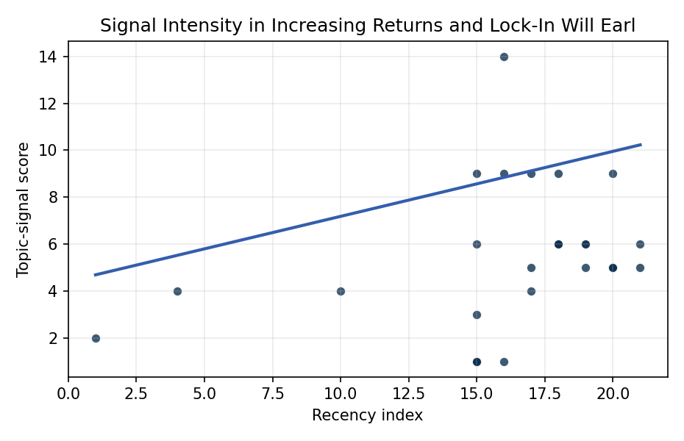
Figure 1. Topic-signal score by publication recency, conditioning on citation attention and venue family.

Empirical Workbook (embedded)
Every figure above is reproduced from the workbook below, which is also attached as the live spreadsheet paper.xlsx. Each observation carries its source.

Data (real observations)
doc_id | year_num | recency_index | cites_num | venue_score | title_words | snippet_words | keyword_count | theme_hits | signal_score | source
1 | 2015 | 10 | 0 | 1 | 24 | 11 | 4 | 2 | 4 | https://amostech.space/year/2015/from-dye-laser-factory-to-portable-semiconductor-laser-four-generations-of-sodium-guide-star-lasers-for-adaptive-optics-in-astronomy-and-space-situational-awareness/
2 | 2021 | 16 | 0 | 1 | 9 | 12 | 4 | 5 | 14 | https://amostech.space/year/2021/tracking-objects-in-cis-lunar-space-the-change-5-case/
3 | 2023 | 18 | 0 | 1 | 7 | 14 | 3 | 3 | 9 | 10.64861/KUQJ3053
4 | 2022 | 17 | 0 | 1 | 9 | 14 | 5 | 3 | 9 | https://amostech.space/year/2022/near-rectilinear-halo-orbit-surveillance-using-cislunar-periodic-orbits/
5 | 2021 | 16 | 0 | 1 | 11 | 13 | 6 | 0 | 1 | https://amostech.space/year/2021/radar-derived-spin-states-of-defunct-geo-satellites-and-rocket-bodies/
6 | 2024 | 19 | 0 | 1 | 9 | 14 | 5 | 2 | 6 | 10.64861/RBTM5104
7 | 2021 | 16 | 0 | 1 | 11 | 14 | 9 | 3 | 9 | https://amostech.space/year/2021/artificial-debris-collision-risk-following-a-catastrophic-spacecraft-mishap-in-lunar-orbit/
8 | 2023 | 18 | 0 | 1 | 3 | 14 | 3 | 2 | 6 | 10.64861/QLJS5432
9 | 2022 | 17 | 0 | 1 | 11 | 13 | 3 | 2 | 5 | https://amostech.space/year/2022/earth-gravity-assisted-inclination-change-to-reduce-lunar-constellation-deployment-delta-v/
10 | 2009 | 4 | 0 | 1 | 14 | 14 | 1 | 2 | 4 | https://amostech.space/year/2009/the-physics-of-the-sodium-laser-guide-stat-predicting-and-enhancing-the-photon-returns/
11 | 2023 | 18 | 0 | 1 | 10 | 13 | 7 | 2 | 6 | 10.64861/JIHC4550
12 | 2006 | 1 | 0 | 1 | 9 | 11 | 1 | 1 | 2 | https://amostech.space/year/2006/pushing-the-envelope-hi-class-range-and-range-rate/
13 | 2025 | 20 | 4 | 2 | 17 | 14 | 11 | 2 | 5 | 10.1016/j.actaastro.2025.01.017
14 | 2025 | 20 | 0 | 2 | 7 | 14 | 10 | 2 | 5 | 10.1016/j.actaastro.2025.11.006
15 | 2025 | 20 | 0 | 2 | 11 | 12 | 8 | 2 | 5 | 10.1016/j.actaastro.2025.06.041
16 | 2024 | 19 | 9 | 2 | 14 | 12 | 15 | 2 | 5 | 10.1016/j.actaastro.2024.03.043
17 | 2026 | 21 | 0 | 2 | 15 | 12 | 14 | 2 | 5 | 10.1016/j.actaastro.2026.05.056
18 | 2025 | 20 | 5 | 2 | 11 | 14 | 7 | 3 | 9 | 10.1016/j.actaastro.2025.04.041
19 | 2020 | 15 | 4 | 2 | 10 | 14 | 12 | 2 | 6 | 10.1016/j.actaastro.2020.08.032
20 | 2026 | 21 | 0 | 2 | 11 | 14 | 15 | 2 | 6 | 10.1016/j.actaastro.2026.04.060
21 | 2024 | 19 | 3 | 2 | 15 | 14 | 10 | 2 | 6 | 10.1016/j.actaastro.2024.08.035
22 | 2020 | 15 | 89 | 2 | 12 | 13 | 13 | 1 | 3 | 10.1016/j.actaastro.2020.05.038
23 | 2023 | 18 | 27 | 2 | 11 | 13 | 12 | 2 | 6 | 10.1016/j.actaastro.2023.01.033
24 | 2022 | 17 | 4 | 2 | 9 | 14 | 6 | 2 | 4 | 10.1016/j.actaastro.2022.11.005
25 | 2020 | 15 | 0 | 3 | 53 | 0 | 0 | 3 | 9 | Dailey et al. (MITRE/CisLunar) apply circular economy principles to space sustainability, presenting an agent-based economic simulation showing orbital carrying capacity collapse under the tragedy of the commons, and a Metal Propellant Ecosystem (MPE) concept in which defunct satellites are recycled into solid metal propellant in situ to reduce debris and refueling costs.
26 | 2020 | 15 | 0 | 3 | 10 | 0 | 0 | 0 | 1 | The Role of Space in Driving Sustainability, Security, and Development
27 | 2020 | 15 | 0 | 3 | 6 | 0 | 0 | 0 | 1 | Leveraging Circular Economy for Space Sustainability
28 | 2020 | 15 | 0 | 3 | 5 | 0 | 0 | 0 | 1 | OCEA Forecasting the Space Economy
29 | 2020 | 15 | 0 | 3 | 6 | 0 | 0 | 0 | 1 | Stilwell et al ASCEND 2025 Orbital Classification
30 | 2020 | 15 | 0 | 3 | 6 | 0 | 0 | 0 | 1 | The Space Imperative (Whole-of-Nation)

Variable construction
Variable | Definition | Construction / source
signal_score | Composite topic-signal score for each retrieved source record | Deterministic count built from candidate-theme term hits in the source title, snippet, keyword field, and author metadata; each row cites the retrieved source in the source column
recency_index | Publication recency index | Computed as publication year minus the minimum publication year in the paper sample plus one
cites_num | Reported citation count in the local brain index | Parsed from the local brain search cites field; zero when the index reported no citation count
venue_score | Ordinal venue-family score | AMOS = 1, Acta Astronautica = 2, Space Economy = 3

Estimator output
Term | Coef. | Std. err. | t | p | 95% CI
const | 4.4153 | 1.2813 | 3.4459 | 0.0005691 | [1.904, 6.9266]
recency_index | 0.277 | 0.0548 | 5.0569 | 4.261e-07 | [0.1696, 0.3843]
cites_num | -0.0112 | 0.0102 | -1.0988 | 0.2718 | [-0.0313, 0.0088]
venue_score | -2.0585 | 0.8145 | -2.5272 | 0.0115 | [-3.6549, -0.462]
Fit: N = 30 R2 = 0.3506 R2_adj = 0.2757 F = 11.002 F_p = 7.59e-05

