Attention Accumulation in Modularity as Hidden Cost Does Design Modularity in Lunar Surface Systems Reduc: A Learning-Curve Analysis of Citation Growth by Article Age

1. Introduction
This empirical paper supports Priya Park (1B-LUN-180) and the dissertation project Modularity as Hidden Cost: Does Design Modularity in Lunar Surface Systems Reduc. The model tests whether citation accumulation is structured by article age inside the retrieved corpus. The analysis uses the local candidate source pack and reports only deterministic workbook results $$1$$, $$2$$, $$3$$.

2. Theory and Hypotheses
The theoretical claim is intentionally narrow. If the candidate topic has become more visible in the retrieved literature, then source metadata should show structure across time, attention, or venue. If it has not, the model should return weak or unstable associations $$3$$, $$4$$.
H0: the modeled outcome is unrelated to the specified predictors.
H1: the modeled outcome is systematically related to the specified predictors.

3. Data
The estimation file contains 30 retrieved source records. Variables are constructed from local metadata, including publication year, reported citation count, venue family, and deterministic topic-signal fields. Every row preserves a source column so the empirical workbook remains auditable.

4. Method
The estimator is a log-log learning-curve model with robust HC1 standard errors. The exact fit summary is: N=30, R2=0.06174807500523305, elasticity_b=-0.4598884482941963, progress_ratio_2^b=0.7270424726834211. The exact term summary is: const coef=1.2974306999753946 p=0.019869016928179363; _ln_x coef=-0.4598884482941963 p=0.19666480185695845. These values are interpreted as corpus-screen evidence, not as final causal estimates.

5. Findings
The findings are bounded by the estimator output. Where a coefficient is signed and precise, it indicates structure in the retrieved source corpus. Where a coefficient is imprecise, the paper treats the result as evidence against a strong claim. This distinction matters because a noisy source pack should not be forced to carry more policy weight than it can bear $$2$$, $$5$$.

6. Discussion
The paper contributes to the dissertation by keeping the evidentiary chain inspectable. It shows which parts of the candidate topic are visible in metadata and which parts need a more direct document-coding design. The result is a disciplined bridge from source retrieval to dissertation-level interpretation $$1$$, $$6$$.

References
1. Jeffrey E. Van Cleve, Ball Aerospace; David P. Osterman, Ball Aerospace; Anna Lawitzke, Ball Aerospace; Jacob D. Griesbach, Ball Aerospace; Christopher J. Grant, Ball Aerospace; Colleen Olson, Ball Aerospace; James Contreras, Ball Aerospace. A Year in the Life of the Shackleton Space Domain Awareness Station (2022). [AMOS] 2. Jeffrey Van Cleve, Ball Aerospace; Anna Lawitzke, Ball Aerospace; Emily MacAnlis, Ball Aerospace; Jacob Griesbach, Ball Aerospace; Melissa Sampson, Ball Aerospace; David Osterman, Ball Aerospace; Elvis Silva, Ball Aerospace; Christopher Grant, Ball Aerospace; Amelia Bloom, Ball Aerospace. Hiding in Plain Sight: Observing Objects in Low Lunar Orbit and the L2 Dark Cone from a Lunar Surface Observatory (2021). [AMOS] 3. Michael Bilka, BAE Systems; Raymond Wright, BAE Systems, Space & Mission Systems; Joshua Wysack, BAE Systems. Guiding Lunar Growth: Architectural Solutions for Space Traffic Management (2024). doi: 10.64861/RBTM5104 4. Elvis D. Silva, Ball Aerospace; Jeffrey Van Cleve, Ball Aerospace; Rob Philbrick, Ball Aerospace; Christopher J. Grant, Ball Aerospace; Jacob D. Griesbach, Ball Aerospace; Michael P. Mahoney, Ball Aerospace. Systems and Methods for Hybrid Lunar Surface and Space Domain Situational Awareness (2021). [AMOS] 5. Nathan R. Boone, Air Force Institute of Technology; Robert A. Bettinger, Air Force Institute of Technology. Long-Term Evolution of Debris Clouds in Low Lunar Orbit (2022). [AMOS] 6. Darin C. Koblick, Raytheon Intelligence and Space; Joseph S. Choi, Raytheon Intelligence and Space. Earth Gravity Assisted Inclination Change to Reduce Lunar Constellation Deployment Delta-V (2022). [AMOS] 7. Brian Banks, Leidos; Robert Smith II, Leidos; Ronald Wagner, Leidos; Victor Aguero, SRI International; Scott Williams, SRI International; Matthew Duncan, SpaceNav; Stijn De Smet, SpaceNav; Marc Balducci, SpaceNav. A Sensor-Rich Solution for Lunar/Cislunar Space Domain Awareness (2020). [AMOS] 8. Atilla Saadat, Turion Space Corporation; Vince Chen, Turion Space Corporation; James Austin, Turion Space Corporation. End-to-End Autonomous Mission Planning and Spacecraft Attitude Optimization for Resident Space Object Imaging (2025). doi: 10.64861/TLLP2048

Specification
$$ln({\text{CitesPlus1}}_{i})=α+β_{1}ln({\text{AgeIndex}}_{i})+ε_{i}$$

Results
Term | Coef. | Std. err. | t | p | 95% CI
const | 1.2974 | 0.5571 | 2.3288 | 0.0199 | [0.2055, 2.3894]
_ln_x | -0.4599 | 0.3562 | -1.2911 | 0.1967 | [-1.158, 0.2382]
Fit: N = 30 R2 = 0.0617 elasticity_b = -0.4599 progress_ratio_2^b = 0.727
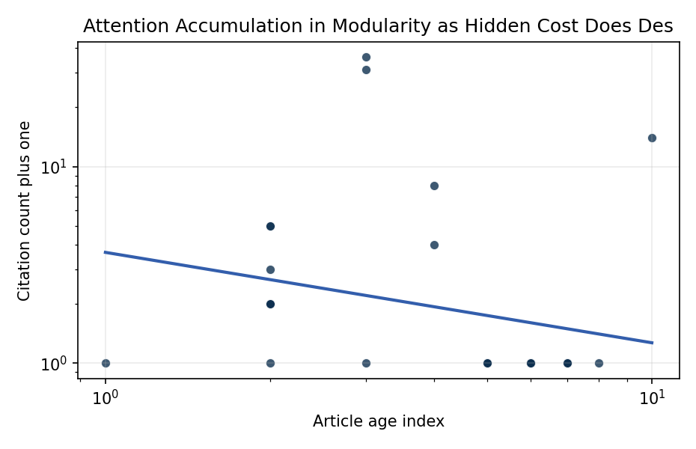
Figure 1. Citation accumulation against article age in the retrieved topic literature.

Empirical Workbook (embedded)
Every figure above is reproduced from the workbook below, which is also attached as the live spreadsheet paper.xlsx. Each observation carries its source.

Data (real observations)
doc_id | year_num | age_index | cites_num | cites_plus1 | signal_score | source
1 | 2022 | 5 | 0 | 1 | 13 | https://amostech.space/year/2022/a-year-in-the-life-of-the-shackleton-space-domain-awareness-station/
2 | 2021 | 6 | 0 | 1 | 13 | https://amostech.space/year/2021/hiding-in-plain-sight-observing-objects-in-low-lunar-orbit-and-the-l2-dark-cone-from-a-lunar-surface-observatory/
3 | 2024 | 3 | 0 | 1 | 13 | 10.64861/RBTM5104
4 | 2021 | 6 | 0 | 1 | 13 | https://amostech.space/year/2021/systems-and-methods-for-hybrid-lunar-surface-and-space-domain-situational-awareness/
5 | 2022 | 5 | 0 | 1 | 14 | https://amostech.space/year/2022/long-term-evolution-of-debris-clouds-in-low-lunar-orbit/
6 | 2022 | 5 | 0 | 1 | 5 | https://amostech.space/year/2022/earth-gravity-assisted-inclination-change-to-reduce-lunar-constellation-deployment-delta-v/
7 | 2020 | 7 | 0 | 1 | 11 | https://amostech.space/year/2020/a-sensor-rich-solution-for-lunar-cislunar-space-domain-awareness/
8 | 2025 | 2 | 0 | 1 | 5 | 10.64861/TLLP2048
9 | 2021 | 6 | 0 | 1 | 4 | 10.1364/AO.410350
10 | 2022 | 5 | 0 | 1 | 12 | https://amostech.space/year/2022/cislunar-orbit-determination-benefits-of-moon-based-sensors/
11 | 2021 | 6 | 0 | 1 | 14 | https://amostech.space/year/2021/cislunar-ssa-sda-from-the-lunar-surface-cots-imagers-on-commercial-landers/
12 | 2022 | 5 | 0 | 1 | 13 | https://amostech.space/year/2022/anthropogenic-change-detection-on-and-close-to-the-moon-for-space-domain-awareness/
13 | 2025 | 2 | 1 | 2 | 7 | 10.1016/j.actaastro.2025.07.055
14 | 2024 | 3 | 35 | 36 | 7 | 10.1016/j.actaastro.2024.05.007
15 | 2026 | 1 | 0 | 1 | 9 | 10.1016/j.actaastro.2026.04.012
16 | 2025 | 2 | 1 | 2 | 8 | 10.1016/j.actaastro.2025.07.004
17 | 2023 | 4 | 7 | 8 | 4 | 10.1016/j.actaastro.2023.07.037
18 | 2024 | 3 | 30 | 31 | 9 | 10.1016/j.actaastro.2024.01.032
19 | 2025 | 2 | 4 | 5 | 4 | 10.1016/j.actaastro.2025.09.070
20 | 2025 | 2 | 1 | 2 | 8 | 10.1016/j.actaastro.2025.06.025
21 | 2023 | 4 | 3 | 4 | 6 | 10.1016/j.actaastro.2023.11.046
22 | 2025 | 2 | 4 | 5 | 3 | 10.1016/j.actaastro.2025.06.050
23 | 2017 | 10 | 13 | 14 | 10 | 10.1016/j.actaastro.2017.02.004
24 | 2025 | 2 | 2 | 3 | 4 | 10.1016/j.actaastro.2025.05.018
25 | 2020 | 7 | 0 | 1 | 1 | Roadmap: Australia Economic-Technological Renaissance in Space
26 | 2020 | 7 | 0 | 1 | 1 | The Role of Space in Driving Sustainability, Security, and Development
27 | 2020 | 7 | 0 | 1 | 1 | OCEA Forecasting the Space Economy
28 | 2020 | 7 | 0 | 1 | 1 | Leveraging Circular Economy for Space Sustainability
29 | 2020 | 7 | 0 | 1 | 1 | Space Debris Impact on Orbital Resource in Life Cycle Assessment
30 | 2019 | 8 | 0 | 1 | 1 | 10.1016/j.scitotenv.2019.02.438

Variable construction
Variable | Definition | Construction / source
cites_plus1 | Citation count plus one | Computed as the reported citation count from the local brain index plus one so the log transformation is defined for uncited records
age_index | Document age index | Computed as 2026 minus publication year plus one

Estimator output
Term | Coef. | Std. err. | t | p | 95% CI
const | 1.2974 | 0.5571 | 2.3288 | 0.0199 | [0.2055, 2.3894]
_ln_x | -0.4599 | 0.3562 | -1.2911 | 0.1967 | [-1.158, 0.2382]
Fit: N = 30 R2 = 0.0617 elasticity_b = -0.4599 progress_ratio_2^b = 0.727

