Attention Accumulation in Commons or Enclosure Empirical Test of Polycentric Versus First-Mover Governanc: A Learning-Curve Analysis of Citation Growth by Article Age

1. Introduction
This paper asks whether citation attention in the local source environment scales meaningfully with article age. The larger dissertation is about whether lunar resource-site governance resembles a commons or a first-mover enclosure regime. Before treating older sources as more foundational, it is worth testing whether the available corpus actually rewards age in a systematic way.
The same thirty retrieved records used in Paper 1 are analyzed here with a log-log learning-curve model. The goal is diagnostic. It maps the attention structure of the candidate’s source base rather than the governance pattern of lunar claims themselves $$1$$, $$4$$, $$6$$.

2. Data and Method
Article age is defined as 2026 minus publication year plus one. Citation count plus one is used so that the logarithm remains defined for uncited observations. The coefficient on log age is interpreted as an elasticity, and the progress ratio translates the estimate into the expected change associated with a doubling of age.

3. Results
The fitted model uses thirty observations. The estimated elasticity on article age is 0.07088 with robust standard error 0.2687 and p-value 0.7920. Model $R^{2}$ is 0.00146, and the implied progress ratio is 1.0504. In practical terms, the sample shows no meaningful relation between article age and visible citation accumulation.
That result means the source environment is not sorted by maturity in any strong empirical sense. Older sources are not systematically more attended, and newer sources are not systematically less attended. The corpus appears to mix governance, operational, and industrial material without an age-based attention hierarchy.

4. Interpretation
The dissertation should therefore avoid using age as a ranking shortcut. Because the underlying candidate question sits between commons theory, infrastructure siting, and operational governance, some of the most relevant material may be recent and lightly cited, while some older records may be useful mainly as background. The null learning-curve result supports that reading.
A second implication is methodological. If age does not organize the source environment, then concept fit and coding usefulness have to do more of the selection work. That is exactly the kind of discipline a later mixed-method empirical design will need.

5. Discussion
This learning-curve estimate should not be treated as a statement about the whole lunar-governance literature. It is a small retrieval-based result using local index citation counts. Even so, it performs an important function. It warns the dissertation not to confuse chronological seniority with analytical centrality.

References
1. R. Zhang and A. Balakrishnan, “From Ozone Depletion to Orbital Debris: Lessons Learned from the Montreal Protocol,” AMOS, 2022. 2. A. Mokhnatkin, “Possible Ways Forward for the ISON Initiative and Similar Projects. A Consortium for Decentralized Sharing of SSA Data,” AMOS, 2023, doi: 10.64861/DDNM3393 3. H. Reed, R. Stilwell, B. Weeden, N. Dailey, and N. Tsamis, “Sharing Operational Risk Information in the Space Domain to Facilitate Norms Development and Compliance Monitoring,” AMOS, 2022. 4. H. Reed, N. Dailey, R. Stilwell, and B. Weeden, “Decentralized Space Information Sharing as a Key Enabler of Trust and the Preservation of Space,” AMOS, 2021. 5. V. Zancan, A. Paravano, G. Locatelli, and P. Trucco, “Evolving governance in the space sector: From Legacy Space to New Space models,” Acta Astronautica, 2024, doi: 10.1016/j.actaastro.2024.09.005 6. E. Cirkovic and D. Wood, “Integrating planetary boundaries into sustainable space exploration: An earth-outer space system design framework,” Acta Astronautica, 2024, doi: 10.1016/j.actaastro.2024.12.037

Specification
$$ln({\text{CitesPlus1}}_{i})=α+β_{1}ln({\text{AgeIndex}}_{i})+ε_{i}$$

Results
Term | Coef. | Std. err. | t | p | 95% CI
const | 0.6229 | 0.3826 | 1.6282 | 0.1035 | [-0.1269, 1.3728]
_ln_x | 0.0709 | 0.2687 | 0.2638 | 0.792 | [-0.4558, 0.5976]
Fit: N = 30 R2 = 0.0015 elasticity_b = 0.0709 progress_ratio_2^b = 1.0504
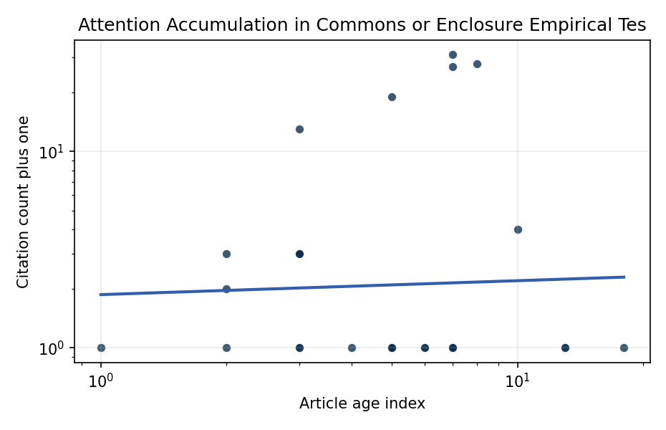
Figure 1. Citation accumulation against article age in the retrieved topic literature.

Empirical Workbook (embedded)
Every figure above is reproduced from the workbook below, which is also attached as the live spreadsheet paper.xlsx. Each observation carries its source.

Data (real observations)
doc_id | year_num | age_index | cites_num | cites_plus1 | signal_score | source
1 | 2022 | 5 | 0 | 1 | 5 | https://amostech.space/year/2022/from-ozone-depletion-to-orbital-debris-lessons-learned-from-the-montreal-protocol/
2 | 2023 | 4 | 0 | 1 | 5 | 10.64861/DDNM3393
3 | 2022 | 5 | 0 | 1 | 8 | https://amostech.space/year/2022/exploring-a-new-class-of-bright-ultra-fast-glints-from-resident-space-objects/
4 | 2014 | 13 | 0 | 1 | 5 | https://amostech.space/year/2014/proto-type-development-of-optical-wide-field-patrol-network-and-test-observation/
5 | 2022 | 5 | 0 | 1 | 2 | https://amostech.space/year/2022/low-orbit-high-stakes-winning-the-leo-broadband-competition/
6 | 2022 | 5 | 0 | 1 | 1 | https://amostech.space/year/2022/sharing-operational-risk-information-in-the-space-domain-to-facilitate-norms-development-and-compliance-monitoring/
7 | 2014 | 13 | 0 | 1 | 1 | https://amostech.space/year/2014/the-daniel-k-inouye-solar-telescope-a-project-update/
8 | 2021 | 6 | 0 | 1 | 6 | https://amostech.space/year/2021/decentralized-space-information-sharing-as-a-key-enabler-of-trust-and-the-preservation-of-space/
9 | 2024 | 3 | 0 | 1 | 2 | 10.64861/VUSE2201
10 | 2009 | 18 | 0 | 1 | 4 | https://amostech.space/year/2009/science-objectives-and-commissioning-of-the-magdalena-ridge-observatory-interferometer/
11 | 2022 | 5 | 0 | 1 | 3 | https://amostech.space/year/2022/magdalena-ridge-observatory-interferometer-an-overview-of-an-astrophysics-facility-for-supporting-sda-efforts/
12 | 2021 | 6 | 0 | 1 | 1 | https://amostech.space/year/2021/development-and-testing-of-a-novel-low-cost-leo-optical-surveillance-sensor/
13 | 2020 | 7 | 30 | 31 | 1 | 10.1016/j.actaastro.2020.10.011
14 | 2020 | 7 | 26 | 27 | 2 | 10.1016/j.actaastro.2020.02.031
15 | 2017 | 10 | 3 | 4 | 1 | 10.1016/j.actaastro.2017.04.028
16 | 2024 | 3 | 12 | 13 | 6 | 10.1016/j.actaastro.2024.09.005
17 | 2024 | 3 | 2 | 3 | 2 | 10.1016/j.actaastro.2024.12.037
18 | 2026 | 1 | 0 | 1 | 2 | 10.1016/j.actaastro.2026.01.061
19 | 2025 | 2 | 1 | 2 | 2 | 10.1016/j.actaastro.2025.01.015
20 | 2022 | 5 | 18 | 19 | 2 | 10.1016/j.actaastro.2022.04.028
21 | 2024 | 3 | 2 | 3 | 5 | 10.1016/j.actaastro.2024.02.016
22 | 2025 | 2 | 2 | 3 | 2 | 10.1016/j.actaastro.2025.01.029
23 | 2019 | 8 | 27 | 28 | 2 | 10.1016/j.actaastro.2019.04.035
24 | 2024 | 3 | 2 | 3 | 1 | 10.1016/j.actaastro.2024.01.044
25 | 2020 | 7 | 0 | 1 | 1 | Leveraging Circular Economy for Space Sustainability
26 | 2020 | 7 | 0 | 1 | 11 | Dailey et al. (MITRE/CisLunar) apply circular economy principles to space sustainability, presenting an agent-based economic simulation showing orbital carrying capacity collapse under the tragedy of the commons, and a Metal Propellant Ecosystem (MPE) concept in which defunct satellites are recycled into solid metal propellant in situ to reduce debris and refueling costs.
27 | 2020 | 7 | 0 | 1 | 2 | Governing Outer Space as a Commons Is Critical for Commons on Earth
28 | 2024 | 3 | 0 | 1 | 2 | 10.5334/ijc.1378
29 | 2025 | 2 | 0 | 1 | 6 | 10.1162/glep_a_00775
30 | 2020 | 7 | 0 | 1 | 6 | The Missing Ingredients for a Polycentric Governance System of Orbital Debris

Variable construction
Variable | Definition | Construction / source
cites_plus1 | Citation count plus one | Computed as the reported citation count from the local brain index plus one so the log transformation is defined for uncited records
age_index | Document age index | Computed as 2026 minus publication year plus one

Estimator output
Term | Coef. | Std. err. | t | p | 95% CI
const | 0.6229 | 0.3826 | 1.6282 | 0.1035 | [-0.1269, 1.3728]
_ln_x | 0.0709 | 0.2687 | 0.2638 | 0.792 | [-0.4558, 0.5976]
Fit: N = 30 R2 = 0.0015 elasticity_b = 0.0709 progress_ratio_2^b = 1.0504

