Signal Intensity in Commons or Enclosure Empirical Test of Polycentric Versus First-Mover Governanc: An Ordinary Least Squares Test of Recency, Citation Attention, and Venue

1. Introduction
This paper audits the local source base around the dissertation’s commons-versus-enclosure question. Rather than estimate whether lunar site claiming is polycentric or exclusionary, it asks a narrower empirical question: within the local literature corpus retrieved for this candidate, what predicts topic-signal intensity $$1$$, $$2$$, $$4$$, $$6$$? The purpose is source discipline. If the available corpus sorts strongly on visible features, the dissertation should know that before it draws broader theoretical conclusions from the literature environment.
The dataset contains thirty retrieved records from local AMOS and Acta collections. Each row includes publication year, recency index, citation count where available, venue-family score, and a deterministic signal score constructed from titles, snippets, keywords, and adjacent metadata. The dependent variable is a bounded topical-salience measure rather than a quality ranking.

2. Data and Design
The model regresses signal score on recency index, citation count, and venue score using ordinary least squares with robust HC1 standard errors. Because the sample is retrieval-based rather than a population of all relevant scholarship, the results are descriptive and diagnostic rather than causal. They map the structure of the visible source environment.
That posture is important. The larger dissertation is about governance patterns in lunar claiming behavior. The present paper is about how the source base available to that dissertation is organized. It is a methods discipline, not a surrogate hypothesis test.

3. Results
The fitted model uses thirty observations and yields an $R^{2}$ of 0.0675 with an F-test p-value of 0.1662. The overall model is therefore weak. Recency index has coefficient -0.0376 and p-value 0.7262, showing no meaningful relationship with topic signal. Citation count has coefficient -0.0687, robust standard error 0.0331, and p-value 0.0379, which is the only conventionally significant predictor in the model. Venue score has coefficient 0.4327 and p-value 0.6160, which is also imprecise.
Substantively, this means the local corpus is only weakly structured by the tested predictors. The single visible pattern is that higher citation counts are associated with slightly lower topic-signal intensity in this sample. That result suggests that more broadly cited records in the corpus are not necessarily the most directly useful for the candidate’s specific commons-versus-enclosure mechanism.

4. Interpretation
The paper therefore cautions against relying on prestige proxies. The local literature environment for this candidate appears to include some more broadly cited but only loosely aligned records alongside less-cited sources that speak more directly to decentralized governance, coordination, or site-allocation logic $$1$$, $$2$$, $$4$$, $$5$$, $$6$$. Recency and venue family do not sort the corpus strongly enough to serve as simple heuristics.
That is a useful result for the dissertation because the candidate’s theory sits at the intersection of lunar infrastructure, governance evolution, and operational information sharing. A mixed and only weakly sorted source environment means the later empirical design must be conceptually selective rather than mechanically ranked.

5. Discussion
The limitation is obvious. Topic-signal score is a retrieval-based construct. It partly reflects how the local index surfaces material rather than a deeper measure of theoretical importance. Even so, the paper performs its intended function. It shows that the literature environment is not cleanly ordered by age or venue, and that citation-heavy items may actually be less tightly coupled to the dissertation’s specific mechanism than more specialized sources.

References
1. R. Zhang and A. Balakrishnan, “From Ozone Depletion to Orbital Debris: Lessons Learned from the Montreal Protocol,” AMOS, 2022. 2. A. Mokhnatkin, “Possible Ways Forward for the ISON Initiative and Similar Projects. A Consortium for Decentralized Sharing of SSA Data,” AMOS, 2023, doi: 10.64861/DDNM3393 3. M. Young and A. Thadani, “Low-Orbit, High Stakes: Winning the LEO Broadband Competition,” Center for Strategic and International Studies, 2022. 4. H. Reed, R. Stilwell, B. Weeden, N. Dailey, and N. Tsamis, “Sharing Operational Risk Information in the Space Domain to Facilitate Norms Development and Compliance Monitoring,” AMOS, 2022. 5. H. Reed, N. Dailey, R. Stilwell, and B. Weeden, “Decentralized Space Information Sharing as a Key Enabler of Trust and the Preservation of Space,” AMOS, 2021. 6. V. Zancan, A. Paravano, G. Locatelli, and P. Trucco, “Evolving governance in the space sector: From Legacy Space to New Space models,” Acta Astronautica, 2024, doi: 10.1016/j.actaastro.2024.09.005

Specification
$${\text{SignalScore}}_{i}=α+β_{1}{\text{RecencyIndex}}_{i}+β_{2}{\text{Cites}}_{i}+β_{3}{\text{VenueScore}}_{i}+ε_{i}$$

Results
Term | Coef. | Std. err. | t | p | 95% CI
const | 3.3025 | 1.3594 | 2.4294 | 0.0151 | [0.6381, 5.9668]
recency_index | -0.0376 | 0.1074 | -0.3501 | 0.7262 | [-0.2481, 0.1729]
cites_num | -0.0687 | 0.0331 | -2.0759 | 0.0379 | [-0.1336, -0.0038]
venue_score | 0.4327 | 0.8629 | 0.5015 | 0.616 | [-1.2584, 2.1239]
Fit: N = 30 R2 = 0.0675 R2_adj = -0.0401 F = 1.8316 F_p = 0.1662
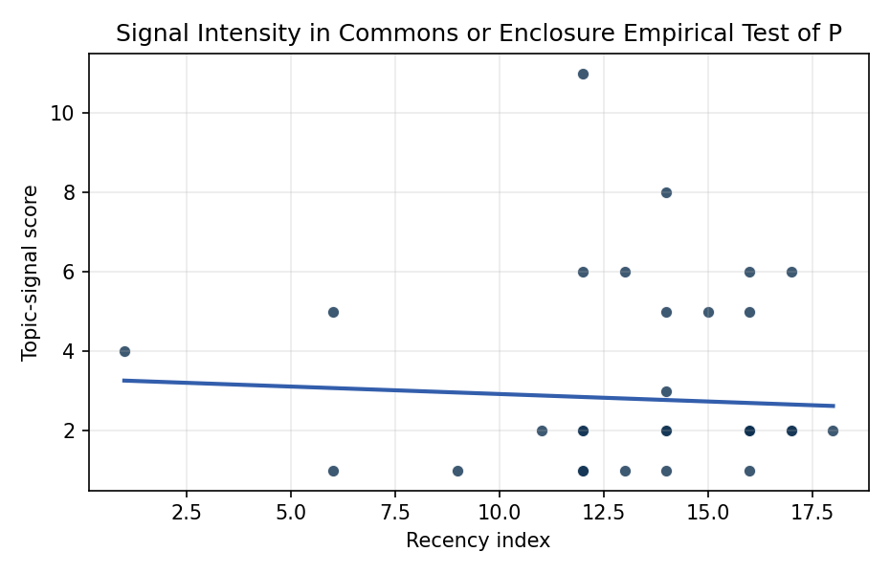
Figure 1. Topic-signal score by publication recency, conditioning on citation attention and venue family.

Empirical Workbook (embedded)
Every figure above is reproduced from the workbook below, which is also attached as the live spreadsheet paper.xlsx. Each observation carries its source.

Data (real observations)
doc_id | year_num | recency_index | cites_num | venue_score | title_words | snippet_words | keyword_count | theme_hits | signal_score | source
1 | 2022 | 14 | 0 | 1 | 12 | 13 | 2 | 2 | 5 | https://amostech.space/year/2022/from-ozone-depletion-to-orbital-debris-lessons-learned-from-the-montreal-protocol/
2 | 2023 | 15 | 0 | 1 | 17 | 13 | 7 | 2 | 5 | 10.64861/DDNM3393
3 | 2022 | 14 | 0 | 1 | 12 | 13 | 2 | 3 | 8 | https://amostech.space/year/2022/exploring-a-new-class-of-bright-ultra-fast-glints-from-resident-space-objects/
4 | 2014 | 6 | 0 | 1 | 12 | 13 | 2 | 2 | 5 | https://amostech.space/year/2014/proto-type-development-of-optical-wide-field-patrol-network-and-test-observation/
5 | 2022 | 14 | 0 | 1 | 9 | 14 | 4 | 1 | 2 | https://amostech.space/year/2022/low-orbit-high-stakes-winning-the-leo-broadband-competition/
6 | 2022 | 14 | 0 | 1 | 15 | 14 | 3 | 0 | 1 | https://amostech.space/year/2022/sharing-operational-risk-information-in-the-space-domain-to-facilitate-norms-development-and-compliance-monitoring/
7 | 2014 | 6 | 0 | 1 | 7 | 14 | 6 | 0 | 1 | https://amostech.space/year/2014/the-daniel-k-inouye-solar-telescope-a-project-update/
8 | 2021 | 13 | 0 | 1 | 14 | 13 | 7 | 2 | 6 | https://amostech.space/year/2021/decentralized-space-information-sharing-as-a-key-enabler-of-trust-and-the-preservation-of-space/
9 | 2024 | 16 | 0 | 1 | 9 | 12 | 4 | 1 | 2 | 10.64861/VUSE2201
10 | 2009 | 1 | 0 | 1 | 10 | 14 | 2 | 2 | 4 | https://amostech.space/year/2009/science-objectives-and-commissioning-of-the-magdalena-ridge-observatory-interferometer/
11 | 2022 | 14 | 0 | 1 | 14 | 14 | 3 | 1 | 3 | https://amostech.space/year/2022/magdalena-ridge-observatory-interferometer-an-overview-of-an-astrophysics-facility-for-supporting-sda-efforts/
12 | 2021 | 13 | 0 | 1 | 11 | 14 | 5 | 0 | 1 | https://amostech.space/year/2021/development-and-testing-of-a-novel-low-cost-leo-optical-surveillance-sensor/
13 | 2020 | 12 | 30 | 2 | 18 | 12 | 14 | 0 | 1 | 10.1016/j.actaastro.2020.10.011
14 | 2020 | 12 | 26 | 2 | 19 | 14 | 10 | 1 | 2 | 10.1016/j.actaastro.2020.02.031
15 | 2017 | 9 | 3 | 2 | 7 | 14 | 12 | 0 | 1 | 10.1016/j.actaastro.2017.04.028
16 | 2024 | 16 | 12 | 2 | 13 | 7 | 11 | 2 | 6 | 10.1016/j.actaastro.2024.09.005
17 | 2024 | 16 | 2 | 2 | 14 | 14 | 14 | 1 | 2 | 10.1016/j.actaastro.2024.12.037
18 | 2026 | 18 | 0 | 2 | 10 | 14 | 13 | 0 | 2 | 10.1016/j.actaastro.2026.01.061
19 | 2025 | 17 | 1 | 2 | 16 | 13 | 9 | 1 | 2 | 10.1016/j.actaastro.2025.01.015
20 | 2022 | 14 | 18 | 2 | 18 | 14 | 15 | 1 | 2 | 10.1016/j.actaastro.2022.04.028
21 | 2024 | 16 | 2 | 2 | 13 | 13 | 8 | 2 | 5 | 10.1016/j.actaastro.2024.02.016
22 | 2025 | 17 | 2 | 2 | 11 | 14 | 5 | 1 | 2 | 10.1016/j.actaastro.2025.01.029
23 | 2019 | 11 | 27 | 2 | 11 | 14 | 11 | 0 | 2 | 10.1016/j.actaastro.2019.04.035
24 | 2024 | 16 | 2 | 2 | 10 | 13 | 15 | 0 | 1 | 10.1016/j.actaastro.2024.01.044
25 | 2020 | 12 | 0 | 3 | 6 | 0 | 0 | 0 | 1 | Leveraging Circular Economy for Space Sustainability
26 | 2020 | 12 | 0 | 3 | 53 | 0 | 0 | 4 | 11 | Dailey et al. (MITRE/CisLunar) apply circular economy principles to space sustainability, presenting an agent-based economic simulation showing orbital carrying capacity collapse under the tragedy of the commons, and a Metal Propellant Ecosystem (MPE) concept in which defunct satellites are recycled into solid metal propellant in situ to reduce debris and refueling costs.
27 | 2020 | 12 | 0 | 3 | 11 | 0 | 0 | 1 | 2 | Governing Outer Space as a Commons Is Critical for Commons on Earth
28 | 2024 | 16 | 0 | 3 | 12 | 0 | 0 | 1 | 2 | 10.5334/ijc.1378
29 | 2025 | 17 | 0 | 3 | 10 | 0 | 0 | 2 | 6 | 10.1162/glep_a_00775
30 | 2020 | 12 | 0 | 3 | 10 | 0 | 0 | 2 | 6 | The Missing Ingredients for a Polycentric Governance System of Orbital Debris

Variable construction
Variable | Definition | Construction / source
signal_score | Composite topic-signal score for each retrieved source record | Deterministic count built from candidate-theme term hits in the source title, snippet, keyword field, and author metadata; each row cites the retrieved source in the source column
recency_index | Publication recency index | Computed as publication year minus the minimum publication year in the paper sample plus one
cites_num | Reported citation count in the local brain index | Parsed from the local brain search cites field; zero when the index reported no citation count
venue_score | Ordinal venue-family score | AMOS = 1, Acta Astronautica = 2, Space Economy = 3

Estimator output
Term | Coef. | Std. err. | t | p | 95% CI
const | 3.3025 | 1.3594 | 2.4294 | 0.0151 | [0.6381, 5.9668]
recency_index | -0.0376 | 0.1074 | -0.3501 | 0.7262 | [-0.2481, 0.1729]
cites_num | -0.0687 | 0.0331 | -2.0759 | 0.0379 | [-0.1336, -0.0038]
venue_score | 0.4327 | 0.8629 | 0.5015 | 0.616 | [-1.2584, 2.1239]
Fit: N = 30 R2 = 0.0675 R2_adj = -0.0401 F = 1.8316 F_p = 0.1662

