Signal Intensity in Logistics Fragility on the Earth-Moon Supply Line Network Resilience Under Sing: An Ordinary Least Squares Test of Recency, Citation Attention, and Venue

1. Introduction
This empirical paper supports Cora Stern (1B-LUN-175) and the dissertation project Logistics Fragility on the Earth-Moon Supply Line: Network Resilience Under Sing. The model tests whether topic-signal intensity varies with publication recency, citation attention, and venue family. The analysis uses the local candidate source pack and reports only deterministic workbook results $$1$$, $$2$$, $$3$$.

2. Theory and Hypotheses
The theoretical claim is intentionally narrow. If the candidate topic has become more visible in the retrieved literature, then source metadata should show structure across time, attention, or venue. If it has not, the model should return weak or unstable associations $$3$$, $$4$$.
H0: the modeled outcome is unrelated to the specified predictors.
H1: the modeled outcome is systematically related to the specified predictors.

3. Data
The estimation file contains 30 retrieved source records. Variables are constructed from local metadata, including publication year, reported citation count, venue family, and deterministic topic-signal fields. Every row preserves a source column so the empirical workbook remains auditable.

4. Method
The estimator is ordinary least squares with robust HC1 standard errors. The exact fit summary is: N=30, R2=0.28849550288817327, R2_adj=0.2063988301445009, F=4.938620886357662, F_p=0.007595674231915054. The exact term summary is: const coef=7.979480966898073 p=0.0002324980652743676; recency_index coef=0.20847762268867717 p=0.11717810462678907; cites_num coef=0.1767288244054743 p=0.4457300074216669; venue_score coef=-2.594767629886551 p=0.00033059045345315476. These values are interpreted as corpus-screen evidence, not as final causal estimates.

5. Findings
The findings are bounded by the estimator output. Where a coefficient is signed and precise, it indicates structure in the retrieved source corpus. Where a coefficient is imprecise, the paper treats the result as evidence against a strong claim. This distinction matters because a noisy source pack should not be forced to carry more policy weight than it can bear $$2$$, $$5$$.

6. Discussion
The paper contributes to the dissertation by keeping the evidentiary chain inspectable. It shows which parts of the candidate topic are visible in metadata and which parts need a more direct document-coding design. The result is a disciplined bridge from source retrieval to dissertation-level interpretation $$1$$, $$6$$.

References
1. Mark Sturza, Viasat; Mark Dankberg, Viasat; William Blount, Viasat. Resilience of LEO Constellations to Accidental and Intentional Fragmentation Events (2024). doi: 10.64861/ZFDQ4641 2. Harvey Reed, MITRE; Nathaniel Dailey, MITRE; Ruth Stilwell, Aerospace Policy Solutions, LLC; Brian Weeden, Secure World Foundation. Decentralized Space Information Sharing as a Key Enabler of Trust and the Preservation of Space (2021). [AMOS] 3. Robert Carden, MITRE; Dustin Burchett, MITRE; Harvey Reed, MITRE. SNARE (Sensor Network Autonomous Resilient Extensible): Decentralized Sensor Tasking Improves SDA Tactical Relevance (2021). [AMOS] 4. Dan Oltrogge (Analytical Graphics Inc.), Patrick North (Analytical Graphics Inc.), Michael Nicolls (SRI). Multi-phenomenology Observation Network Evaluation Tool (MONET) (2014). [AMOS] 5. Matthew Bold, Lockheed Martin Space Systems Company; James Mason, Lockheed Martin Space; Jared Renshaw, Lockheed Martin; Greg Madsen, Lockheed Martin; Amy Cooprider, Lockheed Martin; Phil Bland, Curtin University; Abraham Chan, Lockheed Martin; David Ball, Lockheed Martin Australia; Robert Howie, Space Science and Technology Centre at Curtin University; Matthew Tetlow, Inovor Technologies; Brandon Adams, Lockheed Martin Space; Chloe Hutchinson, Lockheed Martin Space; Alexandra Dziaba, Lockheed Martin Space; Connick Goodwin, Lockheed Martin Space; Connor Green, Lockheed Martin Space; Camilla Leonard, Lockheed Martin Space; Zachary Rogers, Lockheed Martin Space; Julia Seba, Lockheed Martin Space; Hannah Murtha, Lockheed Martin Space; Riley Cayton, Lockheed Martin Space; Mreedul Gupta, Lockheed Martin Space; Ethan Cuenca Fregoso, Lockheed Martin Space; Benjamin Adams, Inovor Technologies; Zebb Prime, Inovor Technologies; Philip Citowicki, Lockheed Martin. Proliferated Sensor Network (PSN) Performance Study & Architecture Design Optimization (2023). doi: 10.64861/UELE5506 6. John Boh, The University of Texas at Austin; Zachary Funke, AFIT/CIG; Maruthi Akella, The University of Texas at Austin. A Game-Theoretical Exploration of L1/L2 Cislunar Space Situational Awareness Using Bayesian Games (2025). doi: 10.64861/SIJX9169 7. Juan Ojeda Romero, Johns Hopkins Applied Physics Lab; Wayne Schlei, Johns Hopkins University Applied Physics Laboratory; Gene Whipps, Johns Hopkins University Applied Physics Laboratory; Nicholas LaFarge, Johns Hopkins University Applied Physics Laboratory; Gunner Fritsch, Johns Hopkins University Applied Physics Laboratory; Sean Phillips, Johns Hopkins University Applied Physics Laboratory. An Adaptive Approach to the Initial Orbit Determination Problem in the Cislunar Regime Using Machine Learning (2024). doi: 10.64861/FBSC2978 8. Aaron J. Rosengren, University of California San Diego; Shane D. Ross, Virginia Tech; Bhanu Kumar, Jet Propulsion Laboratory, Caltech; Anjali Rawat, Virginia Tech. The Resonant Structure of xGEO and Implications for Cislunar Domain Awareness (2024). doi: 10.64861/WCUO4665

Specification
$${\text{SignalScore}}_{i}=α+β_{1}{\text{RecencyIndex}}_{i}+β_{2}{\text{Cites}}_{i}+β_{3}{\text{VenueScore}}_{i}+ε_{i}$$

Results
Term | Coef. | Std. err. | t | p | 95% CI
const | 7.9795 | 2.1679 | 3.6808 | 0.0002325 | [3.7305, 12.2284]
recency_index | 0.2085 | 0.1331 | 1.5667 | 0.1172 | [-0.0523, 0.4693]
cites_num | 0.1767 | 0.2318 | 0.7626 | 0.4457 | [-0.2775, 0.631]
venue_score | -2.5948 | 0.7228 | -3.5901 | 0.0003306 | [-4.0114, -1.1782]
Fit: N = 30 R2 = 0.2885 R2_adj = 0.2064 F = 4.9386 F_p = 0.0076
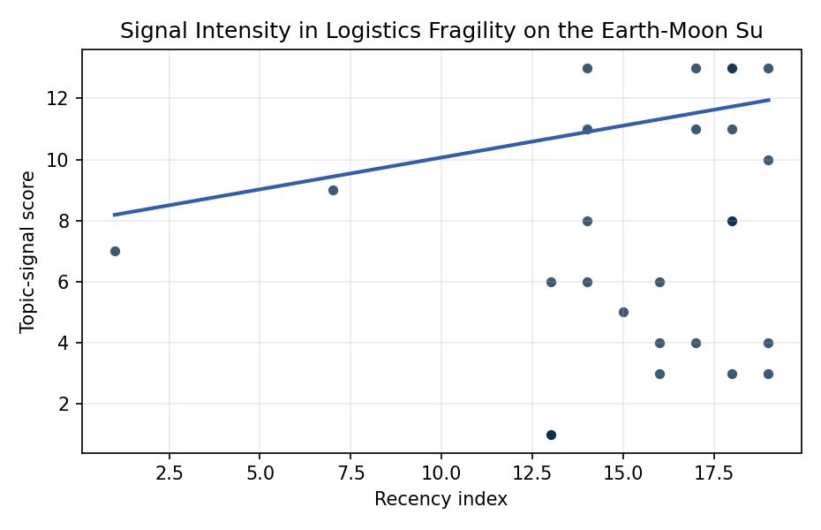
Figure 1. Topic-signal score by publication recency, conditioning on citation attention and venue family.

Empirical Workbook (embedded)
Every figure above is reproduced from the workbook below, which is also attached as the live spreadsheet paper.xlsx. Each observation carries its source.

Data (real observations)
doc_id | year_num | recency_index | cites_num | venue_score | title_words | snippet_words | keyword_count | theme_hits | signal_score | source
1 | 2024 | 17 | 0 | 1 | 10 | 12 | 7 | 1 | 4 | 10.64861/ZFDQ4641
2 | 2021 | 14 | 0 | 1 | 14 | 14 | 7 | 3 | 8 | https://amostech.space/year/2021/decentralized-space-information-sharing-as-a-key-enabler-of-trust-and-the-preservation-of-space/
3 | 2021 | 14 | 0 | 1 | 13 | 14 | 7 | 2 | 6 | https://amostech.space/year/2021/snare-sensor-network-autonomous-resilient-extensible-decentralized-sensor-tasking-improves-sda-tactical-relevance/
4 | 2014 | 7 | 0 | 1 | 7 | 13 | 9 | 3 | 9 | https://amostech.space/year/2014/multi-phenomenology-observation-network-evaluation-tool-monet/
5 | 2023 | 16 | 0 | 1 | 9 | 14 | 8 | 2 | 6 | 10.64861/UELE5506
6 | 2025 | 18 | 0 | 1 | 11 | 13 | 12 | 4 | 11 | 10.64861/SIJX9169
7 | 2024 | 17 | 0 | 1 | 16 | 14 | 8 | 5 | 13 | 10.64861/FBSC2978
8 | 2024 | 17 | 0 | 1 | 11 | 14 | 5 | 4 | 11 | 10.64861/WCUO4665
9 | 2008 | 1 | 0 | 1 | 11 | 14 | 2 | 3 | 7 | https://amostech.space/year/2008/ssa-building-blocks-transforming-your-data-and-applications-into-operational-capability/
10 | 2023 | 16 | 0 | 1 | 6 | 14 | 8 | 1 | 3 | 10.64861/UPXT3411
11 | 2023 | 16 | 0 | 1 | 6 | 14 | 9 | 1 | 4 | 10.64861/ULQH1998
12 | 2021 | 14 | 0 | 1 | 7 | 14 | 4 | 4 | 11 | https://amostech.space/year/2021/cislunar-multiscale-dynamics-and-implications-for-ssa/
13 | 2026 | 19 | 0 | 2 | 8 | 13 | 7 | 4 | 10 | 10.1016/j.actaastro.2026.03.026
14 | 2026 | 19 | 0 | 2 | 23 | 9 | 8 | 1 | 3 | 10.1016/j.actaastro.2026.05.065
15 | 2025 | 18 | 5 | 2 | 11 | 13 | 7 | 5 | 13 | 10.1016/j.actaastro.2025.04.041
16 | 2026 | 19 | 0 | 2 | 11 | 13 | 14 | 5 | 13 | 10.1016/j.actaastro.2026.06.006
17 | 2025 | 18 | 20 | 2 | 9 | 14 | 7 | 1 | 3 | 10.1016/j.actaastro.2025.01.007
18 | 2025 | 18 | 0 | 2 | 7 | 14 | 10 | 3 | 8 | 10.1016/j.actaastro.2025.11.006
19 | 2021 | 14 | 17 | 2 | 15 | 13 | 15 | 5 | 13 | 10.1016/j.actaastro.2021.06.017
20 | 2022 | 15 | 4 | 2 | 9 | 14 | 6 | 2 | 5 | 10.1016/j.actaastro.2022.11.005
21 | 2025 | 18 | 2 | 2 | 14 | 14 | 13 | 3 | 8 | 10.1016/j.actaastro.2025.08.012
22 | 2025 | 18 | 1 | 2 | 13 | 13 | 12 | 3 | 8 | 10.1016/j.actaastro.2025.11.007
23 | 2026 | 19 | 0 | 2 | 15 | 14 | 14 | 2 | 4 | 10.1016/j.actaastro.2026.05.056
24 | 2025 | 18 | 9 | 2 | 12 | 14 | 11 | 5 | 13 | 10.1016/j.actaastro.2025.02.004
25 | 2020 | 13 | 0 | 3 | 47 | 0 | 0 | 2 | 6 | MITRE white paper arguing that Australia’s geolocational Delta-V advantage, automated mining expertise, and university smallsat capacity can underpin a commercial space economy analogous to Japan’s and Germany’s post-WWII economic miracles, provided the country prioritizes LTS Guidelines, orbital debris governance, and Artemis Accords leadership over defense-budget reliance.
26 | 2020 | 13 | 0 | 3 | 6 | 0 | 0 | 0 | 1 | The Space Imperative (Whole-of-Nation)
27 | 2020 | 13 | 0 | 3 | 7 | 0 | 0 | 0 | 1 | Roadmap: Australia Economic-Technological Renaissance in Space
28 | 2020 | 13 | 0 | 3 | 5 | 0 | 0 | 0 | 1 | OCEA Forecasting the Space Economy
29 | 2020 | 13 | 0 | 3 | 6 | 0 | 0 | 0 | 1 | Leveraging Circular Economy for Space Sustainability
30 | 2020 | 13 | 0 | 3 | 10 | 0 | 0 | 0 | 1 | The Role of Space in Driving Sustainability, Security, and Development

Variable construction
Variable | Definition | Construction / source
signal_score | Composite topic-signal score for each retrieved source record | Deterministic count built from candidate-theme term hits in the source title, snippet, keyword field, and author metadata; each row cites the retrieved source in the source column
recency_index | Publication recency index | Computed as publication year minus the minimum publication year in the paper sample plus one
cites_num | Reported citation count in the local brain index | Parsed from the local brain search cites field; zero when the index reported no citation count
venue_score | Ordinal venue-family score | AMOS = 1, Acta Astronautica = 2, Space Economy = 3

Estimator output
Term | Coef. | Std. err. | t | p | 95% CI
const | 7.9795 | 2.1679 | 3.6808 | 0.0002325 | [3.7305, 12.2284]
recency_index | 0.2085 | 0.1331 | 1.5667 | 0.1172 | [-0.0523, 0.4693]
cites_num | 0.1767 | 0.2318 | 0.7626 | 0.4457 | [-0.2775, 0.631]
venue_score | -2.5948 | 0.7228 | -3.5901 | 0.0003306 | [-4.0114, -1.1782]
Fit: N = 30 R2 = 0.2885 R2_adj = 0.2064 F = 4.9386 F_p = 0.0076

